**DATA STRUCTURES – FALL 2021**

**LAB 14**



Learning Outcomes

In this lab you are expected to learn the following:

* To understand and implement the concepts of Graphs in data structures
* Google Unit Test

# Task 1

## Data Items

Each vertex in a graph has a label (of type int) that uniquely identifies it. Vertices may include additional data.

**Structure**

The relationship between the vertices in a graph is expressed using a set of directed/undirected Edges, where each edge connects one pair of vertices. Here is an example of undirected graph and its representation in the form of adjacency list.

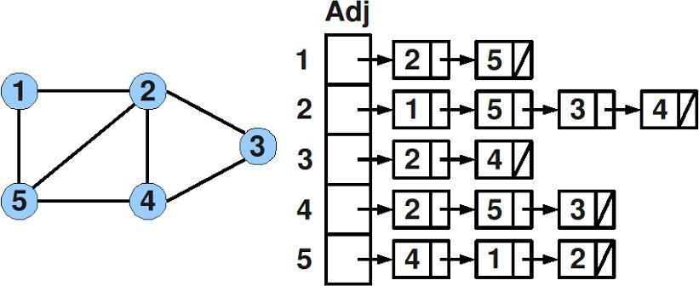

**Operations**

**Node:**

class Node

{

public:

int data;

Node * next;

};

**Adjacency List:**

class AdjList

{

public:

Node *head;

};

**Graph (int maxVertices)**

Results:

Constructor. Creates an empty graph. Allocates enough memory for a graph containing maxNumber vertices.

~ **Graph ()**

Results:

Destructor. Deallocates (frees) the memory used to store a graph.

**Node createVertex (Node newVertex )**

Results:

Create and return a Vertex.

**void insertEdge (int src, int dest)**

Requirements:

The graph includes vertices source and destination.

Results:

Inserts an undirected edge connecting vertices source and destination into a graph.

**void showGraphStructure ()**

Results:

Outputs a graph with the vertices in array form and the edges in adjacency list form. If the graph is empty, outputs “Empty graph”. Note that this operation is intended for testing/debugging purposes only.

**void BFS (int startNode)**

Requirements:

The graph contains start node. You can create an array of visited nodes (size is the same as the size of the graph).

Results:

Outputs nodes of the graph in BFS.

# Task 2

Given below is a weighted, directed, and connected graph of **V** vertices and **E** edges. The task is to find the sum of weights of the edges of the Minimum Spanning Tree by using the prim’s algorithm of the graph given below. You have to implement the graph using the adjacency matrix method.

**Structure**

The relationship between the vertices in a graph is expressed using a set of directed/undirected Edges, where each edge connects one pair of vertices. Here is an example of directed graph and its representation in the form of adjacency matrix.

**Adjacency Matrix**

