**FORMAN CHRISTIAN COLLEGE**

**(A CHARTERED UNIVERSITY)**



**Mobile Application Development (CSCS468)**

**Section A, Fall 2024**

**Assignment 3**  
**WireFrames**

**Group Members:**

**Faraz Waqar (251707570)**

**Raveeha Chaudhary (251731363)**

# Introduction:

This report provides an overview of the wireframes designed for the app project. The wireframes were created using Figma and consist of 22 screens. Each screen represents a specific part of the app’s user interface and outlines its functionality and flow. The purpose of these wireframes is to visualize the app’s structure, layout, and navigation before moving to the development phase.

# Flow Diagram:

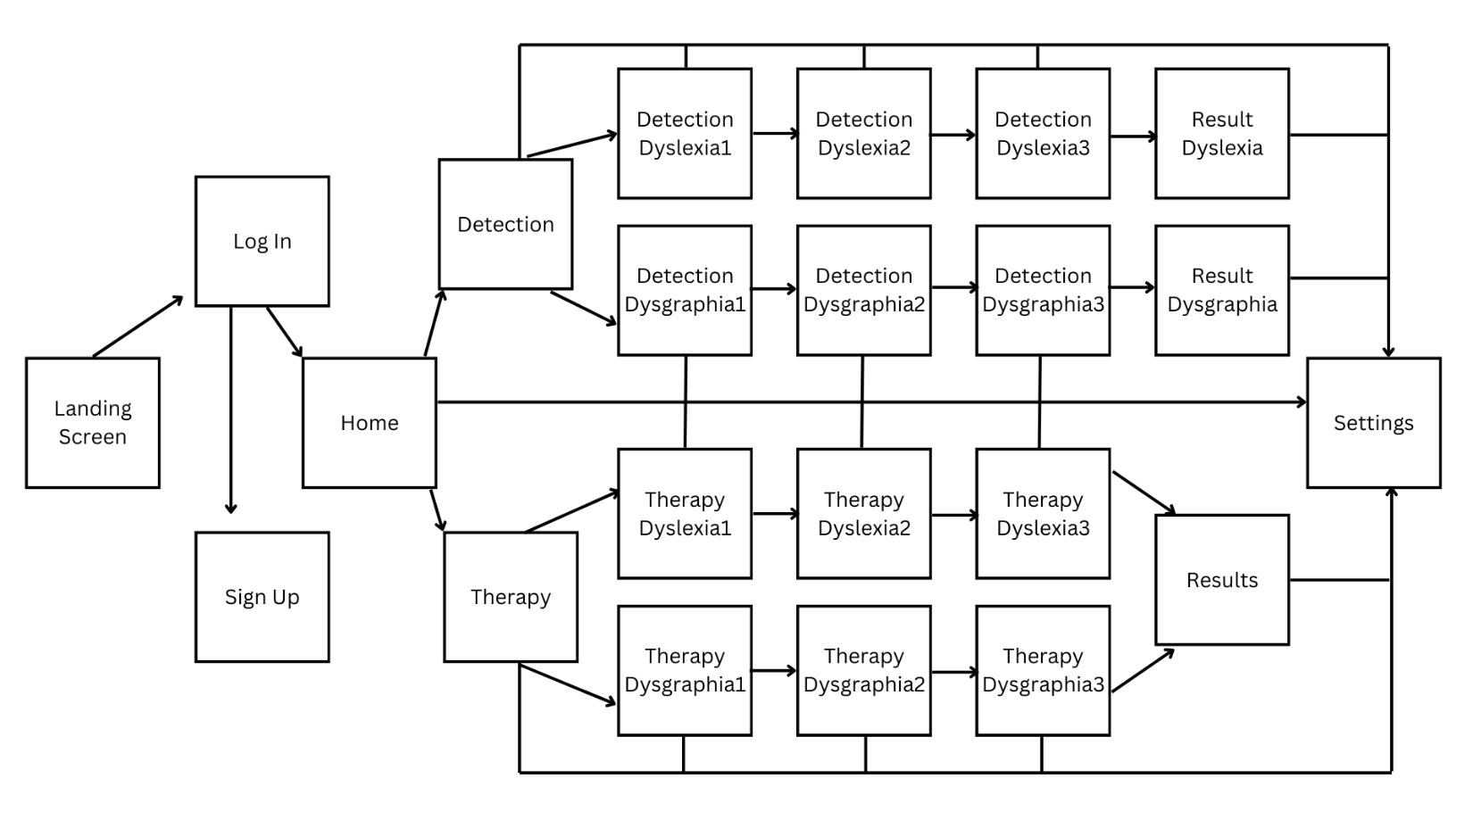

The above diagram is the flow diagram explaining the flow of the app, the navigation would depend on the buttons in the screen.

# WireFrames:

## Landing, Log in and Sign Up Screens:

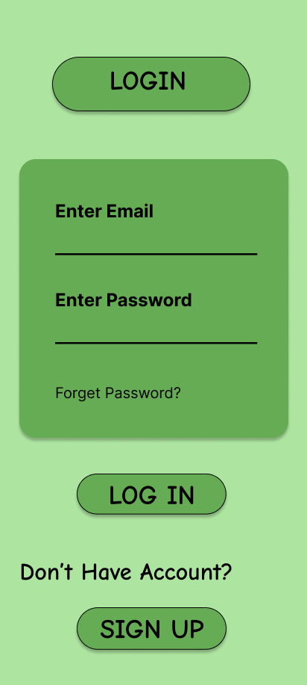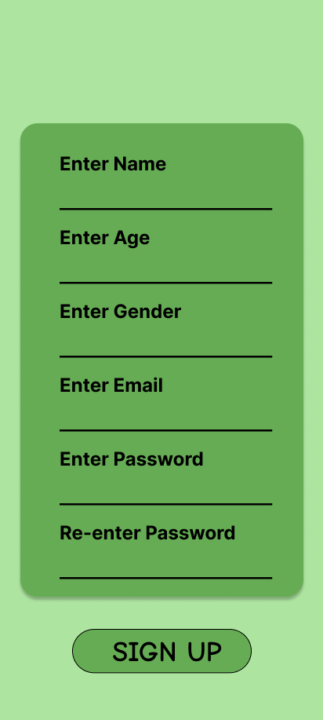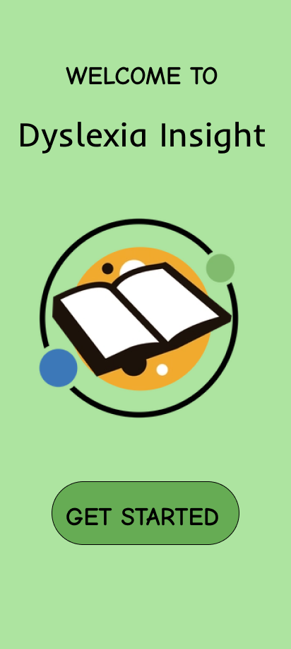

**Sign Up Screen**

This is the Sign Up screen of the app. Here user Sign Up and create their account. Sign up will navigate to the Home Screen.

**LogIn Screen**

This is the LogIn screen of the app. Here user will login to their account and if they don’t have the account there’s a button “Sign Up” which will navigate to the sign up screen where user can create their account. The login button will navigate to the Home Screen and Sign up will navigate to the Sign Up screen.

**Landing Screen**

This is the landing screen of the app. It will be displayed when you open the app. And the start button will navigate to the LogIn Screen.

## Home, Therapy and Detection Screens:

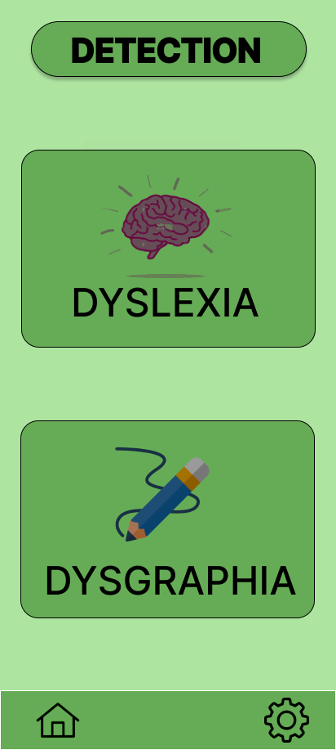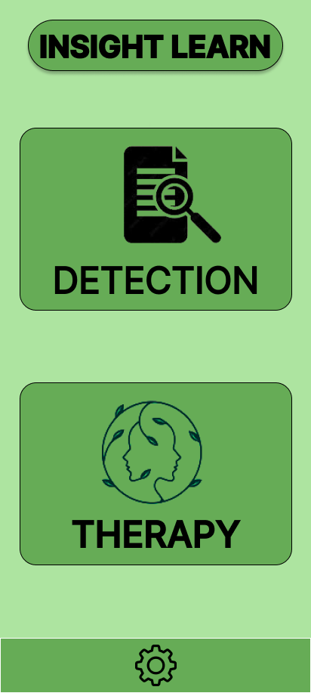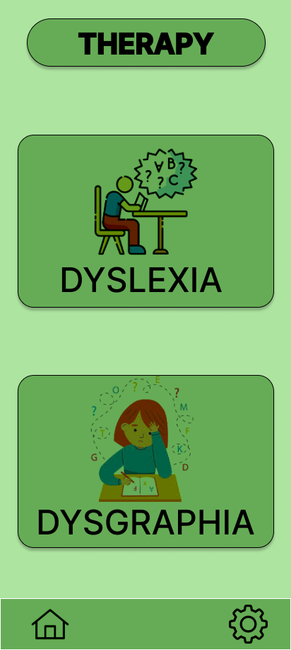

**Detection Screen**

This is the Detection screen, here user can choose if he/she wants the Detection of dyslexia or dysgraphia. Dyslexia button will navigate to Dyslexia Detection Test 1 and Dysgraphia will navigate to Dysgraphia Detection Test 1.

**Home Screen**

This is the home screen, here user can choose whether user wants the therapy or wants to attempt detection tests. Detection will navigate to detection Screen and therapy will navigate to the therapy screen.

**Therapy Screen**

This is the therapy screen, here user can choose if he/she wants the therapy of dyslexia or dysgraphia. Dyslexia button will navigate to Dyslexia Therapy Test 1 and Dysgraphia will navigate to Dysgraphia Therapy Test 1.

## Dyslexia Detection Test Screens:

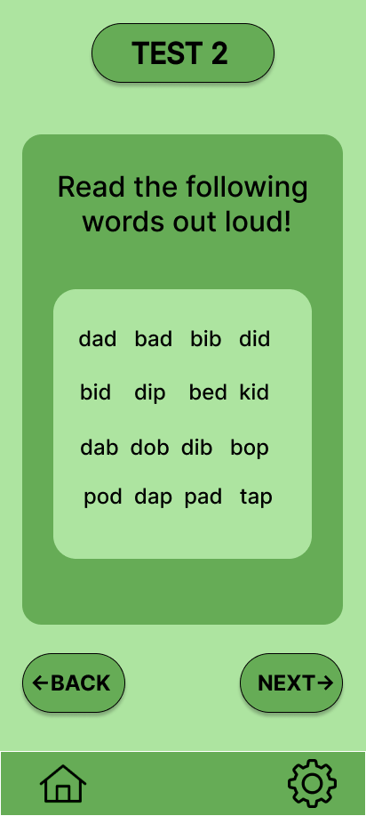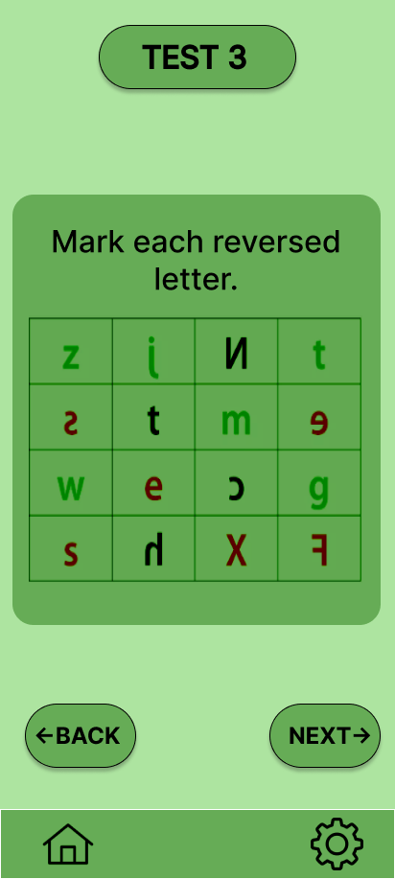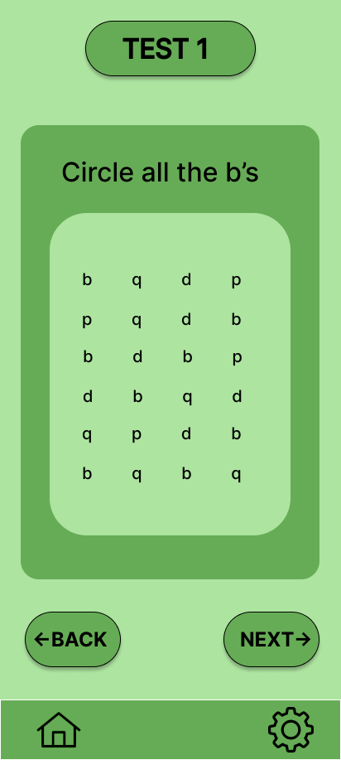

**Dyslexia Detection Test 3 Screen**

This is the Dyslexia Detection Test 3 Screen, next button will navigate to the results and back will go back to the test 2.

**Dyslexia Detection Test 2 Screen**

This is the Dyslexia Detection Test 2 Screen, next button will navigate to the test 3 and back will go back to the test 1.

**Dyslexia Detection Test 1 Screen**

This is the Dyslexia Detection Test 1 Screen, next button will navigate to the test 2 and back will go back to the detection screen.

## Dysgraphia Detection Test Screens:

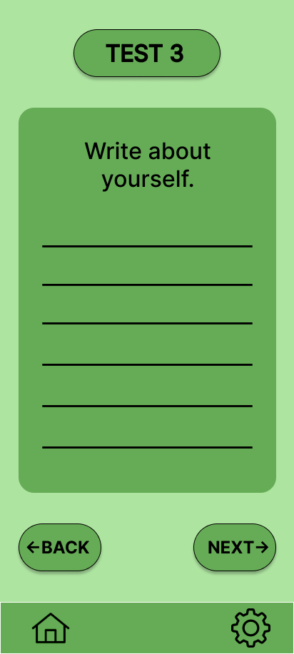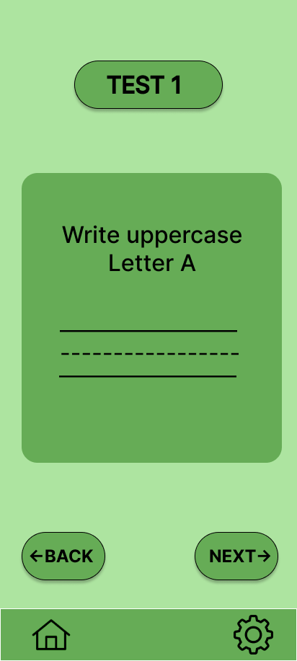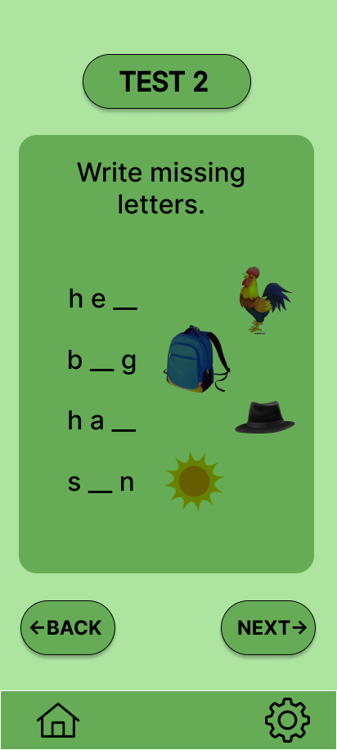

**Dysgraphia Detection Test3 Screen**

This is the Dysgraphia Detection Test 3 Screen, next button will navigate to the results and back will go back to the test 2.

**Dysgraphia Detection Test2 Screen**

This is the Dysgraphia Detection Test 2 Screen, next button will navigate to the test 3 and back will go back to the test 1.

**Dysgraphia Detection Test1 Screen**

This is the Dysgraphia Detection Test 1 Screen, next button will navigate to the test 2 and back will go back to the detection screen.

## Result Screens:

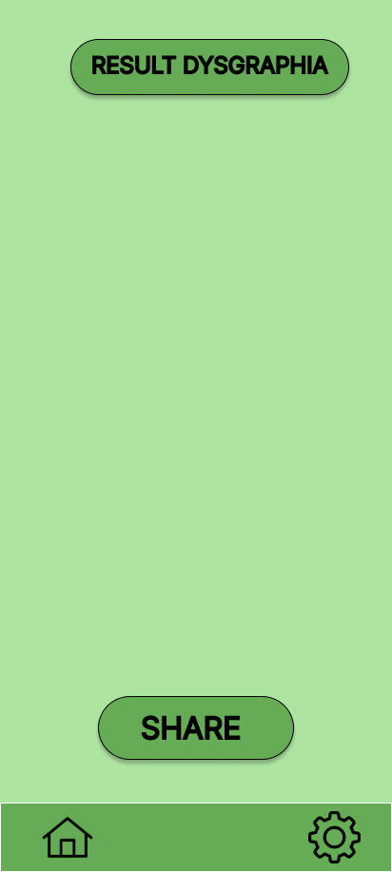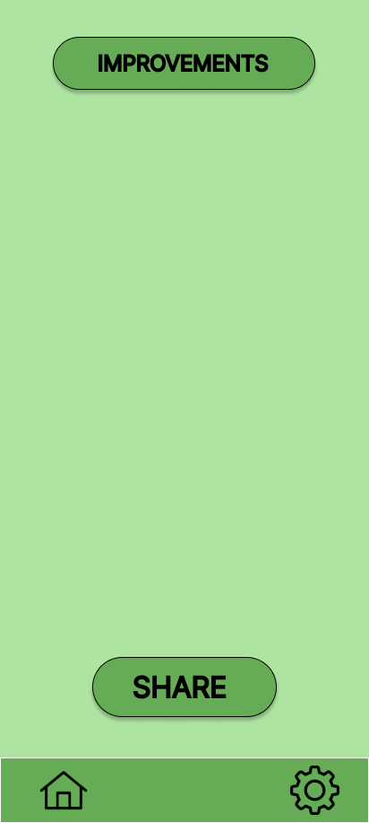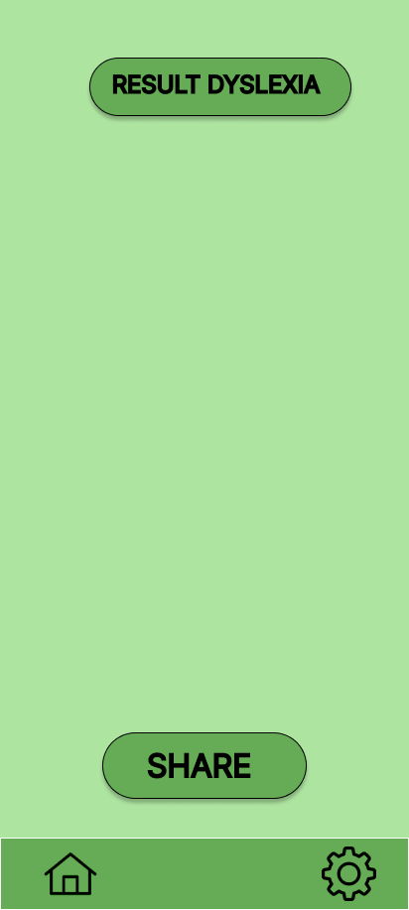

**Result Dyslexia Screen**

This is the result screen, here dyslexia detection results will be displayed.

**Result Dysgraphia Screen**

This is the result screen, here dysgraphia detection results will be displayed.

**Therapy Result Screen**

This is the result screen, here therapy results will be displayed.

## Dyslexia Therapy Screens:

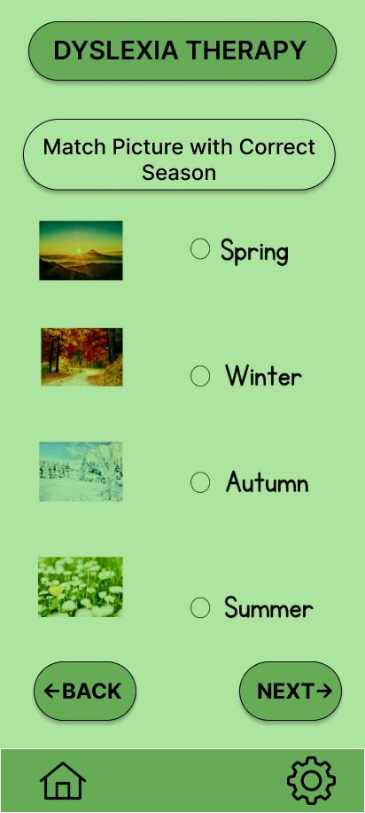

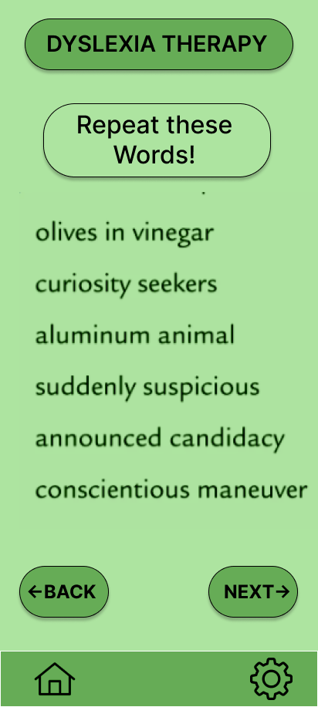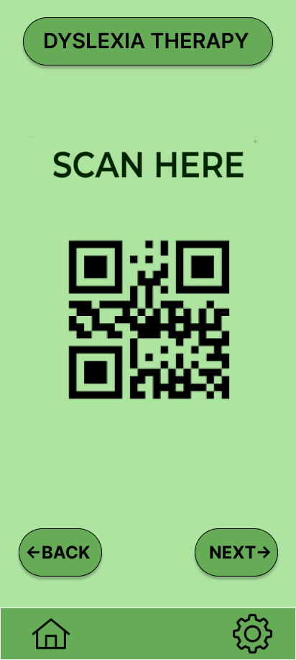

**Dyslexia Therapy3 Screen**

This is the Dyslexia therapy 3 Screen, next button will navigate to the therapy results and back will go back to the therapy 2

**Dyslexia Therapy2 Screen**

This is the Dyslexia therapy 2 Screen, next button will navigate to the therapy 3 and back will go back to the therapy 1.

**Dyslexia Therapy1 Screen**

This is the Dyslexia therapy 1 Screen, next button will navigate to the therapy 2 and back will go back to the therapy screen.

## Dysgraphia Therapy Screens:

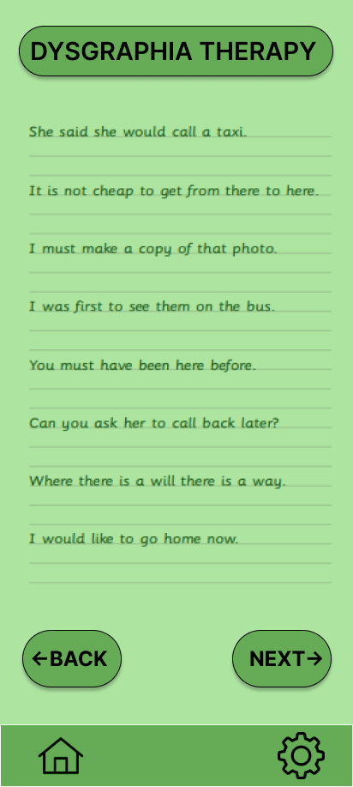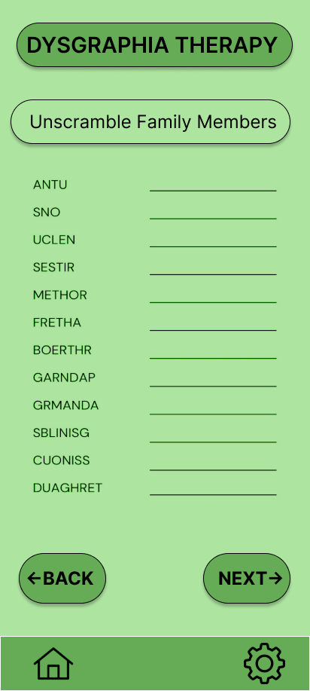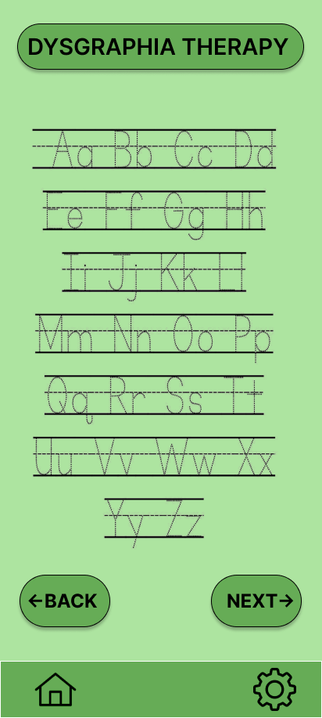

**Dysgraphia Therapy3 Screen**

This is the Dysgraphia therapy 3 Screen, next button will navigate to the therapy results and back will go back to the therapy2 screen.

**Dysgraphia Therapy2 Screen**

This is the Dysgraphia therapy 2 Screen, next button will navigate to the therapy 3 and back will go back to the therapy1 screen.

**Dysgraphia Therapy1 Screen**

This is the Dysgraphia therapy 1 Screen, next button will navigate to the therapy 2 and back will go back to the therapy screen.

## Settings Screen:

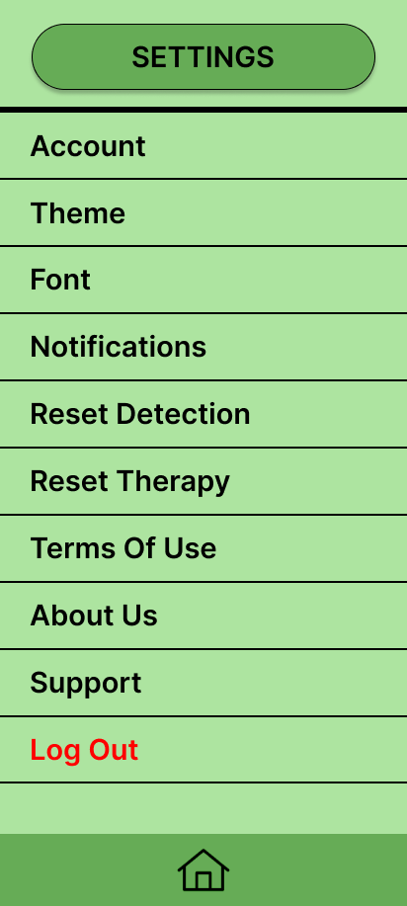

**Settings**

This is the Settings screen, here user can change theme, font and many more.

# GitHub Link:

<https://github.com/FarazWaqar/Insight_Learn_251707570_251731363_Wireframes.git>