Objects and Classes

4.1 Introduction to Object-Oriented Programming
4.2 Using Predefined Classes
4.3 Defining Your Own Classes
4.4 Static Fields and Methods
4.5 Method Parameters
4.6 Object Construction
4.7 Records
4.8 Packages
4.9 JAR Files
4.10 Documentation Comments
4.11 Class Design Hints

4.1 Introduction to Object-Oriented Programming
Object-Oriented Programming (OOP) is a programming approach in which programs are built using objects that contain both data and the methods that operate on that data.
Before OOP, most programs were written using procedural programming, where the focus was on writing procedures or functions first and then designing data structures.
Procedural Programming
- Focuses on functions and algorithms.
- Data is often shared globally.
- Large programs become difficult to manage.
- Bugs are harder to locate because many functions may access the same data.
Object-Oriented Programming
- Focuses on objects and their data.
- Each object manages its own data.
- Easier to maintain and debug.
- Encourages code reuse and modularity.
Advantages of OOP
- Improves code organization.
- Encourages code reuse.
- Simplifies debugging.
- Makes software easier to maintain.
- Reduces code duplication.
- Protects data through encapsulation.
- Makes teamwork easier because classes are modular.
- Suitable for large-scale applications.

Classes
A class is a blueprint or template used to create objects. It defines the properties (fields) and behaviours (methods) that objects created from the class will have.
Identifying Classes: A simple rule for identifying classes is:
Nouns (are) Classes like Student, Teacher or Book
Verbs (are) Methods like Add, Delete or Pay
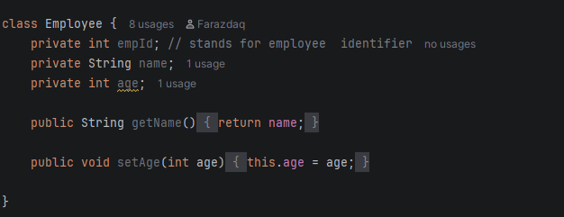
Relationships Between Classes
Dependency ("Uses-a"): One class depends on another if it uses its objects. For example, The Order class uses the Payment class to complete transactions. It is Temporary relationship, Loose coupling and One class calls another.

Aggregation ("Has-a"): Aggregation means one object contains another object. For example, the Department contains Employees

Inheritance ("Is-a"): It is a mechanism that allows a new class (called the child class or subclass) to acquire the properties (fields) and behaviours (methods) of an existing class (called the parent class or superclass). For example, Dog inherits Animal's features and adds its own.

Objects
An object is an instance of a class. It contains: Data (state), Methods (behaviour) and Identity
Every object has three important characteristics:
State: The state of an object represents the current values of its attributes.
Behaviour: Behaviour describes what an object can do and they are represented by methods.
Identity: Identity makes one object different from another even if both have the same state. For Example, two students may have Same name and Same age but they are still different students because each has a unique identity (such as a student ID).
key concept in working with objects: is Encapsulation
Encapsulation (sometimes called information hiding): is the process of combining data and methods into one unit (a class) while hiding the internal implementation details from outside access. Data is accessed through methods instead of directly.
Information Hiding: Information hiding means keeping implementation details private and exposing only what users need.
Encapsulation bundles data and methods together inside a class. Information hiding is the design principle of preventing outside code from seeing or modifying implementation details. In other words, encapsulation is often the technique used to achieve information hiding.
Instance Fields: Instance fields are variables that belong to an object. so, when we say int name or age these are instance fields.
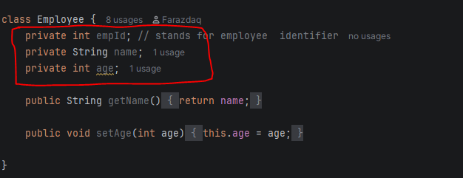
Methods: are functions inside a class that define the behaviour of objects.
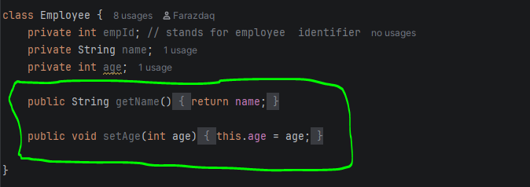
An instance is another name for an object created from a class. so, keep in mind when you declare a class which is a description of your object then create an object by typing Student s1 = new Student (); sl is an object or instance
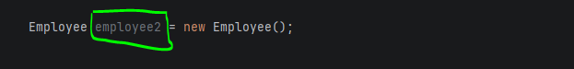

Example:
A large hospital currently manages patient information, doctor schedules, appointments, medical records, billing, prescriptions, laboratory tests, and admissions using multiple disconnected systems and manual paperwork. This causes appointment conflicts, duplicate patient records, delays in accessing medical histories, billing errors, and poor communication between departments. The hospital requires an integrated Healthcare Management System that securely stores patient information, allows online appointment scheduling, manages doctor availability, records diagnoses and treatments, generates prescriptions, processes laboratory requests and results, manages hospital admissions, and handles billing and payments. The system should ensure that authorized healthcare staff can efficiently access accurate information while maintaining patient privacy and improving the quality of healthcare services.
Step 1: Identify the Classes
From the problem statement, the two main nouns are:
- Patient
- Doctor
These become the two primary classes in our healthcare system.

Step 2: Identify the Responsibilities
Patient Class
The Patient class represents a person receiving medical care.
Attributes (Data)
- Patient ID
- Name
- Age
- Gender
- Phone Number
- Disease/Symptoms
Methods (Behavior)
- register()
- bookAppointment()
- cancelAppointment()
- viewDoctor()
- viewPrescription()

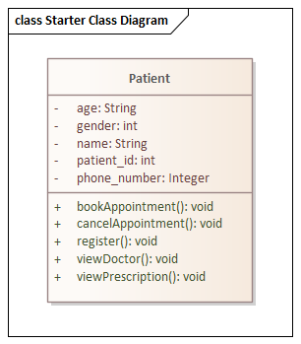

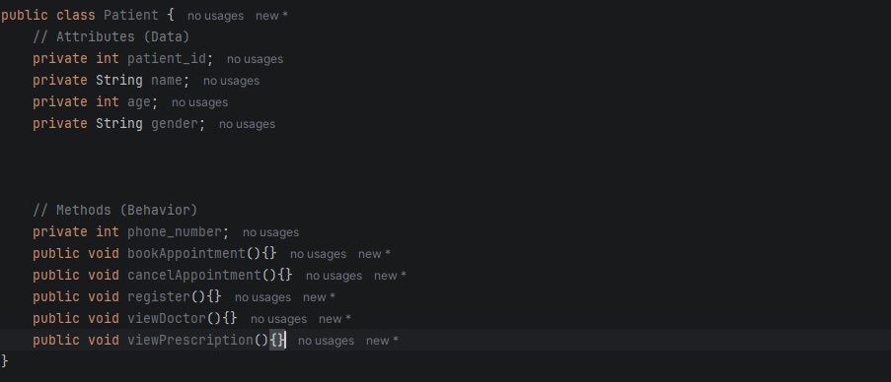

Doctor Class
The Doctor class represents a healthcare professional who treats patients.
Attributes (Data)
- Doctor ID
- Name
- Specialization
- Experience
- Availability
Methods (Behavior)
- viewPatient()
- diagnosePatient()
- prescribeMedicine()
- updateAvailability()
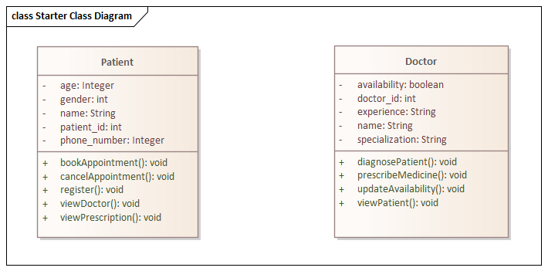

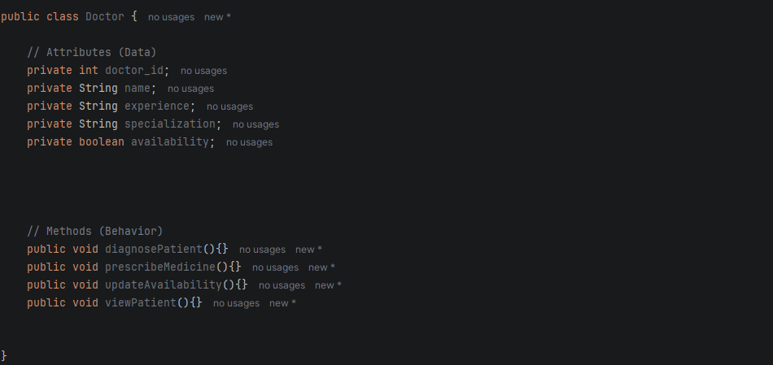

Step 3: Relationship Between Classes
Association ("Uses-a")
A Patient consults a doctor, and a doctor treats many Patients.
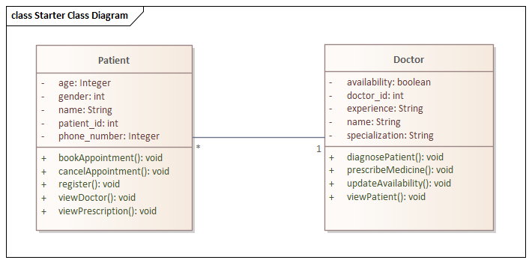
How the Relationship is Represented in the Code
The association relationship between the Patient and Doctor classes is represented by passing a Doctor object as a parameter to the consultDoctor() method and a Patient object as a parameter to the diagnosePatient() method. This allows the two independent objects to communicate by calling each other's methods without either object owning the other. Their interaction is established through method calls and object references, which is a common way to represent an association relationship in object-oriented programming.
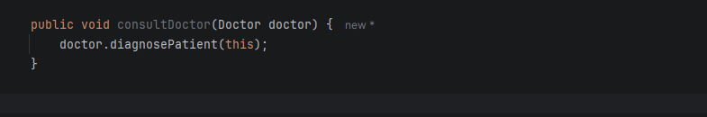

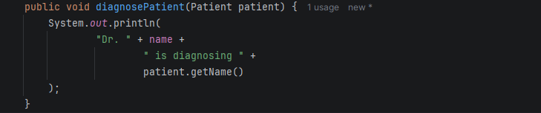

4.2 Using Predefined Classes

