Chapter 3. Fundamental Programming Structures
in Java
3.1 Data Types
3.2 Variables and Constants
3.3 Operators
3.4 Strings
3.5 Input and Output
3.6 Control Flow
3.7 Big Numbers
3.8 Arrays

3.1 Data Types: are classifications that specify what type of data a variable can store, whether it is a basic value like a number or character (primitive) or a reference to an object (non-primitive).
- Used for to allocate memory and define operations that can be performed on data.
- Proper use of data types leads to more efficient and error-free code.
Dynamically vs Statically typed languages:
- Dynamically: the variable type can be change during run time like Python.
- Statically: the variable most be declared the specified data type like Java.
As java is statically typed if we stated (int x = 10;), if later in the code we typed (x = “string”) java complier will Flage an error
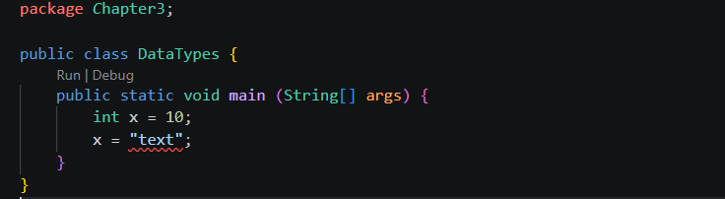
As you see the compiler raised “Type mismatch: cannot convert from String to intJava(16777233)” Error.
There are two java data types:
- Primitive Data Types: the most basic built-in types that store simple values directly in memory.
In java we have 8 primitive data types:
- Boolean

- Number
- Integer
Byte: the size required is 8 bits (2^7 to 2^7 – 1) -128 to 127. Uses 2 compliment to present negative

Short: the size required is 16 bits (2^15 to 2^15 – 1). 32768 to 32767
Int: the size required is 32 bits (2^31 to 2^31 – 1). -2,147,483,648 to 2,147,483,647 the default type
Long: the size required is 64 bits (2^63 to 2^63 – 1).
Implicit casting happens automatically when Java converts a smaller data type → larger data type.
Explicit casting happens when you manually convert a larger data type → smaller data type.

When expression like a + 1 if the type is out of range will not rase error even the value exceeds the what the result storing variable type and java will do byte wraps around, maybe we go int loop or overflow.

Wraps around: when an arithmetic result goes beyond the maximum or minimum value of a primitive type, it does not throw an error (for most integer types). Instead, it wraps around using something called overflow behaviour.

- Flot point (Flot and double)
- Character
A wrapper class: in Java is a class that converts a primitive data type into an object.

- Non-Primitive (Reference) Data Types: These store references (addresses) to objects rather than the actual value.

