MILESTONE 1
Food Waste Management System
ERD & Relational Database Schema

Subject | Database
Instructor | Ali Hassan
Group Members | Faraz Qazi, Maaz Ali
Semester | 4th Semester
Submission Date | April 26, 2025
Milestone | 1 — ERD & Relational Schema (V1)  1 — ERD & Relational Schema (V2)  2 __ ERD Design &Normalization.  3 __ Dataset Preprocessing & Dataflow Documentation  4 __ Database Setup (DDL)

SECTION 1
Project Overview

The Food Waste Management System connects restaurants with NGOs to reduce surplus food waste. Restaurants post available food listings and NGOs claim items for distribution to communities in need.
This document covers Milestone 1: the Entity-Relationship Diagram (ERD) and full Relational Database Schema for the system.
SECTION 2
Entity-Relationship Diagram

The diagram below shows all entities, attributes, primary/foreign keys, and relationships. Core tables are displayed in color; optional feature tables are shown in lighter tones.

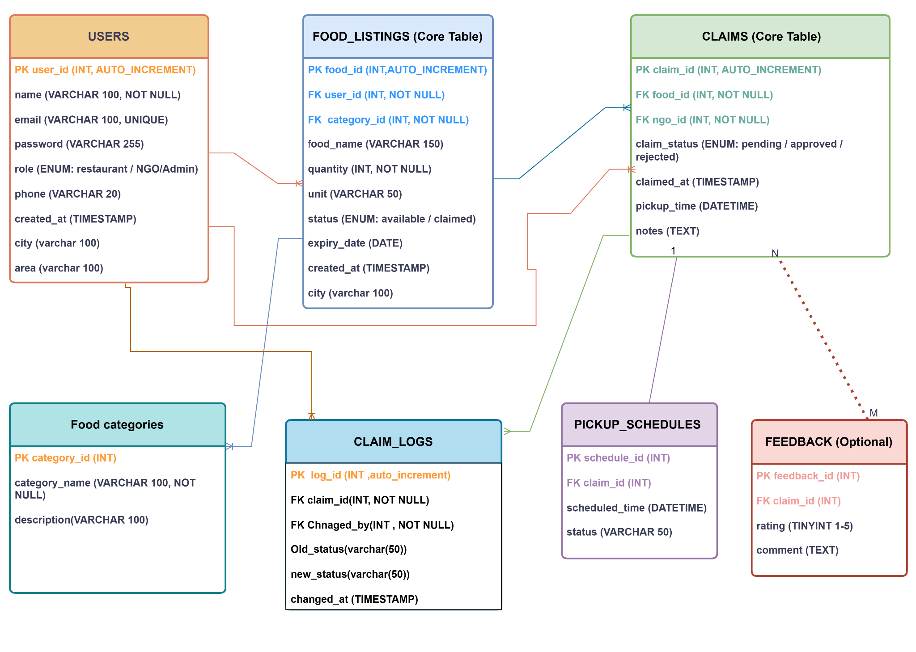
Figure 1 — Entity-Relationship Diagram, Food Waste Management System
SECTION 3
Relational Database Schema

The schema consists of three core tables, one mandatory table (pickup_schedules), one optional table (feedback), plus new tables for food categories, claim audit logs, and location fields — all using MySQL InnoDB for referential integrity support.
3.1 users
Central table storing all system users — restaurants, NGOs, and admins. The role field controls what each user can see and do. City and area fields enable location-based matching between restaurants and nearby NGOs.

Attribute | Data Type | Constraint | Description
user_id | INT | PK, AUTO_INCREMENT | Unique user identifier
name | VARCHAR(100) | NOT NULL | Full name of user
email | VARCHAR(100) | NOT NULL, UNIQUE | Login email address
password | VARCHAR(255) | NOT NULL | Hashed password
role | ENUM('restaurant','NGO','admin') | NOT NULL | Type of user account
phone | VARCHAR(20) | NULL | Contact phone number
created_at | TIMESTAMP | DEFAULT NOW() | Registration timestamp
city | VARCHAR(100) | NULL | City of the user/restaurant
area | VARCHAR(100) | NULL | Area/neighborhood of the user
3.2 food_listings
Stores all surplus food posted by restaurants. Each listing is tied to a restaurant (user_id), a food category (category_id), and a city for location filtering. Status switches from available to claimed once an NGO successfully claims the item.

Attribute | Data Type | Constraint | Description
food_id | INT | PK, AUTO_INCREMENT | Unique food listing ID
user_id | INT | FK → users(user_id) | Restaurant owner (FK)
food_name | VARCHAR(150) | NOT NULL | Name of food item
quantity | INT | NOT NULL | Amount available
unit | VARCHAR(50) | NULL | kg, portions, boxes…
status | ENUM('available','claimed') | DEFAULT 'available' | Listing availability
expiry_date | DATE | NULL | Best-before date
created_at | TIMESTAMP | DEFAULT NOW() | Listing creation time
category_id | INT | FK → food_categories(category_id), NULL | Food category (FK)
city | VARCHAR(100) | NULL | City where food is available
3.3 claims
Records every claim made by an NGO on a food listing. Links the food item and the NGO via foreign keys. The claim_status tracks the current stage of the claim — from pending through to completed or cancelled.

Attribute | Data Type | Constraint | Description
claim_id | INT | PK, AUTO_INCREMENT | Unique claim identifier
food_id | INT | FK → food_listings(food_id) | Claimed food item (FK)
ngo_id | INT | FK → users(user_id) | NGO user who claimed (FK)
claim_status | ENUM('pending','confirmed','completed','cancelled') | NOT NULL | Status of claim
claimed_at | TIMESTAMP | DEFAULT NOW() | Time claim was made
pickup_time | DATETIME | NULL | Scheduled pickup time
notes | TEXT | NULL | Additional notes
3.4 pickup_schedules
Stores the scheduled pickup time for each confirmed claim. This table is mandatory — every confirmed claim must have a corresponding pickup schedule. Ensures no confirmed claim is left without a planned collection time.

Attribute | Data Type | Constraint | Description
schedule_id | INT | PK, AUTO_INCREMENT | Unique schedule ID
claim_id | INT | FK → claims(claim_id) | Associated claim (FK)
scheduled_time | DATETIME | NOT NULL | Pickup datetime
status | VARCHAR(50) | DEFAULT 'pending' | Schedule status
3.5 feedback (Optional)
Allows NGOs to leave a rating and comment after a claim is completed. This is optional — NGOs are not forced to submit feedback. Ratings are constrained between 1 and 5 to maintain data quality.

Attribute | Data Type | Constraint | Description
feedback_id | INT | PK, AUTO_INCREMENT | Unique feedback ID
claim_id | INT | FK → claims(claim_id) | Associated claim (FK)
rating | TINYINT | CHECK (1–5) | Quality/service rating
comment | TEXT | NULL | Written feedback
submitted_at | TIMESTAMP | DEFAULT NOW() | Submission timestamp
3.6 food_categories
A simple lookup table that stores food types such as cooked, raw, bakery, and dairy. Separating categories into their own table avoids repeating category names across listings and keeps the schema in Third Normal Form (3NF).

Attribute | Data Type | Constraint | Description
category_id | INT | PK, AUTO_INCREMENT | Unique category ID
category_name | VARCHAR(100) | NOT NULL, UNIQUE | e.g. cooked, raw, bakery
description | TEXT | NULL | Optional category description
3.7 claim_logs
An audit trail that logs every status change made to a claim. Each row records the previous status, the new status, who made the change, and when. This allows admins to investigate disputes, track accountability, and analyze how long claims take to move through each stage.

Attribute | Data Type | Constraint | Description
log_id | INT | PK, AUTO_INCREMENT | Unique log entry ID
claim_id | INT | FK -> claims(claim_id) | Claim being tracked (FK)
changed_by | INT | FK -> users(user_id) | User who made the change (FK)
old_status | VARCHAR(50) | NULL | Previous claim status
new_status | VARCHAR(50) | NOT NULL | Updated claim status
changed_at | TIMESTAMP | DEFAULT NOW() | Timestamp of change
SECTION 4
Relationships & Cardinality

Relationship | Type | Description
users → food_listings | One-to-Many (1:N) | A restaurant posts many listings; each listing belongs to one restaurant.
users → claims (NGO) | One-to-Many (1:N) | An NGO places many claims; each claim is tied to one NGO.
food_listings → claims | One-to-Many (1:N) | A listing may receive claims; status updates to "claimed" on acceptance.
claims → pickup_schedules | One-to-One (opt.) | Every confirmed claim must have one pickup schedule (mandatory).
claims → feedback | One-to-One (opt.) | A completed claim may optionally receive NGO feedback.
food_categories -> food_listings | One-to-Many (1:N) | A category groups many listings; each listing has one category.
claims -> claim_logs | One-to-Many (1:N) | A claim has many log entries tracking its status changes.
users -> claim_logs | One-to-Many (1:N) | A user appears in many log entries as the one who changed status.
SECTION 5
Integrity Constraints

- Primary Keys — every table uses a surrogate INT AUTO_INCREMENT primary key.
- Foreign Keys — enforced via MySQL with ON DELETE RESTRICT to prevent orphaned records.
- UNIQUE — email in users is unique to prevent duplicate accounts.
- NOT NULL — critical fields (name, email, password, role) cannot be empty.
- ENUM — role, status, and claim_status are restricted to predefined valid values.
- CHECK — rating in feedback is constrained to values between 1 and 5.
SECTION 6
Normalization

The schema is designed to conform to Third Normal Form (3NF):
- 1NF — All attributes are atomic; no repeating groups or multi-valued fields.
- 2NF — All non-key attributes are fully dependent on the entire primary key (no partial dependencies).
- 3NF — No transitive dependencies; every non-key attribute depends only on the primary key.

SECTION 7
Flowdiagram
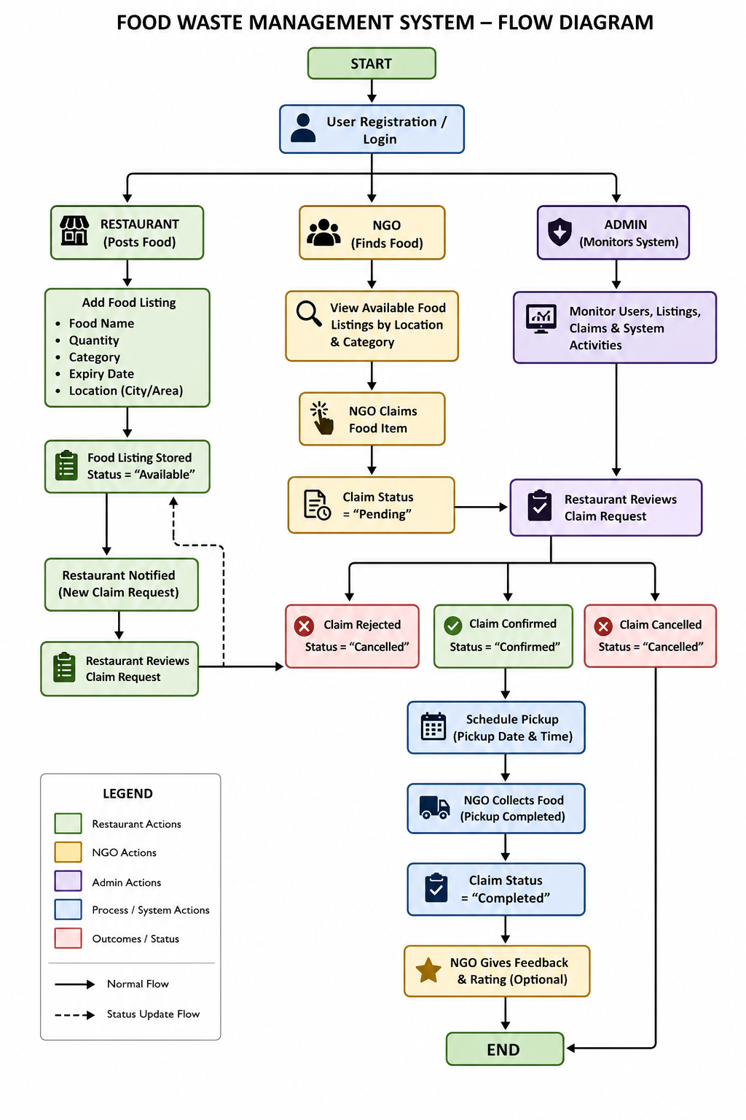

MILESTONE 2 — ERD Design & Normalization
SECTION 1 — Overview
Milestone 2 formally applies database normalization to the schema from Milestone 1. Each table is reviewed through First Normal Form (1NF), Second Normal Form (2NF), and Third Normal Form (3NF). All issues are documented with justification, changes are applied, and the ERD is updated to reflect the final normalized schema.

SECTION 2 — Normalization Process Overview
• 1NF — All attributes must be atomic; no repeating groups; each row uniquely identifiable.
• 2NF — All non-key attributes must be fully dependent on the entire primary key (no partial dependencies).
• 3NF — No non-key attribute should be transitively dependent on the primary key through another non-key attribute.
All tables use single-column surrogate primary keys (INT AUTO_INCREMENT), which eliminates any possibility of partial dependencies, making the 2NF check straightforward throughout.

SECTION 3 — Table-by-Table Normalization Analysis
3.1 users
1NF — PASS. All attributes (user_id, name, email, password, role, phone, created_at, city, area) are atomic and single-valued. No repeating groups exist. user_id is the primary key uniquely identifying each row.
2NF — PASS. Single-column primary key (user_id) means partial dependency is impossible. Every non-key attribute depends entirely on user_id.
3NF — PASS. No transitive dependencies. Each attribute depends directly on user_id. city and area are direct properties of the user account, not derived through any other non-key attribute. No changes needed.
3.2 food_listings
- 1NF — PASS. All attributes are atomic. food_id is the primary key. No multi-valued or repeating fields exist.
- 2NF — PASS. Single-column primary key eliminates partial dependency. All attributes depend fully on food_id.
- 3NF — FAIL ⚠ ISSUE FOUND. The city column is transitively dependent on user_id. Since user_id references users, and users.city already stores the restaurant’s city, food_listings.city creates the transitive chain: food_id → user_id → city. This is a 3NF violation.
- Fix Applied: Removed the city column from food_listings. City is now retrieved by joining food_listings with users via user_id, eliminating the redundancy and the transitive dependency.
3.3 claims
- 1NF — PASS. All attributes are atomic and single-valued. claim_id is the primary key.
- 2NF — PASS. Single-column primary key. No partial dependencies possible.
- 3NF — FAIL ⚠ ISSUE FOUND. The pickup_time column duplicates data already stored in pickup_schedules.scheduled_time. Both columns record the same scheduled pickup time for a claim. Storing it in two places creates an update anomaly — if a schedule changes, both columns must be updated simultaneously or they become inconsistent.
- Fix Applied: Removed pickup_time from claims. All pickup timing is stored exclusively in pickup_schedules.scheduled_time, accessed via claim_id.
3.4 pickup_schedules
- 1NF — PASS. All attributes are atomic. schedule_id is the primary key.
- 2NF — PASS. Single-column primary key. All attributes fully depend on schedule_id.
- 3NF — PASS. scheduled_time and status both depend directly on schedule_id only. The status here refers to the pickup schedule status, not the claim status — these are different attributes about different entities. No transitive dependencies exist. No changes needed.
3.5 feedback
- 1NF — PASS. All attributes are atomic. feedback_id is the primary key.
- 2NF — PASS. Single-column primary key. All attributes fully depend on feedback_id.
- 3NF — PASS. rating, comment, and submitted_at all describe the feedback entry directly through feedback_id. claim_id is a foreign key reference, not a transitive dependency. No non-key attribute depends on another non-key attribute. No changes needed.
3.6 food_categories
- 1NF — PASS. All attributes are atomic. category_id is the primary key with a UNIQUE constraint on category_name.
- 2NF — PASS. Single-column primary key eliminates partial dependency risk.
- 3NF — PASS. This table was specifically created to eliminate a transitive dependency that would have existed if category_name were stored directly in food_listings. By isolating categories here, food_listings.category_id references the category by ID, and category_name depends only on category_id — perfectly normalized. No changes needed.
3.7 claim_logs
- 1NF — PASS. All attributes are atomic. log_id is the primary key.
- 2NF — PASS. Single-column primary key. All attributes depend fully on log_id.
- 3NF — PASS (minor inconsistency noted). No transitive dependencies exist. However, old_status and new_status use VARCHAR(50) while claims.claim_status is an ENUM. These columns log the same domain of values but with different data types.
Fix Applied: Changed old_status and new_status to ENUM(‘pending’,‘confirmed’,‘completed’,‘cancelled’) to match claims.claim_status. This prevents invalid status strings from being logged and improves data integrity.

SECTION 4 — Summary of Changes & Redundancy Removed
- Change 1 — food_listings.city REMOVED: Transitively dependent on user_id → users.city. City is now retrieved by joining with users. Eliminates data redundancy and 3NF violation.

- Change 2 — claims.pickup_time REMOVED: Duplicate of pickup_schedules.scheduled_time. All pickup timing now stored exclusively in pickup_schedules. Eliminates update anomaly risk.

- Change 3 — claim_logs status columns updated to ENUM: old_status and new_status changed from VARCHAR(50) to ENUM matching claims.claim_status. Improves data integrity and prevents
SECTION 5— Changed ERD :
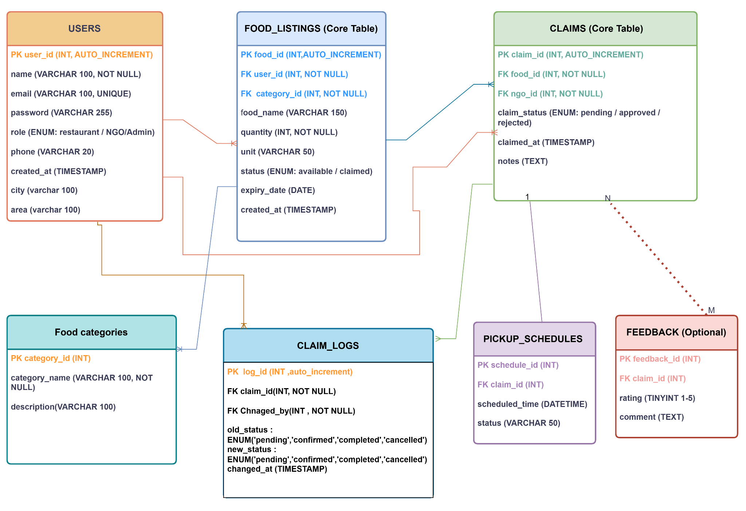
MILESTONE 3
Dataset Preprocessing & Dataflow Documentation

SECTION 1 — Overview
This document covers Milestone 3 for the Food Waste Management System. The milestone has four deliverables:
• Step 1 — Synthetic data generated for all 7 database tables using Python and the Faker library.
• Step 2 — Dataflow documented: how data enters, moves through, and exits the system.
• Step 3 — Seven clean CSV files exported, one per table, ready for Milestone 5 database loading.
• Step 4 — All files committed to the GitHub repository.

Since this project is a newly designed system with no pre-existing real data, structured synthetic data was generated. All data is realistic, consistent with Pakistani context (city names, phone formats, food items), and properly respects the referential integrity constraints defined in the Milestone 2 schema.

SECTION 2 — Synthetic Data Generation

2.1 Tool & Approach
Tool used: Python 3 with the Faker library (v30+). A single deterministic script (random seed = 42) was written to generate all data in dependency order, ensuring referential integrity across all foreign key relationships.

2.2 Generation Order (Dependency-Aware)
Tables were generated in the following strict order to satisfy foreign key constraints:
• 1. food_categories — no dependencies; created first
• 2. users — no dependencies; restaurants and NGOs created before their data
• 3. food_listings — depends on users (restaurant) and food_categories
• 4. claims — depends on food_listings and users (NGO)
• 5. pickup_schedules — depends on claims (confirmed/completed only)
• 6. feedback — depends on claims (completed only)
• 7. claim_logs — depends on claims and users

2.3 Row Counts per Table
Table Name | Row Count | Notes
food_categories | 10 | Lookup table; seeded first as other tables depend on it
users | 60 | 30 restaurants, 20 NGOs, 3 admins, 7 additional users
food_listings | 85 | Surplus food posted by restaurants; linked to categories
claims | 65 | NGO claims on food listings; multiple statuses distributed
pickup_schedules | 44 | One per confirmed/completed claim only (M2 constraint)
feedback | 35 | Optional; ~75% of completed claims received feedback
claim_logs | 101 | Audit trail; one or two log entries per non-pending claim

2.4 Realism & Integrity Measures
• Pakistani city names (Karachi, Lahore, Islamabad, Rawalpindi, Peshawar, Quetta, Multan, Faisalabad) and area names used for all users.
• Phone numbers follow the Pakistani 03XXXXXXXXX format.
• Food items are realistic local foods: Chicken Biryani, Daal Chawal, Naan Bread, Seekh Kebab, Halwa Puri, etc.
• Claim statuses are distributed realistically: mostly completed (60%), confirmed (20%), cancelled (20%), plus 10 pending claims on still-available listings.
• Pickup schedules are only generated for confirmed and completed claims — enforcing the Milestone 2 constraint that removed pickup_time from claims.
• Feedback is only generated for completed claims (75% coverage), matching the optional nature of the feedback table.
• Claim logs trace the real status transitions for each claim (pending→confirmed→completed, pending→cancelled, etc.).
• The city column was NOT included in food_listings CSV — consistent with the 3NF fix applied in Milestone 2.
• The pickup_time column was NOT included in claims CSV — consistent with the 3NF fix applied in Milestone 2.

SECTION 3 — Dataflow Documentation
This section describes exactly how data enters the Food Waste Management System, how it moves through the database tables, and what comes out.

3.1 Data Entry Points
Data enters the system through three distinct actor actions:

A — Restaurant Posts Surplus Food
• A restaurant user registers in the users table (role = 'restaurant').
• The restaurant creates a food listing in food_listings, selecting a category from food_categories, providing food name, quantity, unit, and expiry date.
• The listing status is set to 'available' by default.

B — NGO Claims a Listing
• An NGO user registers in the users table (role = 'NGO').
• The NGO browses available food_listings (filtered by city via JOIN with users) and places a claim.
• A new row is inserted into claims with claim_status = 'pending'.
• A corresponding row is inserted into claim_logs recording the initial status.

C — Admin or System Confirms / Resolves the Claim
• An admin or the restaurant confirms the claim — claim_status in claims changes to 'confirmed'.
• A pickup schedule is created in pickup_schedules with the scheduled_time and status = 'pending'.
• A log entry is added to claim_logs recording the pending → confirmed transition.
• The food listing's status in food_listings is updated to 'claimed'.

3.2 Data Movement Through the System
The diagram below shows the movement of data across tables, from entry to resolution:

Stage | Table(s) Affected | What Happens
1. Registration | users | Restaurant or NGO creates an account. Role, city, and area are stored.
2. Food Posting | food_listings, food_categories | Restaurant posts surplus. Category FK links to food_categories. Status = available.
3. Claim Placed | claims, claim_logs | NGO selects a listing. Claim inserted (pending). Log entry created.
4. Confirmation | claims, pickup_schedules, claim_logs, food_listings | Claim confirmed. Pickup schedule created. Listing marked claimed. Log updated.
5. Pickup Done | pickup_schedules, claims, claim_logs | Schedule status → completed. Claim status → completed. Log entry added.
6. Feedback (opt.) | feedback | NGO optionally submits a rating and comment against the completed claim.
7. Cancellation | claims, claim_logs | Any pending or confirmed claim can be cancelled. Status updated; log entry added.

3.3 Table Dependency Chain
The tables form a strict dependency hierarchy that must be respected during data loading in Milestone 5:

food_categories ──▶ food_listings ──▶ claims ──▶ pickup_schedules
users ──▶ food_listings ──▶ claims ──▶ feedback
claims + users ──▶ claim_logs

3.4 Data Outputs
The system produces the following types of outputs, depending on the user role:

For NGOs
• Available food listings near their city (JOIN food_listings + users on city).
• Status of their current and past claims.
• Pickup schedules with confirmed times.

For Restaurants
• List of their active food postings and which NGO has claimed each one.
• Claim status updates (pending, confirmed, completed, cancelled).

For Admins
• Full audit trail from claim_logs — who changed what, when, and from which status.
• System-wide reports: total food saved (SUM of quantity on completed claims), top-donating restaurants, most-active NGOs.
• Feedback ratings dashboard aggregated across all completed claims.

For Future AI/Analytics Module
• Cleaned CSV exports (this milestone) feed directly into the Milestone 5 database.
• Historical claims + feedback data can train recommendation models to match NGOs with nearby restaurants automatically.

SECTION 4 — Exported CSV Files
The following seven CSV files have been exported, one per table. Each file is clean, consistently formatted, and uses UTF-8 encoding. These files are ready to be loaded into MySQL in Milestone 5.

CSV File | Rows | Columns
food_categories.csv | 10 | category_id, category_name, description
users.csv | 60 | user_id, name, email, password, role, phone, created_at, city, area
food_listings.csv | 85 | food_id, user_id, food_name, quantity, unit, status, expiry_date, created_at, category_id
claims.csv | 65 | claim_id, food_id, ngo_id, claim_status, claimed_at, pickup_time, notes
pickup_schedules.csv | 44 | schedule_id, claim_id, scheduled_time, status
feedback.csv | 35 | feedback_id, claim_id, rating, comment, submitted_at
claim_logs.csv | 101 | log_id, claim_id, changed_by, old_status, new_status, changed_at

Loading order for Milestone 5 (must follow this sequence to satisfy FK constraints):
• 1. food_categories.csv
• 2. users.csv
• 3. food_listings.csv
• 4. claims.csv
• 5. pickup_schedules.csv
• 6. feedback.csv
• 7. claim_logs.csv

Data Integrity Notes
• No NULL values in NOT NULL columns. All required fields are populated.
• All foreign key values in child tables exist in the corresponding parent tables.
• ENUM values (role, status, claim_status, old_status, new_status) match the schema definitions exactly.
• Dates are formatted as YYYY-MM-DD HH:MM:SS for DATETIME/TIMESTAMP fields, and YYYY-MM-DD for DATE fields.
• Password column contains placeholder hashed strings (not plain text) — safe for demonstration.
• Rating values in feedback are all between 1 and 5, satisfying the CHECK constraint.

MILESTONE 4
Database Setup (DDL)

SECTION 1 — Overview
Milestone 4 covers the Database Definition Language (DDL) scripts for the Food Waste Management System. All seven tables from the finalized Milestone 2 normalized schema have been implemented as CREATE TABLE statements in MySQL. Every table includes a primary key, foreign key references, NOT NULL constraints, and UNIQUE or CHECK constraints where applicable. The DDL script has been verified in MySQL Workbench and the EER diagram confirms the schema is correctly structured.
• Step 1 — CREATE TABLE statements written for all 7 tables with full constraints.
• Step 2 — Schema verified in MySQL Workbench; EER diagram generated via Reverse Engineer.
• Step 3 — DDL script committed to GitHub with message: M4: DDL scripts added, EER diagram verified.

SECTION 2 — DDL Script Summary
The DDL script creates the database food_waste_db and all seven tables in dependency order, ensuring no foreign key constraint fails during execution. The table below summarizes the constraints applied to each table.
Table | PK | FK References | UNIQUE / CHECK | Key NOT NULL Fields
food_categories | category_id | — | UNIQUE (category_name) | category_name
users | user_id | — | UNIQUE (email) | name, email, password, role
food_listings | food_id | users, food_categories | CHECK (quantity > 0) | user_id, food_name, quantity
claims | claim_id | food_listings, users | — | food_id, ngo_id, claim_status
pickup_schedules | schedule_id | claims | UNIQUE (claim_id) | claim_id, scheduled_time
feedback | feedback_id | claims | UNIQUE (claim_id) CHECK rating 1–5 | claim_id, rating
claim_logs | log_id | claims, users | — | claim_id, changed_by, new_status

SECTION 3 — EER Diagram Verification
The DDL script was executed in MySQL Workbench with no errors. The EER diagram was generated using Database → Reverse Engineer and confirmed the following:
• All 7 tables are present with no floating or disconnected boxes.
• All foreign key relationships are shown with 1-to-many lines matching the schema design.
• UNIQUE constraints on users.email, pickup_schedules.claim_id, and feedback.claim_id are reflected correctly.
• DDL script committed to GitHub with message: M4: DDL scripts added, EER diagram verified.

Food Waste Management System · Milestone 1 · Faraz Qazi & Maaz Ali · 4th Semester

