MILESTONE 1
Food Waste Management System
ERD & Relational Database Schema

Subject | Database
Instructor | Ali Hassan
Group Members | Faraz Qazi, Maaz Ali
Semester | 4th Semester
Submission Date | April 26, 2025
Milestone | 1 — ERD & Relational Schema

SECTION 1
Project Overview

The Food Waste Management System connects restaurants with NGOs to reduce surplus food waste. Restaurants post available food listings and NGOs claim items for distribution to communities in need.
This document covers Milestone 1: the Entity-Relationship Diagram (ERD) and full Relational Database Schema for the system.
SECTION 2
Entity-Relationship Diagram

The diagram below shows all entities, attributes, primary/foreign keys, and relationships. Core tables are displayed in color; optional feature tables are shown in lighter tones.

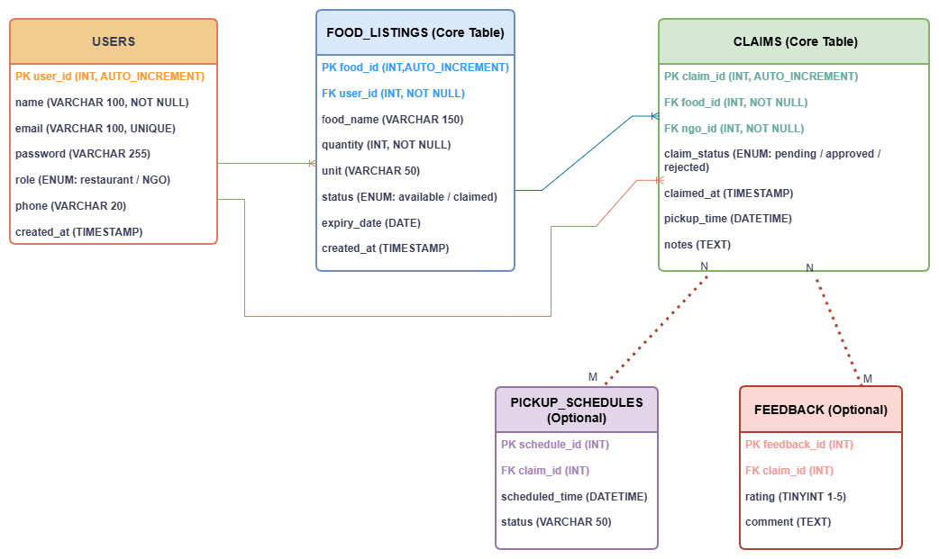
Figure 1 — Entity-Relationship Diagram, Food Waste Management System
SECTION 3
Relational Database Schema

The schema consists of three core tables and two optional tables, all using MySQL InnoDB for referential integrity support.
3.1 users
Shared table for all user types. The role ENUM field differentiates restaurants from NGOs.

Attribute | Data Type | Constraint | Description
user_id | INT | PK, AUTO_INCREMENT | Unique user identifier
name | VARCHAR(100) | NOT NULL | Full name of user
email | VARCHAR(100) | NOT NULL, UNIQUE | Login email address
password | VARCHAR(255) | NOT NULL | Hashed password
role | ENUM('restaurant','NGO') | NOT NULL | Type of user account
phone | VARCHAR(20) | NULL | Contact phone number
created_at | TIMESTAMP | DEFAULT NOW() | Registration timestamp
3.2 food_listings
Records surplus food posted by restaurants. Status updates automatically upon a successful claim.

Attribute | Data Type | Constraint | Description
food_id | INT | PK, AUTO_INCREMENT | Unique food listing ID
user_id | INT | FK → users(user_id) | Restaurant owner (FK)
food_name | VARCHAR(150) | NOT NULL | Name of food item
quantity | INT | NOT NULL | Amount available
unit | VARCHAR(50) | NULL | kg, portions, boxes…
status | ENUM('available','claimed') | DEFAULT 'available' | Listing availability
expiry_date | DATE | NULL | Best-before date
created_at | TIMESTAMP | DEFAULT NOW() | Listing creation time
3.3 claims
Captures each NGO claim on a food listing, linked via two foreign keys.

Attribute | Data Type | Constraint | Description
claim_id | INT | PK, AUTO_INCREMENT | Unique claim identifier
food_id | INT | FK → food_listings(food_id) | Claimed food item (FK)
ngo_id | INT | FK → users(user_id) | NGO user who claimed (FK)
claim_status | ENUM('pending','confirmed','completed','cancelled') | NOT NULL | Status of claim
claimed_at | TIMESTAMP | DEFAULT NOW() | Time claim was made
pickup_time | DATETIME | NULL | Scheduled pickup time
notes | TEXT | NULL | Additional notes
3.4 pickup_schedules (Optional)
Supports optional scheduling of food pickups linked to a specific claim.

Attribute | Data Type | Constraint | Description
schedule_id | INT | PK, AUTO_INCREMENT | Unique schedule ID
claim_id | INT | FK → claims(claim_id) | Associated claim (FK)
scheduled_time | DATETIME | NOT NULL | Pickup datetime
status | VARCHAR(50) | DEFAULT 'pending' | Schedule status
3.5 feedback (Optional)
Allows NGOs to rate and comment on a completed food claim.

Attribute | Data Type | Constraint | Description
feedback_id | INT | PK, AUTO_INCREMENT | Unique feedback ID
claim_id | INT | FK → claims(claim_id) | Associated claim (FK)
rating | TINYINT | CHECK (1–5) | Quality/service rating
comment | TEXT | NULL | Written feedback
submitted_at | TIMESTAMP | DEFAULT NOW() | Submission timestamp
SECTION 4
Relationships & Cardinality

Relationship | Type | Description
users → food_listings | One-to-Many (1:N) | A restaurant posts many listings; each listing belongs to one restaurant.
users → claims (NGO) | One-to-Many (1:N) | An NGO places many claims; each claim is tied to one NGO.
food_listings → claims | One-to-Many (1:N) | A listing may receive claims; status updates to "claimed" on acceptance.
claims → pickup_schedules | One-to-One (opt.) | A claim may optionally have one pickup schedule.
claims → feedback | One-to-One (opt.) | A completed claim may optionally receive NGO feedback.
SECTION 5
Integrity Constraints

- Primary Keys — every table uses a surrogate INT AUTO_INCREMENT primary key.
- Foreign Keys — enforced via MySQL with ON DELETE RESTRICT to prevent orphaned records.
- UNIQUE — email in users is unique to prevent duplicate accounts.
- NOT NULL — critical fields (name, email, password, role) cannot be empty.
- ENUM — role, status, and claim_status are restricted to predefined valid values.
- CHECK — rating in feedback is constrained to values between 1 and 5.
SECTION 6
Normalization

The schema is designed to conform to Third Normal Form (3NF):
- 1NF — All attributes are atomic; no repeating groups or multi-valued fields.
- 2NF — All non-key attributes are fully dependent on the entire primary key (no partial dependencies).
- 3NF — No transitive dependencies; every non-key attribute depends only on the primary key.

Food Waste Management System · Milestone 1 · Faraz Qazi & Maaz Ali · 4th Semester

