[**Computer Vision Annotation Tool (CVAT)**](https://github.com/opencv/cvat) is an open source tool for annotating digital images and videos developed by Intel.

However, CVAT is not hosted on the internet and not available as a web application by default. It can instead run on Docker.

To install Docker on Windows 10 Pro or Ubuntu or MacOS, you may choose the right version of download from here <https://www.docker.com/products/docker-desktop>

To install Docker on any other version of Windows, we need to use Virtual machine to run Ubuntu and use CVAT in the VM.

Though there are many open-source virtualization software available, we recommend using Oracle Virtualbox or VMWare

Free version of VMware can be downloaded from here: <https://www.vmware.com/products/workstation-player/workstation-player-evaluation.html>

You may need an OS image file ISO while setting up the VM post installation, the ISO file for Ubuntu can be downloaded from here: <https://releases.ubuntu.com/18.04/ubuntu-18.04.4-desktop-amd64.iso>

**Configuring VM**

Open VMware post installation,

1.

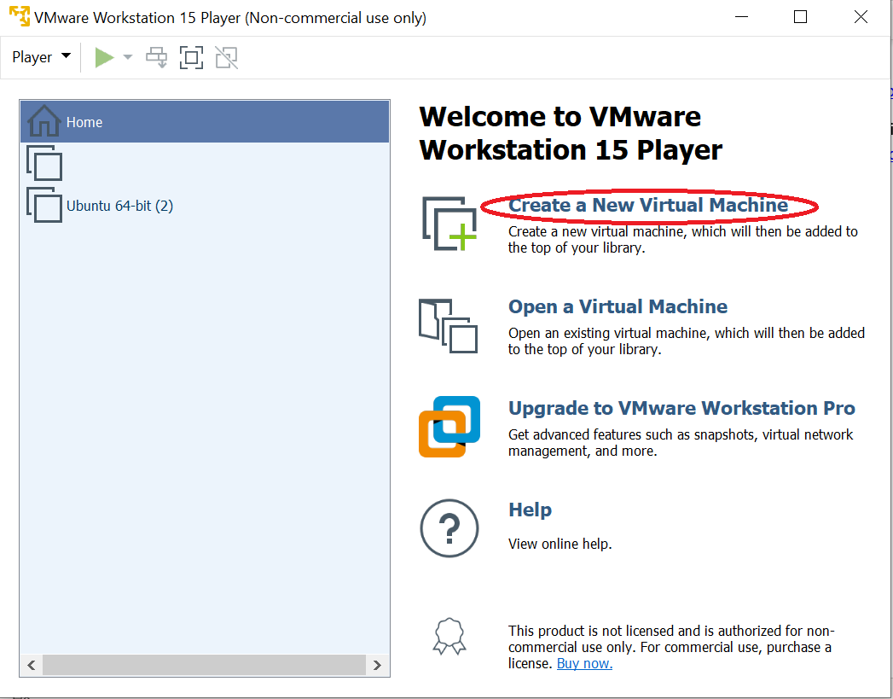

2. Browse the downloaded Ubuntu ISO file here

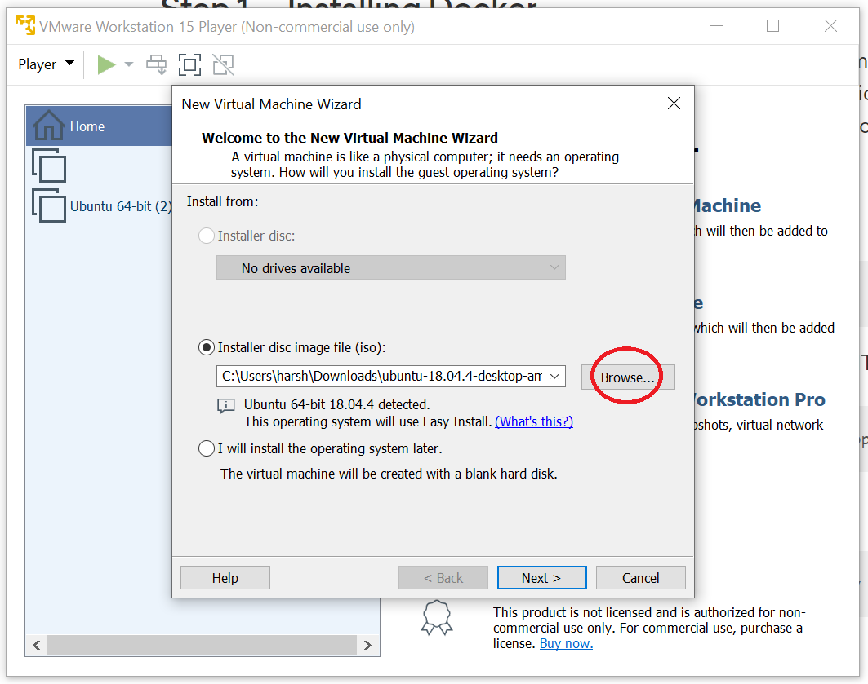

3. Choose the required disk space, RAM and split virtual disk option and continue. 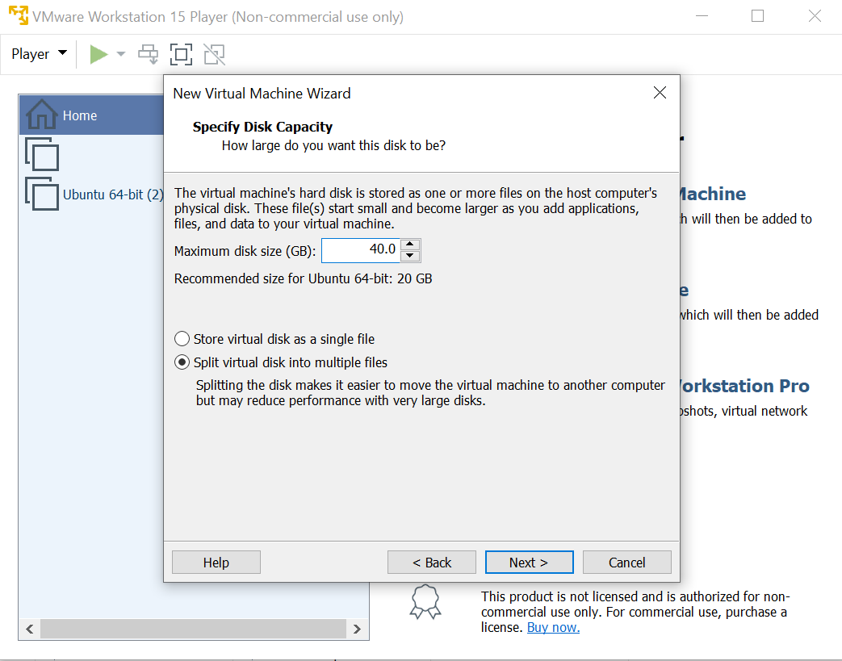

Once the VM is setup, run the VM and open Terminal.

**Installation of Docker:**

Run the following commands in Terminal:

First, update your existing list of packages:

sudo apt update

Next, install a few prerequisite packages which let apt use packages over HTTPS:

sudo apt install apt-transport-https ca-certificates curl software-properties-common

Then add the GPG key for the official Docker repository to your system:

curl -fsSL https://download.docker.com/linux/ubuntu/gpg | sudo apt-key add -

Add the Docker repository to APT sources:

sudo add-apt-repository "deb [arch=amd64] https://download.docker.com/linux/ubuntu bionic stable"

Next, update the package database with the Docker packages from the newly added repo:

sudo apt update

*//Restart the computer if the command does not work.*

Finally, install Docker:

sudo apt install docker-ce

Perform [post-installation steps](https://docs.docker.com/install/linux/linux-postinstall/) to run docker without root permissions (Optional)

sudo groupadd docker

sudo usermod -aG docker $USER

Restart the Computer post installation of Docker.

**CVAT Installation for Ubuntu:**

Run the following commands in the Terminal in order

sudo apt-get --no-install-recommends install -y python3-pip

//Terminal displays another command to be used in case this fails to install python, also you may be prompted to install dependencies if not pre-installed, relevant commands for download are displayed instantly.

sudo python3 -m pip install setuptools docker-compose

#Doesn’t work Use sudo apt install docker-compose  
  
sudo apt-get --no-install-recommends install -y git

git clone <https://github.com/opencv/cvat>

cd cvat

docker-compose build

docker-compose up -d

**Registering superuser:**

docker exec -it cvat bash -ic 'python3 ~/manage.py createsuperuser'

Prompts you to choose login username and password for your admin account

**CVAT URL:** <http://localhost:8080/> (or port 7080).

**CVAT Admin portal URL:** <http://localhost:8080/admin>

More details on installation and commands for windows and macOS can be found here: <https://github.com/opencv/cvat/blob/develop/cvat/apps/documentation/installation.md>