AsteroidsFX
A Component-Oriented Game on the Java Platform Module System
Designing, implementing and validating runtime-replaceable components
Student name | [INSERT YOUR FULL NAME]
Student exam number | [INSERT YOUR EXAM NUMBER]
GitHub user | Fard121
GitHub repository | https://github.com/Fard121/asteroid_game
Forked from | https://github.com/sweat-tek/AsteroidsFX
Video demonstration | [INSERT YOUTUBE LINK]
Course | Component Based Systems, SDU MMMI
Contact | fjama23@student.sdu.dk
Date | 9 August 2026

Fields shown in red must be completed before submission.

Table of Contents
Abstract 4
1 Introduction 5
1.1 Background and motivation 5
1.2 Aim and scope 5
1.3 Structure of this report 6
2 Requirements 7
2.1 Functional requirements 7
2.2 Non-functional requirements 8
2.3 Mandated components and their interfaces 8
3 Analysis 10
3.1 Use cases 10
3.2 Domain model 11
3.3 Behavioural model 12
3.4 Identified and missing components 12
4 Design 14
4.1 Architectural overview 14
4.2 Components and connections 15
4.3 Operation contracts 16
4.4 The two-phase frame 17
4.5 Module layers and split packages 17
4.6 The scoring boundary 18
5 Implementation 20
5.1 Registration and access of components 20
5.2 Reliable configuration and strong encapsulation 21
5.3 Component models applied 22
5.4 Dynamic installation and uninstallation 23
5.5 Collision, splitting and scoring 24
5.6 The scoring client 25
6 Test 27
6.1 Unit testing strategy 27
6.2 Build and unit test results 28
6.3 Integration in a real deployment 30
6.4 Experimental validation of dynamic update 32
6.5 Summary of results 35
7 Discussion 37
7.1 How well the design met the requirements 37
7.2 Trade-offs accepted 37
7.3 Limitations 38
7.4 Reflection on the development process 38
8 Conclusion 39
9 References 39
Appendix A Repository map 42
Appendix B Reproducing the results 42

Abstract
This report documents the design, implementation and validation of AsteroidsFX, a component-oriented reimplementation of the arcade game Asteroids built on the Java Platform Module System (JPMS), JavaFX and the Spring container. The engineering problem addressed is not the game itself but the coupling between the parts that make it. In a conventional implementation the main loop must name every gameplay subsystem it drives, so no subsystem can be added, removed or replaced without recompiling and relinking that loop. The solution presented here inverts that relationship. Five gameplay components, Player, Enemy, Bullet, Asteroids and Collision, are expressed purely as providers of service interfaces declared in shared API modules, are discovered at runtime by ServiceLoader from a plugins directory, and are resolved into a dedicated child ModuleLayer. The composition root, Core, declares no requires clause for any of them, and the Spring container injects whatever the module layer yields. Score keeping is externalised further still, into a separate Spring Boot process reached over HTTP. The result is validated on three levels: 21 JUnit 5 and Mockito unit tests covering the component contracts, an integration run of the complete two-process deployment, and an experimental demonstration that a component can be uninstalled and reinstalled both at runtime and at deployment time without recompiling any source file.

Keywords: component-based software engineering, Java Platform Module System, ServiceLoader, ModuleLayer, whiteboard component model, dependency injection, microservices, operation contracts, JavaFX.

1 Introduction

1.1 Background and motivation
Component-based software engineering treats a system as an assembly of independently deployable units that interact only through explicitly declared interfaces [5]. The promise is substitution: if a unit's obligations are fully captured by its contract, any implementation honouring that contract can replace it without disturbing the rest of the system. The difficulty is that ordinary language mechanisms work against this, because a direct import creates a compile-time dependency, and a compile-time dependency is precisely what prevents substitution at deployment time.
Java addressed this in two stages. ServiceLoader decouples a consumer from a provider by resolving implementations at runtime rather than at compile time [3], [4]. The Java Platform Module System, delivered in Java 9 under JSR 376, added the missing half: reliable configuration and strong encapsulation, so that the dependency graph is validated when the application starts and a module's internals are genuinely unreachable unless deliberately exported [1], [2]. Together they allow a system to be assembled from parts that it never names.

1.2 Aim and scope
The aim of this project was to build a working Asteroids game whose gameplay subsystems are true components in the sense above, and then to demonstrate empirically that one of them can be removed and restored without recompiling the source code. The scope covers the nine laboratory exercises of the course [12]: the initial JavaFX game, the component and data-oriented refactoring, ServiceLoader assembly, the three JPMS exercises on module descriptors, services and module layers, Spring dependency injection in the composition root, the scoring microservice, and unit testing of the components.
Persistence of high scores, networked multiplayer, and hot reloading of components that were not present when the process started are outside scope. Section 7 explains why the last of these is a deliberate boundary rather than an omission.

1.3 Structure of this report
Section 2 states the functional and non-functional requirements and the interface contracts they imply. Section 3 analyses the problem as use cases, a domain model and a behavioural model, without committing to a solution. Section 4 presents the architecture and the operation contracts of every provided and required interface. Section 5 explains how components are registered, discovered and accessed in the source code, and where each component model is applied. Section 6 reports experimental validation, including the dynamic update experiment. Sections 7 and 8 discuss how well the design met its requirements and conclude.

2 Requirements
Requirements are separated into functional requirements, which describe observable behaviour, and non-functional requirements, which constrain how that behaviour is achieved. For this project the non-functional requirements carry most of the engineering weight: a monolithic implementation could satisfy every functional requirement below and still fail the exercise entirely.

2.1 Functional requirements
ID | Requirement | Component responsible
FR1 | The player controls a ship that rotates, thrusts with inertia and wraps around the screen edges | Player
FR2 | The player fires bullets, subject to a cooldown and a bounded number in flight | Player, Bullet
FR3 | Asteroids drift with random headings and wrap around the screen edges | Asteroids
FR4 | An enemy saucer moves randomly and fires at intervals | Enemy
FR5 | Collision between entities is detected using Pythagorean distance | Collision
FR6 | An asteroid hit by a bullet splits into two smaller ones; the smallest is destroyed outright | Collision, Asteroids
FR7 | Ships that collide with an asteroid are destroyed | Collision
FR8 | The player ship and the enemy saucer are destroyed after a number of bullet hits | Collision
FR9 | The score increases by an amount determined by the target destroyed | Collision
FR10 | Waves advance when the field is cleared, raising count and speed; wave 3 is victory | Asteroids
FR11 | The game presents start and pause menus, a help overlay, and game over and victory states | Core
FR12 | The current score is published to an external scoring service | Core, Scoring
Table 1. Functional requirements and the component responsible for each.

2.2 Non-functional requirements
ID | Requirement | Rationale
NFR1 | A gameplay component must be installable and uninstallable without recompiling any source file | The central objective of the course; verified experimentally in Section 6.4
NFR2 | The composition root must not name any gameplay component at compile time | A requires clause would reintroduce exactly the coupling NFR1 removes
NFR3 | Component internals must be unreachable from other components | Strong encapsulation: only the declared interfaces form the contract [1]
NFR4 | The dependency configuration must be validated at start-up, not when a class is first touched | Reliable configuration: a missing module should fail loudly and early [2]
NFR5 | Every component must be unit-testable in isolation, without a running JavaFX stage | A component that can only be exercised by running the whole system is not a component
NFR6 | Failure of the external scoring service must not stop the game loop | Availability across a process boundary; see Section 4.6
Table 2. Non-functional requirements.

2.3 Mandated components and their interfaces
The exercise requires five components in particular: Player, Enemy, Asteroids, Weapon, realised here as the Bullet component, and the rendering and drawing component, realised as Core. Player, Enemy and Weapon must implement provided service interfaces so that they can be updated or removed without recompilation. Table 3 states the resulting contract obligations.
Component | Provides | Requires (uses) | Deployed in
Core | Composition root, rendering, HUD and input; provides no service | The three processing interfaces, indirectly via Common | mods-mvn/
Player | IGamePluginService`, `IEntityProcessingService | BulletSPI | plugins/
Enemy | IGamePluginService`, `IEntityProcessingService | BulletSPI | plugins/
Bullet (Weapon) | IGamePluginService`, `IEntityProcessingService`, `BulletSPI | none | plugins/
Asteroids | IGamePluginService`, `IEntityProcessingService`, `IAsteroidSplitter | none | plugins/
Collision | IPostEntityProcessingService | IAsteroidSplitter | plugins/
Scoring | REST API on port 8081 | none | separate process
Table 3. Mandated components with their provided and required interfaces.

3 Analysis
This section describes what the system must do and what it must contain. It deliberately avoids stating how any of it is achieved, which is the subject of Sections 4 and 5.

3.1 Use cases
Two actors interact with the system. The player drives gameplay. A second actor, the integrator, represents whoever assembles or reconfigures the deployment. This actor is unusual in a game, and its presence is a direct consequence of NFR1: use case UC9 exists only because components are meant to be replaceable, and it is the use case the video demonstration exercises.
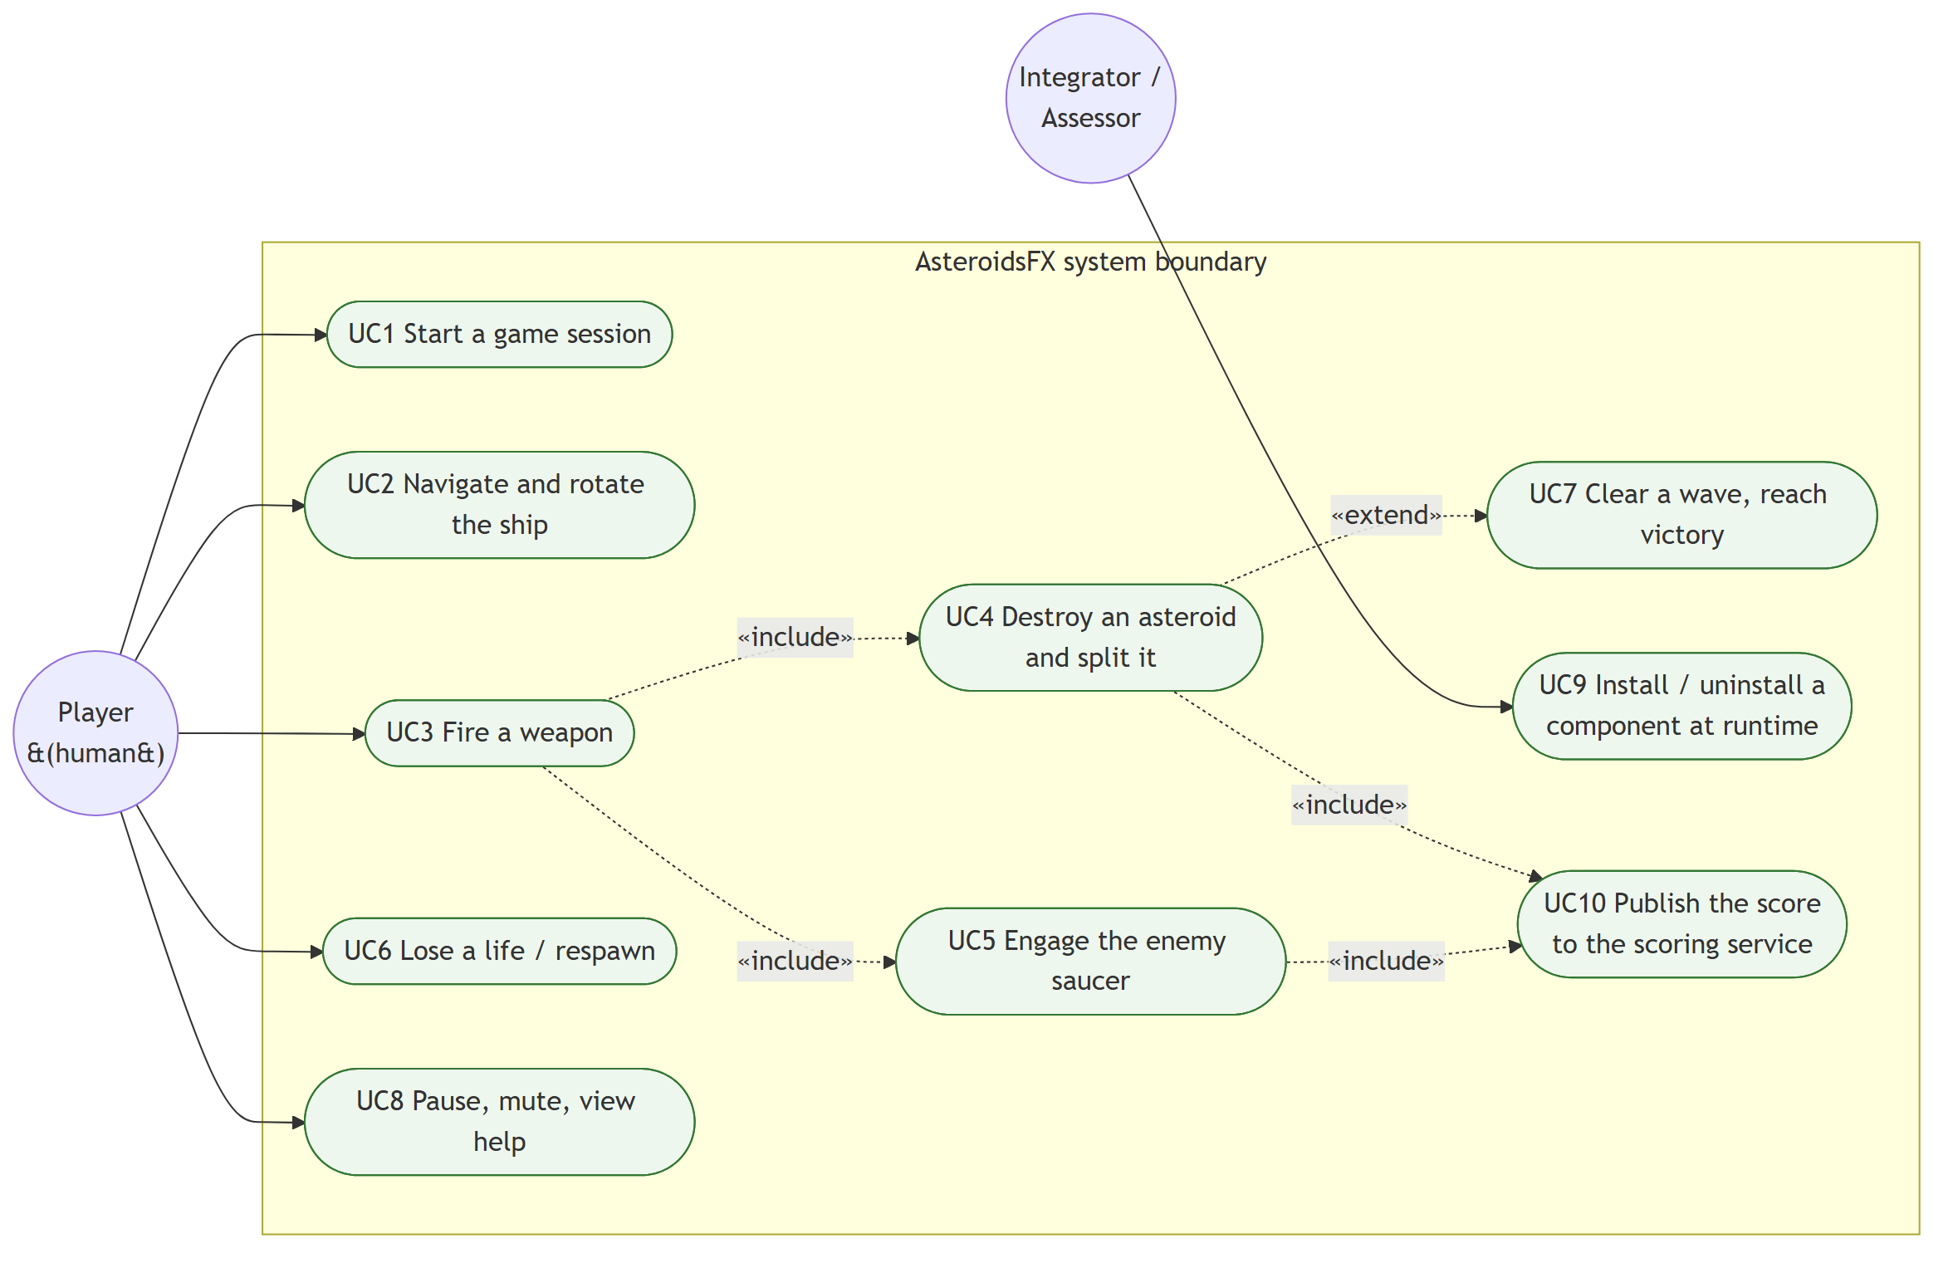
Figure 1. Use case model. The integrator actor and UC9 exist because of the component-replaceability requirement rather than because of gameplay.
Field | UC9 Install or uninstall a component at runtime
Primary actor | Integrator
Precondition | The application is running and the target component was discovered at start-up
Trigger | The integrator presses key 1, 2 or 3 for the Player, Enemy or Weapon component
Main flow | 1. Core resolves the key to a named component. 2. If the component is installed, its IGamePluginService.stop is invoked and its services are removed from the active lists. 3. If it is uninstalled, start is invoked and its services are added back.
Postcondition | The component's entities and per-frame behaviour are absent from, or present in, the running game, and no other component is affected
Guarantee | No source file is recompiled and the JVM is not restarted
Table 4. Expanded description of the use case central to the exercise.

3.2 Domain model
The game state is data-oriented [14]: entities are plain data carriers and behaviour lives in separate processing services, rather than each entity owning its own update method. That separation is what makes behaviour relocatable into a component at all. Entity holds position, rotation, a collision radius, a polygon outline, a category and hit points. World is a keyed collection of entities, and GameData aggregates the session state that every component may read.
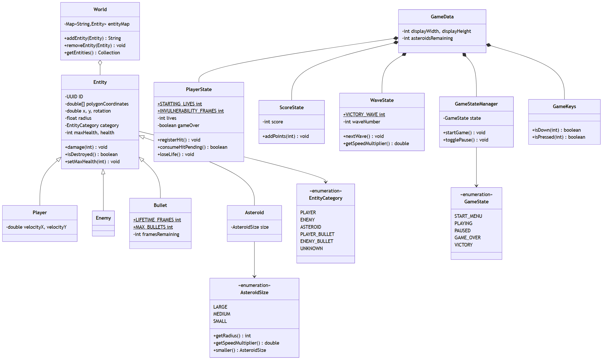
Figure 2. Domain model. Bullet and Asteroid are declared in shared API modules because several components must recognise them; Player and Enemy are declared inside their own components and are named by no one else.
The distinction visible in the diagram matters. Bullet and Asteroid live in CommonBullet and CommonAsteroids because more than one component must recognise them: Player and Enemy count bullets in flight, and Collision asks an asteroid for its size. Player and Enemy, by contrast, are declared inside their own components, and Collision distinguishes a player from an asteroid using the EntityCategory enumeration rather than by type. That is why the Collision component compiles with no knowledge whatsoever of the Player component.

3.3 Behavioural model
Gameplay is a state machine owned by GameStateManager. Only in the playing and terminal states are the entity processors executed. In the menu and paused states the world is rendered but not advanced, which is what allows a menu to be drawn over a frozen field.
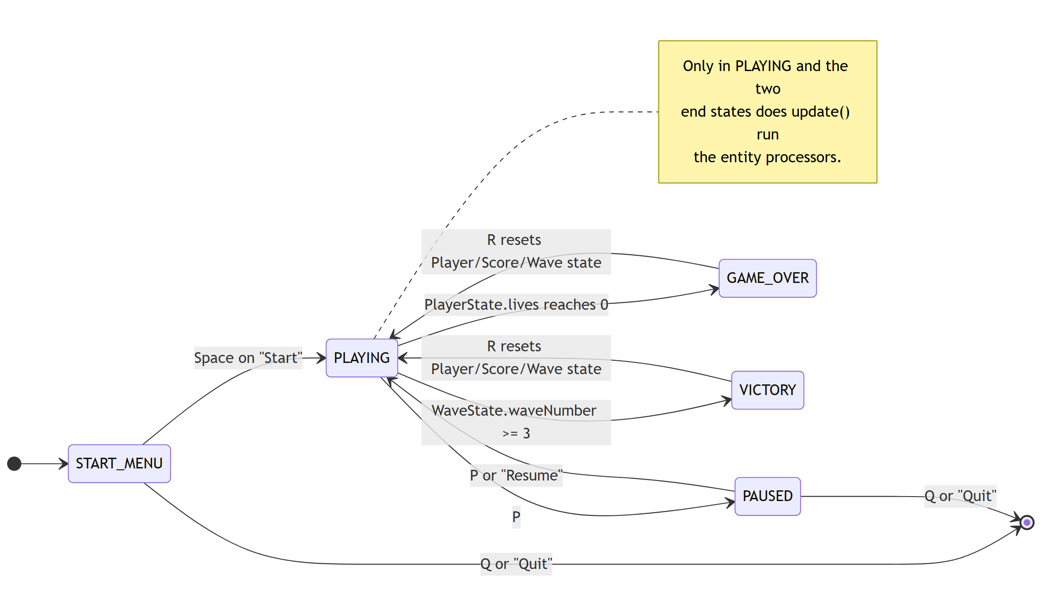
Figure 3. Game state machine as implemented by GameStateManager and interpreted each frame by Core.

3.4 Identified and missing components
The analysis identifies six in-process components, Player, Enemy, Bullet, Asteroids, Collision and Core, and one out-of-process component, Scoring. It also identifies capabilities that exist in the behaviour but are not owned by a component of their own:
- Spawning and difficulty. Wave progression lives inside AsteroidProcessor and enemy spawn timing inside EnemyControlSystem. A dedicated spawn service would allow difficulty to be tuned without modifying either component.
- Score persistence. The scoring service holds the score in memory only, so no component is responsible for retaining a high score between runs.
- Audio. SoundManager is a static utility in the shared module rather than a replaceable provider, so an alternative sound implementation cannot be substituted the way a gameplay component can.
These are recorded rather than resolved. Each would be a straightforward addition using the service mechanism already in place, which is itself evidence that the architecture generalises beyond the components it currently carries.

4 Design

4.1 Architectural overview
The system is deployed as two operating system processes. The game process contains two module layers: the boot layer, holding the composition root and the shared API modules, and a child layer holding the five gameplay components. The scoring process is a self-contained Spring Boot application reached over HTTP. The two-layer split inside a single process is the architectural decision on which every other one depends.
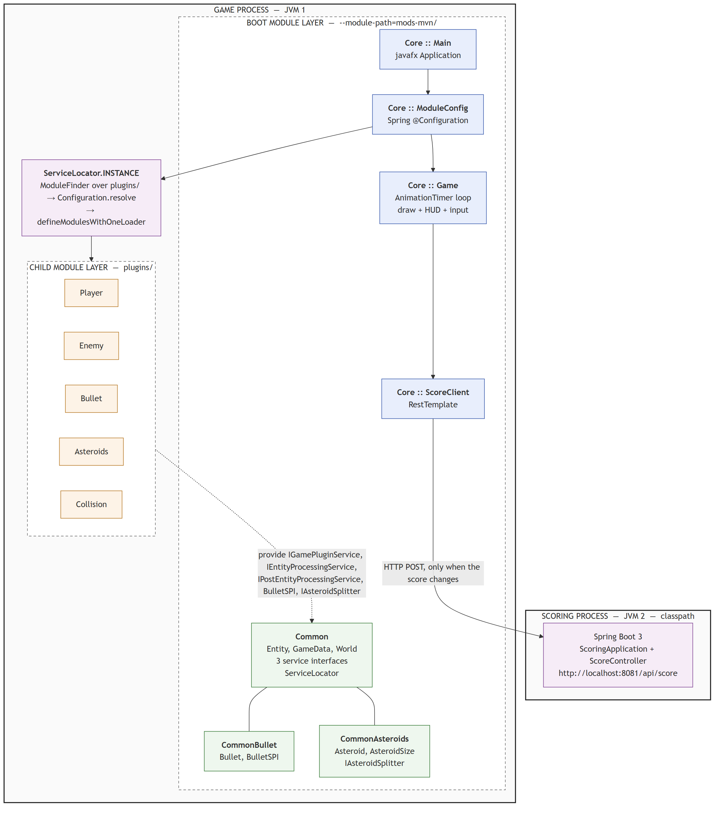
Figure 4. System architecture. Core sits in the boot layer and knows only the interfaces in Common. The five gameplay components are discovered in plugins/ and resolved into a child ModuleLayer at start-up. The score crosses a process boundary over HTTP.
Four architectural principles govern the structure:
- Composition root. Core owns the game loop but declares no requires clause for any gameplay component, satisfying NFR2.
- Interface segregation. Contracts live in Common, CommonBullet and CommonAsteroids, so a component depends on a contract rather than on a peer.
- Layer isolation. Component jars are resolved into their own configuration and class loader, so their resolution cannot corrupt the boot layer's module graph.
- Externalised state. The authoritative score lives in a separate process, which forces the interaction to be an explicit and failure-tolerant protocol rather than a method call.

4.2 Components and connections
Figure 5 shows the assembly in UML component terms. Every connection is a service contract: a provided interface on one side, a required interface on the other. No connection in the diagram represents a compile-time dependency between two gameplay components.
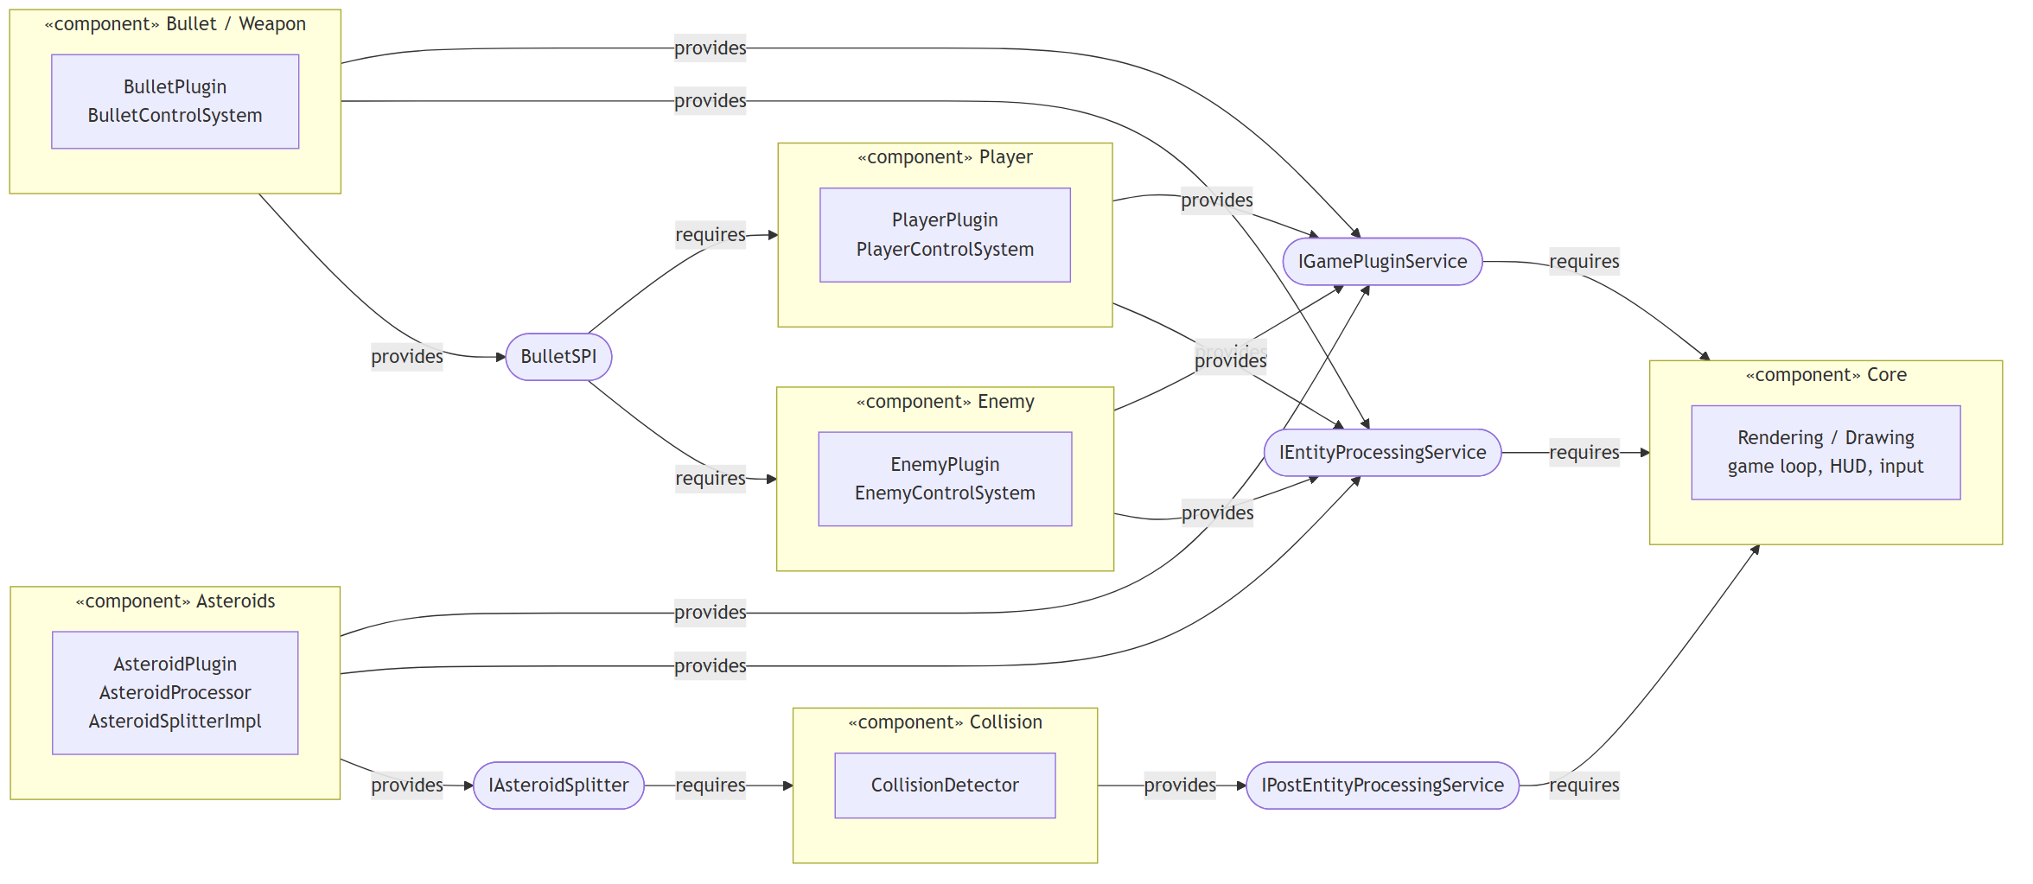
Figure 5. UML component diagram. Player and Enemy require BulletSPI, which Bullet provides; Collision requires IAsteroidSplitter, which Asteroids provides. Neither pair shares a compile-time dependency.
Figure 6 shows the same system from the module system's point of view. Solid edges are requires clauses resolved when the application starts; dashed edges are uses relationships resolved at runtime by ServiceLoader. The absence of any solid edge from Core to a gameplay module is the structural proof of NFR2.
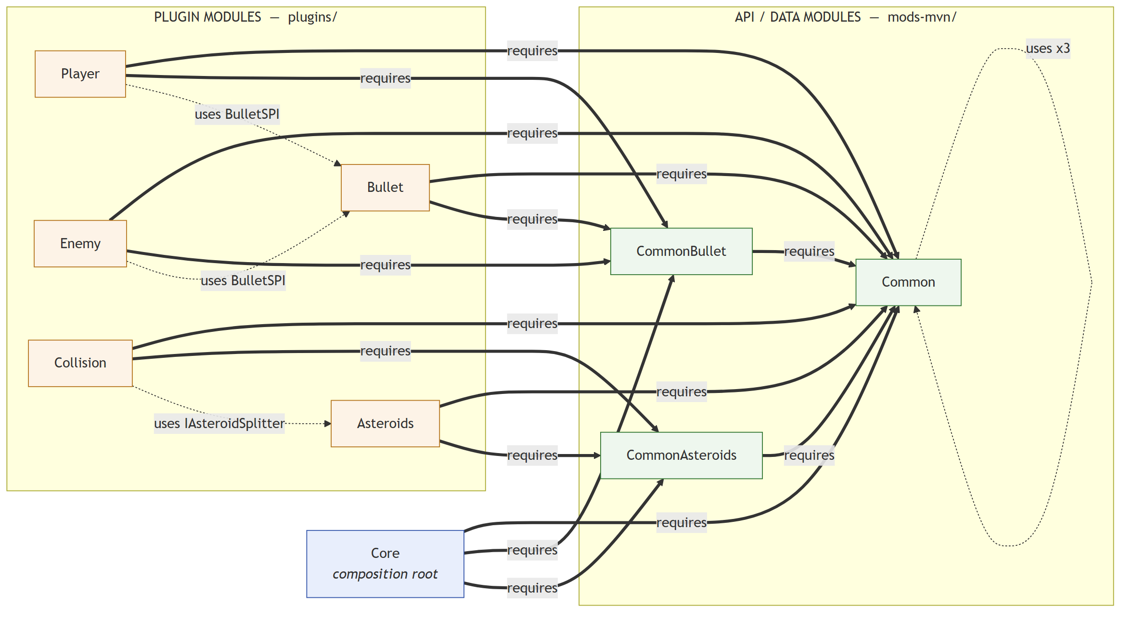
Figure 6. Module dependency graph. Solid edges are requires clauses, dashed edges are runtime service lookups. Core has no solid edge to any gameplay module.

4.3 Operation contracts
Each interface operation is specified as a contract in the style of the Unified Process [13]: a precondition the caller must establish and a postcondition the implementation guarantees. These contracts are written as JavaDoc on the interfaces themselves, so they travel with the code rather than only with this document.
Operation | Precondition | Postcondition
IGamePluginService.start | gameData and world are non-null and represent a fresh session; the world may already hold entities added by plugins started earlier, but none of this plugin's own | Entities this plugin owns up front have been added to the world, and plugin-local state needed by its processor has been initialised
IGamePluginService.stop | start was previously called on this instance with the same gameData and world | Every entity exclusively owned by this plugin has been removed and its resources released; calling stop without a prior start is a no-op, not an error
IEntityProcessingService.process | Called once per frame in no guaranteed order relative to other implementations, so it may not assume any peer has already run this frame | Every entity this component owns has advanced exactly one frame and any entities it spawns have been added; it never removes another component's entities
IPostEntityProcessingService.process | Every IEntityProcessingService for this frame has completed, so all entity positions are final | Cross-entity effects are fully applied for the frame; the implementation must snapshot the world before mutating it so that no pair is skipped or processed twice
BulletSPI.createBullet | The shooter is non-null and has a valid position and rotation | A fully initialised bullet is returned but not added to the world, or empty if the weapon component is not currently installed; adding it is the caller's responsibility
IAsteroidSplitter.createSplitAsteroid | The entity is an asteroid that the caller has removed or is about to remove; this operation does not remove it | Two smaller asteroids have been added at the destroyed asteroid's position, or none if it was already the smallest size
Table 5. Operation contracts for every provided and required interface.

4.4 The two-phase frame
The precondition on IEntityProcessingService.process, that implementations run in no guaranteed order, is the reason collision detection cannot be one of them. If collision ran as an ordinary processor it could observe some entities at their new positions and others at their old ones, and the outcome would depend on the order in which ServiceLoader happened to return providers. Dividing the frame into an entity phase and a post-entity phase makes the ordering guarantee explicit in the type system: any logic that requires settled positions must implement the second interface, and the compiler, rather than a comment, enforces the distinction.
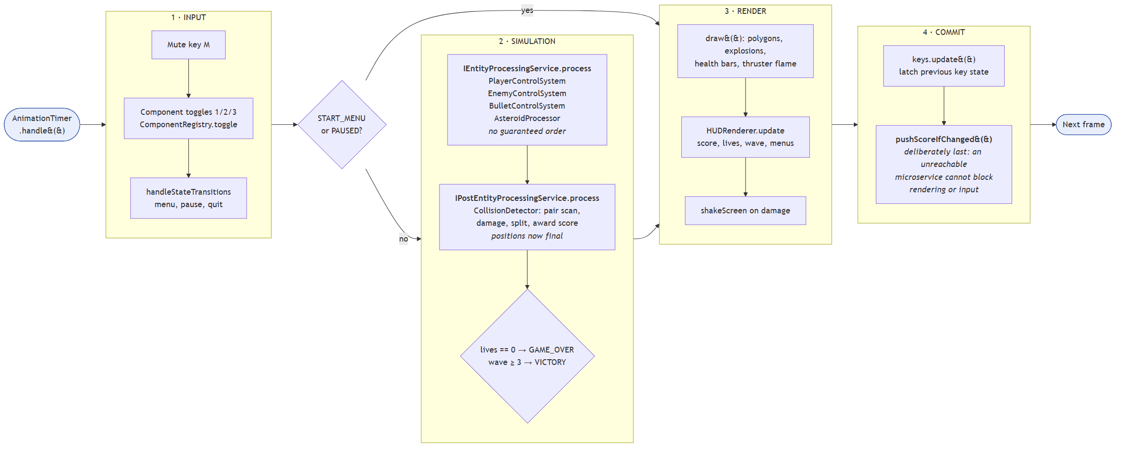
Figure 7. Per-frame control flow. The simulation phases are skipped in the menu and paused states, and score synchronisation deliberately runs last.

4.5 Module layers and split packages
Two modules that export the same package cannot be defined under one class loader; the module system rejects the attempt with a LayerInstantiationException. This was reproduced deliberately in a minimal two-module demonstration kept under docs/jpms-lab3-demo, and the captured behaviour is instructive. Configuration.resolve alone does not detect the clash, because it resolves only the requires graph. The failure appears when the modules are actually defined together, which is exactly what happens when everything sits on one flat module path.
The resolution is to give each conflicting module its own layer, and therefore its own loader. AsteroidsFX applies the same mechanism for a related reason: because the plugin set is resolved as its own isolated configuration, a package clash between two components fails loudly and specifically when ServiceLocator is constructed, instead of silently corrupting the boot layer's module graph.

4.6 The scoring boundary
Moving the score out of process turns a field access into a network call, and a network call can fail. NFR6 requires that this failure be contained, and two design decisions achieve it. First, synchronisation runs as the last statement of the frame, after rendering and input handling have already completed, so an exception cannot abort the remainder of the frame. Second, the client publishes only on an actual change of score, and after a failure backs off for roughly three seconds rather than retrying every frame.
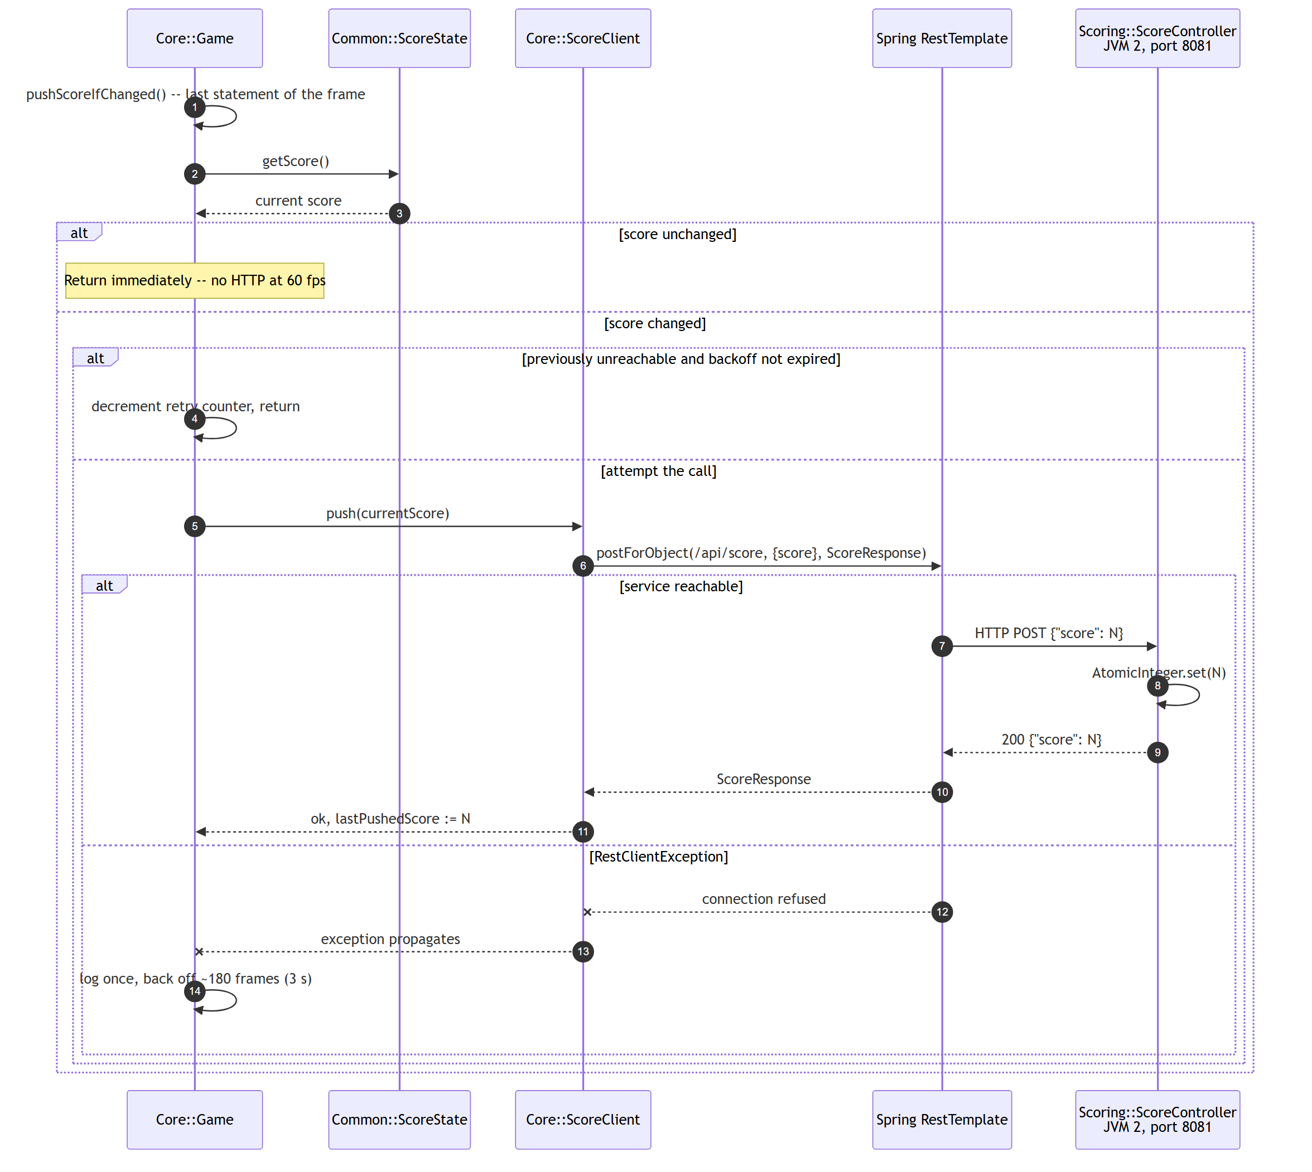
Figure 8. Score synchronisation including the failure path. The game continues at full frame rate whether or not the scoring service is reachable.
This design was not arrived at analytically. An earlier version placed the call before rendering, and when the scoring service was stopped the uncaught exception aborted the rest of the frame: the screen stopped redrawing and input stopped responding, which presented exactly as a frozen game. The ordering is therefore a corrective response to an observed defect, and is documented as such in the repository.

5 Implementation
This section explains how the design is realised in source code: how components are registered and accessed, how reliable configuration and strong encapsulation are obtained, and where each component model appears in the repository.

5.1 Registration and access of components
Components are never registered explicitly. A component joins the running game solely by declaring a provides clause in its module descriptor; nothing imports it and nothing lists it. The single point of assembly is ServiceLocator in the Common module, which builds the child module layer once and then answers lookups against it.
Path pluginsDir = Paths.get("plugins");
ModuleFinder pluginsFinder = ModuleFinder.of(pluginsDir);

List<String> plugins = pluginsFinder.findAll().stream()
.map(ModuleReference::descriptor)
.map(ModuleDescriptor::name)
.collect(Collectors.toList());

Configuration pluginsConfiguration = ModuleLayer
.boot().configuration()
.resolve(pluginsFinder, ModuleFinder.of(), plugins);

layer = ModuleLayer.boot()
.defineModulesWithOneLoader(pluginsConfiguration, ClassLoader.getSystemClassLoader());
Listing 6. ServiceLocator builds the child ModuleLayer from whatever jars are present in plugins/. Common/src/main/java/dk/sdu/mmmi/cbse/common/util/ServiceLocator.java
The set of components is therefore determined by the contents of a directory at start-up, not by anything written in the source. Figure 9 traces the full bootstrap, from the launch command to the first frame.
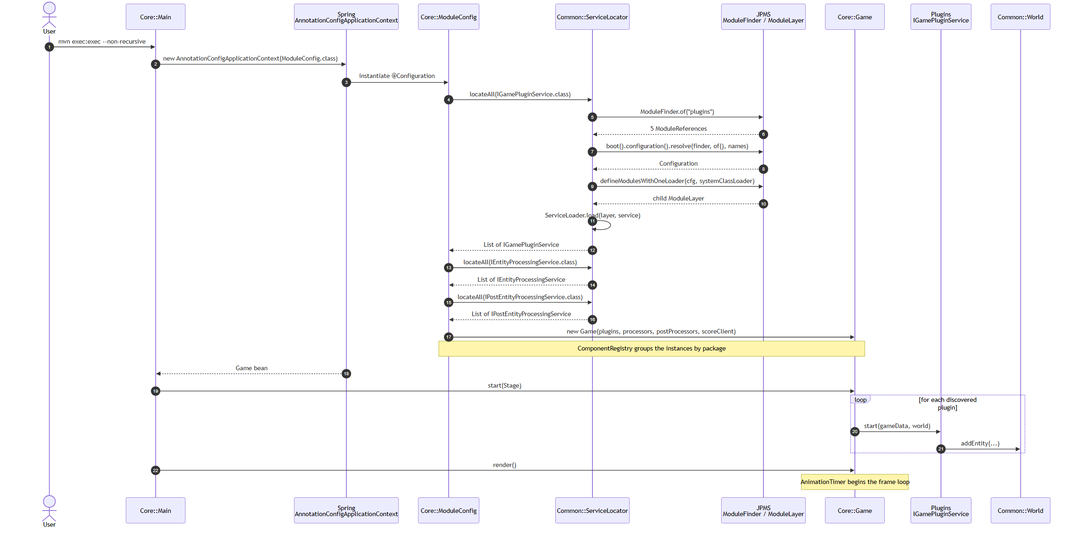
Figure 9. Application start-up. Spring asks ServiceLocator for each service type, ServiceLocator resolves the plugins directory into a child ModuleLayer, and Game receives the discovered lists without ever naming a concrete component.

5.2 Reliable configuration and strong encapsulation
The module descriptors are where NFR2, NFR3 and NFR4 are enforced. Two properties are worth reading carefully in the excerpt below. Core requires only shared API modules, so the compiler physically cannot allow it to reach into a gameplay component. The Player component declares uses BulletSPI but never requires Bullet, so it compiles, and runs, whether or not a weapon implementation exists.
module Core { module Player {
requires Common; requires Common;
requires CommonBullet; requires CommonBullet;
requires CommonAsteroids; uses dk.sdu.mmmi.cbse.common.bullet.BulletSPI;
requires javafx.graphics; provides IGamePluginService
requires spring.context; with ...playersystem.PlayerPlugin;
exports dk.sdu.mmmi.cbse.main; provides IEntityProcessingService
opens dk.sdu.mmmi.cbse.main with ...playersystem.PlayerControlSystem;
to javafx.graphics, spring.core; }
// no requires Player / Enemy /
// Bullet / Asteroids / Collision module Bullet {
} requires Common;
requires CommonBullet;
provides BulletSPI
with ...bulletsystem.BulletControlSystem;
}
Listing 7. Module descriptors. Core names no gameplay module; Player consumes BulletSPI without depending on the component that provides it.
Encapsulation is asymmetric by design. The shared modules export their packages because their types are the contract. The five gameplay components export nothing at all: their classes are reachable only as service implementations, so no other component can bind to their internals even accidentally. This is a stricter reading of the exercise than exporting every package would be, and it is what makes substitution safe.

5.3 Component models applied
Three distinct component models are used, each in the place where it fits. Their coexistence is deliberate: JPMS supplies reliable configuration, ServiceLoader supplies late binding, and Spring supplies runtime wiring.
Component model | Where it is applied | Source location
Whiteboard model [15] | A component publishes an implementation and is called by the framework; it never registers itself with, or looks up, the framework | Common/.../services/*.java` and every plugin module-info
JPMS services | provides ... with and uses declarations express the contract at module granularity, checked when the configuration resolves | */src/main/java/module-info.java
ServiceLoader with ModuleLayer | Late binding of implementations discovered from a directory rather than a class path | Common/.../util/ServiceLocator.java
Dependency injection | The discovered lists are turned into beans and injected into the Game constructor | Core/.../main/ModuleConfig.java
Microservice [17], [18] | The authoritative score is owned by a separate process behind a REST interface | Scoring/.../ScoreController.java`, `Core/.../ScoreClient.java
Table 8. Component models applied and where each appears in the repository.
@Configuration
class ModuleConfig {

@Bean public Game game() {
return new Game(gamePluginServices(), entityProcessingServiceList(),
postEntityProcessingServices(), scoreClient());
}

@Bean public List<IEntityProcessingService> entityProcessingServiceList() {
return ServiceLocator.INSTANCE.locateAll(IEntityProcessingService.class);
}
...
}
Listing 9. The Spring configuration wires whatever the module layer yielded. Core/src/main/java/dk/sdu/mmmi/cbse/main/ModuleConfig.java

5.4 Dynamic installation and uninstallation
ComponentRegistry, held by Core, groups the already discovered service instances by the package of their implementing class and maintains the lists that the frame loop iterates. Installing or uninstalling a component is therefore a list operation plus a lifecycle call; no discovery is repeated, no class is reloaded, and nothing is recompiled.
void toggle(String name, GameData gameData, World world) {
for (Component component : components) {
if (!component.name.equals(name)) continue;
if (component.installed) {
for (IGamePluginService plugin : component.plugins) plugin.stop(gameData, world);
activePlugins.removeAll(component.plugins);
activeProcessors.removeAll(component.processors);
} else {
for (IGamePluginService plugin : component.plugins) plugin.start(gameData, world);
activePlugins.addAll(component.plugins);
activeProcessors.addAll(component.processors);
}
component.installed = !component.installed;
return;
}
}
Listing 10. Runtime installation and uninstallation. Core/src/main/java/dk/sdu/mmmi/cbse/main/ComponentRegistry.java
The weapon component illustrates why the contract must anticipate absence. BulletSPI.createBullet returns an Optional, and when the component is uninstalled it returns empty. Player and Enemy therefore keep running normally and simply stop producing bullets; neither contains any knowledge that the weapon can disappear beyond honouring the Optional. Figure 11 traces the sequence.
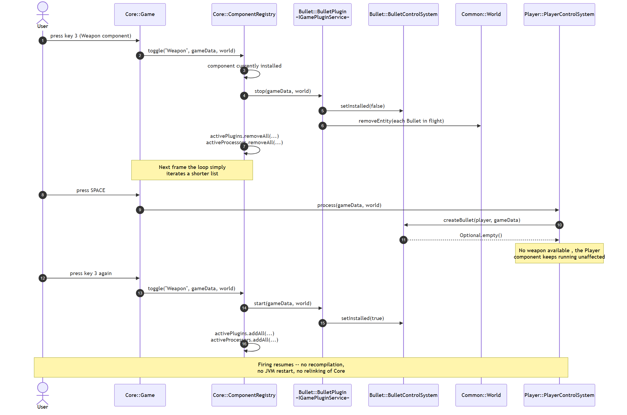
Figure 10. Runtime uninstallation and reinstallation of the weapon component. The Player component continues to run throughout, receiving an empty Optional while no weapon is installed.

5.5 Collision, splitting and scoring
CollisionDetector is the only implementer of IPostEntityProcessingService. It filters candidate pairs by category before performing any distance arithmetic, so friendly fire and asteroid-against-asteroid contacts are never considered, and it defers all removals until the scan is complete so that no pair is skipped or processed twice.
public Boolean collides(Entity entity1, Entity entity2) {
float dx = (float) entity1.getX() - (float) entity2.getX();
float dy = (float) entity1.getY() - (float) entity2.getY();
float distance = (float) Math.sqrt(dx * dx + dy * dy);
return distance < (entity1.getRadius() + entity2.getRadius());
}
Listing 11. Pythagorean collision test. Collision/src/main/java/dk/sdu/mmmi/cbse/collisionsystem/CollisionDetector.java
Three destruction paths are distinguished, and the difference between them is a design decision rather than an accident. A collision involving the player never removes the player entity; it registers a hit that the Player component consumes on the following frame, which is what allows lives and respawn invulnerability to live entirely inside that component. A ship that flies into an asteroid is destroyed outright, because a rock is not a bullet. Only a bullet kill awards points, so neither ramming nor a ship wrecked by an asteroid inflates the score.
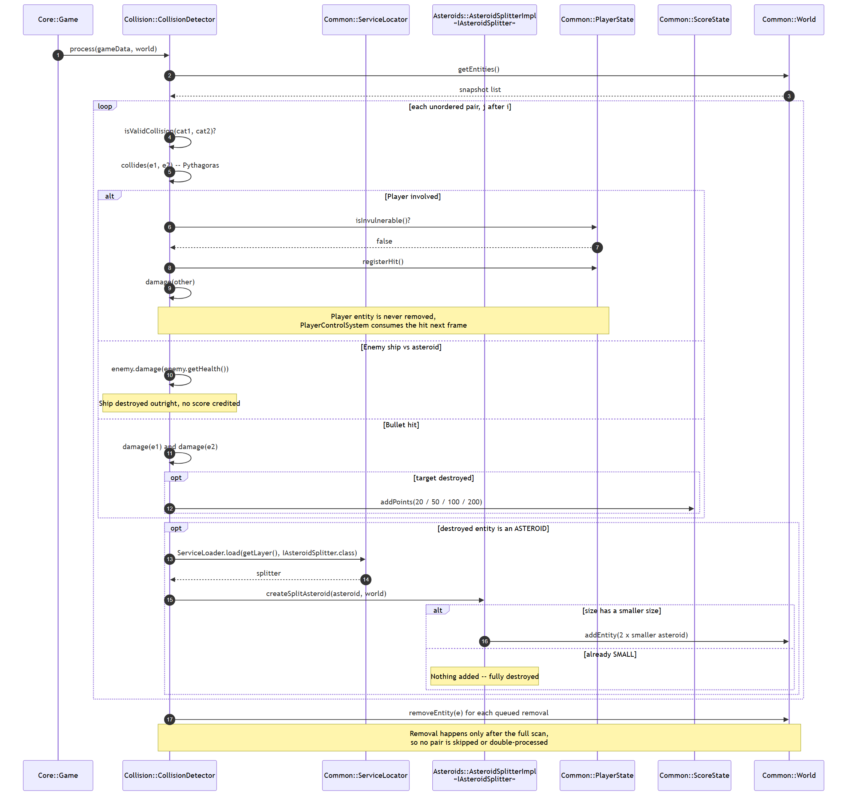
Figure 11. Collision resolution. The splitter is reached through IAsteroidSplitter, so the Collision component never names a concrete asteroid type.
Note in the figure that Collision obtains the splitter through a service lookup. It knows that something can split an asteroid; it does not know what, and if the Asteroids component were absent the lookup would simply yield nothing.

5.6 The scoring client
ScoreClient is a thin wrapper over Spring's RestTemplate [6]. Making a plain JPMS module use RestTemplate required three additions to the module descriptor that are worth recording, because each was discovered by running the application rather than by reading documentation: spring.web itself; micrometer.observation, which RestTemplate references during class initialisation; and com.fasterxml.jackson.databind, without which no JSON message converter is registered and posting an object fails outright.
class ScoreClient {
private static final String SCORE_URL = "http://localhost:8081/api/score";
private final RestTemplate restTemplate = new RestTemplate();

void push(int score) {
restTemplate.postForObject(SCORE_URL, new ScoreUpdateRequest(score), ScoreResponse.class);
}
}
Listing 12. Core/src/main/java/dk/sdu/mmmi/cbse/main/ScoreClient.java
The server side is a conventional Spring Boot REST controller [7] holding the score in an AtomicInteger, exposing GET and POST on /api/score and a reset endpoint. It carries no module-info: it is deployed on the class path as an ordinary executable jar, which reinforces that the boundary between the two processes is the HTTP contract and nothing else.

6 Test
Validation was carried out at three levels: unit tests of individual components, an integration run of the complete deployment in its real configuration, and a controlled experiment demonstrating dynamic update. All evidence in this section is reproduced from actual runs of the built application.

6.1 Unit testing strategy
The exercise asks for one unit test [12]. Twenty-one were written across five test classes, covering both examples the exercise names, moving the player ship and collision detection, and both testing styles its reading material describes. NFR5 is what makes this possible: because every component's logic is reachable through plain objects, no test requires a JavaFX stage.
Test class | Module | Tests | What it establishes
CollisionDetectorTest | Collision | 6 | Pythagorean distance including the 3-4-5 case, multi-hit destruction, ship destroyed by an asteroid without scoring, and removal of both sides of a collision
PlayerStateTest | Common | 5 | Lives decrement to game over, hits ignored during respawn invulnerability, one-shot hit consumption, and reset
EntityTest | Common | 4 | Default single-hit destruction, survival until max health is depleted, damage floored at zero, and refill on setMaxHealth
PlayerControlSystemTest | Player | 3 | Rotation on arrow keys, thrust followed by friction, and wrapping at the screen edge
AsteroidSizeTest | CommonAsteroids | 3 | The split chain large to medium to small, and that the smallest size has no successor
Table 13. Unit test inventory. 21 tests across 5 classes and 4 modules.
The two styles are deliberately contrasted within one class. The state-based test builds a real World, fires three bullets one frame at a time, and asserts that the enemy survives the first two and is destroyed by the third. The interaction-based test replaces World with a Mockito mock [10] and verifies that removeEntity was called exactly twice, once per side of the collision, which is a claim about the interaction rather than about the resulting state.
@Test
void enemyShipIsDestroyedByAnAsteroidWithoutScoringForThePlayer() {
GameData gameData = new GameData();
World world = new World();

Entity enemy = entityAt(100, 100, 8, EntityCategory.ENEMY);
enemy.setMaxHealth(3); // survives 3 bullets, but not one asteroid
world.addEntity(enemy);
world.addEntity(entityAt(100, 100, 14, EntityCategory.ASTEROID));

detector.process(gameData, world);

assertFalse(world.getEntities().contains(enemy), "enemy should be destroyed by the asteroid");
assertEquals(0, gameData.getScoreState().getScore(), "a rock kill is not the player's kill");
}
Listing 14. A state-based test of the contract in Section 5.5. Collision/src/test/java/dk/sdu/mmmi/cbse/collisionsystem/CollisionDetectorTest.java

6.2 Build and unit test results
The full reactor builds and all tests pass. Figure 13 and Figure 14 are captured from the terminal session that produced the artefacts used everywhere else in this section.
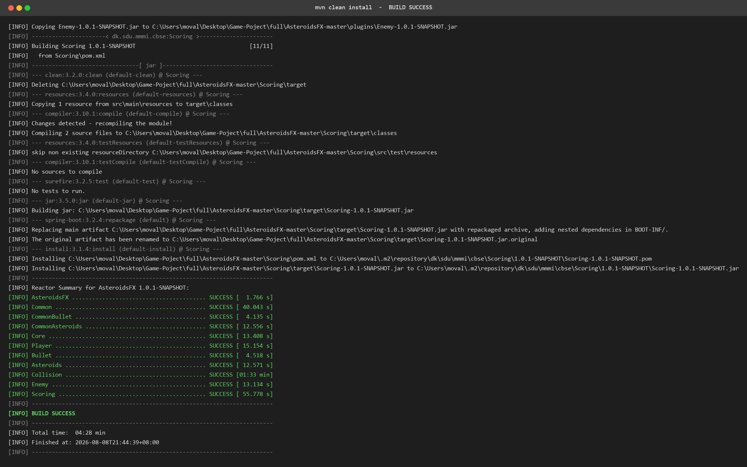
Figure 12. mvn clean install over all eleven Maven modules, ending in BUILD SUCCESS and populating mods-mvn/ and plugins/.
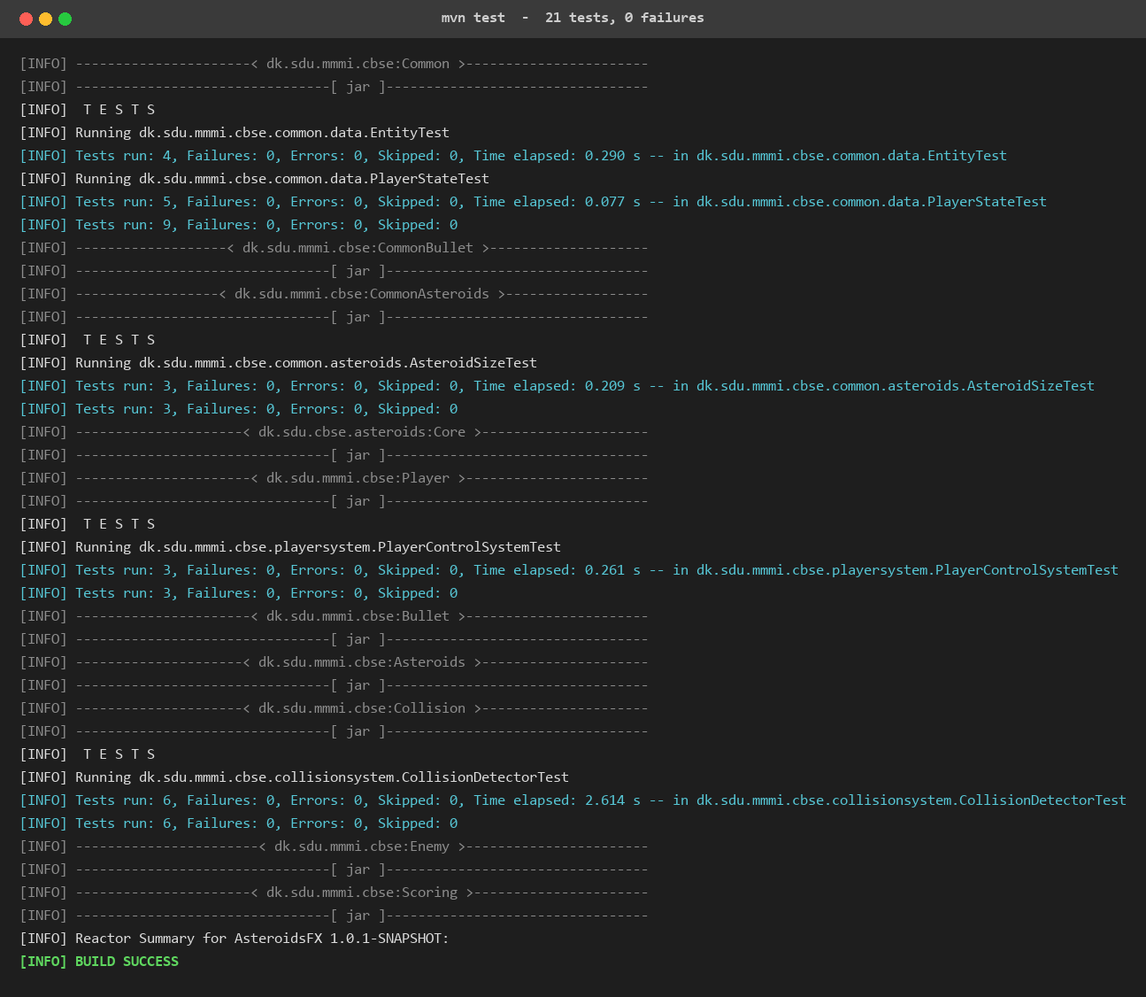
Figure 13. mvn test. All 21 tests pass across the four modules that carry tests.

6.3 Integration in a real deployment
Integration was validated by running the system exactly as it is meant to be deployed: two processes, the game launched from the module path and the scoring service as a standalone jar. Figure 15 shows the scoring service starting on port 8081 and answering a full round trip: read the score, set it, read it back, reset it.
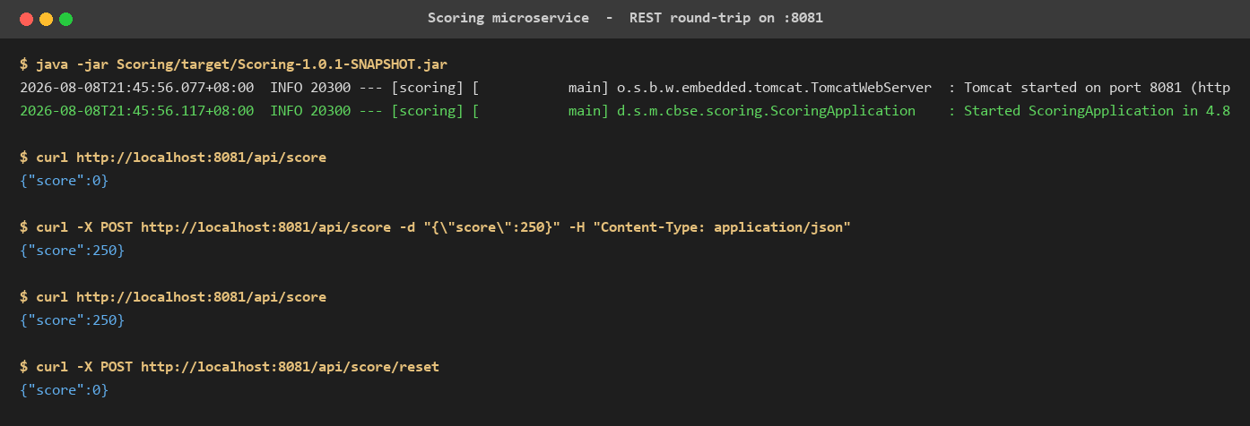
Figure 14. The scoring microservice starting and answering GET, POST and reset over HTTP.
Figure 16 shows the application at its start menu, and Figure 17 during play with the components cooperating: the Player component's ship, the Enemy component's saucer, an asteroid from the Asteroids component, and bullets from the Bullet component, with the Collision component arbitrating between them. Every entity visible in that frame was contributed by a module that Core does not name.
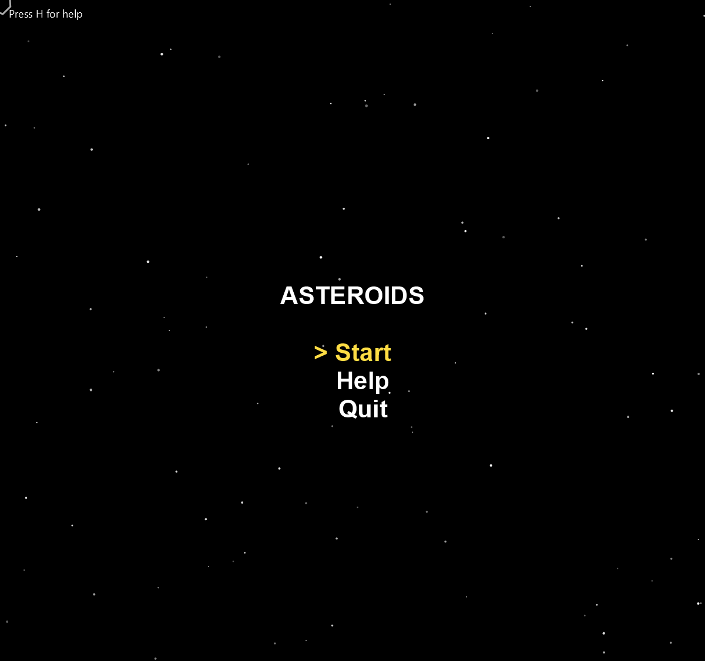
Figure 15. The application at start-up, in the START_MENU state, rendered by the Core component.
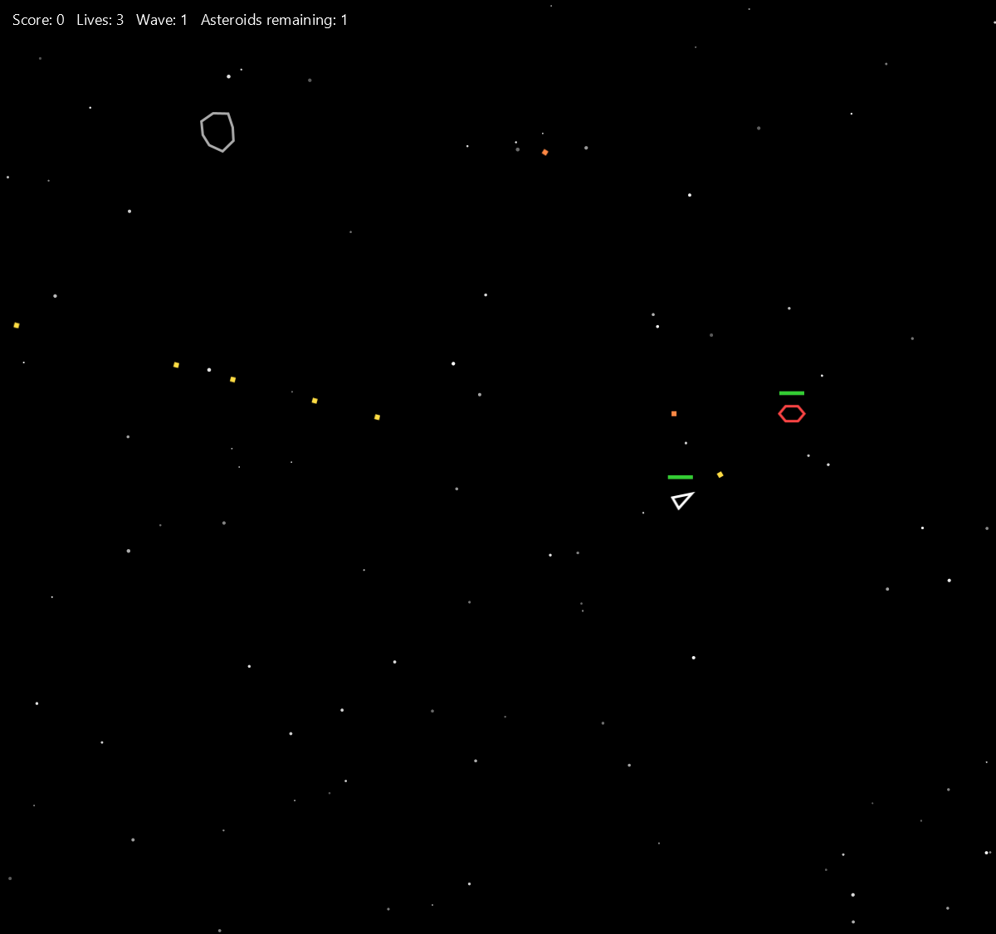
Figure 16. Gameplay with all five components installed. Player ship and enemy saucer both carry health bars; player bullets are yellow and enemy bullets orange.

6.4 Experimental validation of dynamic update
This is the experiment that addresses NFR1 and the deliverable required by the course information sheet. It was performed twice, at two different levels, because the two demonstrate different claims.
Experiment 1: uninstallation while the process runs.
With the game running, the Weapon component was uninstalled by pressing key 3, the fire key was pressed repeatedly, and the component was then reinstalled and the fire key pressed again. Figure 18 shows the three states. In the first, bullets are in flight. In the second, no bullet exists anywhere on the field despite repeated firing, because BulletSPI.createBullet is returning an empty Optional. In the third, firing works again. The player ship continues to fly throughout, and no other component is disturbed.

Figure 17. Weapon component installed: bullets in flight.
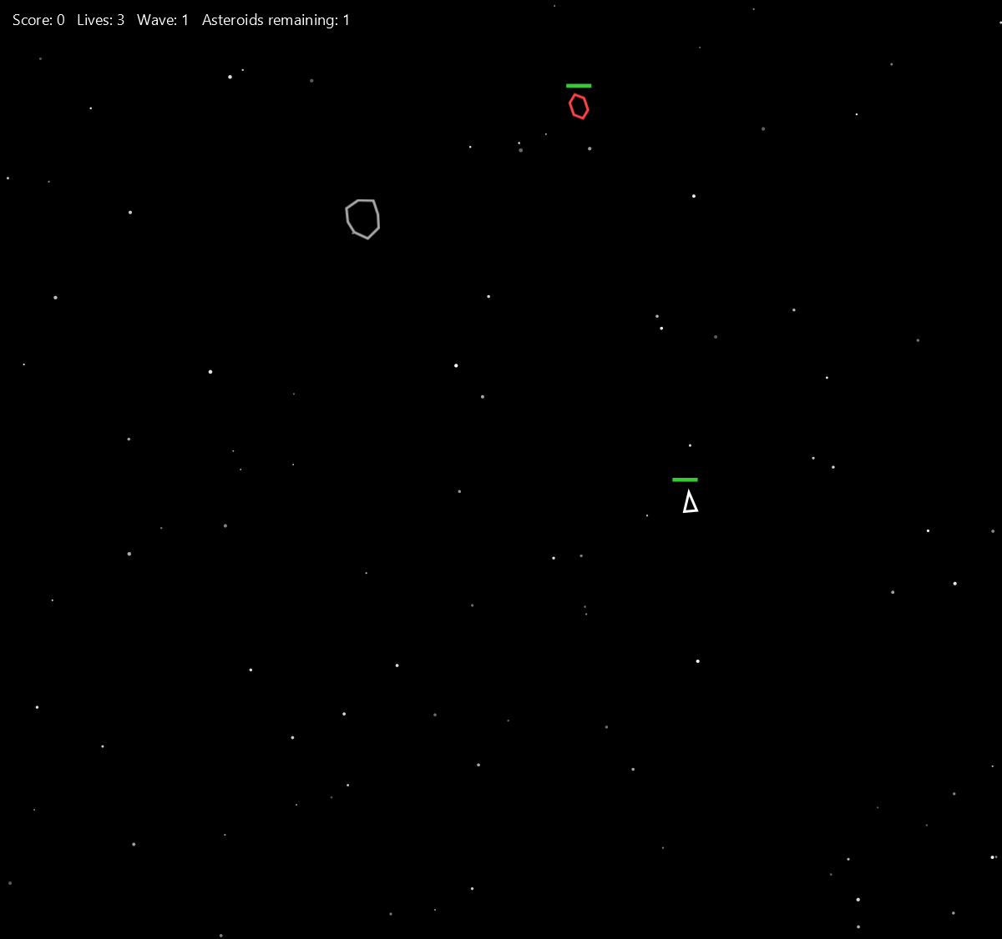
Figure 18. Weapon component uninstalled at runtime with key 3. The fire key was pressed repeatedly and no bullet exists on the field; the rest of the game continues normally.
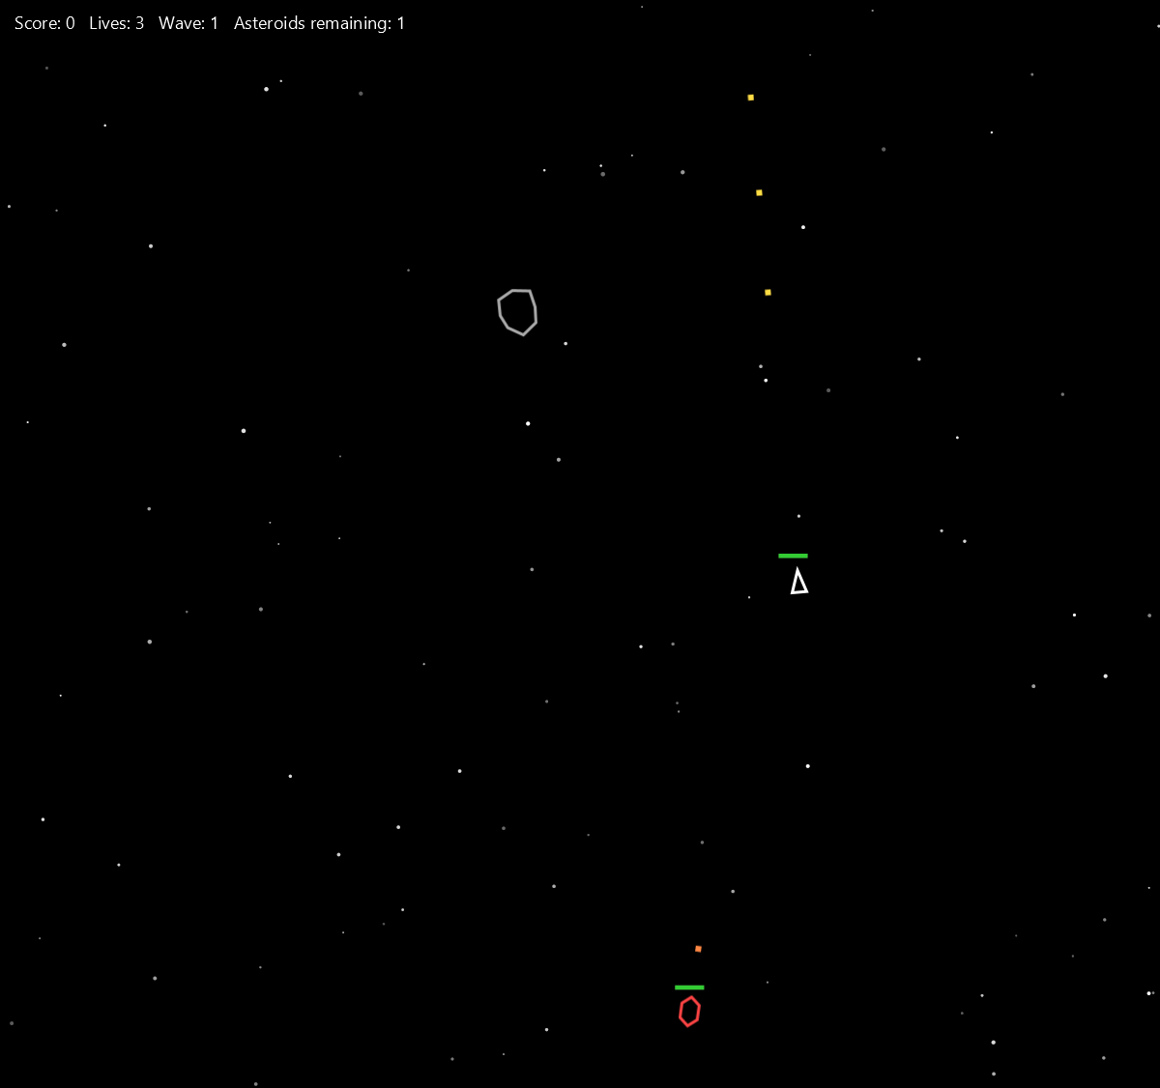
Figure 19. Weapon component reinstalled with key 3. Firing resumes immediately, with no recompilation and no restart of the JVM.
Experiment 2: removal from the deployment.
The first experiment shows a component being switched off inside a running process, but the instances were still discovered at start-up. The stronger claim is that a component need not be present at all. To test this, the Enemy component's jar was moved out of the plugins directory and the application was launched again. No source file was touched and no module was rebuilt.
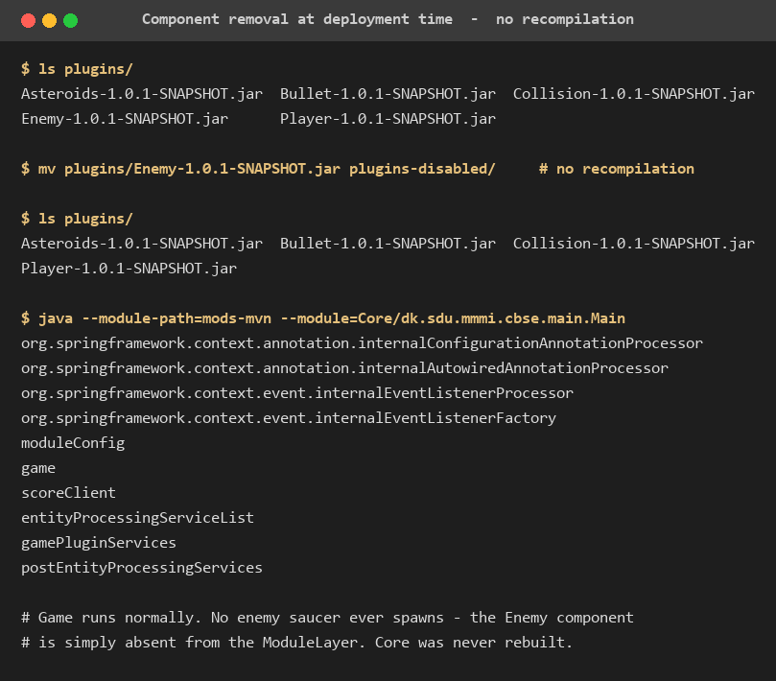
Figure 20. The Enemy component removed from the deployment by moving its jar out of plugins/. Core is not rebuilt.
The application started normally and played correctly with four components instead of five. No enemy saucer ever appeared, no enemy bullets were fired, and nothing failed: the module layer simply resolved a smaller set of modules, and the lists Spring injected were shorter by one entry.
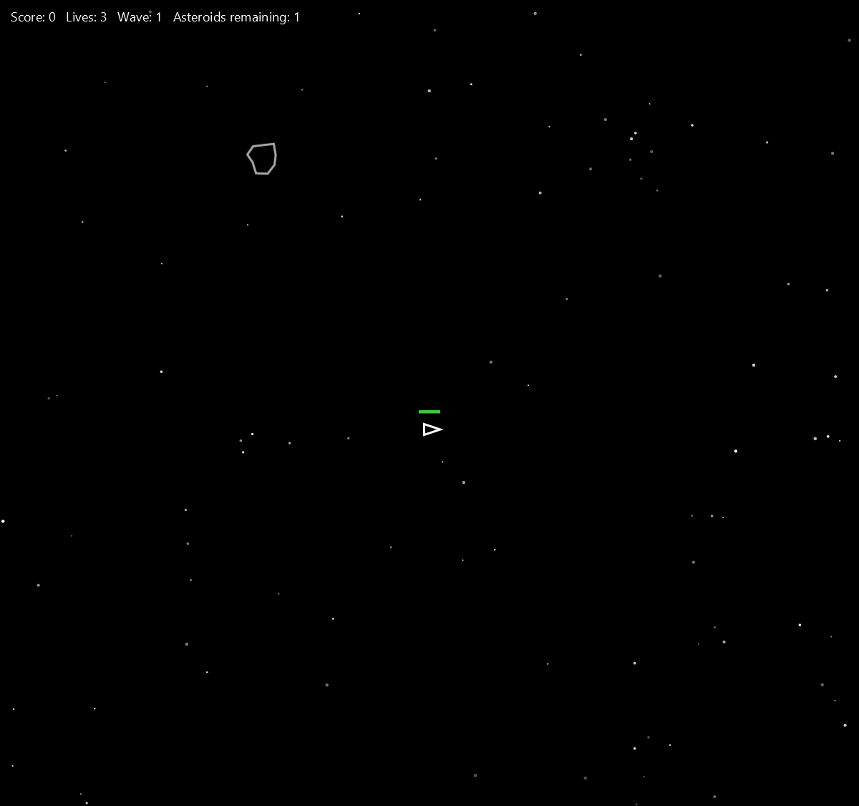
Figure 21. The game running with the Enemy component absent from the deployment. Player, Asteroids, Bullet and Collision continue to function; no saucer spawns.
The jar was then moved back and the enemy returned on the next launch. Taken together the two experiments establish NFR1 at both levels the exercise cares about: a component can be disabled in a live process, and a component can be absent from the deployment entirely, in both cases without recompiling the source code.

6.5 Summary of results
Requirement | Method of validation | Result
FR1 to FR11 | Unit tests plus observation of the running game (Figures 16, 17) | Met
FR12 | HTTP round trip against the running service (Figure 15) | Met
NFR1 | Experiments 1 and 2 (Figures 18 to 22) | Met at both runtime and deployment level
NFR2 | Inspection of Core/module-info.java; no gameplay module is named | Met
NFR3 | Inspection of the five plugin descriptors; none exports a package | Met
NFR4 | Resolution occurs in the ServiceLocator constructor and fails there if a module is missing | Met
NFR5 | 21 unit tests run with no JavaFX stage (Figure 14) | Met
NFR6 | Game observed running normally with the scoring service stopped | Met
Table 15. Validation summary.

7 Discussion

7.1 How well the design met the requirements
The decisive requirement was NFR1, and the two experiments in Section 6.4 satisfy it directly. What is worth examining is why they succeed, because the outcome rests on a structural property rather than on a feature. Core cannot break when a component is removed because Core was never able to refer to that component in the first place. The compiler enforces this through the module descriptor, so the guarantee is not a matter of discipline that a later change might erode.
The same reasoning explains why the weapon experiment is the most informative of the three. Player and Enemy genuinely depend on a weapon to function as intended, and yet neither fails when it disappears, because the dependency is expressed as an Optional returned by a service rather than as a field of a known type. The contract anticipates absence, which is what distinguishes a component boundary from a mere package boundary.

7.2 Trade-offs accepted
Indirection has a cost, and it would be dishonest to present the architecture as free. Three costs are visible in the code.
- Traceability. Reading the source does not reveal which components will run; that is determined by a directory at start-up. The behaviour is discoverable only by running the application or listing plugins/, which is a real loss of static comprehensibility.
- Service lookup cost. Player and Enemy resolve BulletSPI through the module layer on each shot rather than caching a provider. At sixty frames per second with a firing cooldown this is not measurable, but it is a deliberate simplicity-over-efficiency choice rather than an oversight.
- Coordination through shared state. Collision cannot call into the Player component, so a hit is communicated by setting a flag in PlayerState that the Player component consumes on the next frame. This keeps the two components independent, but it moves part of the protocol into shared mutable state, where it is less explicit than a method call would be.

7.3 Limitations
The most significant limitation is that ServiceLocator constructs its module layer exactly once. A jar added to plugins/ after start-up is not seen, so Experiment 2 requires a relaunch even though it requires no recompilation. Supporting genuine hot deployment would mean building a new layer and migrating live entities between loaders, which is a substantially harder problem and well beyond what the exercise asks for. The boundary is therefore deliberate, and it is stated here rather than left for a reader to discover.
A second limitation is that the toggling mechanism groups service instances by the package name of their implementing class. This is a pragmatic mapping local to Core and it does not create a compile-time dependency, but it does encode a naming convention that a new component would have to follow to become toggleable. A more principled solution would carry the component name in the service contract itself.
Finally, the scoring service holds its state in memory. This satisfies the exercise, which asks for a microservice rather than for durable storage, but it means the externalised score is authoritative only for the lifetime of that process.

7.4 Reflection on the development process
Two defects found during development shaped the final design more than any diagram did. The first was the frozen-game symptom described in Section 4.6, which established that a call across a process boundary must be positioned so that its failure cannot abort work that has nothing to do with it. The second was found while auditing the implementation against the exercise text: enemy ships passed through asteroids untouched, because the collision table listed the player against asteroids but not the enemy. The exercise says ships, in the plural. The fix was small, but the lesson is that a requirement expressed in one word of prose can be missed entirely by an implementation that otherwise looks complete, which is precisely the argument for writing explicit contracts and tests against them.

8 Conclusion
This project set out to build an Asteroids game whose gameplay subsystems are genuine components, and to demonstrate that one of them can be removed and restored without recompiling the source code. Both objectives were met.
The resulting system is assembled from five gameplay components that the composition root cannot name. Their contracts are declared in shared API modules as JPMS services with explicit pre- and post-conditions, they are discovered at runtime by ServiceLoader from a plugins directory, they are resolved into their own ModuleLayer so that their resolution is isolated from the boot layer, and they are injected into the game loop by the Spring container. Score keeping was moved out of the process altogether, behind an HTTP contract, with the failure of that service contained so that it cannot affect the frame rate.
Validation was carried out on three levels. Twenty-one unit tests exercise the component contracts in isolation, with no JavaFX stage required. The complete two-process deployment was run and a score round trip confirmed end to end. Most importantly, two experiments established dynamic update at the two levels that matter: a component was uninstalled and reinstalled inside a live process, and a component was removed from the deployment entirely, in both cases with no recompilation of any source file.
The wider result is the one the course is aimed at. Each exercise replaced a direct dependency with a discovered one, and the cumulative effect is a composition root whose module descriptor names no gameplay module at all. That absence is not a stylistic preference; it is the property that makes the parts of this system replaceable, and it is what the experiments in Section 6.4 ultimately measure.

9 References
[1] S. Mak and P. Bakker, Java 9 Modularity: Patterns and Practices for Developing Maintainable Applications. Sebastopol, CA, USA: O'Reilly Media, 2017.
[2] M. Reinhold, "JSR 376: Java Platform Module System," Java Community Process, Sep. 2017. [Online]. Available: https://openjdk.org/projects/jigsaw/spec/
[3] Oracle Corporation, "Class ServiceLoader," Java Platform, Standard Edition API Specification, 2023. [Online]. Available: https://docs.oracle.com/en/java/javase/21/docs/api/java.base/java/util/ServiceLoader.html
[4] Oracle Corporation, "Creating Extensible Applications," The Java Tutorials, 2023. [Online]. Available: https://docs.oracle.com/javase/tutorial/ext/basics/spi.html
[5] C. Szyperski, Component Software: Beyond Object-Oriented Programming, 2nd ed. Boston, MA, USA: Addison-Wesley, 2002.
[6] VMware, Inc., "Spring Framework Reference Documentation, version 6.1," 2024. [Online]. Available: https://docs.spring.io/spring-framework/reference/
[7] VMware, Inc., "Spring Boot Reference Documentation, version 3.2," 2024. [Online]. Available: https://docs.spring.io/spring-boot/docs/current/reference/html/
[8] OpenJFX Project, "JavaFX 21 API Documentation," 2023. [Online]. Available: https://openjfx.io/javadoc/21/
[9] JUnit Team, "JUnit 5 User Guide," 2024. [Online]. Available: https://junit.org/junit5/docs/current/user-guide/
[10] Mockito Contributors, "Mockito Framework Documentation," 2024. [Online]. Available: https://site.mockito.org/
[11] R. C. Martin, "The Dependency Inversion Principle," C++ Report, vol. 8, no. 6, pp. 61-66, 1996.
[12] Course teaching staff, "Component Based Systems: Laboratory Exercises (labs.pdf)," Maersk Mc-Kinney Moller Institute, University of Southern Denmark, 2026.
[13] C. Larman, Applying UML and Patterns: An Introduction to Object-Oriented Analysis and Design and Iterative Development, 3rd ed. Upper Saddle River, NJ, USA: Prentice Hall, 2004.
[14] N. Llopis, "Data-Oriented Design (or Why You Might Be Shooting Yourself in the Foot with OOP)," Game Developer Magazine, pp. 11-13, Sep. 2009.
[15] OSGi Alliance, "Listeners Considered Harmful: The Whiteboard Pattern," Technical Whitepaper revision 2.0, Aug. 2004.
[16] E. Gamma, R. Helm, R. Johnson, and J. Vlissides, Design Patterns: Elements of Reusable Object-Oriented Software. Reading, MA, USA: Addison-Wesley, 1994.
[17] J. Lewis and M. Fowler, "Microservices: a definition of this new architectural term," martinfowler.com, Mar. 2014. [Online]. Available: https://martinfowler.com/articles/microservices.html
[18] R. T. Fielding, "Architectural Styles and the Design of Network-based Software Architectures," Ph.D. dissertation, Univ. California, Irvine, CA, USA, 2000.

Appendix A Repository map
Path | Contents
Core/ | Composition root: Main, Game, ModuleConfig, ComponentRegistry, HUDRenderer, ScoreClient
Common/ | Entity, World, GameData and the state objects; the three service interfaces; ServiceLocator
CommonBullet/ | Bullet entity and the BulletSPI contract
CommonAsteroids/ | Asteroid entity, AsteroidSize and the IAsteroidSplitter contract
Player/ | Player component: PlayerPlugin and PlayerControlSystem
Enemy/ | Enemy component: EnemyPlugin and EnemyControlSystem
Bullet/ | Weapon component: BulletPlugin and BulletControlSystem, provider of BulletSPI
Asteroids/ | Asteroids component: plugin, processor and splitter implementation
Collision/ | Collision component: CollisionDetector
Scoring/ | Spring Boot scoring microservice, deployed as a standalone jar
mods-mvn/ | Build output: boot layer module path
plugins/ | Build output: component jars discovered at start-up
docs/ | Architecture notes, microservice notes, the split-package demonstration, and this report
docs/report-figures/ | Mermaid sources for every diagram and the captured screenshots used above
Table 16. Repository layout.

Appendix B Reproducing the results
Every figure and measurement in Section 6 can be reproduced from a clean checkout with the following commands, run from the repository root. A JDK of version 17 or newer is required.
git clone https://github.com/Fard121/asteroid_game.git
cd asteroid_game

mvn clean install # builds 11 modules, runs 21 tests,
# populates mods-mvn/ and plugins/

java -jar Scoring/target/Scoring-1.0.1-SNAPSHOT.jar # terminal 2: scoring service, port 8081

mvn exec:exec --non-recursive # terminal 1: launches the game

curl http://localhost:8081/api/score # terminal 3: score matches the in-game HUD
Listing 17. Full reproduction sequence.
To reproduce Experiment 2 of Section 6.4, move plugins/Enemy-1.0.1-SNAPSHOT.jar out of the directory and launch the game again. No rebuild is required, and the enemy saucer will not appear. Moving the jar back restores it on the following launch.
The --non-recursive flag matters: it runs the exec plugin once for the root project only. Without it, Maven repeats the launch for every child module.

