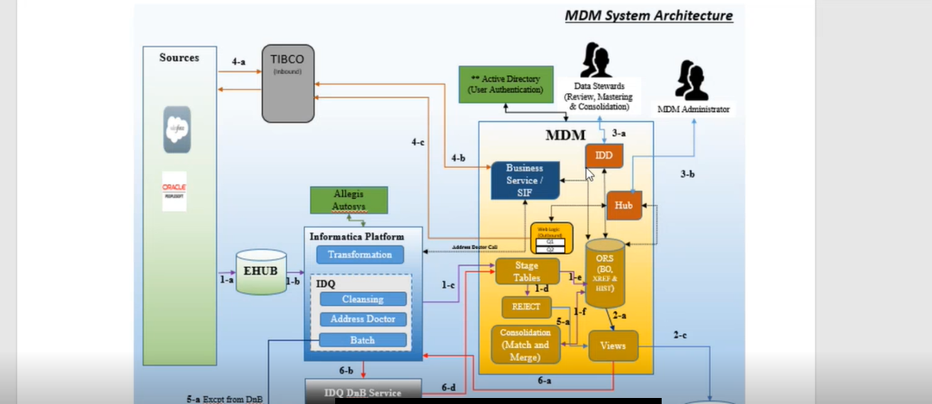

Mdm – master data management

Master the data and maintain the data quality

Provide the golden records for down stream team and different sources

In mdm match and merge process

Trying to set the single set record

How we are maintaining the source systems

Salesforce oracle – source systems

Third party source system – dnb

To enrich the data

Mdm 2 processes – batch process and real time process

From the source system we maintain db e hub and we are fetching the data into idq(it is nothing but informatica) in the we are doing cleansing and validations

Address doctor – if we are given wrong details it will be corrected by the address doctor

From the idq we are loading data to the stage tables

If its is a peoplesoft data we are maintaining a peoplesoft stage table

If it’s a salesforce data we are maintaining a salesforce stage table

From the stage tables we are loading into the bo and xref tables

On top of this bo and xref tables we are creating views

From this views the down stream team consuming the data

We are having a team aaw based on their request we are creating views and they are consuming on top of these bu using these views

This d&b acts as a source system

And we are having another source system called data stewards – which acts a source system

Basically mdm having an ui which is called idd

Data stewards they can do match and merge from their end and they can update from their end by logging into the idd

Mdm adminsitrators they can do loging using and they can update y using cm ors schema

Ehub is a landing area

f

rom the source system we are having a mulesoft and we are sending a sif services

the process is same in real time and in batch process

in mulesoft also we are having and api calls

batch process

mulesoft will call apis cleansing address doctor apis validation apis everything they will call within the mulesoft and output will be load into the madm tables

mulesoft will call the sif services and they will load into the xref history tables

from the idq we are having exception data they will load into the exception tables

from this views we are having data which is not enriched then they will push back to idq and they will call the d&b services they will do the enrichment and sent back to the stage tables

