**GESTURE CONTROLLED ROBOT**

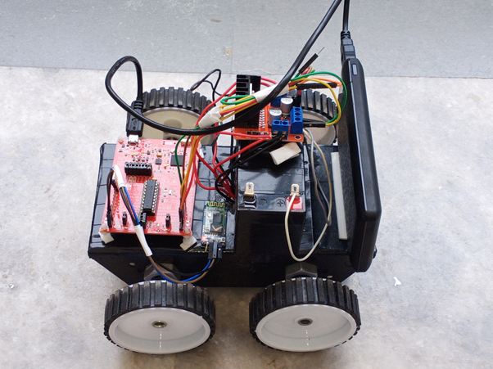

**AIM**

The aim of this project is to control a robot using an android smartphone applications with gestures.

**HARDWARE COMPONENTS**

* MSP430 LAUNCHPAD
* 4 * 300 RPM MOTORS
* 12V BATTERY
* HC-05 BLUETOOTH MODULE
* L298 MOTOR DRIVER MODULE
* JUMPER WIRES AND CONNECTING WIRES
* 4 * WHEELS AND CHASIS
* POWER SUPPLY

**SOFTWARE USED**

Texas Instruments Energia

MIT App Inventer

**IMPLEMENTATION AND WORKING**

MSP430G2ET launchpad has been used for controlling the motors of Robot.

MSP430G2ET launchpad is programmed using Energia Software.

HC05 bluetooth module is interfaced with the launchpad for receiving the data from mobile app and forwarding it serially to the launchpad unit.

**PROGRAMMING LOGIC**

If ‘A’ is received via bluetooth then robot moves forward.

If ‘B’ is received via bluetooth then robot moves backward.

If ‘C’ is received via bluetooth then robot moves left.

If ‘D’ is received via bluetooth then robot moves right.

If ‘E’ is received via bluetooth then robot stops.

**ADVANTAGES**

Speed and sufficient reliable for recognition system. Good performance system with complex background.

The system successfully recognized static and dynamic gestures. Could be applied on a mobile robot control.

Simple, fast and easy to implement. Can be applied on real system and play games.

No training is required.

**DISADVANTAGES**

Irrelevant object might overlap with the hand.Wrong object extraction appeared if the object are larger than the hand.

Performance recognition algorithm decreases when the distance is greater than 1.5 meters between the user and the camera.

System limitation restrict the application such as the arm must be vertical,the palm is facing the camera and the finger colour must be basic colour such as either red or green or blue.

Ambient light affects the colour detection threshold.

**APPLICATIONS**

Though the use of gesture recognition, remote control with the wave of a hand of various devices is possible.

Gesture controlling is very helpful for handicapped and physically disabled people to achieve certain tasks, such as driving a vehicle.

Gestures can be used to control interactions for entertainment purposes such as gaming to make the game players experience more interactive or immersive.

Traditional interfaces, keyboards and mice present a bottleneck in application that rely on heavy interaction of the user with the machine due to the unnaturalness of the interaction.

From reading lots of related articles, we have learnt that recent efforts have attempted to eliminate this bottleneck by developing different ways of interacting with computers, for example: speech, handwriting.

**CONCLUSION**

With this, your robot is all set to catch the slightest of your gestures and report to you!

PS. Our Indiegogo campaign, which we decided to extend owing to the wonderful response, is going to end soon! So, if you haven’t had the time to have look till now, go check it out NOW.