Name: SAFA AHMED ID: 1831059042

Course: CSE311L.9 Faculty: RAH1

**individual Contribution to CSE311L.9 Project:**

Both me and Fardin bin Islam were responsible for coming up with the project idea for the proposal. After that Rifah Shanjida and I wrote out our project proposal. We then researched on how these projects are made and soon enough realized how essential the planning was.

I started with a more complex idea with many more entities and visualized it with an E-R diagram(fig:1). Next, I mapped the E-R diagram to a UML diagram according to the various cardinalities and participations(fig:2). Then, I normalized it to 3NF by making sure that the data in each cell was atomic, fully dependent on their respective Primary Keys, and had no transitive dependency.

Initial E-R diagram:

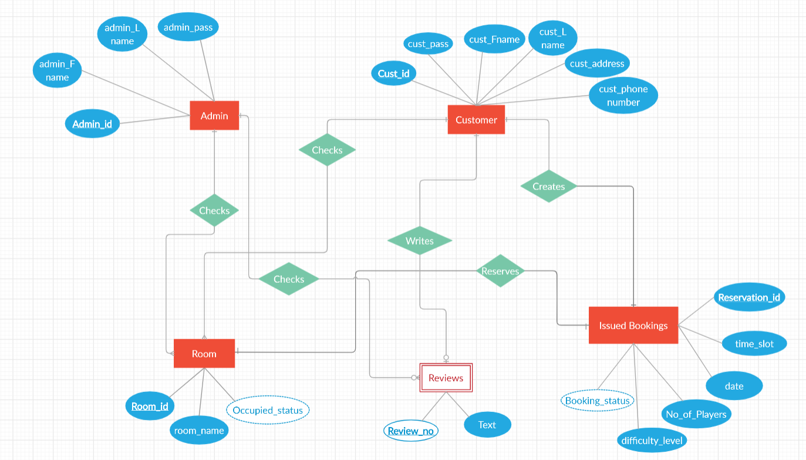

Fig:1

Initial UML diagram:

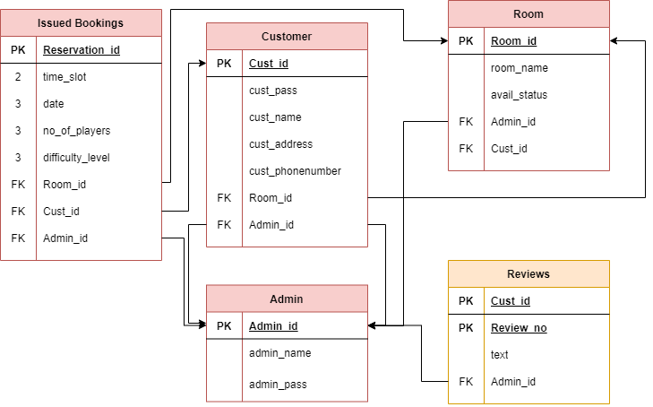

Fig:2

After visualizing my project on paper I realized that the plan didn’t have to be so unnecessarily difficult, hence I simplified the ER diagram a lot (fig:3) and mapped a UML diagram (fig:4) from it again. This way I had eliminated a separate entity for Admin and got the same functionality by creating a Manager with a unique set of attributes, who plays the admin, has admin privileges and works as a supervisor for all Managers.

Final E-R diagram:

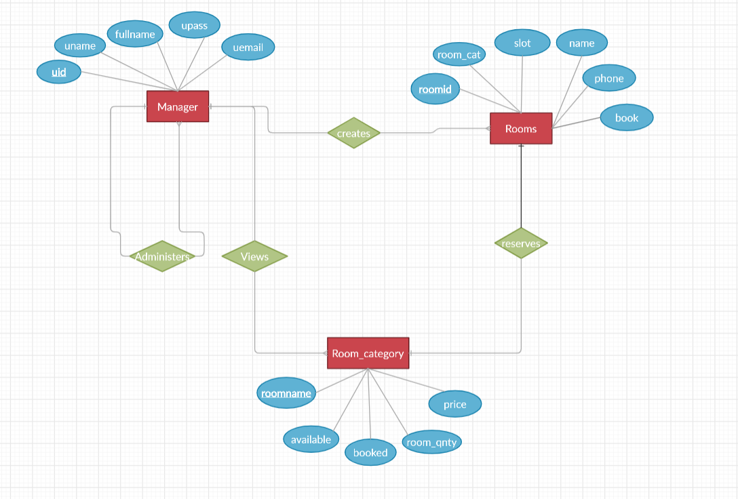

Fig:3

Final UML diagram:

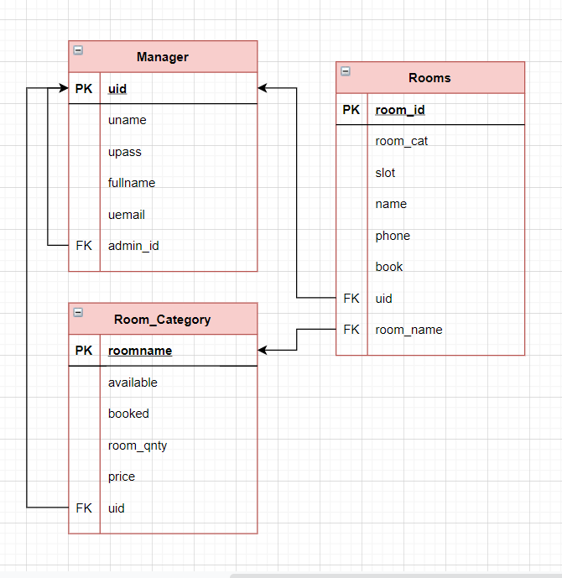

Fig:4

From my now simplified and normalized UML diagram I constructed the database `barely_alive` required using SQL. This works as the schema for the entire website.

Lastly, I helped my teammate Fardin change around some of the data in the Html and Css codes that would better suite to our website in accordance to the constructed database schema.

Finally, Rifah Shanjida and I wrote the final project proposal together too, with her working more on the text while I wrote the logic.