**Data**

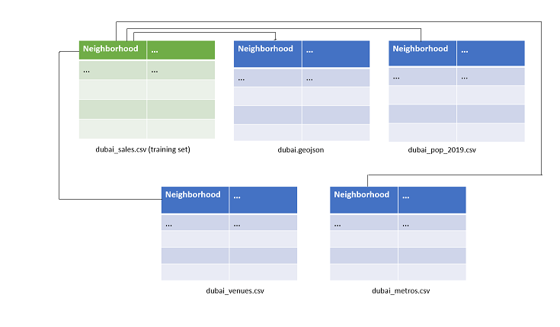

Figure 1. Data set relation diagram.

A total of five datasets were used for this

|  |  |  |  |  |
| --- | --- | --- | --- | --- |
| ***Dataset*** | ***Role*** | ***Description*** | ***Size*** | ***File format*** |
| dubai_sales | Training set | Apartment sales data |  | csv |
| dubai.geojson | Feature supplementation | Geospatial data | - | geojson |
| dubai_pop_2019 | Feature supplementation | Demographic data |  | csv |
| dubai_venues | Feature supplementation | Venues data |  | csv |
| dubai_metros | Feature supplementation | Metro stations data |  | csv |

|  |  |  |
| --- | --- | --- |
| **Inherent type** | **Data type** | **Process** |
| GPS coordinates | float | Convert to radians |
| Numerical data | float | Normalize |
| Boolean data | bool | Convert to int |
| Categorical data - Ordinal | string | OneHot encoding |
| Categorical data - Nominal | string | Label encoding |

|  |  |
| --- | --- |
| **Statistic** | **Value** |
| Skew | 6.096520 |
| Kurtosis | 47.792884 |
| Count | 1844 |
| Mean | 2107441.4446854666 |
| Standard deviation | 2949678.5712087657 |
| Min | 220000.0 |
| Max | 35000000.0 |
| 50th percentile | 1425000.0 |

|  |  |
| --- | --- |
|  | **DNN** |
| **MAE** | 619741.69 |
| **RMSE** | 1267673.33 |
| **Normalized RMSE** | 0.04 |
| **Accuracy ( 1 – MAPE )*100** | 75.86 % |