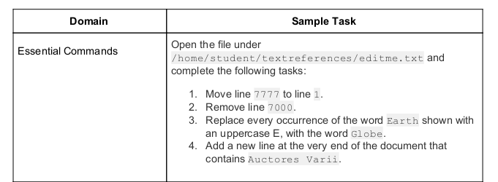
Ans;

/home/fadin
fadin@fardin:~$ mkdir student
fadin@fardin:~$ cd student
fadin@fardin:~/student$ mkdir textreferences
fadin@fardin:~/student$ cd textreferences/
fadin@fardin:~/student/textreferences$ touch editme.txt
fadin@fardin:~/student/textreferences$ vim editme.txt
fadin@fardin:~/student/textreferences$

Ans;
Install the ​ tmux​ package on your system;

fadin@fardin:~/student/textreferences$ sudo apt install tmux
[sudo] password for fadin:
Reading package lists... Done
Building dependency tree
Reading state information... Done
tmux is already the newest version (3.0a-2ubuntu0.3).
0 upgraded, 0 newly installed, 0 to remove and 198 not upgraded.
fadin@fardin:~/student/textreferences$

Ans;

fadin@fardin:~$
fadin@fardin:~$ sudo groupadd students

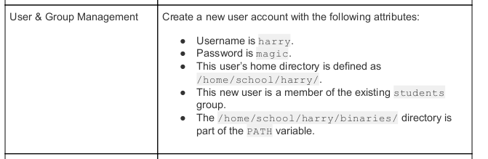

fadin@fardin:~$ sudo useradd harry
fadin@fardin:~$ sudo passwd harry
New password: magic
Retype new password: magic
passwd: password updated successfully
fadin@fardin:~$
fadin@fardin:~$ sudo usermod -a -G students harry
[sudo] password for fadin: *******
fadin@fardin:~$
fadin@fardin:~$ cd ~
fadin@fardin:~$ pwd
/home/fadin
fadin@fardin:~$ mkdir school
fadin@fardin:~$ cd school
fadin@fardin:~/school$ mkdir harry
fadin@fardin:~/school$ cd harry
fadin@fardin:~/school/harry$ ls
fadin@fardin:~/school/harry$ ls
fadin@fardin:~/school/harry$ mkdir binaries
fadin@fardin:~/school/harry$ cd binaries/
fadin@fardin:~/school/harry/binaries$

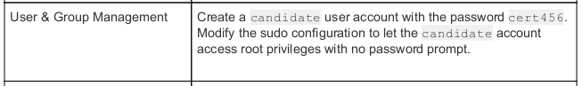

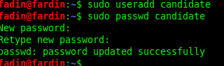
fadin@fardin:~$ sudo useradd candidate
fadin@fardin:~$ sudo passwd candidate
New password: ****** (cert456)
Retype new password: ****** (cert456)
passwd: password updated successfully
fadin@fardin:~$

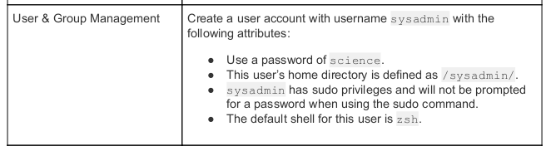

fadin@fardin:~$ sudo useradd sysadmin
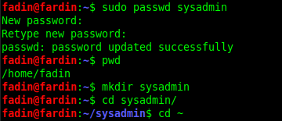
fadin@fardin:~$ sudo passwd sysadmin
New password:
Retype new password:
passwd: password updated successfully
fadin@fardin:~$
fadin@fardin:~$ pwd
/home/fadin
fadin@fardin:~$ mkdir sysadmin
fadin@fardin:~$ cd sysadmin/
fadin@fardin:~/sysadmin/$

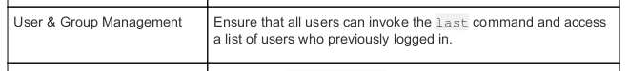

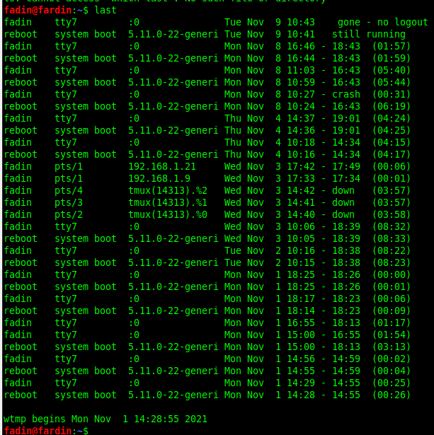
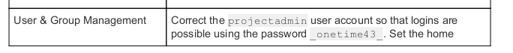

Ans:
fadin@fardin:~$ sudo useradd projectadmin
fadin@fardin:~$ sudo passwd idsahfoh
New password: _onetime43_
Retype new password: _onetime43_
passwd: password updated successfully
fadin@fardin:~$ mkdir projectadmin

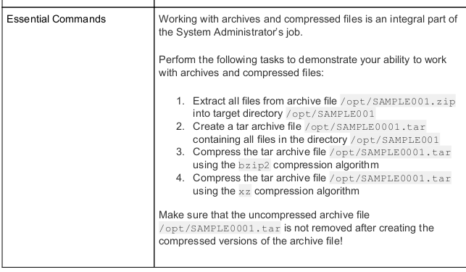
​ /opt/SAMPLE001.zip
fadin@fardin:~$ $ unzip /opt/SAMPLE001.zip

Example:
fadin@fardin:~$ pwd
/home/fadin
fadin@fardin:~$ cd Downloads/
fadin@fardin:~/Downloads$ unzip gradle-7.2-bin.zip
Archive: gradle-7.2-bin.zip
creating: gradle-7.2/
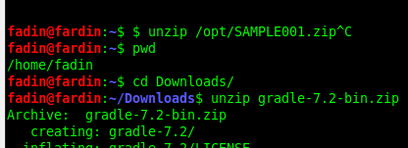
inflating: gradle-7.2/LICENSE
inflating: gradle-7.2/NOTICE
inflating: gradle-7.2/README
creating: gradle-7.2/init.d/
inflating: gradle-7.2/init.d/readme.txt
creating: gradle-7.2/bin/
inflating: gradle-7.2/bin/gradle
inflating: gradle-7.2/bin/gradle.bat
creating: gradle-7.2/lib/
fadin@fardin:~/Downloads$

**Successfully Extract all files from archive file gradle-7.2-bin.zip

Before commend : jdk-17_linux-aarch64_bin.tar.gz is zip tar gz file

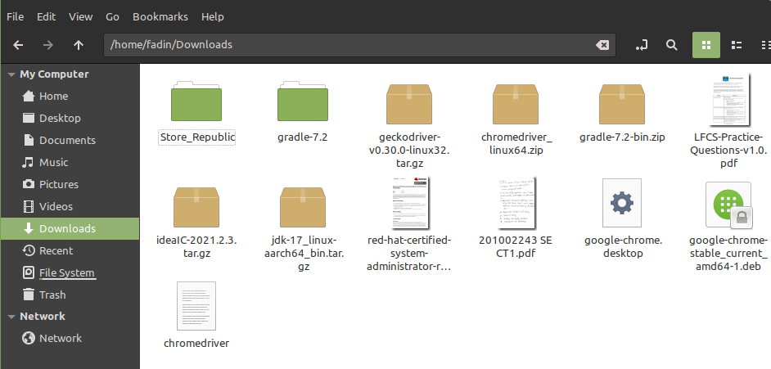

After Apply the commend :
fadin@fardin:~/Downloads$ tar -zxf jdk-17_linux-aarch64_bin.tar.gz
is successfully convert jdk-17.0.1

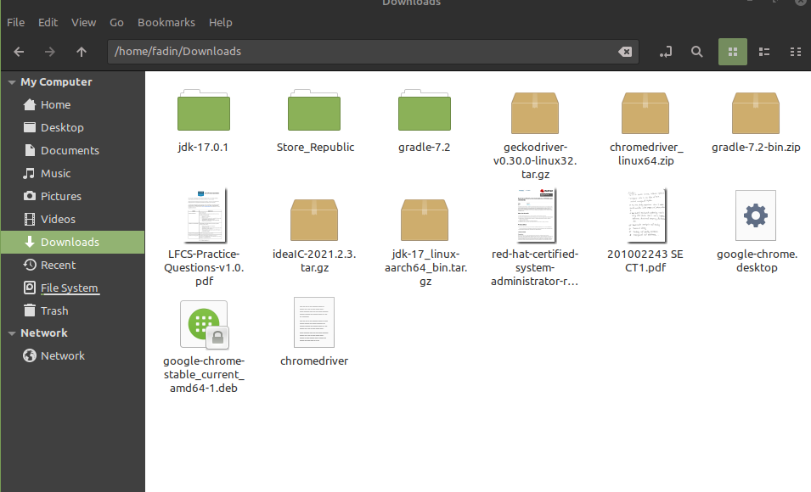
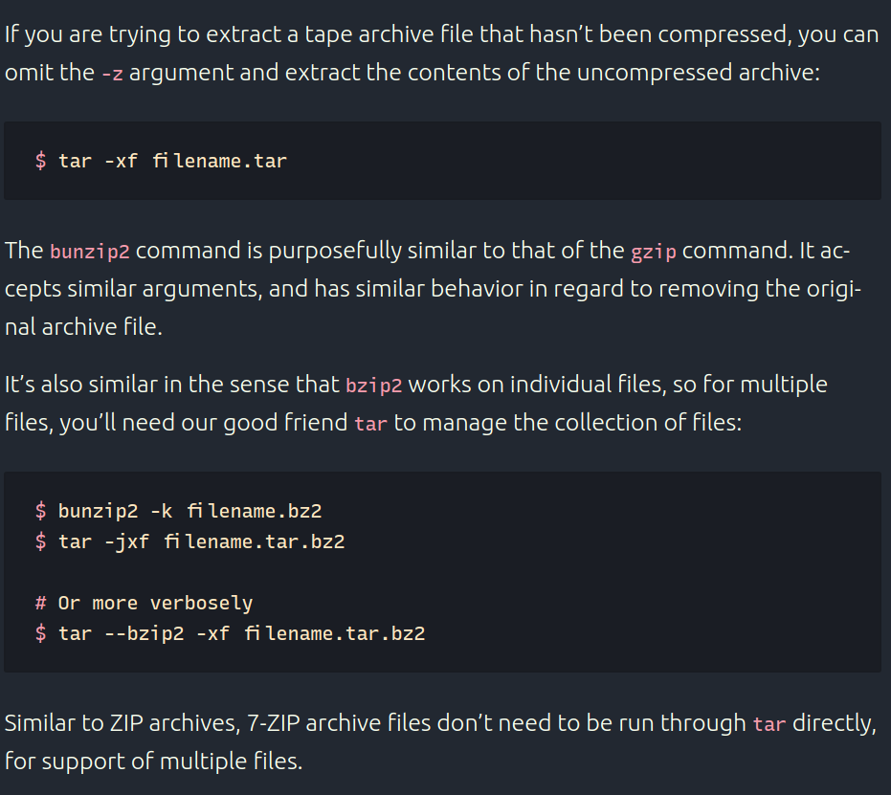
Compression Structure algorithm and method and command;

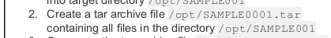

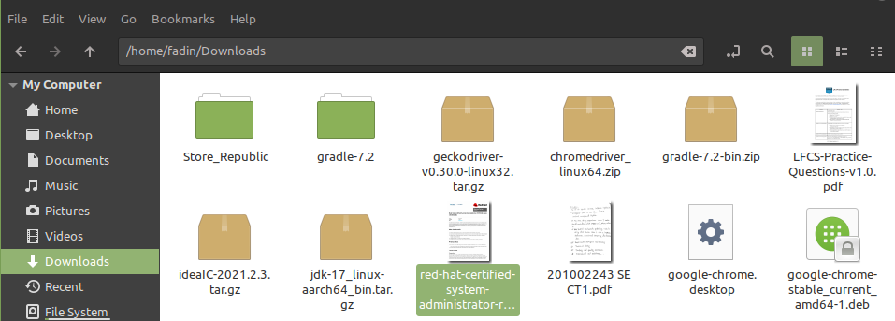
2. Create a tar archive file ​ /opt/SAMPLE0001.tar
containing all files in the directory ​ /opt/SAMPLE001

Example:
fadin@fardin:~/Downloads$ tar -cf archive.tar Store_Republic/
fadin@fardin:~/Downloads$ tar -cf store_Republic.tar Store_Republic/
fadin@fardin:~/Downloads$

Store_Republic.tar file create

