Color Board V0.9

Fardin Rastakhiz

# Introduction

Thank you for purchasing "Color Board V0.9". This asset contains a color palette and a color picker to use in your game. Also, you can change or separate code parts for your own usage.

# How to Use it

## ColorTerminal

First of all, You need to drag "ColorBoard/Prefab/ ColorBoard.prefab" into your scene, then to use it in your code you need to use "Fardin.ColorTools" namespace, then create a variable of type "ColorTerminal".

* **colorForm**
  + **RGB:** Get red, green, blue color, must not to change (type Color)
  + **Alpha:** Get alpha, must not to change (type float)
  + **HSB:** Get hue, saturation and brightness, must not to change (type ColorHSB*)
  + **HexColor:** Get hex color, must not to change (type string)
  + **Initialize:** Initialize "colorForm" parameters with parameter of type "Color"
* **changedColor:** the event that executes all registered handler for any change in color

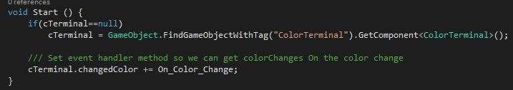

Figure 1: Adding event handler method for color board to the event list

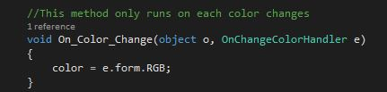

Figure 2: Creating event handler method for color board, you can put your own implementations

* **SetColorForm:** Any color changes outside color board should submitted by this method
* **methodRegistered:** Test if "changedColor" event contains a handler method

## ColorPick

"ColorBoard/Prefab/ ColorPick.prefab" contains a button that can be used easily. You just need to use "Fardin.ColorTools" namespace, then create a variable of type "ColorPick". There is an event that is raised anytime you picking a color.

* **OnPickColor:** the event that executes all related method on any color change that registered

For using the information distributed by "OnPickColor" event you just need to create a method with your out implementations in it and add it to that event:

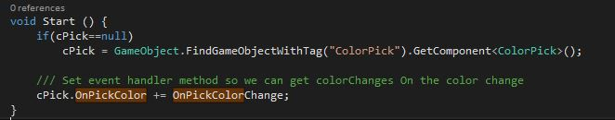

Figure 3: Adding event handler method for color board to the event list

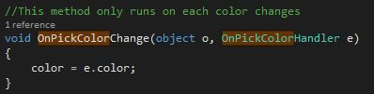

Figure 4: Creating event handler method for color board, you can put your own implementations

# Samples

From directory "ColorBoard/Scene" you can find two sample scenes for tools usage. The corresponding sample scripts are in "ColorBoard/TestScript"

# Contact Info

* **Email:** [fardin.uasset@gmail.com](mailto:fardin.uasset@gmail.com)
* **Telegram:** <https://t.me/FardinRastakhiz>
* **Linked-in:** <https://www.linkedin.com/in/fardin-rastakhiz-499770144>