**Entropy in decision tree, how it works**

What is a Decision Tree?

Ans: A decision tree is a sort of probability tree that may be used to choose a process. For example, you may decide whether to manufacture item A or item B, or whether to invest in option 1, option 2, or option 3. Trees are a great method to cope with these sorts of complicated decisions, which typically include a lot of variables and are frequently fraught with ambiguity. Although they may be created by hand, the software is frequently utilized since trees can quickly grow complicated.

In a tree, there are three main areas:

**How Entropy works in decision tree:**

entropy helps us to build an appropriate decision tree for selecting the best splitter. Entropy can be defined as a measure of the purity of the sub split. Entropy always lies between 0 to 1. The entropy of any split can be calculated by this formula

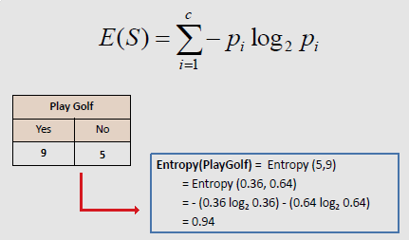

**Information gain in the decision tree**

**Information Gain use in decision tree:**

Information gain can be used as a split criterion in most modern implementations of decision trees, such as the implementation of the Classification and Regression Tree (CART) algorithm in the scikit-learn Python machine learning library in the Decision Tree Classifier class for classification.

