**Iris-Classification**

**Introduction:**

Understanding gathered through data training with Machine Learning (ML) algorithms has given us a new depth of knowledge in this time of Artificial Intelligence (AI). We can now forecast numerous outcomes respect to data training and model creation. This effort highlights how far science and technology have progressed and how much they affect everything.

Iris-Classification by using ML is a very popular dataset. The Iris flower data set is a multivariate data set that was first published in 1936 by British statistician and biologist Ronald Fisher as an example of linear discriminant analysis in his paper. The dataset is often used in data mining, classification and clustering examples and to test different algorithms.

**The Data**

The set of attributes that I am working with are, ID, SepalLength, SepalWidth, PetalLength, PetalWidth and the class attribute that we are trying to predict is Species.

The datasets which I have chosen from Kaggle had 150 instances among which I have split the data for train and test. 120 instances have been taken for train and 6 instances was taken for the test.

At first, I have imported the data as a CSV filed, went to the filter option, then on to unsupervised. Thus, this gave us a solid prepared file that we could use whenever we needed to. The same was done for the test data it was prepared the same way.

**The Procedure:**

**Training:**

* First opened the weka 3.8 and selected the explore option
* Then clicked on open filed section and choose the training data CSV file and imported it.
* Then selected the classify tab and choose different algorithms and ran the training
* After the training the results were interpreted.

**Testing:**

* Again, on classify tab imported the test data by selecting run test data and inside that selected the open file option, selected the test CSV file
* Ran that upon the created model
* Lastly, took the results and compared them.

**The Results:**

By looking at the **Confusion Matrix** it can be said that there is no error and the result came out 100% accurate.

*All these results are shown below:*

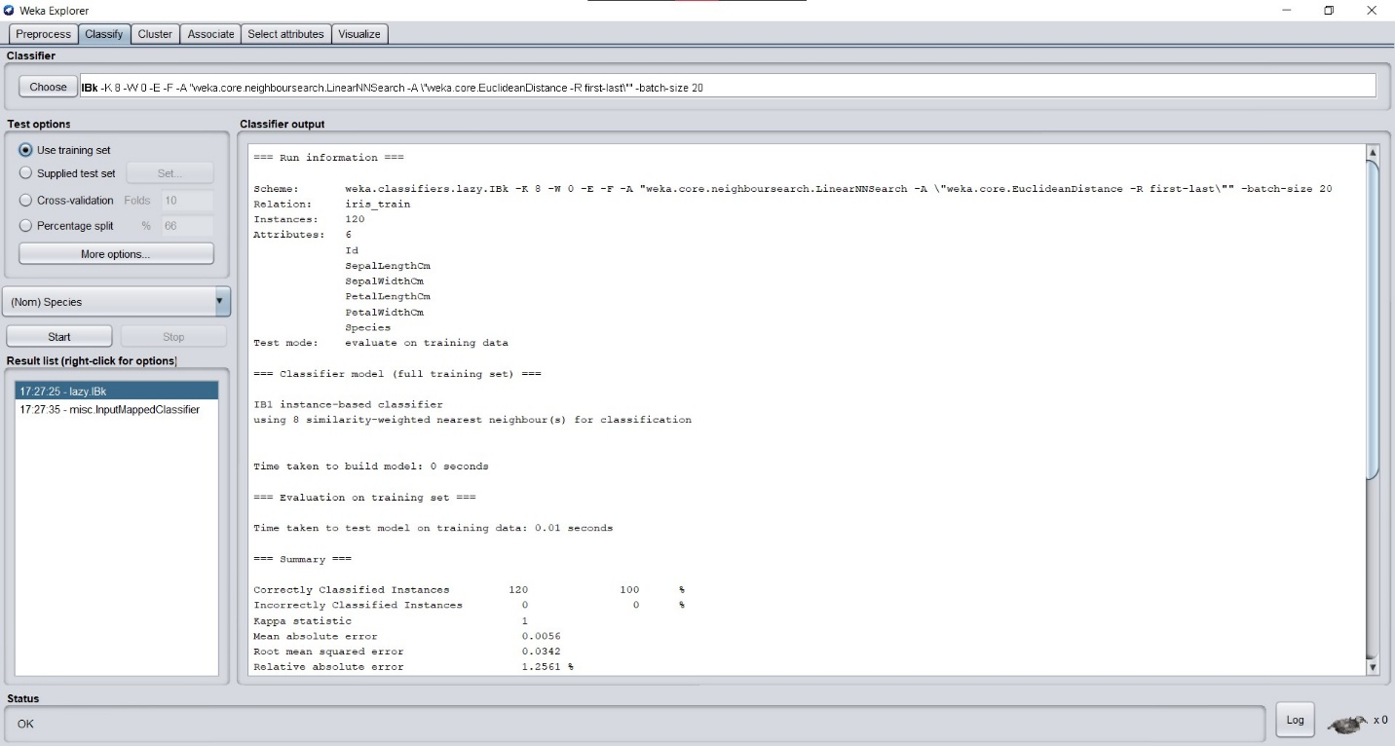

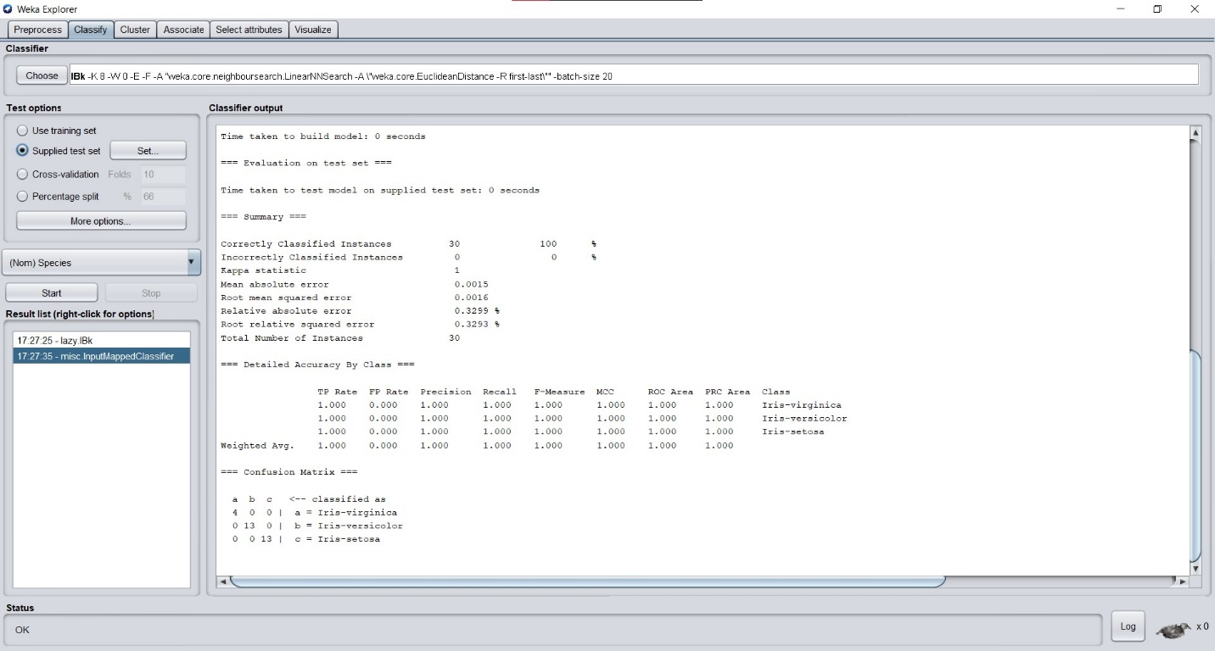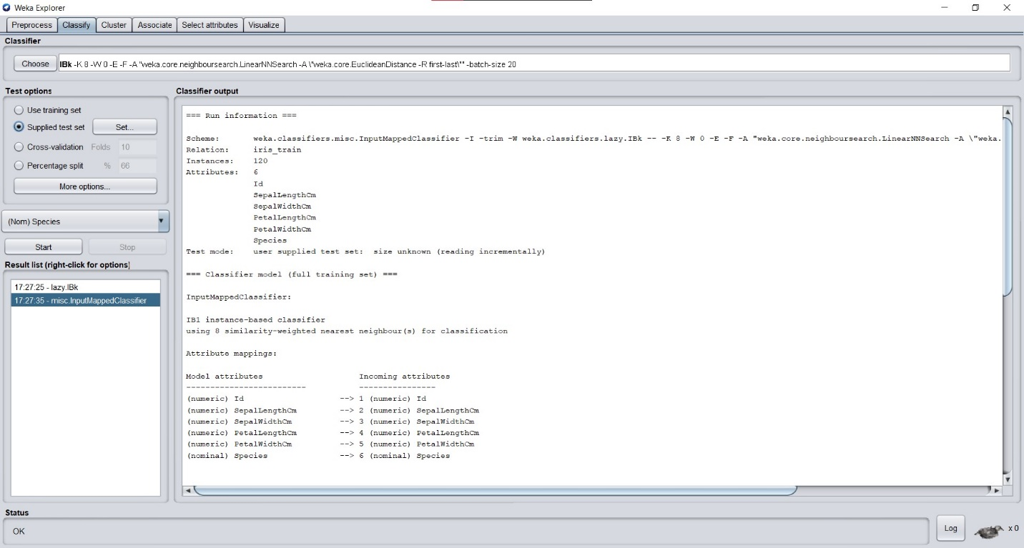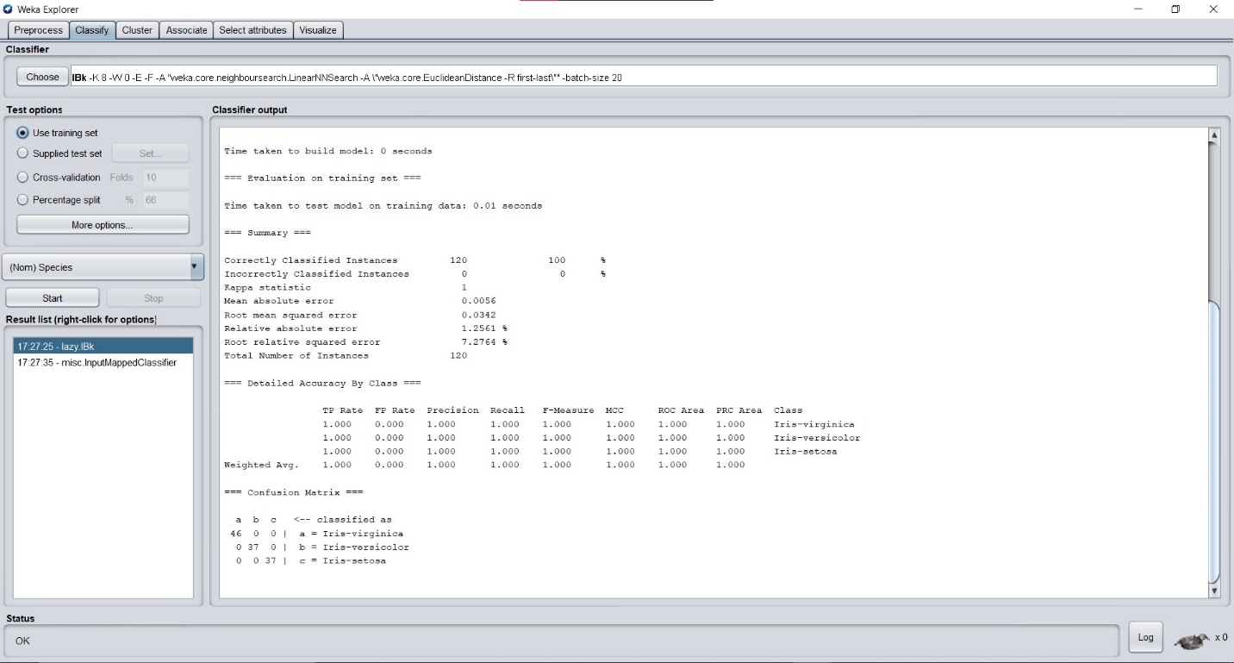

**Conclusion:**

By looking at all the outcomes, it can be conducted that new flowers can be classified which belong to the classes Setosa, Versicolor and Virginia by using Iris dataset and by applying various data analysis techniques. Thus, data mining has blessed us with the power to identify new species which is around our environment.