# Workout Master using local Storage

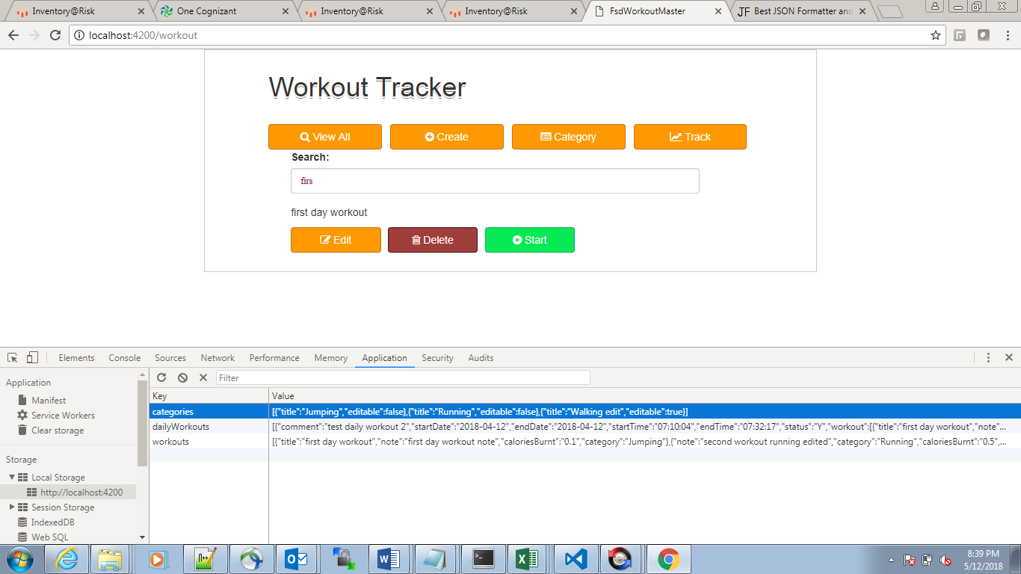

# Create Workout

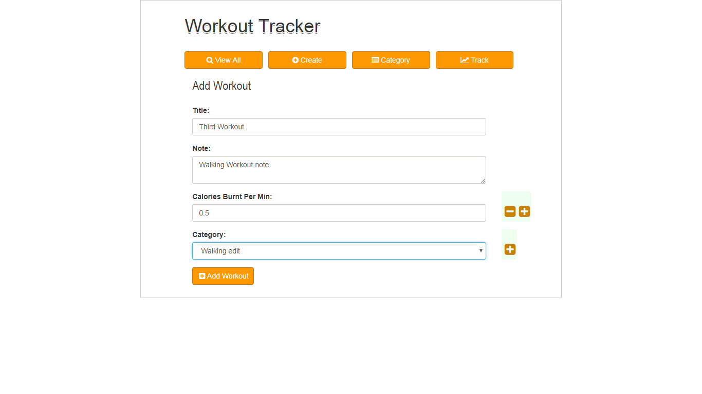

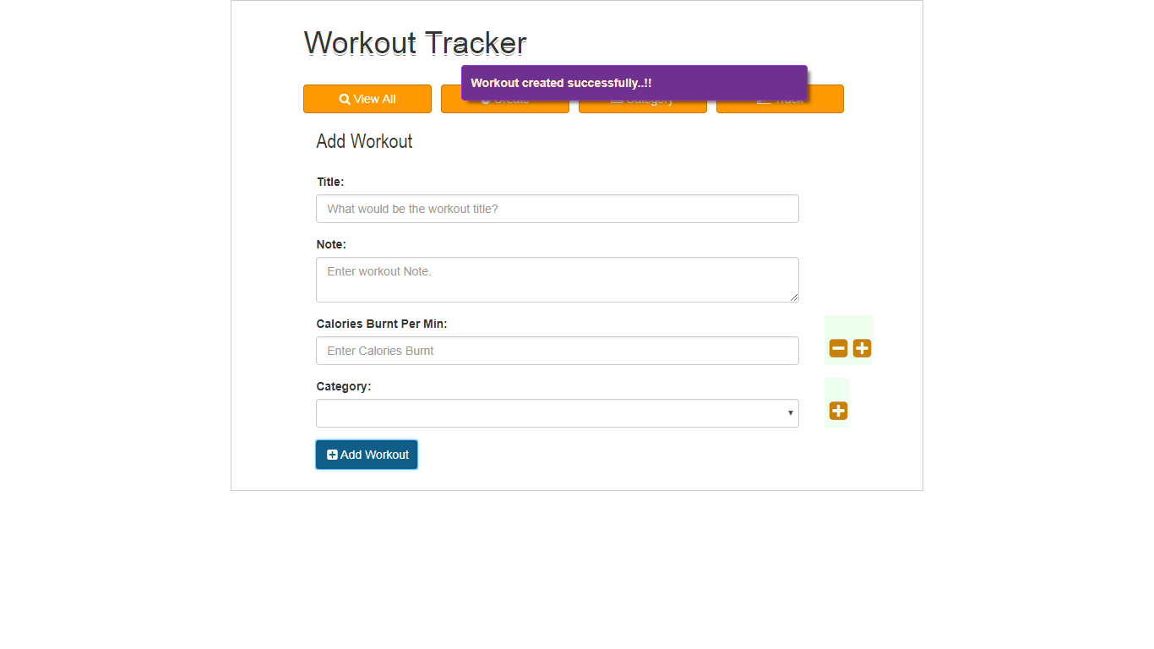

# Edit Workout

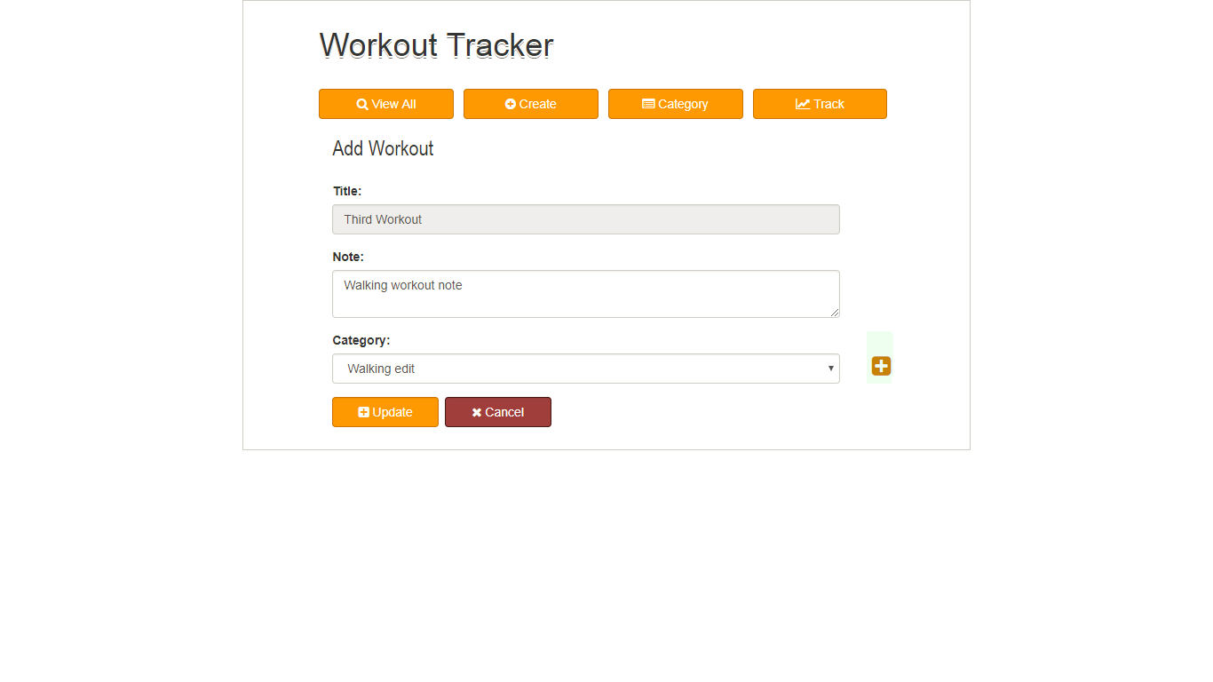

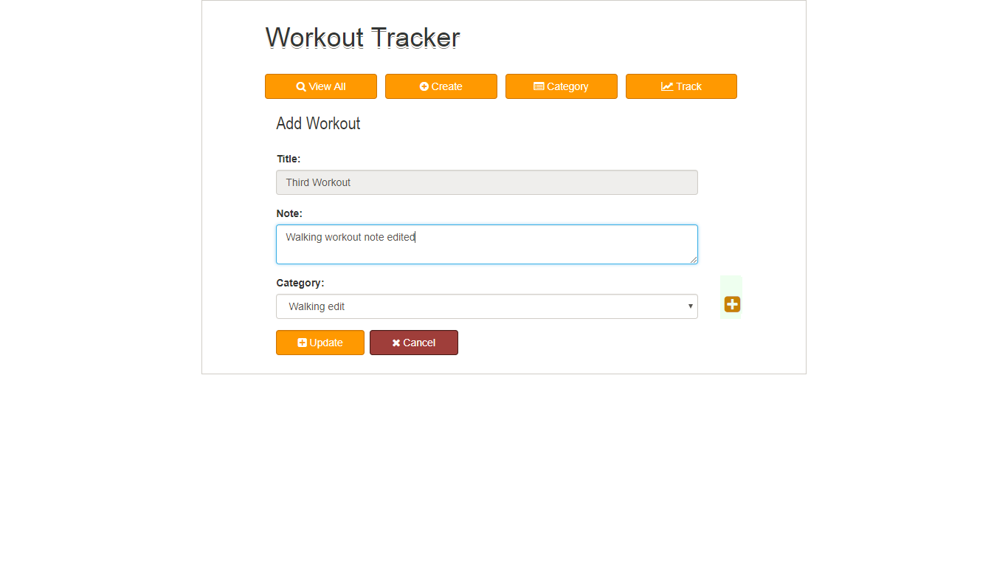

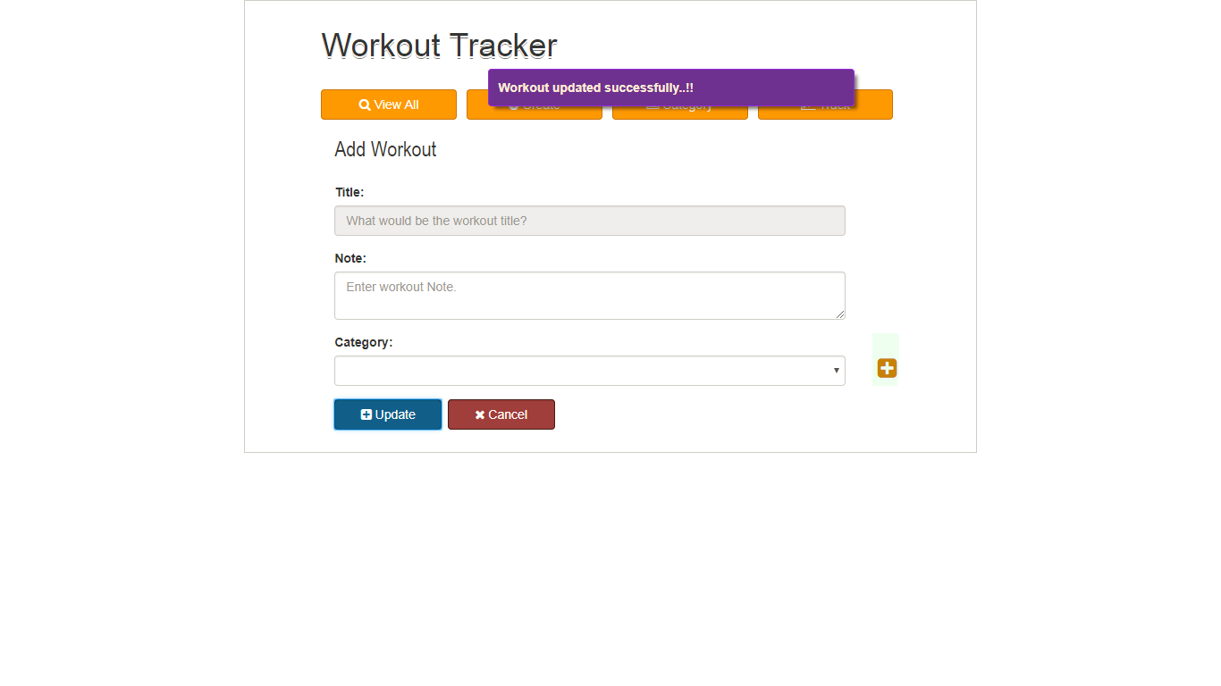

# View Workout

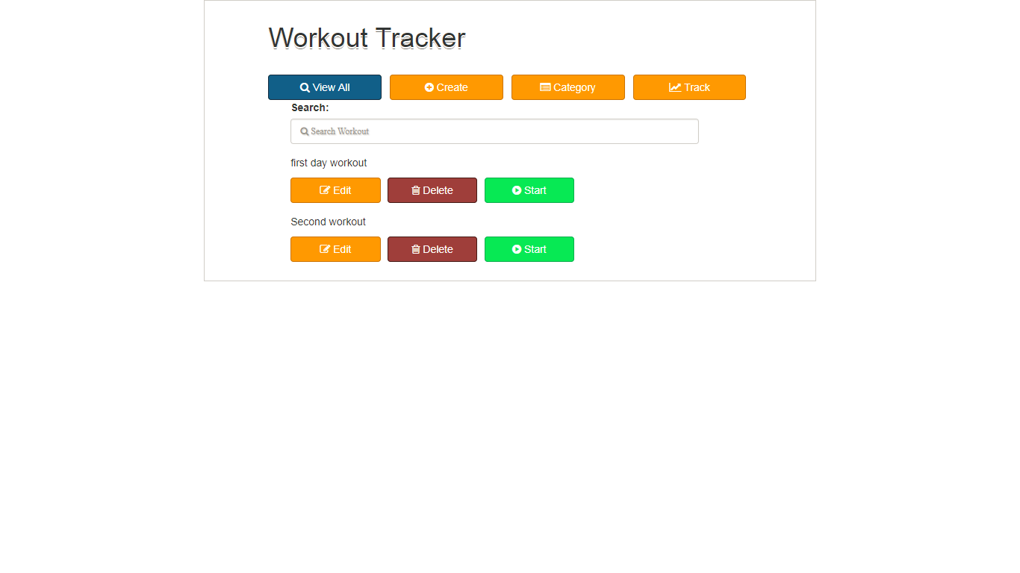

# Search Workout

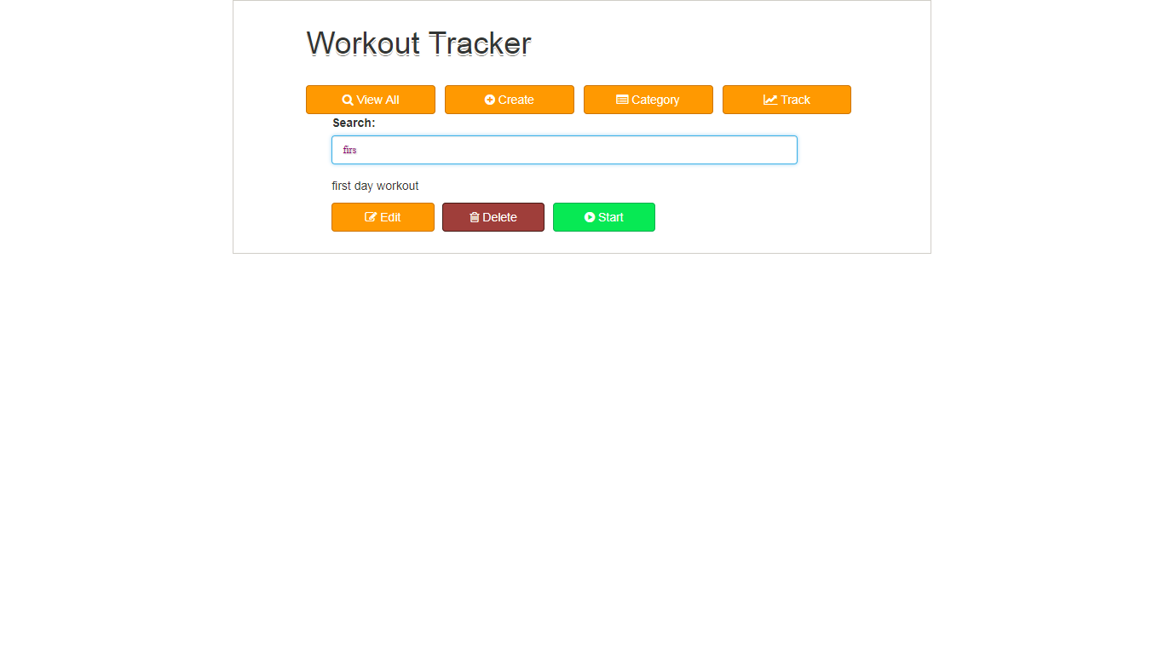

# Delete Workout

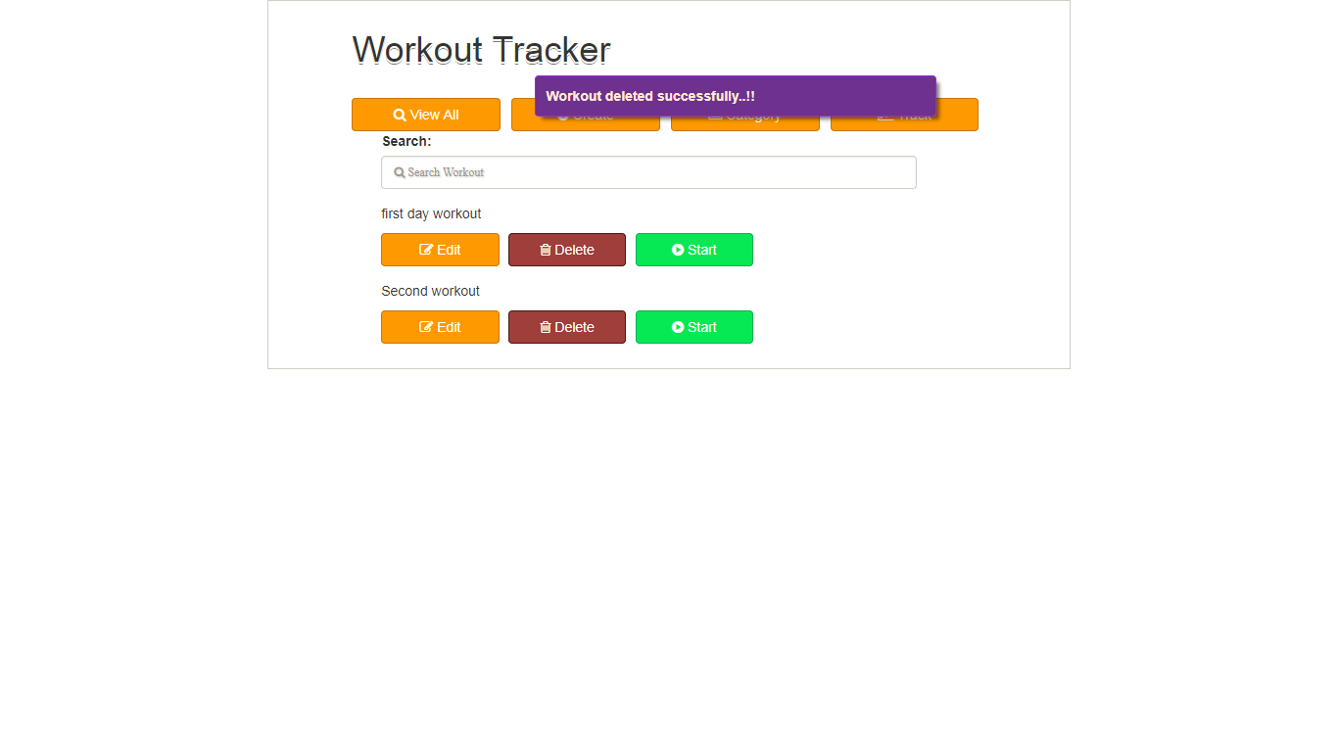

# Daily Workout

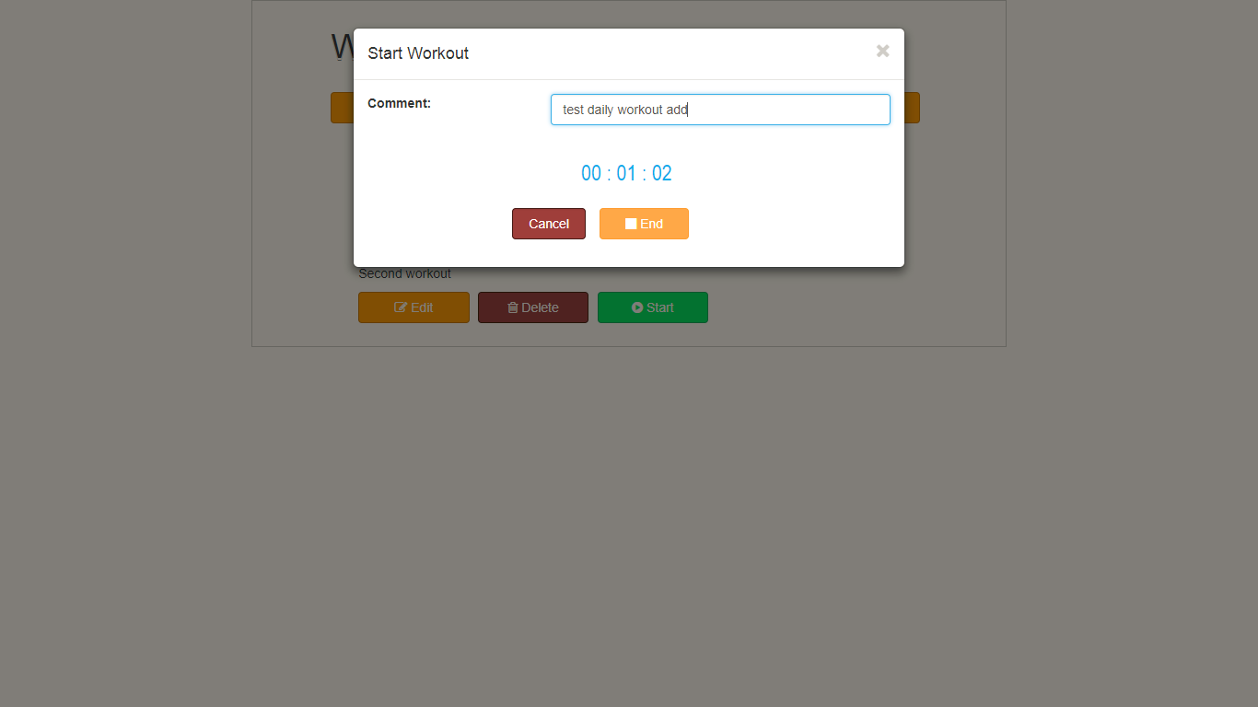

# View Category

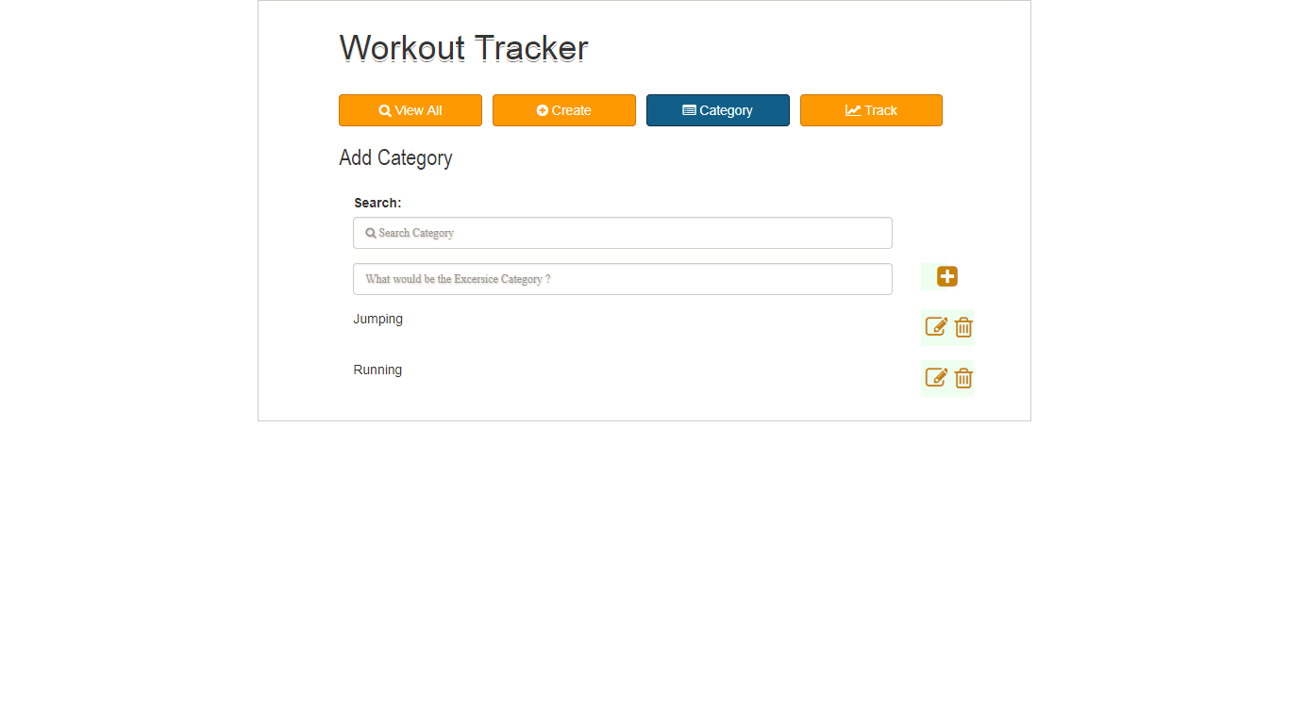

# Add Category

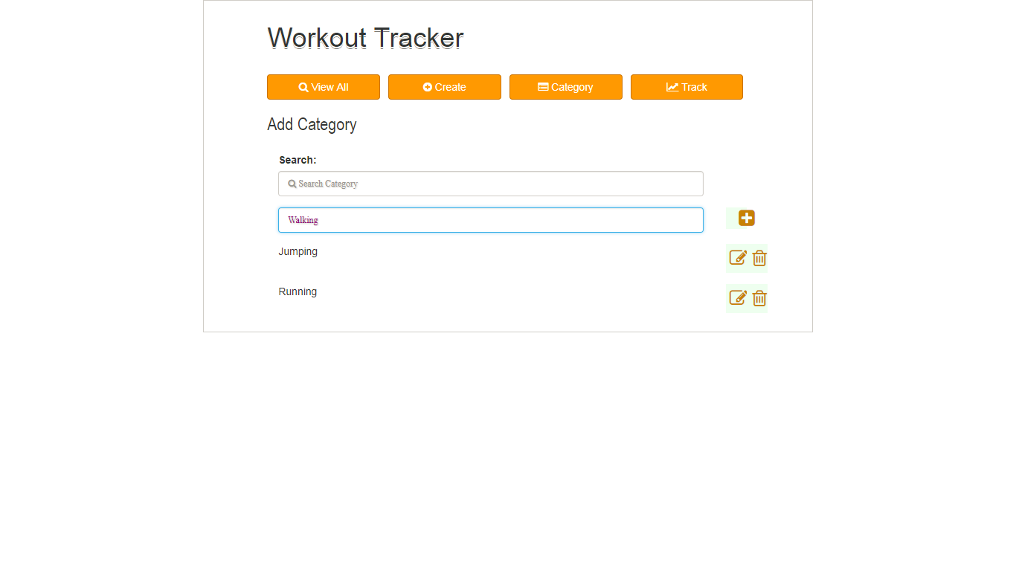

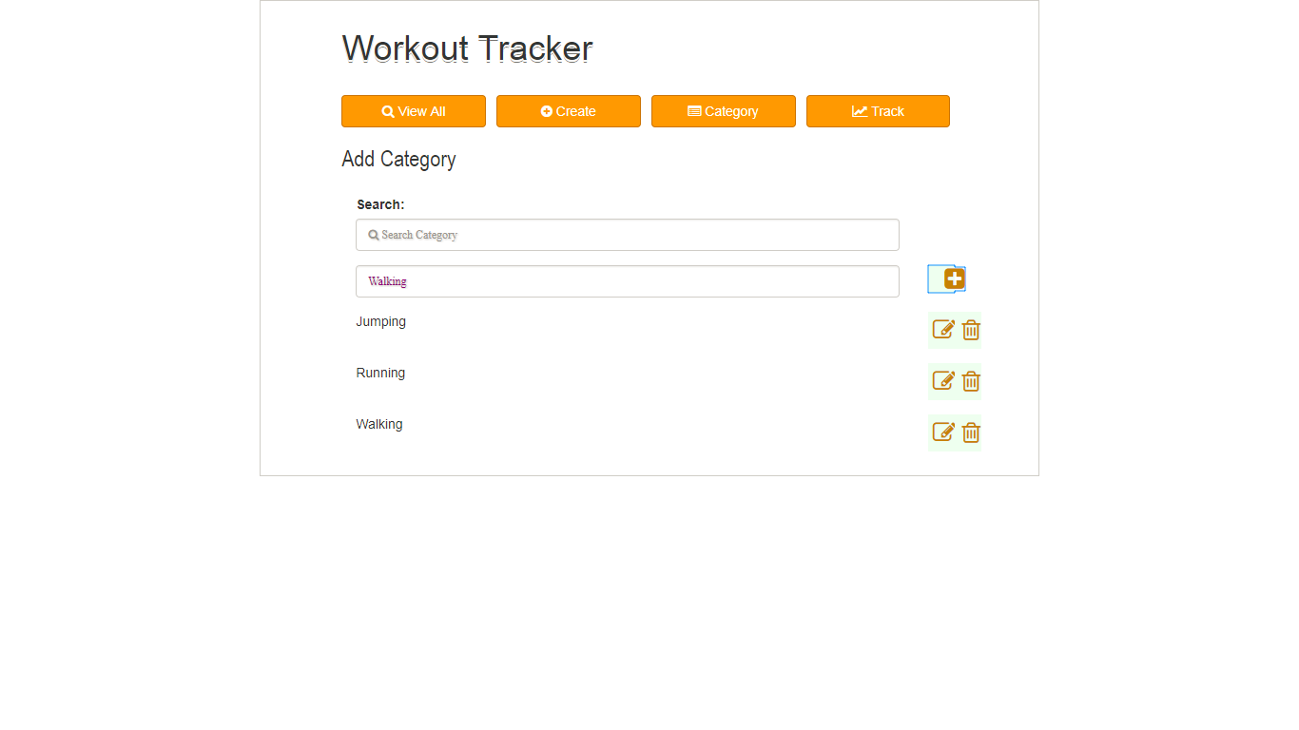

# Edit Category

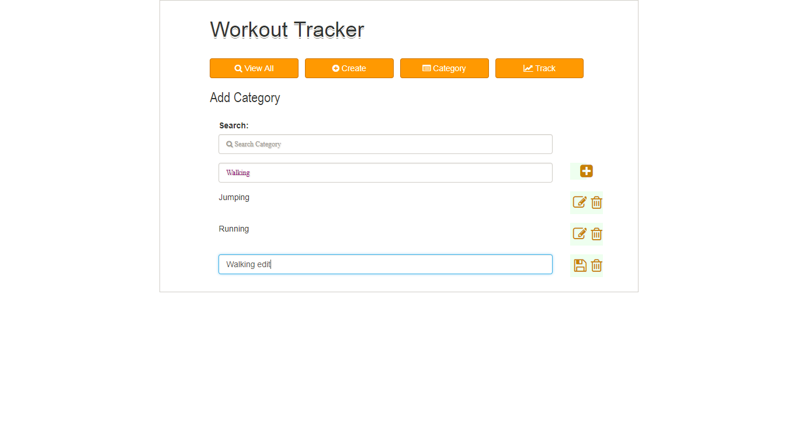

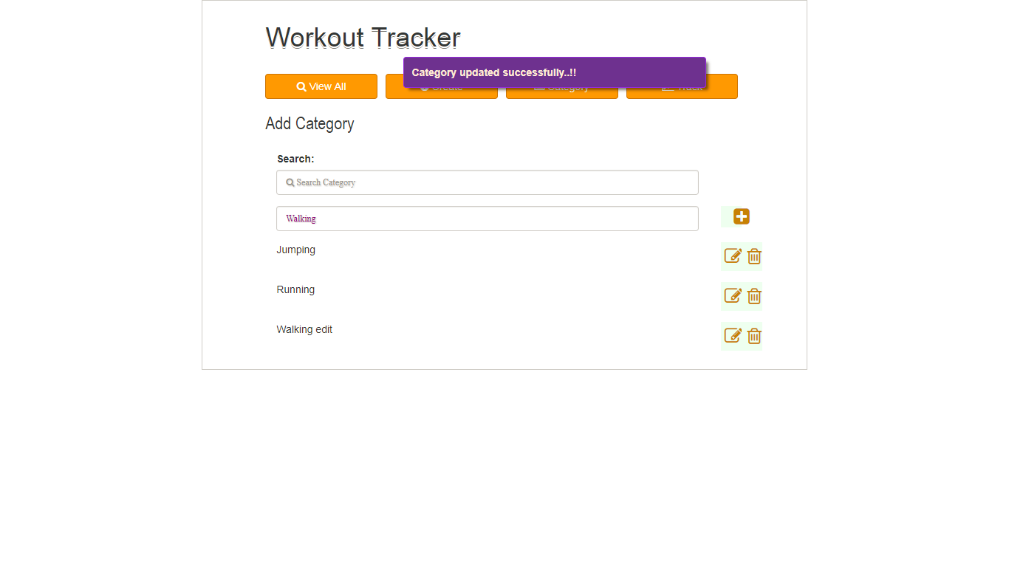

# Search Category

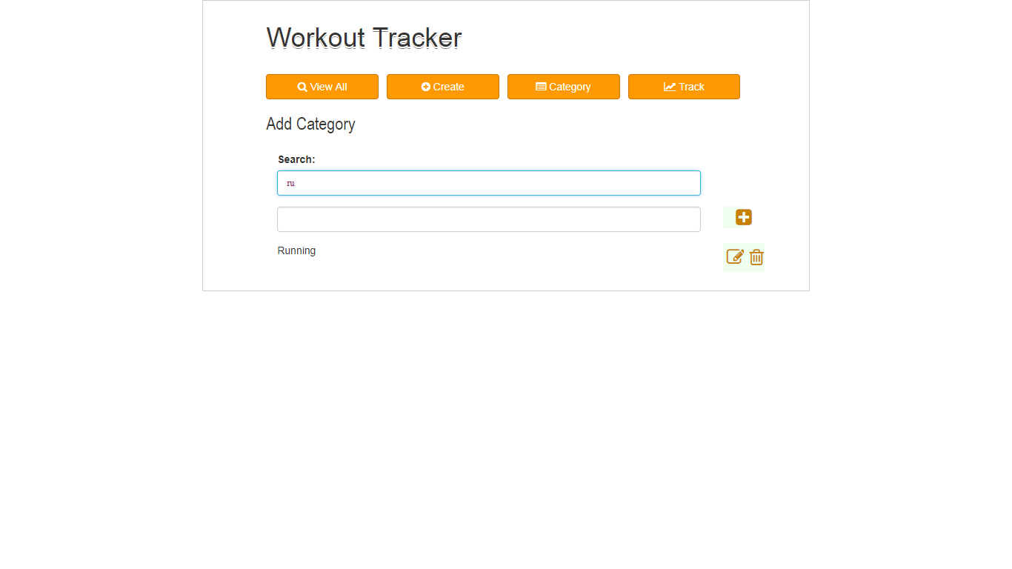

# Delete Category

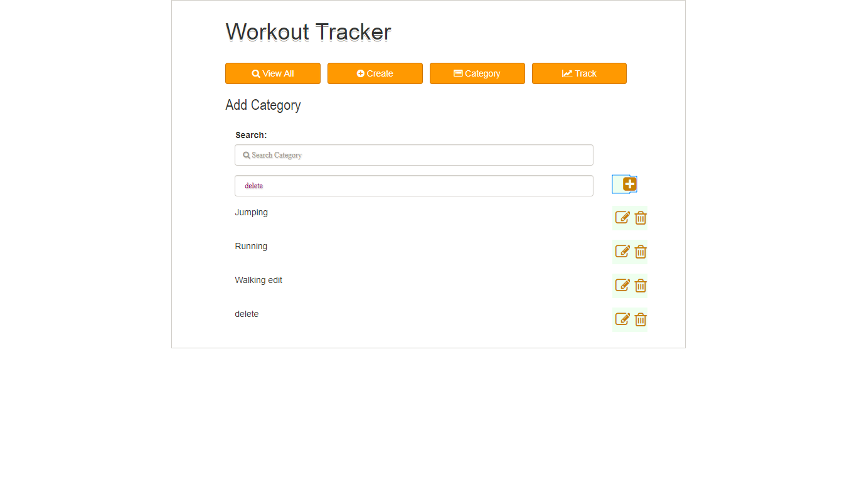

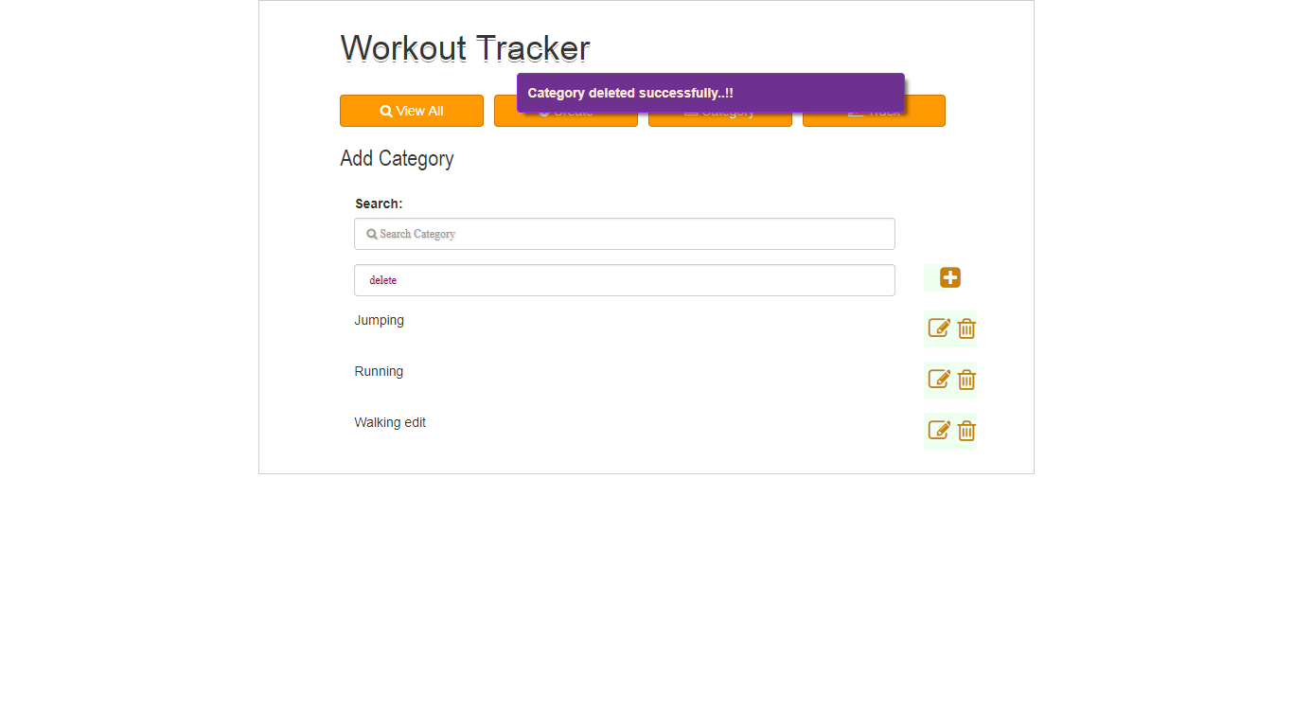

# Track Workout

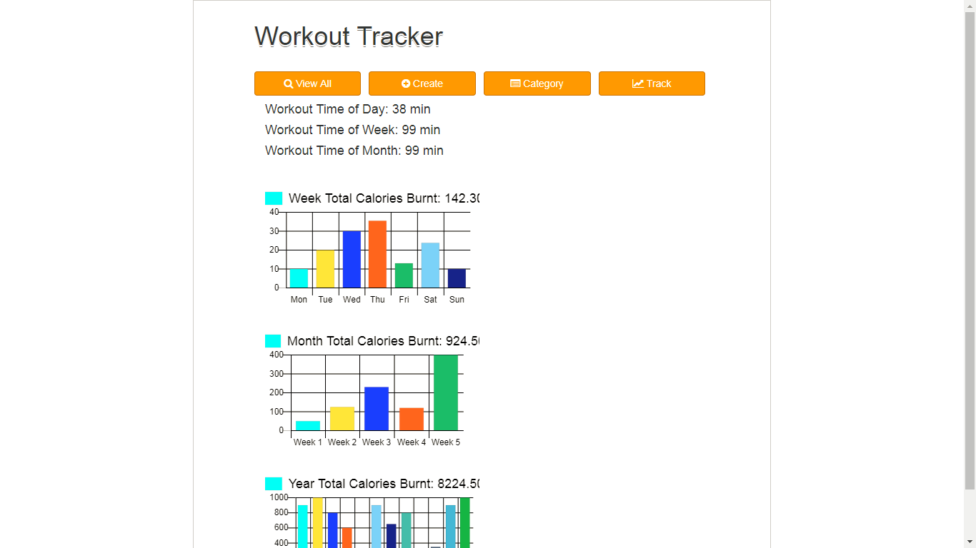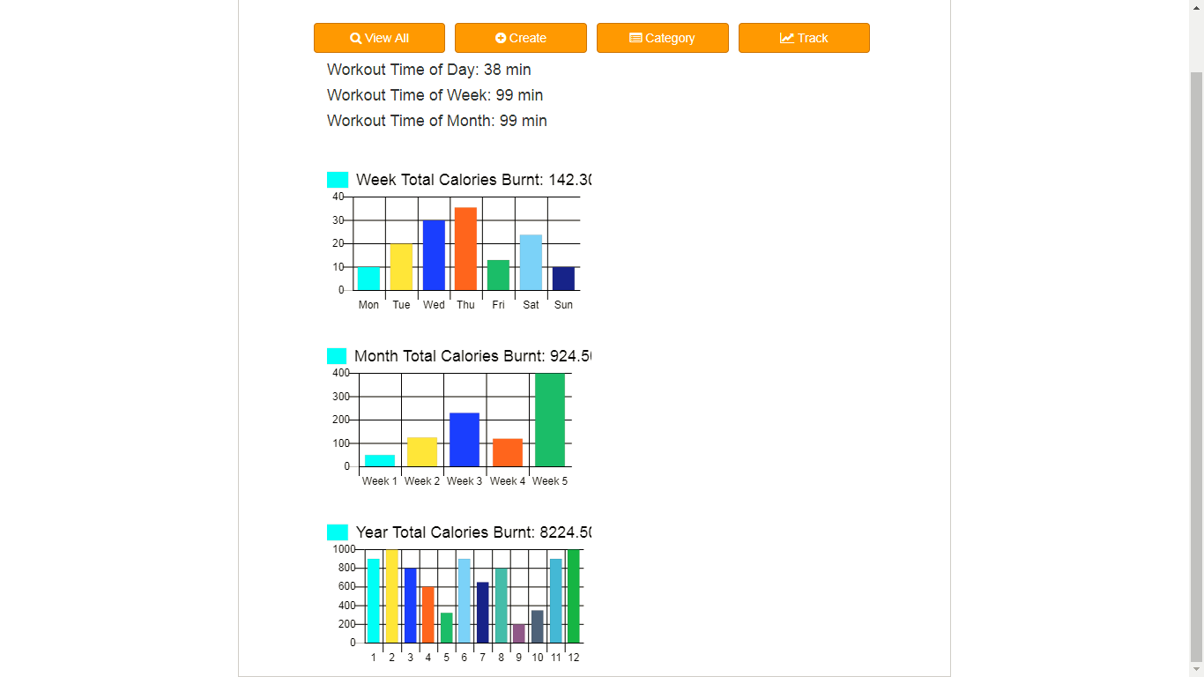

# Test Data:

## dailyWorkouts

[{"comment":"test daily workout 2","startDate":"2018-04-12","endDate":"2018-04-12","startTime":"07:10:04","endTime":"07:32:17","status":"Y","workout":[{"title":"first day workout","note":"first day workout note","caloriesBurnt":"0.1","category":"Jumping"}],"workoutId":0,"dailyWorkoutId":0},{"comment":"test daily workout 3","startDate":"2018-05-11","endDate":"2018-05-11","startTime":"07:04:04","endTime":"07:34:50","status":"Y","workout":[{"title":"first day workout","note":"first day workout note","caloriesBurnt":"0.1","category":"Jumping"}],"workoutId":0,"dailyWorkoutId":0},{"comment":"second workout daily test","startDate":"2018-05-10","endDate":"2018-05-10","startTime":"07:01:52","endTime":"07:32:10","status":"Y","workout":[{"note":"second workout running edited","category":"Running","caloriesBurnt":"0.5","title":"Second workout"}],"workoutId":1,"dailyWorkoutId":1},{"comment":"daily workout 4","startDate":"2018-05-12","endDate":"2018-05-12","startTime":"07:04:50","endTime":"07:42:58","status":"Y","workout":[{"title":"first day workout","note":"first day workout note","caloriesBurnt":"0.1","category":"Jumping"}],"workoutId":0,"dailyWorkoutId":0},{"comment":"test daily workout add","startDate":"2018-05-12","endDate":"2018-05-12","startTime":"08:31:03","endTime":"08:32:26","status":"Y","workout":[{"title":"first day workout","note":"first day workout note","caloriesBurnt":"0.1","category":"Jumping"}],"workoutId":0,"dailyWorkoutId":0}]

## Categories

[{"title":"Jumping","editable":false},{"title":"Running","editable":false},{"title":"Walking edit","editable":true}]

## Workouts

[{"title":"first day workout","note":"first day workout note","caloriesBurnt":"0.1","category":"Jumping"},{"note":"second workout running edited","category":"Running","caloriesBurnt":"0.5","title":"Second workout"}]