**Reflection**

1. Our app aims to comply with as many accessibility requirements as possible. A good set of standards is defined by WCAG (Web Content Accessibility Guidelines) 2.0 Standard. This includes the font sizes and color contrast between text and background and different elements. In general a contrast ratio of 3 to 1 is considered perceivable by users. Font size should be 16px or larger. We welcome larger font sizes as it is estimated that most, if not all our users will be using our app on a mobile device, which tend to have smaller screen sizes. Font weights should be used to convey a level of importance. Since several interviewees cited ease-of-use as a primary contributing factor to using kiosks, accessibility is important to ensure ease-of-use for all potential users.
2. Our app requires the use of limited internet, it could also be a local connection from the kiosk or the establishment itself - many locations with touchscreen kiosks also provide Wifi. Our app does not require the transfer of audio or video over the internet which tends to take up more bandwidth, our app essentially will be more of a web app that users can fill out to make orders or fill forms as needed. This also eliminates the need for users to take up space on their device by downloading an app. Especially in the infancy from the release of our product, we want to make sure that our service is accessible to as many people as possible. Browsers have longevity across most platforms and we find it to be the best use for our app. The majority of people surveyed agreed that the service provided should be contact-less and that they also have access to mobile data apart from the building's Wi-Fi.
3. In order to be able to reach as many people as possible, our app should be able to translate content into different languages. This should be possible because of the variety of services available. This can be done by a service such as Translational AI by Google or IBM’s Watson Language translator. Canadian demographics indicate that the majority of people in shopping centers are more proficient in another language besides English, having multiple languages available in the service would provide a more seamless experience.

**Conceptual Sketches**

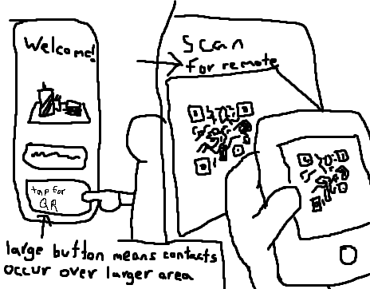

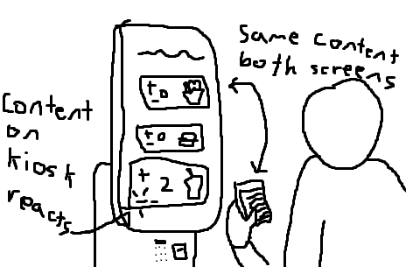

**Functionality**

1. Since time-efficiency was cited as an important factor by nearly every interviewee, the solution should require very little input on startup (not counting first time setup) to connect to the kiosk. Something as minimal as opening their camera app to open a QR code/scanner and have users redirected to our site should suffice - users should not have to login or go through heavy dialog every time they want to connect. Kiosks should be able to connect to one device at a time in order to eliminate confusion. The results displayed on the kiosk should be synced with the input on the device. If a form is being filled out with private information, this will either be obscured or not displayed altogether on the kiosk itself.
2. As some interviewees have pointed out, the flat surface of a touchscreen interface reduces surface area and reduces the risk of mechanical components wearing down through regular use. As such, any buttons or interface elements used in the process of connecting the solution to the kiosk(s) should be virtual, not physical (i.e. a UI element within a process running on the touchscreen itself, and not a mechanical button/switch/etc).
3. Some interviewed users mentioned that kiosk usage is more attractive if the kiosk is located at an establishment that they frequent. Any processes that allow for orders (or inputs) to be saved and repeated, while not necessary, could be a highly useful feature for power users. In order to avoid confusing casual users with extra options (some interviewees have expressed concerns about potential learning curves), it might be wise to have this feature hidden somewhere unobtrusive if implemented.
4. Any solution implemented should be a potential option, and not mandatory, to avoid becoming an obstacle for use instead of being a useful tool. Due to the digital divide, not every potential user may have the means to own a mobile phone (especially in public places like hospitals or transit systems), and in some cases those who have mobile phones may simply have run out of charge (while supplying a physical connection for such a case may be possible, this would present additional costs, and may present an additional security risk).

**Scenarios**

Persona 1 - Primary stakeholder (Terrance):

* Age 63
* Works as an accountant
* Children are in their 30s
* Has a new smartphone as a gift from his son
* Still getting used to a smartphone
* Wears glasses

1. Terrance is coming home from work and would like to pick up something to eat from Tim Hortons. The drive thru appears to be full so he decides to go inside instead, where all the employees are busy making food.
2. Terrance sees an order here sign and moves to the kiosk where he is asked to scan a QR code, by opening his camera app.
3. Terrance, being technologically challenged, asks another customer to help him find the camera app on his phone.
4. The customer shows Terrance his camera app and he then clicks on the link given to him, redirecting him to a site where he can order.
5. As Terrance scrolls through, whatever he adds to his order appears on the kiosk in front of him, and when he removes an item it removes it from the kiosk. The amount he owes is also displayed on the kiosk.
6. Once Terrance finishes making his order he has to pay, but he is unsure how to pay online, an option comes for him to pay at the counter. He selects this option and a receipt prints out with his order number and the kiosk disconnects, but Terrance still has access to a read only version of his order on his phone.
7. Terrance hands the receipt to the employee at the register and pays with his credit card, as he is used to. He then waits and collects his order.
8. While Terrance did not make full use of the app’s capabilities, he used what he was able to, in order to make the process as easy for him as possible. He is confident that he can repeat the process without someone else’s assistance next time.

Persona 2 - Primary stakeholder (Michael):

* Age 22
* Works in retail
* Single
* Is handicap
* Is experienced with a smartphone

1. Michael needs to purchase groceries at Wal-Mart. He enters the store using his wheelchair and places his items in his basket. It is difficult for him to reach the counter and the aisles are too narrow so he decides to use the self check-out.
2. He moves to the self checkout area and scans the kiosk's QR code using his mobile phone, this allows him to connect to Wal-Mart’s wi-fi and directs him to the check-out page for the station he is located at.
3. As he scans his items by placing the items on the scanner, the items and total are displayed on his device and on the kiosk’s checkout screen.
4. The payment options are then shown on his device and he chooses to pay with Apple pay on his device instead of manually entering his credit card information.
5. He is prompted with the option to download the receipt as an image, which he does. Then he places his items back in his wheelchair basket and goes home.