1. Database and Table Creation

**SQL Command:**

CREATE DATABASE library_db;  
  
USE library_db;  
  
CREATE TABLE books (  
 book_id INT AUTO_INCREMENT PRIMARY KEY,  
 title VARCHAR(255) NOT NULL,  
 author VARCHAR(255) NOT NULL,  
 borrowed_date DATE NOT NULL  
);

# 2. Data Entry

# SQL Command:

INSERT INTO books (title, author, borrowed_date)  
VALUES   
('To Kill a Mockingbird', 'Harper Lee', '2024-01-01'),  
('1984', 'George Orwell', '2024-02-15'),  
('The Great Gatsby', 'F. Scott Fitzgerald', '2024-03-10'),  
('Moby Dick', 'Herman Melville', '2024-04-20'),  
('Pride and Prejudice', 'Jane Austen', '2024-05-05');

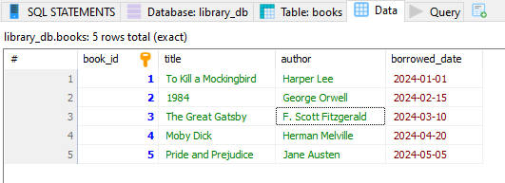

# 3. Basic Queries

## a) List All Books

**SQL Command:**

SELECT * FROM books;

## Screenshot:

[Insert Screenshot showing the list of all books]

## b) Find Books by a Specific Author

Example: Finding books by *George Orwell*.

**SQL Command:**

sql

Copy code

SELECT * FROM books  
WHERE author = 'George Orwell';

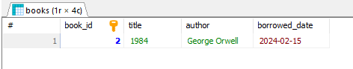

## c) Find Books Borrowed on a Specific Date

Example: Borrowed on *2024-03-10*.

**SQL Command:**

SELECT * FROM books  
WHERE borrowed_date = '2024-03-10';

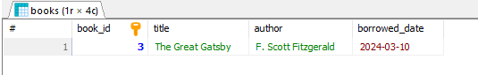

#### **d) Find Books Borrowed After a Certain Date**

Example: After *2024-02-01*.

**SQL Command:**

SELECT * FROM books  
WHERE borrowed_date > '2024-02-01';

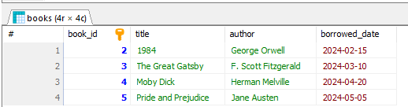

### **4. Data Manipulation**

#### **a) Update Borrowed Date**

Example: Update the borrowed_date of *1984* to *2024-06-01*.

**SQL Command:**

UPDATE books  
SET borrowed_date = '2024-06-01'  
WHERE title = '1984';

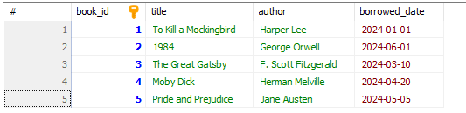

#### **b) Delete a Book**

Example: Delete *Moby Dick*.

**SQL Command:**

DELETE FROM books  
WHERE title = 'Moby Dick';

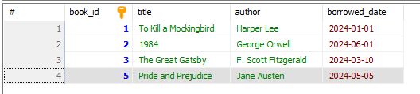

#### **c) Re-add Deleted Book**

Example: Re-insert *Moby Dick*.

**SQL Command:**

INSERT INTO books (title, author, borrowed_date)  
VALUES ('Moby Dick', 'Herman Melville', '2024-04-20');

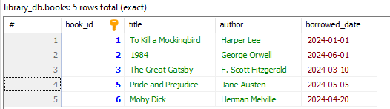

### **5. Final Verification**

**SQL Command:**

SELECT * FROM books;

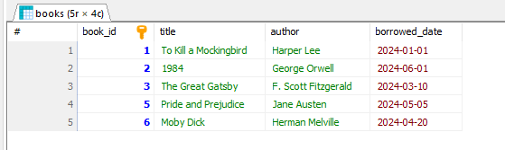

### **6. Conclusion**

In this task, I successfully:

* Created a library_db database and books table.
* Inserted, queried, updated, deleted, and re-added records.
* Documented all steps with screenshots and SQL commands.