**Attention!** To complete the test tasks, download and open the data array using the link:

[Копия Данные для тестового задания](https://docs.google.com/spreadsheets/d/1TB8gc40MtI4SK0pwo2XOg0o51OHYTSujBjYK7rKlWm4/edit?gid=1687485228#gid=1687485228)

1. In the "Audience Data" tab, information about users who visited our app in November. What is the MAU of the product?

*MAU (Monthly Active Users) is a metric used to measure user activity for one month. It shows the number of unique users who have interacted with a product, service, or application at least once in the last month.

✔7639168141048216529



2. Using the "Audience Data" tab, calculate what the DAU will be.

*DAU (Daily Active Users) is a metric that shows the number of unique users who have interacted with a product, application, or service at least once during the day. DAU helps to understand how many users actively use the product every day.

✔255490560483



3. Using the "Audience Data" tab, calculate what the first-day retention rate will be for users who joined the product on November 1st.

*Retention is a metric that shows how many users continue to use a product after a certain period following their initial interaction. Retention can be calculated as the percentage of users who returned to the product after a specific time (e.g., after 1 day, 1 week, 1 month) out of the total number of new users.

✔28,3%26,6%38,5%32,7%



4. On the graph, there are retention curves for two products. What conclusions can be drawn by looking at them?

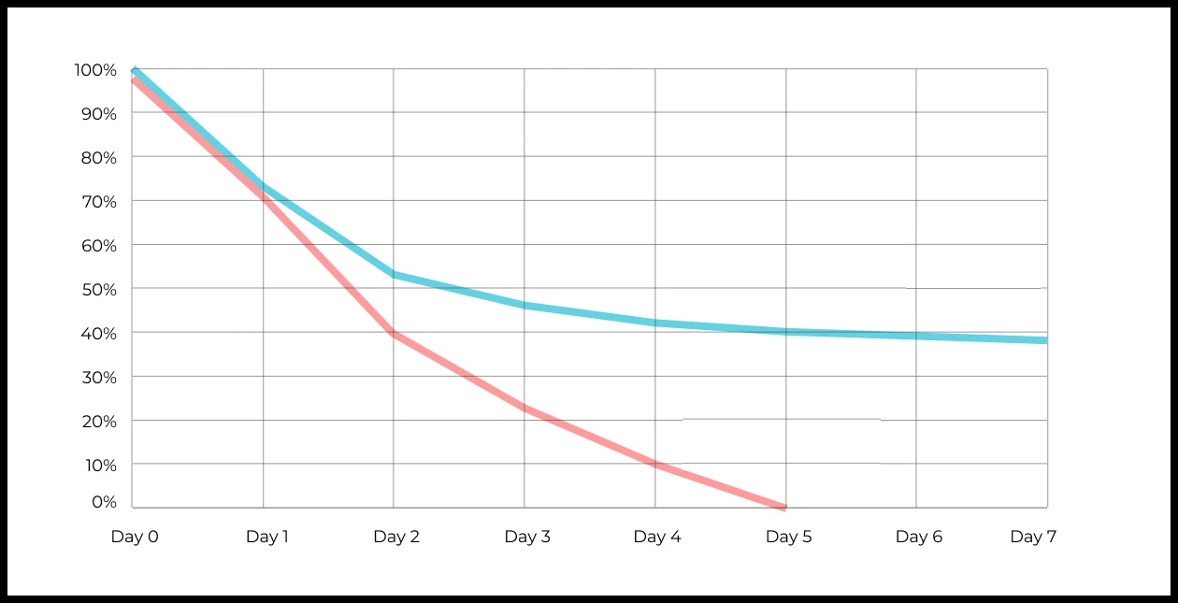

Your answer: If one product’s retention curve is consistently higher, it indicates better user engagement and long-term value compared to the other. A rapid drop in retention might show initial user interest but poor sustained engagement. If one curve stabilizes at a higher level than the other, it suggests users of that product continue returning more consistently over time.

5. In the "Audience Data" tab, there is information about how many ads each user has viewed (view_adverts). Do you calculate the user conversion per ad view for November? (in users)

* User conversion is a metric that shows what percentage of users completed a target action relative to the total number of users. In the context of websites, this can be an action such as viewing an ad or clicking on an advertising banner.

✔41,8%54,7%46,3%39%



6. Using the information from the Audience Data tab, calculate the average number of ads viewed per user in November

✔4,96,25,32,9



7. We conducted a survey among 2,000 users. Of them, 500 are "critics," 1,200 are "promoters," and 300 are "neutrals." Calculate the NPS.

*NPS (Net Promoter Score) — is a metric that measures user loyalty towards a company or product and categorizes them into three groups: Promoters, Passives, and Detractors. NPS is calculated as (% of promoters - % of detractors).

30%43%40%✔35%



8. In the "AB Test Data" tab, there are results of three unrelated AB tests for ARPU (total revenue/total number of users).

1. **Look at the test results and interpret them.**
2. **Write down the p-values you obtained.**
3. **Prepare conclusions and recommendations.**

**Data Columns:**

* **experiment_num**: Experiment number
* **experiment_group**: Group the user was assigned to
* **user_id**: User ID
* **revenue**: Revenue generated by the user through purchasing a paid promotion service.

Your answer:

### Experiment 1:

* **ARPU (Control)**: 722.46
* **ARPU (Test)**: 665.74
* **p-value**: 0.6889 (not statistically significant)

**Interpretation**: There is no significant difference between the control and test groups' ARPU values, as the p-value is well above 0.05. This suggests that the changes introduced in the test group did not significantly impact revenue.

**Conclusion**: The test did not show any benefit in terms of revenue per user.

**Recommendation**: Since there is no evidence of a positive impact, retain the control group’s version of the product without implementing the test changes.

### Experiment 2:

* **ARPU (Control)**: 704.65
* **ARPU (Test)**: 332.93
* **p-value**: 0.0011 (statistically significant)

**Interpretation**: The test group’s ARPU is significantly lower than that of the control group, with a p-value below 0.05. This indicates that the test changes had a negative impact on revenue per user.

**Conclusion**: The results strongly suggest that the test group changes harm revenue generation.

**Recommendation**: Avoid implementing the changes tested in this experiment, as they lead to a reduction in ARPU. Stick with the control version of the product to maintain higher revenue.

### Experiment 3:

* **ARPU (Control)**: 663.21
* **ARPU (Test)**: 998.67
* **p-value**: 0.0603 (borderline significance)

**Interpretation**: Although the test group’s ARPU is higher than the control’s, the p-value is slightly above 0.05, indicating borderline statistical significance. This result suggests a potential benefit from the test changes, but further validation is needed to confirm this effect reliably.

**Conclusion**: The test group shows promise for increased revenue, but the findings are not yet conclusive.

**Recommendation**: Conduct additional testing to validate the results before making a final decision. If subsequent tests confirm the positive impact, consider implementing the test group changes to increase ARPU.

9. Calculate the average income per user based on the dataset with the listers

✔121.2156.470.930.7the average is not applicable here



10. Based on the dataset with the listers, calculate the median age of the user

27,422827,93✔27the median is not applicable here



11. Which chart is best suited to display the spread of prices for goods in different stores?

*There may be several possible answers.

Line chartPie chart ✔Box with whiskers (box plot)



The histogram



12.What is the bimodal distribution graph?

№1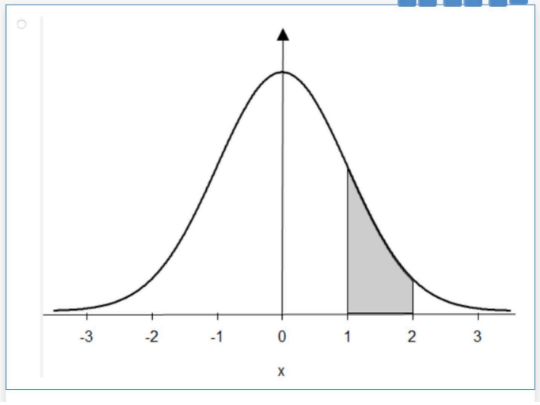



№2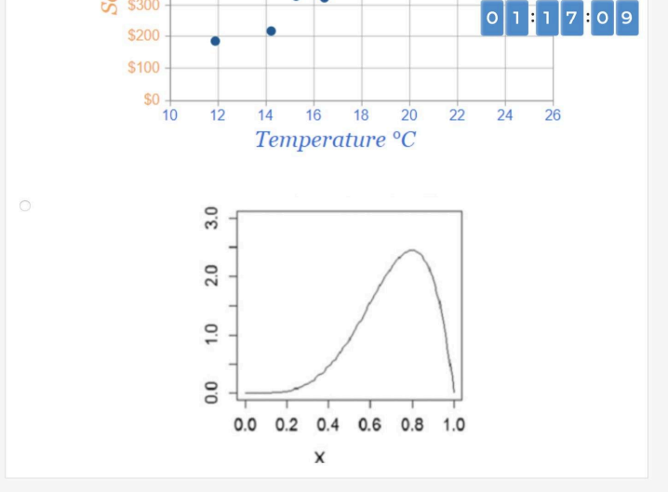



✔№3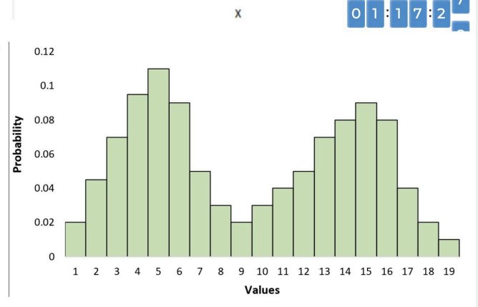



№4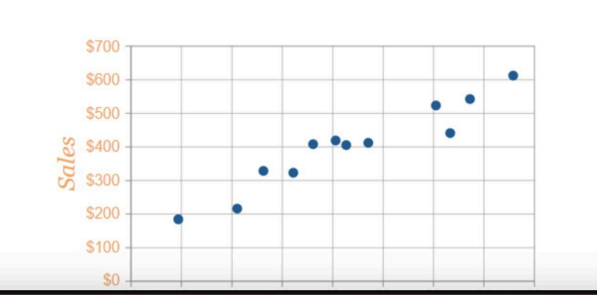



13. Which random variable has the largest data variance according to the following distribution density graph?

№1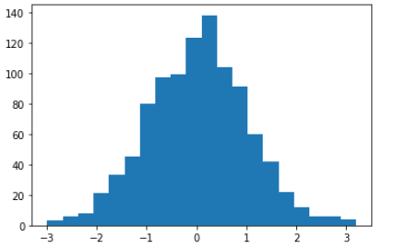



№2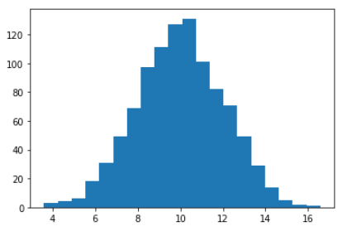



№3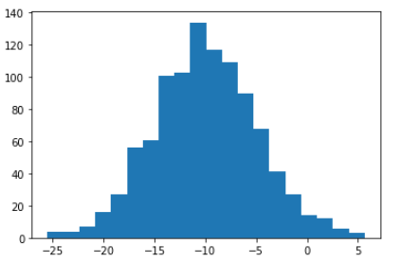



✔№4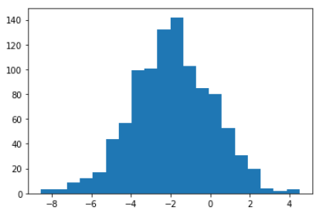



14. On which graph can the correlation be calculated?  
\**There may be several possible answers.*

✔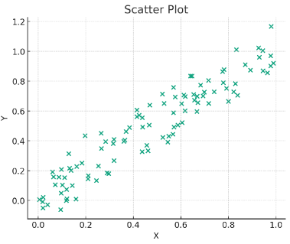



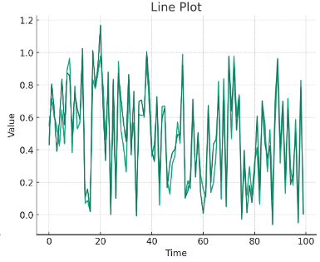



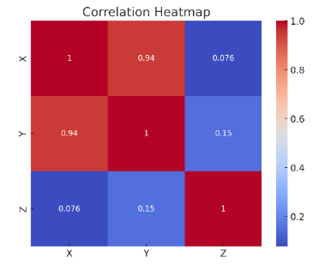



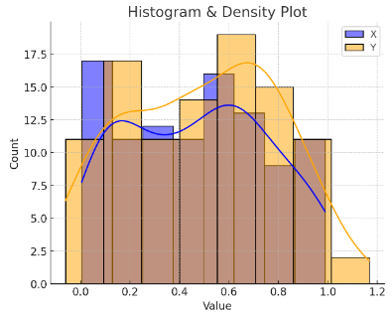



15. What does it mean if, when testing hypotheses, we got p-value = 0.05?

This means that there is no statistically significant difference between the groups



✔There is a 5% chance of accidentally getting this or an even more extreme result if the null hypothesis is correct



This means that the results of the experiment are 95% accurate



This suggests that the alternative hypothesis is correct with a probability of 95%



16. Which method is most suitable for testing the hypothesis of equality of the average of two samples from a normal distribution?

✔t-testChi-square testAnalysis of Variance (ANOVA)Pearson Correlation



17. How to interpret quartiles in the distribution of user income?

They show the maximum and minimum income



✔Divide the data into four equal parts



Indicate the most common income



Graph of the density distribution of matter in the universe



18. The following results were obtained. Colleagues ask you to confirm them and make a final conclusion on the experiment.

* + - * Option A (control group) — 100,047,501 visitors, 1003 payments.
      * Option B (test group) — 100,001,055 visitors, 1099 payments.

What recommendations would you make based on this data?

Your answer:

For Option A and Option B, calculate the payment conversion rate:

* Option A: 1003/100,047,501×100≈0.001003%
* Option B: 1099/100,001,055×100≈0.001099%

Recommendation: If Option B shows a higher conversion rate, recommend implementing changes consistent with Option B’s approach.