

**Qwitter**

**Qwitter**

**DevOps Tools**

**Prepared By**

**Fares Atef**

**Qwitter DevOps Engineer**

**17/10/2023**

Contents

Introduction 2

1) Cloud Hosting Service 3

2) Automation 5

3) Monitoring 7

4) Dockerization 9

References 10

# Introduction

In the ever-evolving landscape of software development and IT operations, the effective management and automation of tasks are paramount.

DevOps, a portmanteau of "Development" and "Operations," is an approach that emphasizes collaboration and communication between these two traditionally distinct departments. DevOps practices, when combined with a robust set of tools, facilitate continuous integration, continuous delivery (CI/CD), and the efficient management of infrastructure and applications.

In this document, I will discuss the tools I plan to use, their alternatives, and optional tools that I may consider if time permits.

# 1) Cloud Hosting Service

Cloud hosting services have revolutionized the way individuals and businesses access and utilize computing resources. In today's digital age, where data and applications play a pivotal role in our lives, cloud hosting has emerged as a dynamic and flexible solution. These services, offered by providers like Amazon Web Services, Microsoft Azure, and Google Cloud Platform, empower users to tap into a virtually limitless pool of computing power, storage, and services, all while eliminating the need to invest in and manage physical infrastructure.

**In this project, I plan to use AWS (Amazon Web Services) for hosting for some reasons like**:

1. **Global Reach**: AWS has a vast and geographically distributed network of data centers, known as Availability Zones, located in multiple regions worldwide.
2. **Scalability**: AWS provides on-demand scaling of resources, allowing businesses to quickly adapt to changing workloads.
3. **Pay-as-You-Go Pricing**: AWS follows a pay-as-you-go pricing model, where you only pay for the resources, you consume. This flexibility can result in cost savings compared to traditional IT infrastructure.
4. **Security and Compliance:** AWS invests heavily in security and compliance, offering a wide array of tools and features to help customers secure their data and meet regulatory requirements.
5. **Reliability and Availability**: AWS boasts high levels of service uptime and availability. Its globally distributed infrastructure and redundant design minimize the risk of downtime.

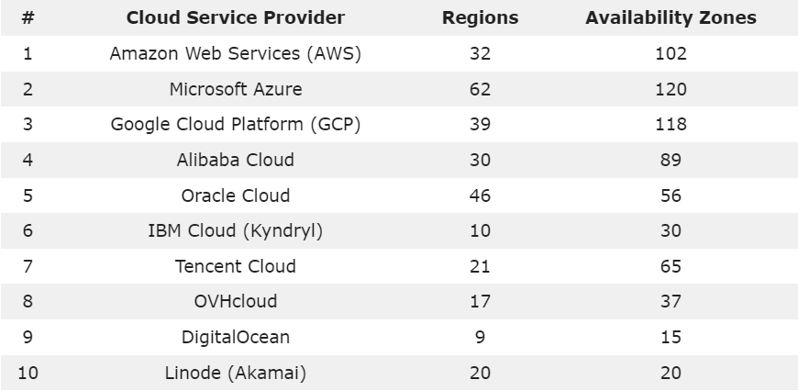

*Fig1: Top 10 cloud service providers availability zones*

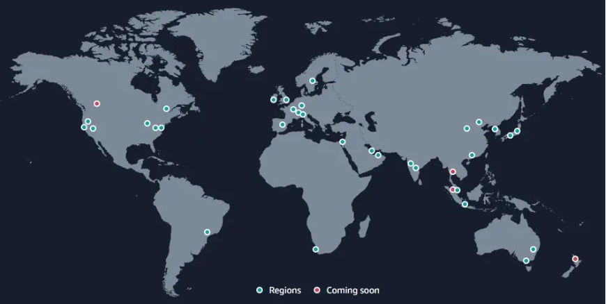

*Fig2: AWS regions*

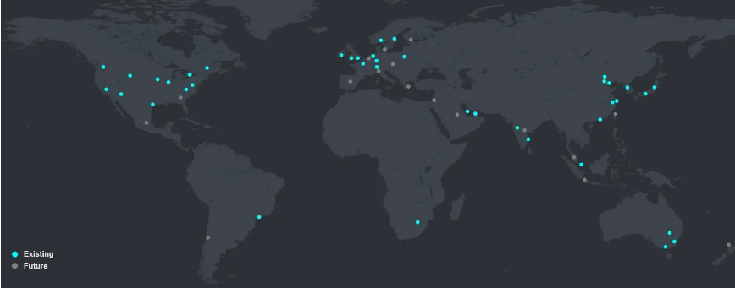

*Fig3: Microsoft Azure regions*

In Figures 2 and 3, we can see that AWS regions offer better performance in Egypt.

AWS holds the largest market share, accounting for 33% of the total market. Microsoft Azure follows in the second position with a 21% share, and Google Cloud Platform comes third, representing 8% of the market share. Microsoft Azure and Google Cloud Platform are considered the second and third most feature-rich cloud platforms, respectively. They are close competitors to AWS in the cloud computing services sector and provide robust data security for the safe storage of information within their cloud infrastructures.

**Note**: I'll consider using Microsoft Azure if I can't access the one-year free tier of AWS.

# 2) Automation

In the rapidly evolving landscape of modern software development, automation has emerged as a pivotal force in streamlining processes, enhancing efficiency, and ensuring the reliability of software applications. Among the array of automation tools available, Jenkins stands out as a cornerstone in the realm of continuous integration and continuous delivery (CI/CD). Jenkins is an open-source automation server that has revolutionized the way software is developed, tested, and deployed.

**What Jenkins provides:**

1. **Open Source and Extensible:** Jenkins is an open-source automation server with an extensive library of plugins. Its open nature allows users to customize and extend its functionality to suit their specific needs.
2. **Continuous Integration (CI):** Jenkins is renowned for its CI capabilities, automatically building and testing code changes as they are integrated into the shared repository. This ensures that issues are detected and fixed early in the development process.
3. **Continuous Delivery and Deployment (CD):** Jenkins supports CD, automating the deployment process, ensuring that software changes are automatically and consistently pushed to various environments (e.g., development, staging, production).
4. **Automation of Repetitive Tasks:** Jenkins helps eliminate manual, time-consuming tasks by automating repetitive jobs like code building, testing, and deployment, leading to increased efficiency and reduced human error.
5. **Security and Authentication:** Jenkins has built-in security features, including user authentication, access control, and security plugins, ensuring that your automation pipeline is protected.

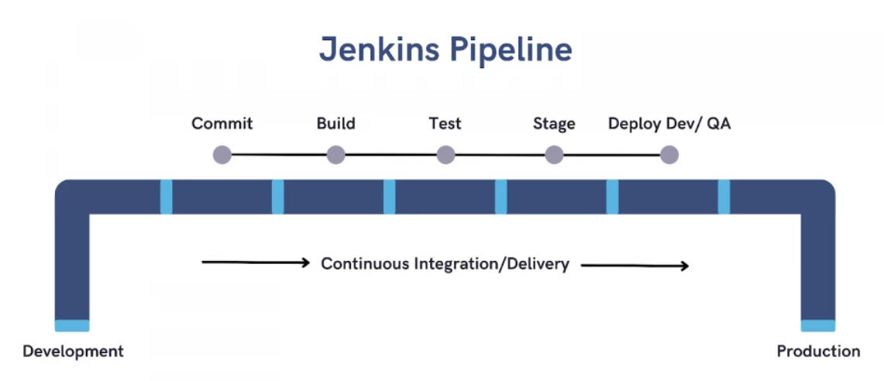

*Fig4: Jenkins Pipeline*

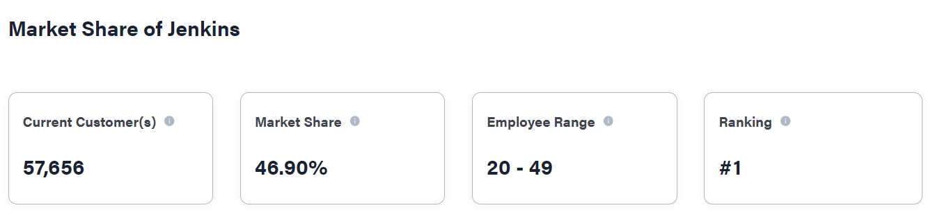

*Fig5: 2023 Jenkins Market Share*

In Figure 5, we can see that Jenkins is ranked #1 among its competitors.

**Why to use Jenkins over its competitors:**

1. **Core functionality:** Jenkins is considered highly reliable for DevOps testing and ensures high-quality product development without the need to monitor the entire deployment process like other CI/CD tools. This makes it more unique and competitive in the market.
2. **Plugin support**: Jenkins is popular for supporting a plugin ecosystem and is highly sought-after among other CI/CD tools. Equipped with 1,700+ plugins, this ecosystem makes Jenkins even more efficient for product development and delivery.

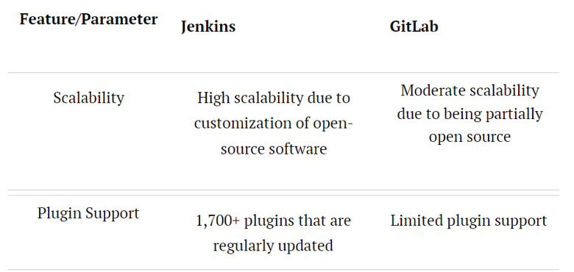

*Fig6: Jenkins vs. GitLab*

# 3) Monitoring

Grafana and Prometheus are open-source monitoring tools that work in tandem to offer comprehensive observability and actionable insights for modern, cloud-native applications. Grafana is a versatile visualization and dashboarding platform, while Prometheus is a powerful time-series database and alerting system. Together, they form a robust solution for monitoring, visualizing, and troubleshooting the intricate and ever-evolving IT environments that DevOps teams manage.

**What Prometheus** **provides:**

1. **Time-Series Database**: Prometheus is designed to collect and store time-series data, which makes it ideal for tracking and monitoring metrics over time.
2. **Data Scraping**: Prometheus uses a pull-based model to collect data from various targets, such as applications, servers, and services.
3. **Service Discovery**: Prometheus can dynamically discover and monitor services and endpoints, which is crucial for modern, cloud-native architectures where services can come and go.
4. **Alerting**: It has a built-in alerting system that allows you to define custom alert rules based on the collected metrics. Alerts can be configured to notify teams when certain thresholds are breached.

**What Grafana** **provides:**

1. **Visualization**: Grafana is known for its versatile and interactive dashboarding capabilities. It allows you to create visually appealing and highly customizable dashboards that display data from various sources, including Prometheus.
2. **Data Source Integration**: Grafana can integrate with a wide range of data sources, including Prometheus, databases, cloud services, and more. This flexibility allows you to aggregate and visualize data from multiple systems in a single dashboard.
3. **Alerting**: Grafana also provides alerting features, allowing you to set up alert conditions and notifications based on data from Prometheus or other sources. Alerts can be sent via various channels, such as email, Slack, or other messaging platforms.
4. **Templating**: Grafana supports template variables, enabling dynamic dashboard content based on user selections. This is useful for creating dashboards that adapt to different use cases or environments.

Instead of choosing one tool over the other, since they both have great features, I chose to use them both to combine their powers.

**Why to use Grafana and Prometheus** **over their competitors:**

1. **Open Source**: Both Grafana and Prometheus are open-source, making them cost-effective and transparent.
2. **Powerful Visualization**: Grafana offers customizable, interactive dashboards for effective data monitoring and analysis.
3. **Alerting**: Both tools provide robust alerting capabilities to proactively address issues.
4. **Compatibility**: They are highly flexible and can integrate with a wide range of data sources and platforms.

# 4) Dockerization

Dockerization, also known as containerization, is a technology that has sparked a revolution in the world of software development and deployment. It offers a means to package applications, along with all of their dependencies, into isolated, lightweight containers. These containers are highly portable and can run consistently across different environments, from a developer's laptop to a production server.

The allure of Dockerization lies in its ability to simplify the software development process, ensuring that what works on one system will work on another without unexpected issues. This newfound predictability and consistency have brought significant benefits to the DevOps and IT worlds, where the demand for agility and scalability is ever-increasing.

**What Docker provides:**

1. **Isolation**: Docker containers provide process and filesystem isolation. Each container runs in its own environment, separated from the host and other containers, which enhances security and prevents conflicts between applications and their dependencies.
2. **Portability**: Docker containers are highly portable. You can build a container image on one system and run it on another without worrying about compatibility issues. This makes it easy to move applications between development, testing, and production environments.
3. **Efficiency**: Docker containers are lightweight and share the host OS kernel. This reduces resource overhead and allows you to run more containers on the same hardware compared to traditional virtualization.
4. **Version Control**: Docker images are versioned, making it easy to track changes and roll back to previous versions of an application. This is especially valuable for software development and continuous integration.

**Why to use Docker** **over its competitors:**

1. **Wide Adoption**: Docker is one of the most widely adopted containerization technologies. This popularity translates to a large community, extensive documentation, and a wealth of third-party tools and resources.
2. **Standardization**: Docker has become a de facto standard for containers, making it easier to collaborate and share containerized applications across teams and organizations.
3. **User-Friendly**: Docker is known for its user-friendly interface, making it accessible to both developers and operations teams. This ease of use can accelerate adoption and integration into existing workflows.
4. **Docker Compose**: Docker Compose simplifies the definition and management of multi-container applications. This can streamline development and testing processes.
5. **Integrated Security**: Docker has made significant improvements in container security, including features like container image scanning and seccomp profiles. These security enhancements are critical for production environments.

# References

1. [Best AWS Competitors and Alternatives](https://inferenz.ai/resources/blogs/best-aws-competitors-and-alternatives-2023-comparison/#:~:text=Azure%20is%20one%20of%20the,%2Das%2Da%2DService.)
2. [AWS](https://aws.amazon.com/application-hosting/benefits/)
3. [Cloud Service Providers Statistics](https://dgtlinfra.com/top-cloud-service-providers/)
4. [What is Jenkins](https://hackr.io/blog/what-is-jenkins)
5. [Jenkins Statistics](https://6sense.com/tech/continuos-integration/jenkins-market-share)
6. [Jenkins and its competitors](https://www.spiceworks.com/tech/devops/articles/gilab-vs-jenkins/)
7. [Grafana vs. Prometheus](https://www.techtarget.com/searchitoperations/tip/Consider-Grafana-vs-Prometheus-for-your-time-series-tools)
8. [Top 3 Docker Alternatives in 2023](https://medium.com/buildpiper/top-3-docker-alternatives-to-consider-in-2023-712b1ca0cdd1#:~:text=LXD%20and%20Docker%20are%20both,Docker%20is%20a%20container%20runtime.https://medium.com/buildpiper/top-3-docker-alternatives-to-consider-in-2023-712b1ca0cdd1)

**Note**: I will explore other tools such as Terraform and Kubernetes if time permits.