Ex1:  
write a JavaScript program that will create image slider

1. Get slider image Using XMLHttpRequest from <https://jsonplaceholder.typicode.com/albums/1/photos>
2. User url property to view image
3. Use title property to view text over the image
4. Create play button (start auto play slider)
5. Create stop button (stop auto play slider)
6. Create next button (view next image)
7. Create pervious button (view pervious image)
8. Create 1x 6s button (change speed to 6 second)
9. Create 2x 4s button (change speed to 4 second)
10. Create 3x 2s button (change speed to 2 second)

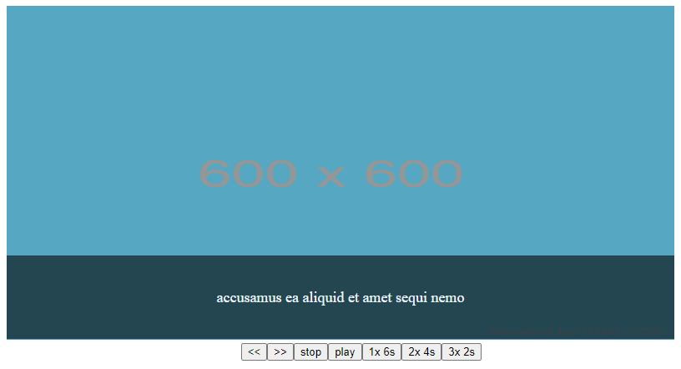

Ex2:

1. Create contact form
2. On click add user save all input to local storage and get them to show in the table
3. On click edit get data from local storage and display to inputs (data must be saved after edit with new value)
4. On click delete the data must delete from local storage and table
5. On search you can search by user name or a part of name

