Docx sample document

This is a document exhibiting basic docx features.

# This is style Heading 1

Some text.

# Tables

|  |  |  |
| --- | --- | --- |
| Cell text |  | Shaded grey |
| Vertical merge |  | Shaded grey |
|  |  |
|  | Horizontal merge | |

(There is another document which tests tables more thoroughly)

# Paragraph properties

Left indent

Centred

Align Right

Justified text

Indented indented indented indented indented indented indented indented indented indented indented indented indented indented indented indented indented indented indented indented

First line indent, Left indent, Hanging indent aaa bbb aaa bbb aaa bbb aaa bbb aaa bbb aaa bbb aaa bbb aaa bbb aaa bbb aaa bbb aaa bbb aaa bbb aaa bbb aaa bbb

Normal

A short paragraph with 10 points spacing before, 20 points after.

# Run properties

Font styles Aerial Black

Font styles 18 point

Font styles **bold**

Font styles *italic*

Font styles underline

# Bullets & numbering

Bullets

* Level 1
  + Level 2

Numbering

1. Level 1
   1. Level 2
      1. Level 3

# Images

Jpeg:

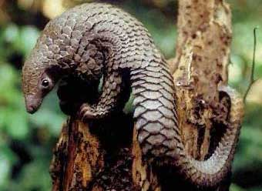

Gif (scaled):

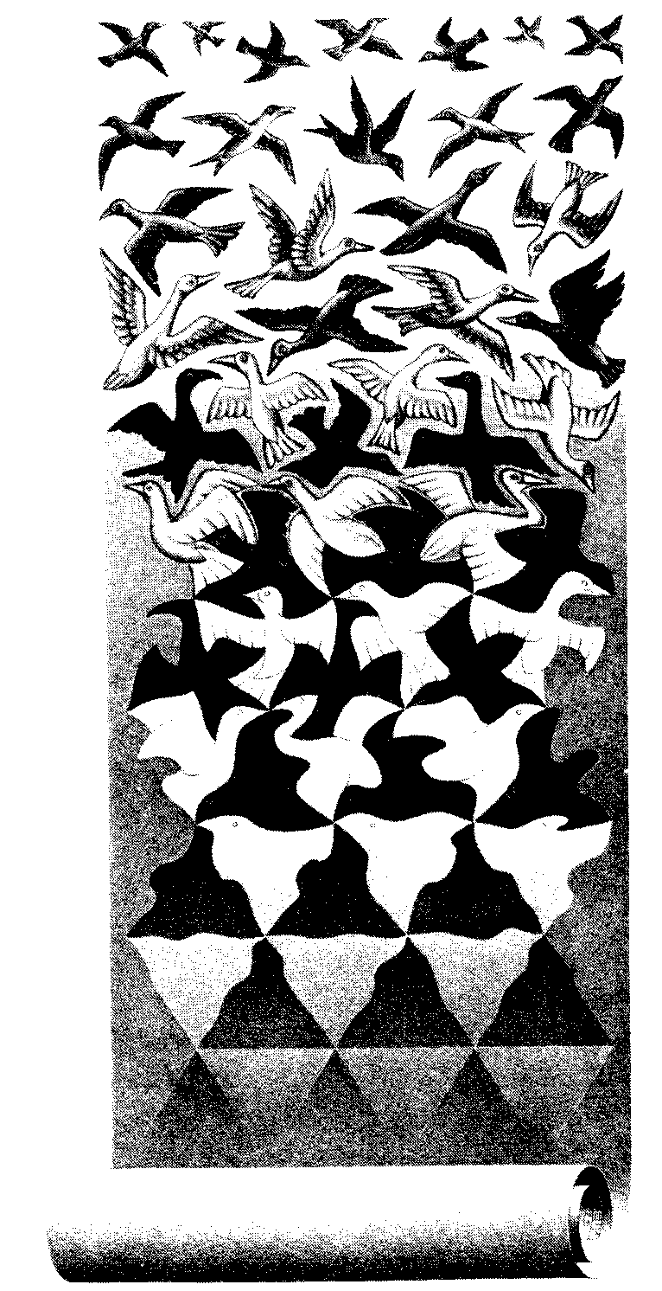

Png (from <http://davidpritchard.org/images/pacsoc-s1b.png> )

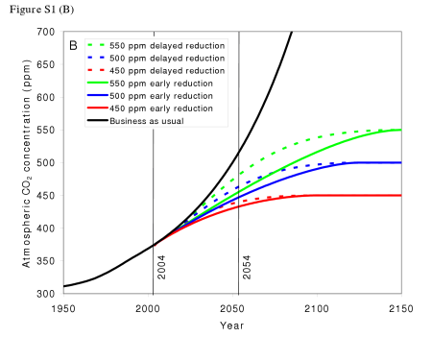

(TODO: we really should have both 2003 & 2007 pictures)

That was a page break

Here is some change tracking. An insertion Followed by A deletion.

This line contains a soft return  
and here it continues