Capture du flow :

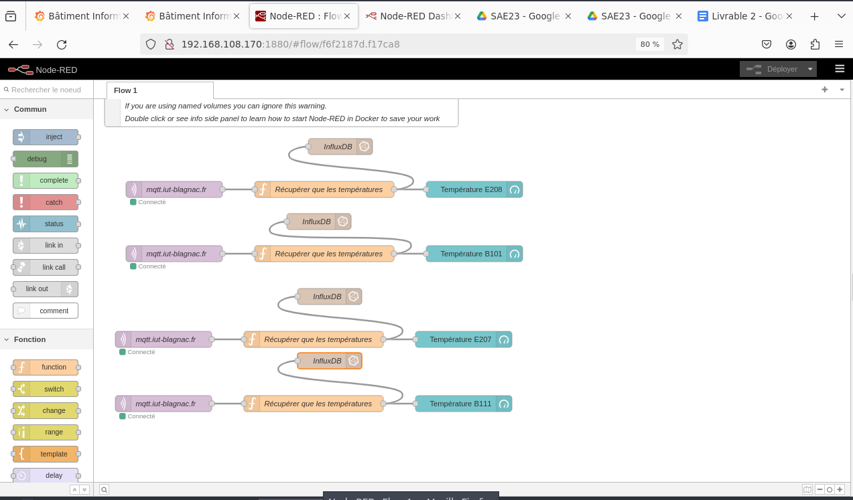

Capture du JSON :

[

{

"id": "f6f2187d.f17ca8",

"type": "tab",

"label": "Flow 1",

"disabled": false,

"info": ""

},

{

"id": "3cc11d24.ff01a2",

"type": "comment",

"z": "f6f2187d.f17ca8",

"name": "WARNING: please check you have started this container with a volume that is mounted to /data\\n otherwise any flow changes are lost when you redeploy or upgrade the container\\n (e.g. upgrade to a more recent node-red docker image).\\n If you are using named volumes you can ignore this warning.\\n Double click or see info side panel to learn how to start Node-RED in Docker to save your work",

"info": "\nTo start docker with a bind mount volume (-v option), for example:\n\n```\ndocker run -it -p 1880:1880 -v /home/user/node_red_data:/data --name mynodered nodered/node-red\n```\n\nwhere `/home/user/node_red_data` is a directory on your host machine where you want to store your flows.\n\nIf you do not do this then you can experiment and redploy flows, but if you restart or upgrade the container the flows will be disconnected and lost. \n\nThey will still exist in a hidden data volume, which can be recovered using standard docker techniques, but that is much more complex than just starting with a named volume as described above.",

"x": 350,

"y": 80,

"wires": []

},

{

"id": "ffa7e231068c9f39",

"type": "mqtt in",

"z": "f6f2187d.f17ca8",

"name": "mqtt.iut-blagnac.fr",

"topic": "AM107/by-room/E208/data",

"qos": "2",

"datatype": "auto-detect",

"broker": "2ca12541c65e0182",

"nl": false,

"rap": true,

"rh": 0,

"inputs": 0,

"x": 150,

"y": 260,

"wires": [

[

"10fd992fb0ff2b5b"

]

]

},

{

"id": "10fd992fb0ff2b5b",

"type": "function",

"z": "f6f2187d.f17ca8",

"name": "Récupérer que les températures",

"func": "// Accède au message reçu\nvar donnee = msg.payload;\n// Extrait la température du fichier\nvar temperature = donnee[0].temperature;\n//remplace le payload par la température\nmsg.payload = temperature;\n//retourne le nouveau message qui est température\n\nreturn msg;",

"outputs": 1,

"timeout": 0,

"noerr": 0,

"initialize": "",

"finalize": "",

"libs": [],

"x": 430,

"y": 260,

"wires": [

[

"7a88889a77c63b93",

"564e3acfe951393d"

]

]

},

{

"id": "7a88889a77c63b93",

"type": "ui_gauge",

"z": "f6f2187d.f17ca8",

"name": "",

"group": "cd92290279e9efeb",

"order": 0,

"width": 0,

"height": 0,

"gtype": "gage",

"title": "Température E208",

"label": "°C",

"format": "{{value}}",

"min": 0,

"max": "30",

"colors": [

"#00b500",

"#e6e600",

"#ca3838"

],

"seg1": "10",

"seg2": "20",

"diff": false,

"className": "",

"x": 710,

"y": 260,

"wires": []

},

{

"id": "564e3acfe951393d",

"type": "influxdb out",

"z": "f6f2187d.f17ca8",

"influxdb": "2d92fe5270a09b22",

"name": "InfluxDB",

"measurement": "temperature,building=RT,room=E208",

"precision": "",

"retentionPolicy": "",

"database": "database",

"precisionV18FluxV20": "ms",

"retentionPolicyV18Flux": "",

"org": "organisation",

"bucket": "bucket",

"x": 460,

"y": 180,

"wires": []

},

{

"id": "08598460b59e220f",

"type": "mqtt in",

"z": "f6f2187d.f17ca8",

"name": "mqtt.iut-blagnac.fr",

"topic": "AM107/by-room/E101/data",

"qos": "2",

"datatype": "auto-detect",

"broker": "2ca12541c65e0182",

"nl": false,

"rap": true,

"rh": 0,

"inputs": 0,

"x": 150,

"y": 380,

"wires": [

[

"7ac4b46de8199218"

]

]

},

{

"id": "7ac4b46de8199218",

"type": "function",

"z": "f6f2187d.f17ca8",

"name": "Récupérer que les températures",

"func": "// Accède au message reçu\nvar donnee = msg.payload;\n// Extrait la température du fichier\nvar temperature = donnee[0].temperature;\n//remplace le payload par la température\nmsg.payload = temperature;\n//retourne le nouveau message qui est température\n\nreturn msg;",

"outputs": 1,

"timeout": 0,

"noerr": 0,

"initialize": "",

"finalize": "",

"libs": [],

"x": 430,

"y": 380,

"wires": [

[

"e2fe40585c4a662f",

"0e82a24306b581a7"

]

]

},

{

"id": "e2fe40585c4a662f",

"type": "ui_gauge",

"z": "f6f2187d.f17ca8",

"name": "",

"group": "cd92290279e9efeb",

"order": 0,

"width": 0,

"height": 0,

"gtype": "gage",

"title": "Température B101",

"label": "°C",

"format": "{{value}}",

"min": 0,

"max": "30",

"colors": [

"#00b500",

"#e6e600",

"#ca3838"

],

"seg1": "10",

"seg2": "20",

"diff": false,

"className": "",

"x": 710,

"y": 380,

"wires": []

},

{

"id": "0e82a24306b581a7",

"type": "influxdb out",

"z": "f6f2187d.f17ca8",

"influxdb": "2d92fe5270a09b22",

"name": "InfluxDB",

"measurement": "temperature,building=Informatique,room=B101",

"precision": "",

"retentionPolicy": "",

"database": "database",

"precisionV18FluxV20": "ms",

"retentionPolicyV18Flux": "",

"org": "organisation",

"bucket": "bucket",

"x": 420,

"y": 320,

"wires": []

},

{

"id": "aee0330fc794b68c",

"type": "mqtt in",

"z": "f6f2187d.f17ca8",

"name": "mqtt.iut-blagnac.fr",

"topic": "AM107/by-room/E207/data",

"qos": "2",

"datatype": "auto-detect",

"broker": "2ca12541c65e0182",

"nl": false,

"rap": true,

"rh": 0,

"inputs": 0,

"x": 130,

"y": 540,

"wires": [

[

"0c8c8c9b10a45395"

]

]

},

{

"id": "0c8c8c9b10a45395",

"type": "function",

"z": "f6f2187d.f17ca8",

"name": "Récupérer que les températures",

"func": "// Accède au message reçu\nvar donnee = msg.payload;\n// Extrait la température du fichier\nvar temperature = donnee[0].temperature;\n//remplace le payload par la température\nmsg.payload = temperature;\n//retourne le nouveau message qui est température\n\nreturn msg;",

"outputs": 1,

"timeout": 0,

"noerr": 0,

"initialize": "",

"finalize": "",

"libs": [],

"x": 410,

"y": 540,

"wires": [

[

"0488db2dafe83f0b",

"dbe8fe83073e7092"

]

]

},

{

"id": "0488db2dafe83f0b",

"type": "ui_gauge",

"z": "f6f2187d.f17ca8",

"name": "",

"group": "cd92290279e9efeb",

"order": 0,

"width": 0,

"height": 0,

"gtype": "gage",

"title": "Température E207",

"label": "°C",

"format": "{{value}}",

"min": 0,

"max": "30",

"colors": [

"#00b500",

"#e6e600",

"#ca3838"

],

"seg1": "10",

"seg2": "20",

"diff": false,

"className": "",

"x": 690,

"y": 540,

"wires": []

},

{

"id": "dbe8fe83073e7092",

"type": "influxdb out",

"z": "f6f2187d.f17ca8",

"influxdb": "2d92fe5270a09b22",

"name": "InfluxDB",

"measurement": "temperature,building=RT,room=E207",

"precision": "",

"retentionPolicy": "",

"database": "database",

"precisionV18FluxV20": "ms",

"retentionPolicyV18Flux": "",

"org": "organisation",

"bucket": "bucket",

"x": 440,

"y": 460,

"wires": []

},

{

"id": "0a9efa3621d67e39",

"type": "mqtt in",

"z": "f6f2187d.f17ca8",

"name": "mqtt.iut-blagnac.fr",

"topic": "AM107/by-room/B111/data",

"qos": "2",

"datatype": "auto-detect",

"broker": "2ca12541c65e0182",

"nl": false,

"rap": true,

"rh": 0,

"inputs": 0,

"x": 130,

"y": 660,

"wires": [

[

"f901f9f8dcc981a5"

]

]

},

{

"id": "f901f9f8dcc981a5",

"type": "function",

"z": "f6f2187d.f17ca8",

"name": "Récupérer que les températures",

"func": "// Accède au message reçu\nvar donnee = msg.payload;\n// Extrait la température du fichier\nvar temperature = donnee[0].temperature;\n//remplace le payload par la température\nmsg.payload = temperature;\n//retourne le nouveau message qui est température\n\nreturn msg;",

"outputs": 1,

"timeout": 0,

"noerr": 0,

"initialize": "",

"finalize": "",

"libs": [],

"x": 410,

"y": 660,

"wires": [

[

"63ad54da6df881de",

"85998e06f7d80127"

]

]

},

{

"id": "63ad54da6df881de",

"type": "ui_gauge",

"z": "f6f2187d.f17ca8",

"name": "",

"group": "cd92290279e9efeb",

"order": 0,

"width": 0,

"height": 0,

"gtype": "gage",

"title": "Température B111",

"label": "°C",

"format": "{{value}}",

"min": 0,

"max": "30",

"colors": [

"#00b500",

"#e6e600",

"#ca3838"

],

"seg1": "10",

"seg2": "20",

"diff": false,

"className": "",

"x": 690,

"y": 660,

"wires": []

},

{

"id": "85998e06f7d80127",

"type": "influxdb out",

"z": "f6f2187d.f17ca8",

"influxdb": "2d92fe5270a09b22",

"name": "InfluxDB",

"measurement": "temperature,building=Informatique,room=B111",

"precision": "",

"retentionPolicy": "",

"database": "database",

"precisionV18FluxV20": "ms",

"retentionPolicyV18Flux": "",

"org": "organisation",

"bucket": "bucket",

"x": 440,

"y": 580,

"wires": []

},

{

"id": "2ca12541c65e0182",

"type": "mqtt-broker",

"name": "Broker IUT",

"broker": "mqtt.iut-blagnac.fr",

"port": "1883",

"clientid": "",

"autoConnect": true,

"usetls": false,

"protocolVersion": "4",

"keepalive": "60",

"cleansession": true,

"autoUnsubscribe": true,

"birthTopic": "",

"birthQos": "0",

"birthRetain": "false",

"birthPayload": "",

"birthMsg": {},

"closeTopic": "",

"closeQos": "0",

"closeRetain": "false",

"closePayload": "",

"closeMsg": {},

"willTopic": "",

"willQos": "0",

"willRetain": "false",

"willPayload": "",

"willMsg": {},

"userProps": "",

"sessionExpiry": ""

},

{

"id": "cd92290279e9efeb",

"type": "ui_group",

"name": "Capteurs Température",

"tab": "f1c3a763d726a5aa",

"order": 1,

"disp": true,

"width": "6",

"collapse": false,

"className": ""

},

{

"id": "2d92fe5270a09b22",

"type": "influxdb",

"hostname": "192.168.108.170",

"port": "8086",

"protocol": "http",

"database": "capteurs",

"name": "",

"usetls": false,

"tls": "",

"influxdbVersion": "1.x",

"url": "http://localhost:8086",

"timeout": "10",

"rejectUnauthorized": true

},

{

"id": "f1c3a763d726a5aa",

"type": "ui_tab",

"name": "Bâtiment RT",

"icon": "dashboard",

"disabled": false,

"hidden": false

}

]

Capture d’écran du DashBoard pour le bâtiment Informatique :

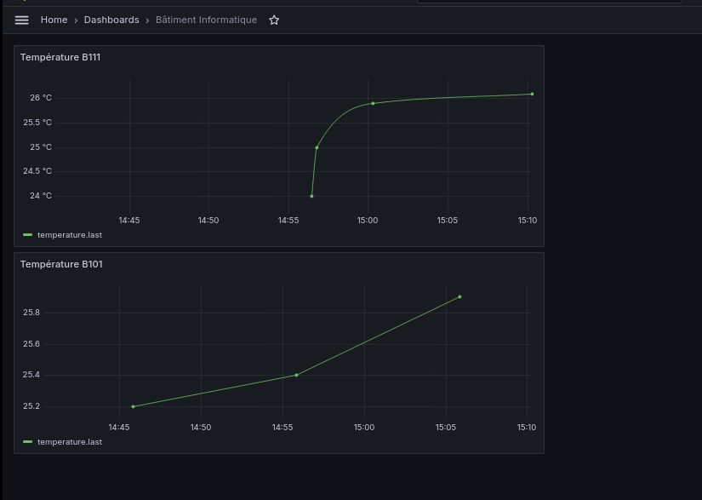

Capture JSON du Dashboard Bâtiment Informatique :

{

"annotations": {

"list": [

{

"builtIn": 1,

"datasource": {

"type": "grafana",

"uid": "-- Grafana --"

},

"enable": true,

"hide": true,

"iconColor": "rgba(0, 211, 255, 1)",

"name": "Annotations & Alerts",

"type": "dashboard"

}

]

},

"editable": true,

"fiscalYearStartMonth": 0,

"graphTooltip": 0,

"id": 4,

"links": [],

"panels": [

{

"datasource": {

"type": "influxdb",

"uid": "ado1udy9i7yf4f"

},

"fieldConfig": {

"defaults": {

"color": {

"mode": "palette-classic"

},

"custom": {

"axisBorderShow": false,

"axisCenteredZero": false,

"axisColorMode": "text",

"axisLabel": "",

"axisPlacement": "auto",

"barAlignment": 0,

"drawStyle": "line",

"fillOpacity": 0,

"gradientMode": "none",

"hideFrom": {

"legend": false,

"tooltip": false,

"viz": false

},

"insertNulls": false,

"lineInterpolation": "smooth",

"lineWidth": 1,

"pointSize": 5,

"scaleDistribution": {

"type": "linear"

},

"showPoints": "auto",

"spanNulls": false,

"stacking": {

"group": "A",

"mode": "none"

},

"thresholdsStyle": {

"mode": "off"

}

},

"mappings": [],

"thresholds": {

"mode": "absolute",

"steps": [

{

"color": "green",

"value": null

},

{

"color": "red",

"value": 80

}

]

},

"unit": "celsius"

},

"overrides": []

},

"gridPos": {

"h": 8,

"w": 12,

"x": 0,

"y": 0

},

"id": 2,

"options": {

"legend": {

"calcs": [],

"displayMode": "list",

"placement": "bottom",

"showLegend": true

},

"tooltip": {

"maxHeight": 600,

"mode": "single",

"sort": "none"

}

},

"targets": [

{

"datasource": {

"type": "influxdb",

"uid": "ado1udy9i7yf4f"

},

"groupBy": [

{

"params": [

"$__interval"

],

"type": "time"

},

{

"params": [

"none"

],

"type": "fill"

}

],

"measurement": "temperature",

"orderByTime": "ASC",

"policy": "default",

"refId": "A",

"resultFormat": "time_series",

"select": [

[

{

"params": [

"value"

],

"type": "field"

},

{

"params": [],

"type": "last"

}

]

],

"tags": [

{

"key": "building::tag",

"operator": "=",

"value": "Informatique"

},

{

"condition": "AND",

"key": "room::tag",

"operator": "=",

"value": "B111"

}

]

}

],

"title": "Température B111",

"type": "timeseries"

},

{

"datasource": {

"type": "influxdb",

"uid": "ado1udy9i7yf4f"

},

"fieldConfig": {

"defaults": {

"color": {

"mode": "palette-classic"

},

"custom": {

"axisBorderShow": false,

"axisCenteredZero": false,

"axisColorMode": "text",

"axisLabel": "",

"axisPlacement": "auto",

"barAlignment": 0,

"drawStyle": "line",

"fillOpacity": 0,

"gradientMode": "none",

"hideFrom": {

"legend": false,

"tooltip": false,

"viz": false

},

"insertNulls": false,

"lineInterpolation": "linear",

"lineWidth": 1,

"pointSize": 5,

"scaleDistribution": {

"type": "linear"

},

"showPoints": "auto",

"spanNulls": false,

"stacking": {

"group": "A",

"mode": "none"

},

"thresholdsStyle": {

"mode": "off"

}

},

"mappings": [],

"thresholds": {

"mode": "absolute",

"steps": [

{

"color": "green",

"value": null

},

{

"color": "red",

"value": 80

}

]

}

},

"overrides": []

},

"gridPos": {

"h": 8,

"w": 12,

"x": 0,

"y": 8

},

"id": 1,

"options": {

"legend": {

"calcs": [],

"displayMode": "list",

"placement": "bottom",

"showLegend": true

},

"tooltip": {

"maxHeight": 600,

"mode": "single",

"sort": "none"

}

},

"targets": [

{

"datasource": {

"type": "influxdb",

"uid": "ado1udy9i7yf4f"

},

"groupBy": [

{

"params": [

"$__interval"

],

"type": "time"

},

{

"params": [

"none"

],

"type": "fill"

}

],

"measurement": "temperature",

"orderByTime": "ASC",

"policy": "default",

"refId": "A",

"resultFormat": "time_series",

"select": [

[

{

"params": [

"value"

],

"type": "field"

},

{

"params": [],

"type": "last"

}

]

],

"tags": [

{

"key": "building::tag",

"operator": "=",

"value": "Informatique"

},

{

"condition": "AND",

"key": "room::tag",

"operator": "=",

"value": "B101"

}

]

}

],

"title": "Température B101",

"type": "timeseries"

}

],

"schemaVersion": 39,

"tags": [],

"templating": {

"list": []

},

"time": {

"from": "now-6h",

"to": "now"

},

"timeRangeUpdatedDuringEditOrView": false,

"timepicker": {},

"timezone": "browser",

"title": "Bâtiment Informatique",

"uid": "ado1uro5pgs8wf",

"version": 3,

"weekStart": ""

}

Capture D’écran du Dashboard du bâtiment RT :

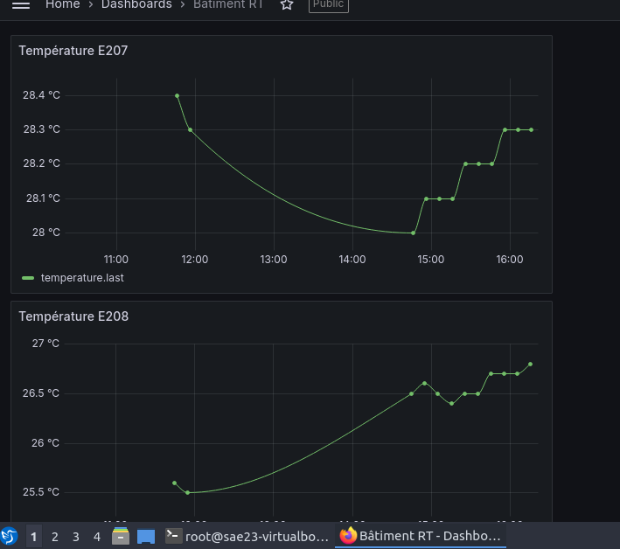

Capture d’écran JSON du bâtiment RT :

{

"annotations": {

"list": [

{

"builtIn": 1,

"datasource": {

"type": "grafana",

"uid": "-- Grafana --"

},

"enable": true,

"hide": true,

"iconColor": "rgba(0, 211, 255, 1)",

"name": "Annotations & Alerts",

"type": "dashboard"

}

]

},

"editable": true,

"fiscalYearStartMonth": 0,

"graphTooltip": 0,

"id": 3,

"links": [],

"panels": [

{

"datasource": {

"type": "influxdb",

"uid": "ado1udy9i7yf4f"

},

"fieldConfig": {

"defaults": {

"color": {

"mode": "palette-classic"

},

"custom": {

"axisBorderShow": false,

"axisCenteredZero": false,

"axisColorMode": "text",

"axisLabel": "",

"axisPlacement": "auto",

"barAlignment": 0,

"drawStyle": "line",

"fillOpacity": 0,

"gradientMode": "none",

"hideFrom": {

"legend": false,

"tooltip": false,

"viz": false

},

"insertNulls": false,

"lineInterpolation": "smooth",

"lineWidth": 1,

"pointSize": 5,

"scaleDistribution": {

"type": "linear"

},

"showPoints": "auto",

"spanNulls": false,

"stacking": {

"group": "A",

"mode": "none"

},

"thresholdsStyle": {

"mode": "off"

}

},

"mappings": [],

"thresholds": {

"mode": "absolute",

"steps": [

{

"color": "green",

"value": null

},

{

"color": "red",

"value": 80

}

]

},

"unit": "celsius"

},

"overrides": []

},

"gridPos": {

"h": 8,

"w": 12,

"x": 0,

"y": 0

},

"id": 2,

"options": {

"legend": {

"calcs": [],

"displayMode": "list",

"placement": "bottom",

"showLegend": true

},

"tooltip": {

"maxHeight": 600,

"mode": "single",

"sort": "none"

}

},

"targets": [

{

"datasource": {

"type": "influxdb",

"uid": "ado1udy9i7yf4f"

},

"groupBy": [

{

"params": [

"$__interval"

],

"type": "time"

},

{

"params": [

"none"

],

"type": "fill"

}

],

"measurement": "temperature",

"orderByTime": "ASC",

"policy": "default",

"refId": "A",

"resultFormat": "time_series",

"select": [

[

{

"params": [

"value"

],

"type": "field"

},

{

"params": [],

"type": "last"

}

]

],

"tags": [

{

"key": "building::tag",

"operator": "=",

"value": "RT"

},

{

"condition": "AND",

"key": "room::tag",

"operator": "=",

"value": "E207"

}

]

}

],

"title": "Température E207",

"type": "timeseries"

},

{

"datasource": {

"type": "influxdb",

"uid": "ado1udy9i7yf4f"

},

"fieldConfig": {

"defaults": {

"color": {

"mode": "palette-classic"

},

"custom": {

"axisBorderShow": false,

"axisCenteredZero": false,

"axisColorMode": "text",

"axisLabel": "",

"axisPlacement": "auto",

"barAlignment": 0,

"drawStyle": "line",

"fillOpacity": 0,

"gradientMode": "none",

"hideFrom": {

"legend": false,

"tooltip": false,

"viz": false

},

"insertNulls": false,

"lineInterpolation": "smooth",

"lineWidth": 1,

"pointSize": 5,

"scaleDistribution": {

"type": "linear"

},

"showPoints": "auto",

"spanNulls": false,

"stacking": {

"group": "A",

"mode": "none"

},

"thresholdsStyle": {

"mode": "off"

}

},

"mappings": [],

"thresholds": {

"mode": "absolute",

"steps": [

{

"color": "green",

"value": null

},

{

"color": "red",

"value": 80

}

]

},

"unit": "celsius"

},

"overrides": []

},

"gridPos": {

"h": 8,

"w": 12,

"x": 0,

"y": 8

},

"id": 1,

"options": {

"legend": {

"calcs": [],

"displayMode": "list",

"placement": "bottom",

"showLegend": true

},

"tooltip": {

"maxHeight": 600,

"mode": "single",

"sort": "none"

}

},

"targets": [

{

"datasource": {

"type": "influxdb",

"uid": "ado1udy9i7yf4f"

},

"groupBy": [

{

"params": [

"$__interval"

],

"type": "time"

},

{

"params": [

"none"

],

"type": "fill"

}

],

"measurement": "temperature",

"orderByTime": "ASC",

"policy": "default",

"refId": "A",

"resultFormat": "time_series",

"select": [

[

{

"params": [

"value"

],

"type": "field"

},

{

"params": [],

"type": "last"

}

]

],

"tags": [

{

"key": "building::tag",

"operator": "=",

"value": "RT"

},

{

"condition": "AND",

"key": "room::tag",

"operator": "=",

"value": "E208"

}

]

}

],

"title": "Température E208",

"type": "timeseries"

}

],

"schemaVersion": 39,

"tags": [],

"templating": {

"list": []

},

"time": {

"from": "now-6h",

"to": "now"

},

"timeRangeUpdatedDuringEditOrView": false,

"timepicker": {},

"timezone": "browser",

"title": "Bâtiment RT",

"uid": "ado1umsanti4gc",

"version": 2,

"weekStart": ""

}