Identification and verification of the prognostic value of the DHX genes in colorectal cancer

**Abstract**

**Introduction**

Besides, there is a lack of studies focusing on the value of the DHX family of genes as prognostic biomarkers in CRC.

**Materials and methods**

**Results**

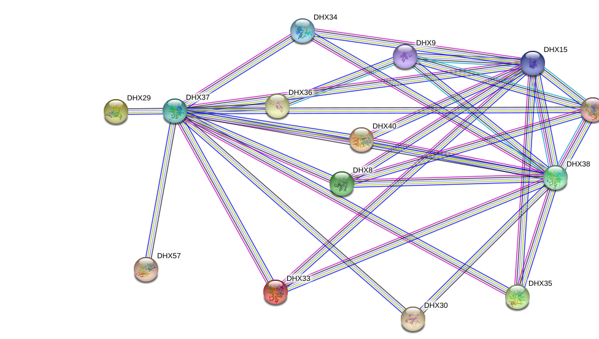

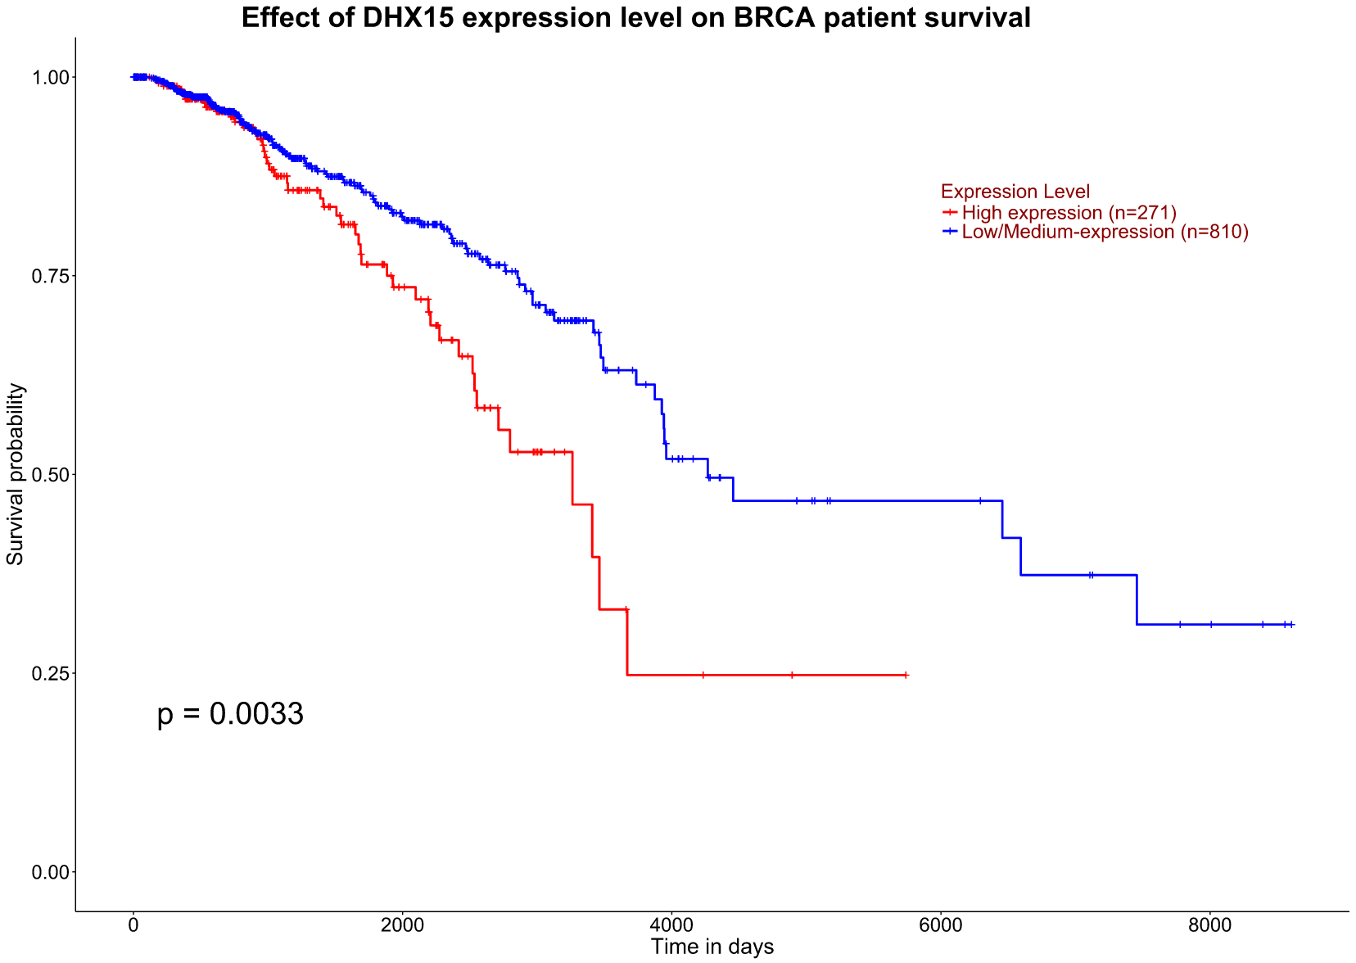

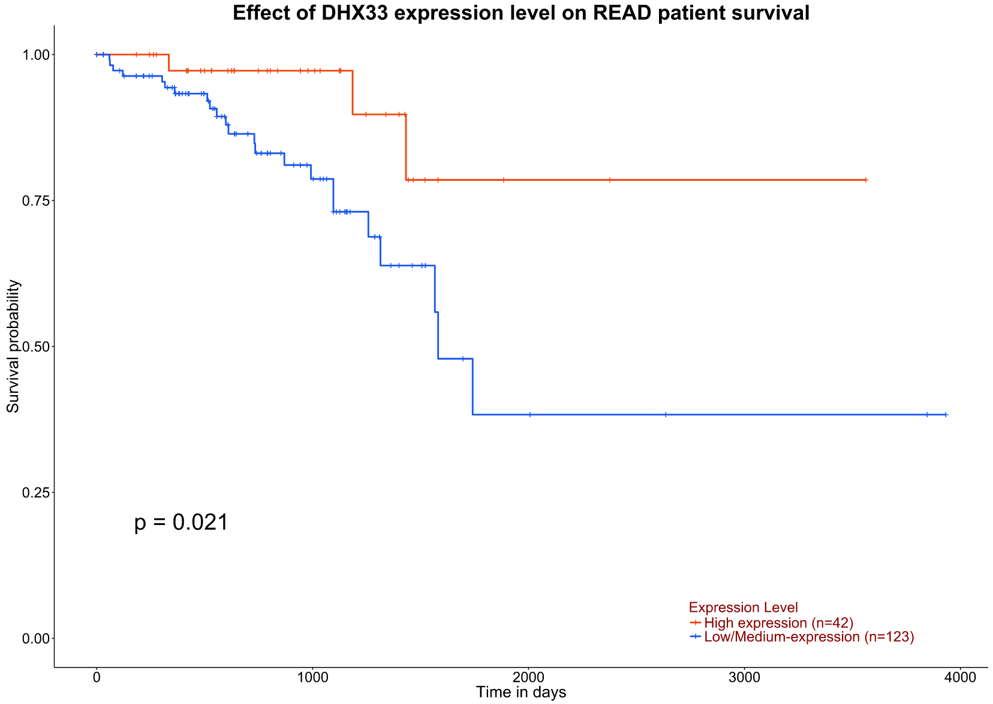

**Discussion**