

**Module Title :** Internet of Things

**Module Code :** BCC611

**Credit Points :** 20

**FHEQ Level :** 6

**Assessment :** AE1

**Student Number :** 1012717

**Course title :** BSc (Hons) in Software Engineering

**Seminar Tutor :** Anis Saboordeen

# Table of Content

Table of Content 2

Table of Figures 5

Table of Tables 5

Acronyms 6

Abstract 7

1. Introduction 8

1.1 Title 8

1.2 Brief 8

1.3 Aims 8

1.4 Objectives 8

2. Design 9

2.1 Overview Diagram for IoT Based Baby Monitoring System 9

2.2 Block Diagram 10

2.3 Ecosystem for IoT Based Baby Monitoring System 11

2.3.1 Sensors and Actuators 11

2.3.2 Automation (Board) 12

I. Comparison 12

II. Selection 12

2.3.3 Communication 13

I. Gateway 13

A. Comparison 13

B. Selection 13

II. Connectivity Protocols 14

A. MQTT 14

B. CoAP 14

C. Comparison 14

D. Selection 15

2.3.4 Cloud 16

I. Comparison 16

II. Selection 17

2.3.5 IoT Platforms 18

I. Comparison 18

II. Selection 19

2.3.6 Data Visualization, Analysis and Mining 20

I. Comparison 20

II. Selection 20

2.4 Tools and Technologies 21

2.4.1 Sensors 21

2.4.2 Actuators 21

2.4.3 Board 21

2.4.4 Communication 21

2.4.5 Cloud 22

2.4.6 Platform 22

3. Strengths, weaknesses and Future Development of the overall project 23

3.1 Strengths 23

3.2 Weaknesses 23

3.3 Future Development 24

4. Conclusion 25

5. Appendices 26

5.1 Literature Articles and critical reviews 26

5.1.1 IoT-BBMS: Internet of Things-Based Baby Monitoring System for Smart Cradle 26

I. Literature Article 26

II. Critical Review 27

5.1.2 IoT Based Baby Monitoring System Using RaspberryPi 27

I. Literature Article 27

II. Critical Review 28

5.1.3 Infant Cradle Monitoring System using IoT 28

I. Literature Article 28

II. Critical Review 29

5.2 Risks Analysis 30

5.3 Features of components required for Baby Monitoring System 31

5.3.1 NodeMCU 31

5.3.2 Temperature Sensor 32

5.3.3 Sound Sensor 33

5.3.4 Light Intensity Sensor 34

5.3.5 Servo Motor 35

6.3.6 Speaker 36

5.3.6 LED Light 37

5.4 Gantt chart 38

5.5 Cost Analysis 39

6. References 40

# Table of Figures

Figure 3 – Echo System (Author’s work, 2019) 11

*Figure 4- Comparison between Gateways (Retscher, 2017)* 13

*Figure 5- Comparison between MQTT and CoAP (Mishra, 2019)* 14

*Figure 6- Comparison between MQTT and CoAP (Aguiar, 2014)* 15

*Figure 7- Comparison between Cloud services, (Sharma, 2018)* 16

Figure 8- Comparison between IoT platforms (Author’s work, 2019) 18

Figure 9- Comparison between Anaconda and Power BI (Author’s work, 2019) 20

Figure 10- NodeMCU, (amazon.com, n.d.) 31

*Figure 11- Temperature Sensor,* 32

Figure 12- Sound Sensor, (amazon.in, n.d.) 33

Figure 13- Specification of Sound Sensor, (wiki.robobloq.com, n.d.) 33

Figure 14- Light Intensity Sensor, (Loke, 2017) 34

Figure 15- Servo Motor, (smart-prototyping.com, n.d.) 35

Figure 16- Speaker, (adafruit.com, n.d.) 36

Figure 17- LED Light, 37

Figure 18- Gantt chart for IoT based Baby Monitoring System, (Author’s work, 2019) 38

# Table of Tables

Table 1- Comparison between NodeMCU and Arduino UNO 12

Table 2- Specification of Temperature Sensor, (nikhef.nl, n.d.) 32

Table 3- Cost Analysis for my device, (adafruit.com, n.d.) 39

# Acronyms

IoT- Internet of Things

IIoT- Industrial Internet of Things

LED- Light Emitting Diode

MQTT- Message Queue Telemetry Transport

Wi-Fi- Wireless Fidelity

AWS- Amazon Web Service

RAM- Random Access Memory

ROM- Read Only Memory

USB- Universal Serial Bus

M2M- Machine-to-Machine

CoAP- Constrained Application Protocol

IBM- International Business Machines

BI- Business Intelligence

AI- Artificial Intelligence

LDR- Light Dependent Resistor

DDoS- Distributed Denial of Service

# Abstract

In this era parents are very busy in home works and office works. Then, they can’t monitor their baby. This project focuses on a Baby monitoring system which based on IoT. From that, Parents’ workload will reduce. At the same time they can monitor baby very well. Baby temperature, light intensity of cot and sound of surrounding will capture by sensors and sending to cloud. Users can control actuators by IoT platform. Sensors (Temperature sensor, Light Intensity sensor and Sound sensor), actuators (Servo motor, Night LED bulbs and Speaker) and NodeMCU has been used for our project.

# Introduction

## Title

IOT BASED BABY MONITORING SYSTEM

## Brief

I selected this title because in this era almost every parents are busy with office works and home works. When baby crying meant Parents can’t do any works. They need to care the baby. So, all the works will be remaining. To solve these problems I will create baby monitoring system to reduce the pressure of parents from a monitoring infant child and control the baby living environment’s fan, music and LED lights.

## Aims

To reduce the pressure of parents from a monitoring infant child in efficient way.

## Objectives

* Research about existing baby monitoring systems
* According to those ideas, I Develop my system to solve these existing problems
* Study about sensors and actuators for this system
* Testing the final system and creating final report
* Completing the assignment in on time.

# Design

## Overview Diagram for IoT Based Baby Monitoring System

Figure 1 – Overview Diagram (Author’s work, 2019)

## Block Diagram

Figure 2- Block Diagram (Author’s work, 2019)

Temperature Sensor, Light Intensity Sensor and Sound sensor sense their data and send to the AWS cloud. From cloud User can access those data as information in Blynk Platform. From Platform, user can manually control actuators. As actuators I use Servo motor, Night LED bulbs and speaker. All these sensors and actuators connected to Node MCU. These sensors work as automation and control these actuators from themselves also.

## Ecosystem for IoT Based Baby Monitoring System

Figure 3 – Echo System (Author’s work, 2019)

### Sensors and Actuators

As mentioned above I use many sensors and actuators. **Temperature Sensor** is measure the body Temperature of baby and we can control **Servo Motor** from our devices. Servo motor is fix to fan. Through that we can control fan. **Light Intensity Sensor** to measure light intensity of baby living room. According to that we can control **Night LED bulbs**. **Sound sensor** to detect strength of sound (Cry detection) of baby according to that we can set music in **speaker**.

### Automation (Board)

This is the main bond which connect Sensors and Actuators. Blynk is connect with this board by AWS cloud in wireless and control this system.

#### Comparison

|  |  |  |
| --- | --- | --- |
|  | NodeMCU | Arduino UNO |
| Is Inbuilt Wi-Fi Available | Yes | No |
| RAM | 128KB | 2kB |
| ROM(flash) | 4Mbytes | 32 KB |
| USB Connector | micro USB port | USB type B connector |
| Size | Small Board Size | Bigger in size than NodeMCU |

Table 1- Comparison between NodeMCU and Arduino UNO

#### Selection

We can use as a board Arduino UNO but we use NodeMCU because as above comparison, NodeMCU is ESP8266. RAM and Rom is higher than Arduino UNO and less in size. This cost is cheaper compared to other original boards.

### Communication

#### Gateway

This is a network connectivity between our system, cloud and Blynk Platform.

##### C:\Users\Dell\Desktop\Kealy-Table1.jpgComparison

*Figure 4- Comparison between Gateways (Retscher, 2017)*

##### Selection

I can use as a gateway Bluetooth and ZigBee. But I use Wi-Fi because according to above comparison data rate (speed) is very high, we can transfer any type of files with 100m range and well protected.

#### Connectivity Protocols

##### MQTT

“MQTT stands for MQ Telemetry Transport. It is a publish/subscribe, extremely simple and lightweight messaging protocol, designed for constrained devices and low-bandwidth, high-latency or unreliable networks. The design principles are to minimize network bandwidth and device resource requirements whilst also attempting to ensure reliability and some degree of assurance of delivery. These principles also turn out to make the protocol ideal of the emerging “machine-to-machine” (M2M) or “Internet of Things” world of connected devices, and for mobile applications where bandwidth and battery power are at a premium.” (mqtt.org, n.d.)

##### CoAP

“Constrained Application Protocol (CoAP), on the other hand, is a client-server protocol that, unlike MQTT, is not yet standardized. With CoAP, a client node can command another node by sending a CoAP packet. The CoAP server will interpret it, extract the payload, and decide what to do depending on its logic. The server does not necessarily have to acknowledge the request.” (Prava, 2019)

##### Image result for what is the difference between MQTT and CoAPComparison

*Figure 5- Comparison between MQTT and CoAP (Mishra, 2019)*

*Figure 6- Comparison between MQTT and CoAP (Aguiar, 2014)*

##### Selection

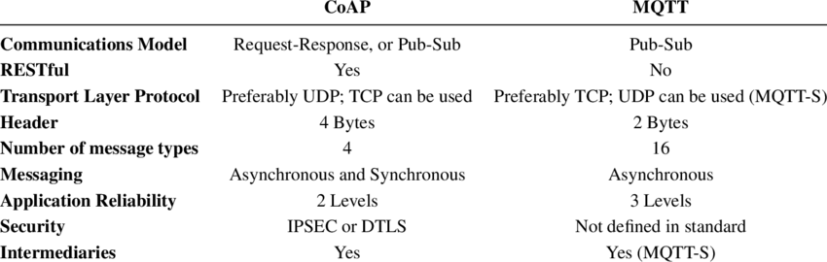As a connectivity protocol I can use CoAP but I use MQTT because according to above table MQTT’s Speed is high, data low overhead, low power consumption and high number of message types and light weighted.

### Cloud

This is a technology to maintain and store data and applications. It uses internet and central remote servers. Our cloud is connected to our system through Wi-Fi and store data and sending it to Blynk.

#### https://qph.fs.quoracdn.net/main-qimg-29fef45ea6395a272db31a4a782e8527Comparison

*Figure 7- Comparison between Cloud services, (Sharma, 2018)*

#### Selection

As a cloud I can use MS Azure, Google Cloud and IBM Cloud. But I use Amazon AWS because according to requirements they provide high security database services and storage and they completely manage them than other services. Specially, IoT Greengrass delivers cloud-based management of application logic that runs on our devices. For that deployed Lambda functions and connectors.

### IoT Platforms

We are using platforms to view information about sensors through the cloud and control actuators through Wi-Fi.

#### Comparison

Figure 8- Comparison between IoT platforms (Author’s work, 2019)

#### Selection

I can use TheThings.io and myDevices Cayenne. But I use for my system is Blynk because, it has many features than others. Blynk can connect to cloud any networks, direct pin manipulation without coding, using virtual pins we can add new features and set of easy to use widgets.

### Data Visualization, Analysis and Mining

This is a process of checking, cleaning, changing and modeling data with the goal of determining useful information and visualize it. This simplify decision making. For that we can use many tools. In our system sensors sensing data are store in cloud. Then, we can access by some tools and get information. From that we can make data analytical, data mining and data visualizing.

#### Comparison

Figure 9- Comparison between Anaconda and Power BI (Author’s work, 2019)

#### Selection

I can use power BI also. But, I am using Anaconda because, from above comparison my project main focus is not business purpose. I need to collect data for decision making. Also, it has Good integrations with Jupyter and other visual tools. I can processing data from multiple sources of data. This makes these tools easy to launch and to use.

## Tools and Technologies

### Sensors

* **Temperature Sensor** – To measure the temperature of someone or something
* **Sound Sensor** – To detect the sound strength of environment
* **Light Intensity Sensor** – To measure the physical quality of light rays

### Actuators

* **Servo Motor** – This is an Actuator that allows for accurate control of angular or linear point, speed and acceleration.
* **Speaker** – To produce Audio output
* **Night LED bulbs** – To produce light

### Board

* **Node MCU** – This is a hardware board which based on the ESP-12 module.

### Communication

* **Wi-Fi** –This is a technology which uses radio waves to provide network connectivity. It create hotspots wirelessly and allow users to connect to it.
* **MQTT Protocol** –This is light weight sub and pub system where we can pub and sub messages.

### Cloud

* **AWS** – Most demanded cloud platform to store data high secure.

### Platform

* **Blynk** - IoT platform to connect our devices to the cloud and design apps to control them.
  + 1. **Data** **Visualization,** **Analysis**
* **Anaconda** - open-source distribution of the Python and R languages for scientific computing

# Strengths, weaknesses and Future Development of the overall project

## Strengths

* Low cost. Anyone can afford it.
* This system is located in the home. So, it will protect sensors from weather effects.
* Parents’ workload will reduce. So, they can manage all the works together.
* I use best tool and technologies for this system.
* I can analyze data and can get decision about baby.
* System work as automation and we can manually control actuators by our platform.
* I am using Wi-Fi. So, we can access our system in any other places.
* Reduce waste of power and Time

## Weaknesses

* I store our system’s data in third party cloud system. We can’t exactly trust security
* If there is a power cut meant system not work.
* I detect only three parameters in my system. From that we can’t take exact decision.
* Our system we aren’t included Camera. So, we can’t view baby.
* When Wi-Fi slow down meant our system working will effect.
* Sound sensor detect not only baby cry detection but also it detect environment also.

## Future Development

* I will increase our system with more exact parameters about baby.
* I will include camera to capture baby from anywhere.
* Now we use mobile to control system. In future I will use wrist watch and many devices.
* I have idea to output parents’ direct voice as live instead of playing music.
* I will power system by solar panel
* I will set cot to swing when baby is crying.
* I will set AI. So, According to baby’s behavior and sensing data it will give many solutions.

# Conclusion

This report is about IoT based baby monitoring system. This prototype system is develop to reduce workload of parents. First, I plan our system and design diagrams. Then, finalize tools and technologies which I will use and discussed about Alternative options for those tools and technologies. Finally, discussed about system overall strengths, weakness and future development.

We learned from this IoT report applications of sensors and actuators, Boards, Gateways, Connectivity protocols, Cloud, IoT platforms and Data visualization, analysis and miming tools. From them I choose exact selection for my system. I deeply understand IoT working pattern.

# Appendices

## Literature Articles and critical reviews

Many researches developed for baby monitoring system based on IoT. Some of them we discuss below:

### IoT-BBMS: Internet of Things-Based Baby Monitoring System for Smart Cradle

#### Literature Article

“The current number of working mothers has greatly increased. Subsequently, baby care has become a daily challenge for many families. Thus, most parents send their babies to their grandparents' house or to baby care houses. However, the parents cannot continuously monitor their babies' conditions either in normal or abnormal situations. Therefore, an Internet of Things-based Baby Monitoring System (IoT-BBMS) is proposed as an efficient and low-cost IoT-based system for monitoring in real time. We also proposed a new algorithm for our system that plays a key role in providing better baby care while parents are away. In the designed system, Node Micro-Controller Unit (NodeMCU) Controller Board is exploited to gather the data read by the sensors and uploaded via Wi-Fi to the AdaFruit MQTT server. The proposed system exploits sensors to monitor the baby's vital parameters, such as ambient temperature, moisture, and crying. A prototype of the proposed baby cradle has been designed using Nx Siemens software, and a red meranti wood is used as the material for the cradle. The system architecture consists of a baby cradle that will automatically swing using a motor when the baby cries. Parents can also monitor their babies' condition through an external web camera and switch on the lullaby toy located on the baby cradle remotely via the MQTT server to entertain the baby. The proposed system prototype is fabricated and tested to prove its effectiveness in terms of cost and simplicity and to ensure safe operation to enable the baby-parenting anywhere and anytime through the network. Finally, the baby monitoring system is proven to work effectively in monitoring the baby's situation and surrounding conditions according to the prototype.” (IEEE, 2019)

#### Critical Review

In this system has many best features than our system. They are; when baby cries motor cradle will automatically swing, babies’ condition monitor by Parents through an external web camera, Parents can switch on lullaby toy remotely via MQTT server to entertain the baby and Nx Siemens software. We also have idea to expand our project like this best features in future. Then, we can get exact decision about baby and we can monitor well. In this system they monitor three parameters. Such as moisture, temperature and crying. But we also using same like these parameters except moister we use light intensity. From light intensity control we can set environment light rays weight. In future we have idea to include moisture sensor to our system.

### IoT Based Baby Monitoring System Using RaspberryPi

#### Literature Article

“This paper presents an idea to design a Smart Cradle System using IOT which will help the Parents to monitor their child even if they are away from home & detect every activity of the Baby from any distant corner of the world. It is an innovative, smart & protective Cradle System to nurture an infant in an efficient way. This system considers all the minute details required for the care & protection of the Baby in the cradle. The design of smartness & innovation comes with the use of technologies/methodologies which include Internet of Things (IOT) (Modules like Raspberry Pi, Humidity & Temperature sensing), Cry Detecting Mechanism, Live Video Surveillance, Cloud Computing (Data Storage) & User Friendly Web application (for User Controls). In order to detect each & every activity of Baby, different Sensors/Modules are attached to the Cradle: Humidity & Temperature Sensing Module for detection of Wetness of the bed, A Camera on top of the Cradle for live video footage & Cry Detection Circuit to analyze Cry Patterns. All the data which is been taken from the sensors/modules will be stored in Cloud (ThingSpeak) & analyzed at regular intervals. A Health Algorithm is applied to these datasets to get information about the body conditions which is helpful as any regular symptoms of a disease can be identified easily.” (pantechsolutions.net, n.d.)

#### Critical Review

In this system have some of new features than our system. They are Live Video Observation, Web application, Cry Detection Circuit to analyze Cry Patterns, Health Algorithm apply to stored datasets. From that, they can get to know body conditions and it is help to identify regular symptom of disease easily. We also have to expand our project in future according to these features. Mainly we have to improve analyzing cry pattern and apply health algorithm to identify disease easily. We also use AWS cloud but they use ThingSpeak. If they improve their cloud service meant good. They use Humidity sensor. We have idea to use it in future. They use Raspberry Pi. But we use NodeMCU. Because it has in built Wi-Fi available.

### Infant Cradle Monitoring System using IoT

#### Literature Article

“During the early stages, infants need proper rest and sleep for growth and development. Hence, it is the responsibility of the parents/guardian to provide the necessary care and attention to the infant. But with the modern lifestyle, parents are busy and have a lot of work with little time to provide for their little ones. In today’s world we see that most of the families consist of mainly the parents and children. When a baby is born in a family there has to be someone to look after the baby. Some parents have to do a double task of keeping a check on the baby as well as do the household work. Keeping a nanny could be an option but not all can afford nannies and also it is always difficult for parents to rely on some strangers to look after their baby. So to help such parents we have decided to come up with a smart cradle which will help a mother or a father have a track of their child and do some household work simultaneously. When the baby cries the cradle will start swinging with the help of DC motor. The temperature and wetness sensor detects the temperature and wetness of the baby and if it increases a particular level, message will be send to the parents. The mic in the system detect, if the baby cries and a song will play through the speaker set up in the APR, also message is send to the parents using smart phones with the help of Blynk server. Feeding time is also preset according to baby’s growth and is notified to the parent.” (Nazar1, 2019)

#### Critical Review

In this system have many best features than our system. They are when baby crying cot will swing and notifying parents about baby’s feeding time according to their growth. We have to include these features to our system in future development. They use wetness sensor. In future we also need to use that. Other than that we also have their other features. They are Temperature information will send to parents using smart phone with Blynk platform. If baby cries then, song will play through the speaker.

## Risks Analysis

Security is main risk in IoT. When we are transferring data to databases hackers can hack our data. If someone hack Private Key meant he can hack and access to whole account. Trouble of DDoS attacks and IoT botnets also another main risk. We are using third party cloud. So, we can’t sure security of that.

If sensor readings go wrong meant device also work wrong. If Wi-Fi or power disconnected meant device not working.

“Top 10 security risks created by the current IoT environment that organizations must address, according to Deloitte:

1. Not having a security and privacy program
2. Lack of ownership/governance to drive security and privacy
3. Security not being incorporated into the design of products and ecosystems
4. Insufficient security awareness and training for engineers and architects
5. Lack of IoT/IIoT and product security and privacy resources
6. Insufficient monitoring of devices and systems to detect security events
7. Lack of post-market/ implementation security and privacy risk management
8. Lack of visibility of products or not having a full product inventory
9. Identifying and treating risks of fielded and legacy products
10. Inexperienced/immature incident response processes” (Rayome, 2019)

## Features of components required for Baby Monitoring System

### NodeMCU

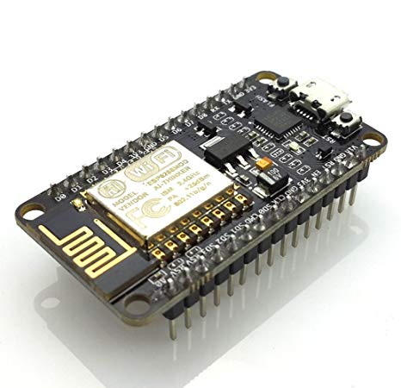

Figure 10- NodeMCU, (amazon.com, n.d.)

“Specification of NodeMCU:

Developer : ESP8266 Open source Community  
Type :  Single-board microcontroller  
Operating system : XTOS  
CPU : ESP8266  
Memory : 128kBytes  
Storage : 4MBytes  
Power By : USB  
Power Voltage : 3v ,5v (used with 3.3v Regulator which inbuilt on Board using Pin VIN)  
Code : Arduino Cpp  
IDE Used : Arduino IDE  
GPIO : 10 ”

(ahirlabs.com, n.d.)

### Temperature Sensor

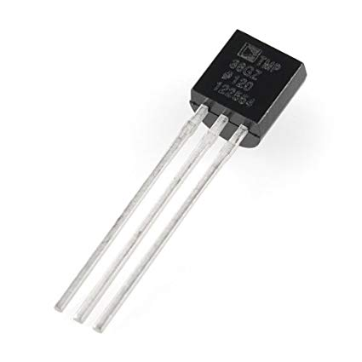

*Figure 11- Temperature Sensor,*

*(amazon.com, n.d.)*

“Specification of Temperature Sensor:

|  |  |
| --- | --- |
| Range | 0°...100°C |
| Accuracy | < 0,1°C + NTC-spread over 0°...70°C |
| Resolution | 2 m°C@30°C and 25 m°C@100°C |
| Linearity | see table |
| No. Sensors | 1....30 |
| Type | 5 kOhm NTC-resistors  Max. wire resistance 3,3 Ohm |
| Conditioner | Wheatstone-bridge with +15 Bits ADC |
| Calibration | at  0°C and 100°C _ 0,1°C |
| Drift | 1 m°C/°C with periodic calibration and 5 m°C/°C without calibration |
| Scan freq. | default max. 10 meas./s |
| Amb.temp | 0°...60° |
| Control | Micro-WireTM 5 (Di, Do, Clk en CS) |
| Levels | 0 and 5 Volt |
| Power | +12 Volt 3,5 mAmp (+5,5 .... +20 Volt)  -5 Volt 1 mAmp (-4,5 ....-8 Volt) |
| Dimensions | 224 x 120 x 60 + 40 mm” |

Table 2- Specification of Temperature Sensor, (nikhef.nl, n.d.)

### Sound Sensor

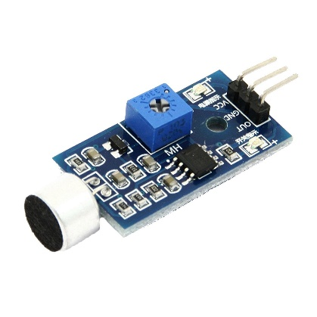

Figure 12- Sound Sensor, (amazon.in, n.d.)

Figure 13- Specification of Sound Sensor, (wiki.robobloq.com, n.d.)

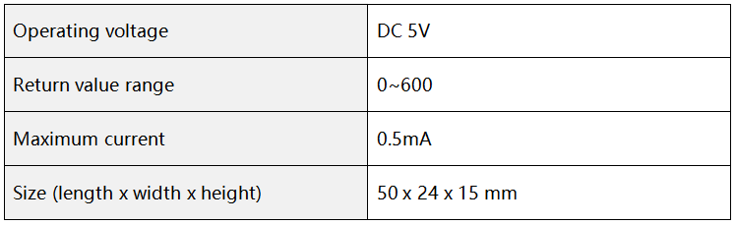Specification of Sound Sensor:

### Light Intensity Sensor

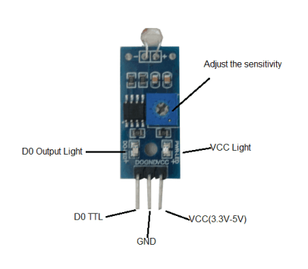

Figure 14- Light Intensity Sensor, (Loke, 2017)

“Specification of Light Intensity Sensor:

* Comes with a high-quality light dependent resistor (LDR).
* Equipped with an on-board potentiometer to adjust light brightness threshold.
* Digital output
* Fixed bolt hole for convenient installation
* Uses LM393 wide range voltage comparator
* LED indicator – ON when ambient light exceeds threshold
* Operating Voltage is 3.3-5 V
* Dimensions: 3.2cm x 1.4cm”

(Loke, 2017)

### Servo Motor

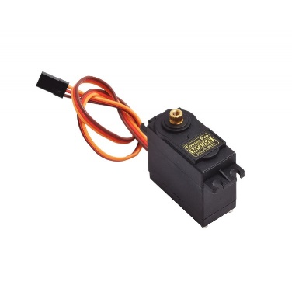

Figure 15- Servo Motor, (smart-prototyping.com, n.d.)

“Specs of a servo motor:

* Size- 32 × 11.5 × 24mm (Include tabs) 23.5 × 11.5 × 24mm (Not include tabs)
* Weight- 8.5g (Not include a cable and a connector) 9.3g (Include a cable and a connector)
* Speed- 0.12sec/60degrees (4.8V) 0.10sec/60degrees (6.0V)
* Torque- 1.5kgf-cm (4.8V) 2.0kgf-cm (6.0V)
* Voltage- 4.8V-6.0V
* Connector type- JR type (Yellow: Signal, Red: VCC, Brown: GND)”

(rapiro.com, n.d.)

### 6.3.6 Speaker

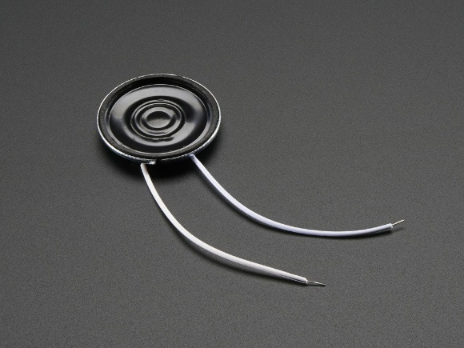

Figure 16- Speaker, (adafruit.com, n.d.)

“Specifications of Speaker:

* Datasheet
* Resonance Frequency (FO): 680 ±20% Hz at 1V
* Rated Impedance: 8 ±20% Ω (at 1KHz)
* Frequency Range: ~600-10KHz
* Rated Input Power: 0.25W
* Max Input Power: 0.5W
* Temperature Range: -20ºC ~ 55ºC”

(adafruit.com, n.d.)

### LED Light

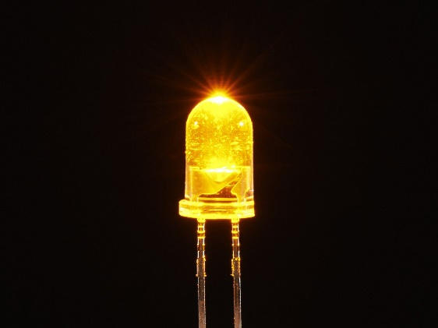

Figure 17- LED Light,

(adafruit.com, n.d.)

“Specification of LED:

Intensity: 5,800mcd  
Colour Freq: 595nm  
Viewing Angle: 32º  
Lens: Water Clear  
Blink Rate: 1.5Hz  
90-96 blinks per minute

Voltage: 3.4v-3.7v  
Typical: 3.6v  
Current: 20mA”

(make-it.ca, n.d.)

## Gantt chart

Figure 18- Gantt chart for IoT based Baby Monitoring System, (Author’s work, 2019)

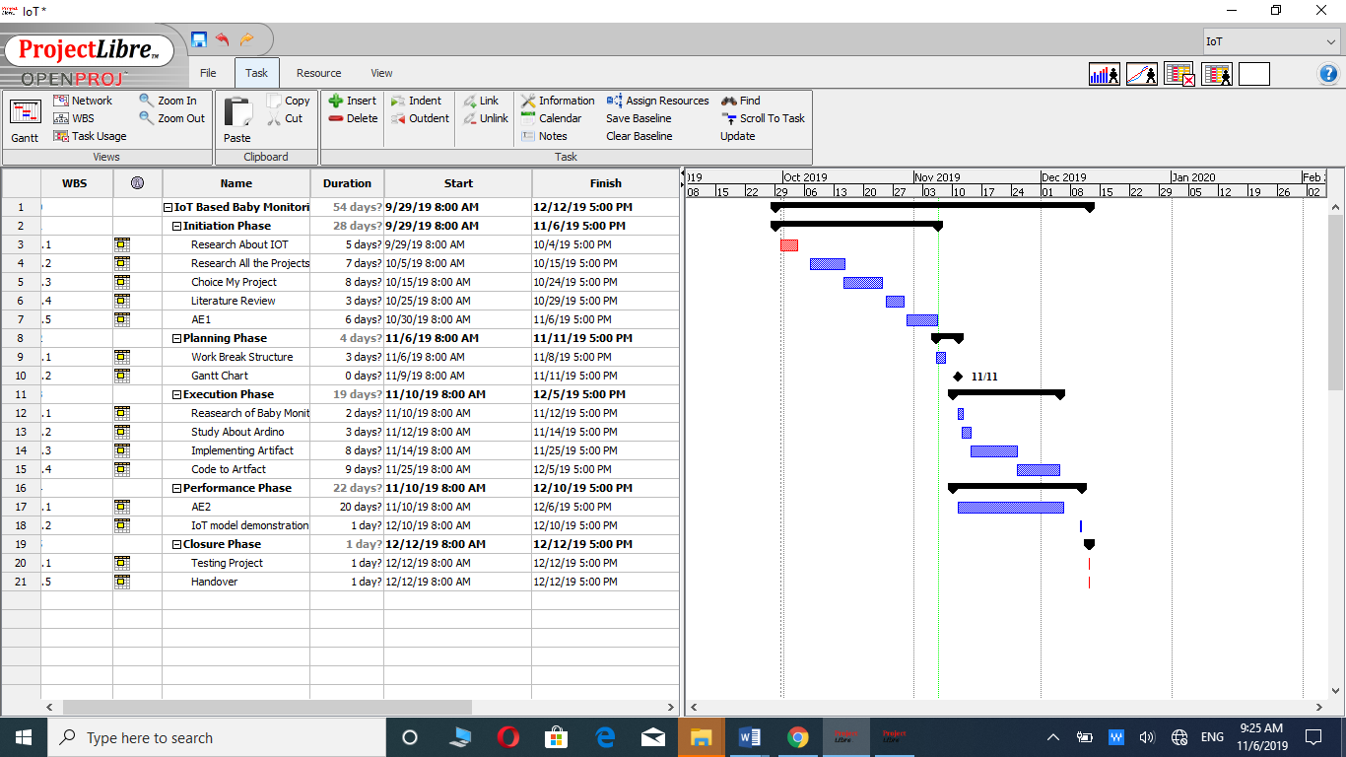

## Cost Analysis

This is cost for my prototype device components.

|  |  |
| --- | --- |
| **Components** | **Price** |
| NodeMCU | $16.95 |
| Temperature sensor | $1.50 |
| Sound Sensor | $0.9 |
| Light Intensity Sensor | $7.50 |
| Servo Motor | $5.95 |
| Speaker | $1.95 |
| Night LED lights | $0.05 |
| **Total Price** | **$34.8** |

Table 3- Cost Analysis for my device, (adafruit.com, n.d.)

# References

adafruit.com, n.d. *adafruit.com.* [Online]   
Available at: https://www.adafruit.com/product/1890  
[Accessed 6 11 2019].

adafruit.com, n.d. *adafruit.com.* [Online]   
Available at: https://www.adafruit.com/product/2700  
[Accessed 6 11 2019].

Aguiar, A., 2014. *researchgate.net.* [Online]   
Available at: https://www.researchgate.net/figure/Comparison-between-main-features-of-Constrained-Application-Protocol-CoAP-and-Message_tbl2_267273288  
[Accessed 5 11 2019].

ahirlabs.com, n.d. *ahirlabs.com.* [Online]   
Available at: https://www.ahirlabs.com/2017/10/21/what-is-nodemcu-esp8266/  
[Accessed 6 11 2019].

amazon.com, n.d. *amazon.com.* [Online]   
Available at: https://www.amazon.com/HiLetgo-Internet-Development-Wireless-Micropython/dp/B010O1G1ES  
[Accessed 6 11 2019].

amazon.com, n.d. *amazon.com.* [Online]   
Available at: https://www.amazon.com/Analog-Devices-TMP36-Temperature-Sensor/dp/B00JYQAIBM  
[Accessed 6 11 2019].

amazon.in, n.d. *amazon.in.* [Online]   
Available at: https://www.amazon.in/xcluma-Sensor-Module-Detection-Arduino/dp/B0716Z28MW  
[Accessed 6 11 2019].

geeksforgeeks.org, n.d. *geeksforgeeks.org.* [Online]   
Available at: https://www.geeksforgeeks.org/project-idea-baby-monitoring-smart-cradle/  
[Accessed 6 11 2019].

IEEE, 2019. *ieeexplore.ieee.org.* [Online]   
Available at: https://ieeexplore.ieee.org/abstract/document/8760478  
[Accessed 6 11 2019].

Loke, T. F., 2017. *tutorial.cytron.io.* [Online]   
Available at: https://tutorial.cytron.io/2017/07/10/getting-started-light-sensor-module-sn-light-mod/  
[Accessed 6 11 2019].

make-it.ca, n.d. *make-it.ca.* [Online]   
Available at: https://www.make-it.ca/5mm-led-specifications/  
[Accessed 6 11 2019].

Mishra, H., 2019. *iotbyhvm.ooo.* [Online]   
Available at: https://iotbyhvm.ooo/coap-vs-mqtt/  
[Accessed 4 11 2019].

mqtt.org, n.d. *mqtt.org.* [Online]   
Available at: http://mqtt.org/faq  
[Accessed 4 11 2019].

Nazar1, N. N., 2019. *ijarcce.com.* [Online]   
Available at: https://ijarcce.com/wp-content/uploads/2019/04/IJARCCE.2019.8402.pdf  
[Accessed 6 11 2019].

nikhef.nl, n.d. *nikhef.nl.* [Online]   
Available at: https://www.nikhef.nl/~p63/www/sens_spec.html  
[Accessed 6 11 2019].

pantechsolutions.net, n.d. *pantechsolutions.net.* [Online]   
Available at: https://www.pantechsolutions.net/iot-based-baby-monitoring-system-using-raspberrypi  
[Accessed 6 11 2019].

Prava, S., 2019. *quora.com.* [Online]   
Available at: https://www.quora.com/What-is-the-difference-between-MQTT-protocol-and-COAP-protocol  
[Accessed 5 11 2019].

rapiro.com, n.d. *rapiro.com.* [Online]   
Available at: http://www.rapiro.com/servo-motors-specifications/  
[Accessed 6 11 2019].

Rayome, A. D., 2019. *techrepublic.com.* [Online]   
Available at: https://www.techrepublic.com/article/top-10-iot-security-risks-for-businesses/  
[Accessed 6 11 2019].

Retscher, A. K. a. G., 2017. *gpsworld.com.* [Online]   
Available at: https://www.gpsworld.com/mems-and-wireless-options-user-localization-in-cellular-phones/  
[Accessed 4 11 2019].

Rouse, M., n.d. *whatis.techtarget.com.* [Online]   
Available at: https://whatis.techtarget.com/definition/Constrained-Application-Protocol  
[Accessed 4 11 2019].

Sharma, R., 2018. *quora.com.* [Online]   
Available at: https://www.quora.com/Which-cloud-service-is-best-AWS-IBM-Cloud-Microsoft-Azure-or-Google-Cloud-What-are-your-experiences-and-what-would-you-recommend  
[Accessed 5 11 2019].

Sharma, R., 2018. *quora.com.* [Online]   
Available at: https://www.quora.com/Which-cloud-service-is-best-AWS-IBM-Cloud-Microsoft-Azure-or-Google-Cloud-What-are-your-experiences-and-what-would-you-recommend  
[Accessed 5 11 2019].

smart-prototyping.com, n.d. *smart-prototyping.com.* [Online]   
Available at: https://www.smart-prototyping.com/Servo-Motor-M-Metal-Gear-MG995  
[Accessed 6 11 2019].

wiki.robobloq.com, n.d. *wiki.robobloq.com.* [Online]   
Available at: https://wiki.robobloq.com/SENSOR/sound.html  
[Accessed 6 11 2019].