Module 3: Training AI Models — Model Training Notes
Name: Farha Kousar

1.Training Setup
- Platform: Google Teachable Machine.
- Model type: Image classification model.
- Dataset: Six images across two classes: Pen (3 images) and Pencil (3 images).
- Goal: Train a model to classify images as either a pen or a pencil.

2. Training Process
- Organized the images into the Pen and Pencil classes and checked their labels.
- Used the Train Model option to train the image classification model.
- Training settings shown in the project were 50 epochs, a batch size of 16, and a learning rate of 0.001.
- No additional training adjustments were documented.

3. Model Outputs
- The platform displayed the model as trained, and the preview showed a pen image.
- Predictions and confidence scores for separate, unseen pen and pencil images have not yet been recorded.
- Therefore, the model’s accuracy and consistency cannot yet be confirmed.

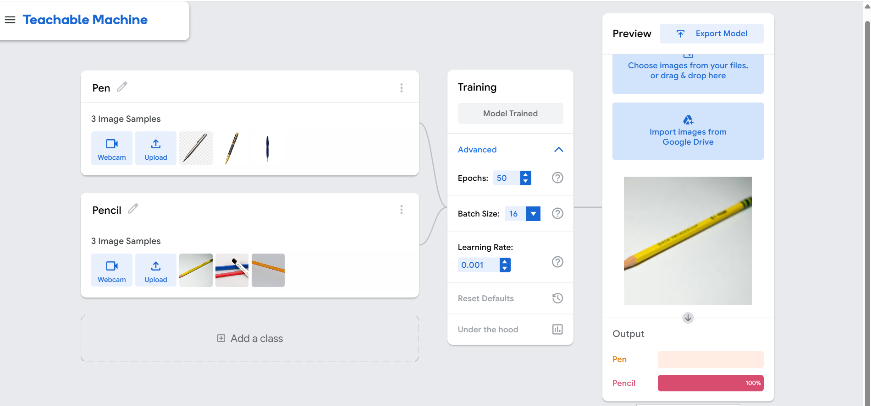

4. Observations
- The no-code interface made it easy to organize image classes and train a model without programming.
- The dataset was balanced, with three images per class, but it was very small.
- With so few examples, the model may not classify unfamiliar images reliably.
- A trained status does not necessarily mean that a model performs well on new data.

5. Improvement Ideas
- Add more pen and pencil images with different shapes, colors, angles, backgrounds, and lighting.
- Check that every image has the correct label and remove duplicate or unclear examples.
- Test the model using images that were not included in training.
- Record the predicted class and confidence score for each test image.
- Use the test results to identify weaknesses and improve the dataset or training setup.

Conclusion: This activity helped me understand the basic process of training an AI image classification model using a no-code platform. I also learned that dataset quality and variety are important, and that testing on unseen images is necessary to evaluate model performance.

