**JUMP, RUN & BUTCHER**

**What is the game?**

My game is a simple 3 level platform game where you can kill and pick up actions to move onto the next level. There are multiple options that allow you to pause, play, restart, quit, mute, unmute, turn the volume up and down, saving and loading the game from 3 different file locations and switching from 3 different characters that have 3 different traits.

**What is included in the game?**

In the game there are multiple different items included such as:

* Different background images
* Effects
* Multiple enemies depending on the level
* 3 different types of heroes
* Different icons to click on – i.e. pause the game, play the game, quit, restart, volume up, volume down, mute and unmute.
* Different sounds for different levels and attacks

**Background Images:**

For each level there is a different background to set the scene of each level. As the level increases the backgrounds get more darker and gloomier to signify the intensity of the levels.

Level 1 Level 2

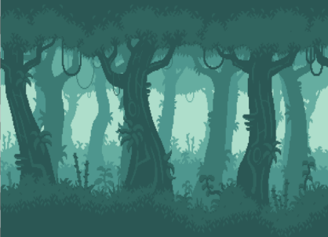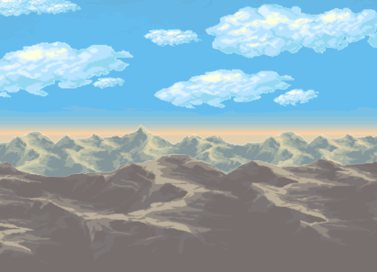

The first level is bright and sunny to show the level is easy.

The second level is in a forest to show that it is progressively getting harder, but it is not that hard

Level 3

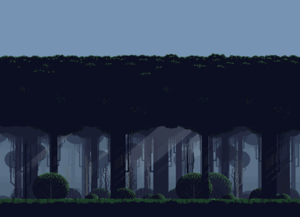

The third level has a gloomy and a darker background to show that it is the hardest level and that it is easier to die in this level

**Effects**

These are the effects that will be used in my game to attack and progress on.

**Bomb Attacking Bubbles Explosions Vortex**

****

**Enemy:**

1. Attacking Mode
2. Dying Action
3. Normal Position
4. Jumping Action
5. Running Action

Hero 1:

1. Attacking Mode
2. Dying Action
3. Normal Position
4. Jumping Action
5. Running Action



Hero 2:

1. Attacking Mode
2. Dying Action
3. Normal Position
4. Jumping Action
5. Running Action

Hero 3:

1. Attacking Mode
2. Dying Action
3. Normal Position
4. Jumping Action
5. Running Action



Menu Icons:

1. Pause
2. Play
3. Quit
4. Restart
5. Volume Down
6. Volume Up
7. Mute
8. Unmute
9. Saved Position 1, 2 , 3

Controls:

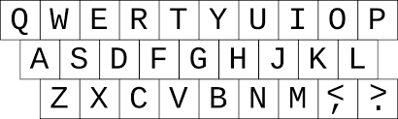W – Jump

A – Move Left

D – Move Right

J – Switch Heroes

L – Attack

1 – Save Game Slot 1

2 – Save Game Slot 2

3 – Save Game Slot 3