**2. Create a poster of forthcoming film:**

**Step1:** Download the required images/png files.(Here I’ve selected TASM2 ,venom images and their logos etc)

**Step 2:** Open new background image in photoshop

**Step 3:**  Now take other two main images in other file and make a new layer mask for the main characters carefully to be exported.

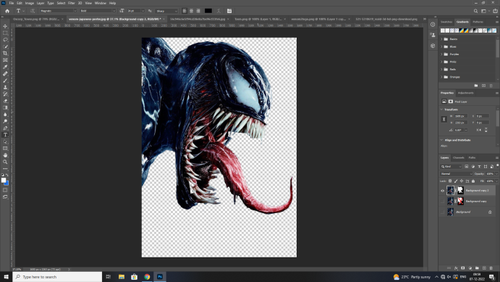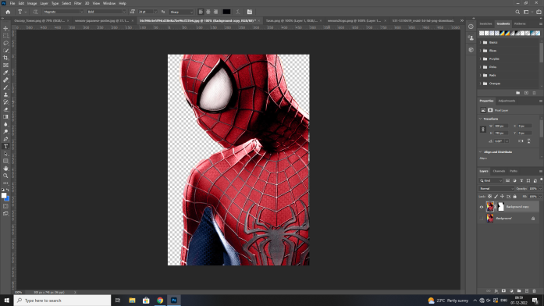

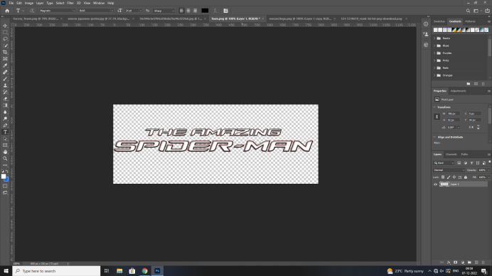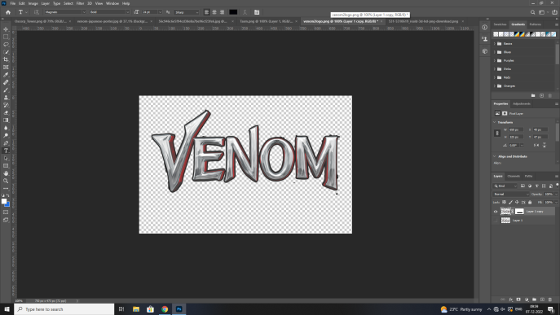

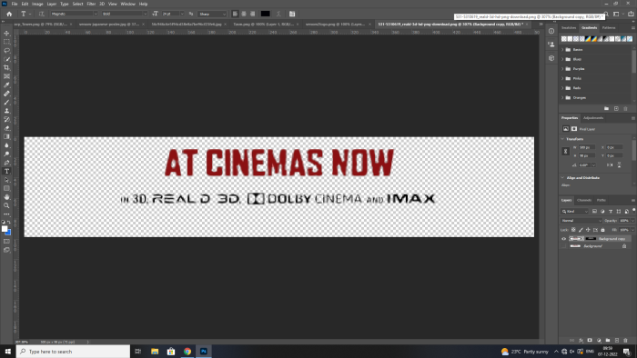

**Step 4:**Using move option drag the two main images onto the background.

**Step 5:** Put a new hue saturation layer and adjust as required .

**Step 6:** Drag the logos into the main working image .

**Step 7:** Adjust the logos and their lighting in new layer

**Step 8:**  Copt the logo layer and place is slightly above the previous one and change the original layer’s kind to make the logo pop.

**Final result**

