**8.Timeline:**

**Step 1:** Open a new image here I selected a butterfly.

**Step 2:**Open windows panel from menu at the top.

**Step 3:**Check the timeline option.

**Step 4:**Now make new frames and new layers correspondingly for each.

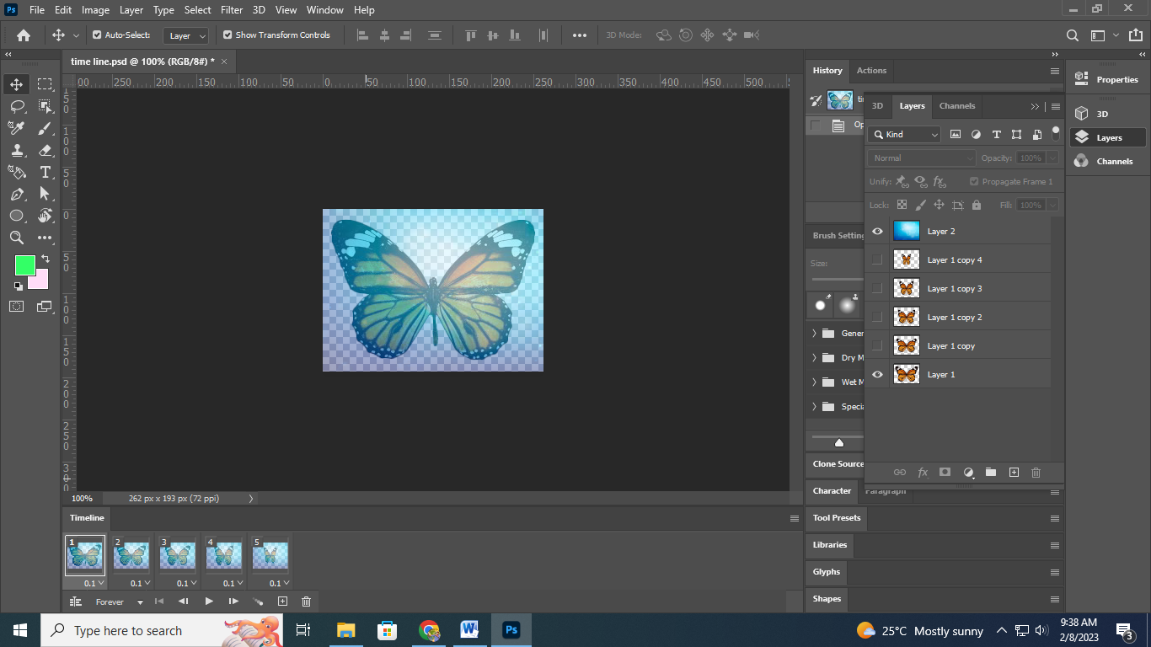

**Step 5:** Now adjust the layers which should be visible for what frame.

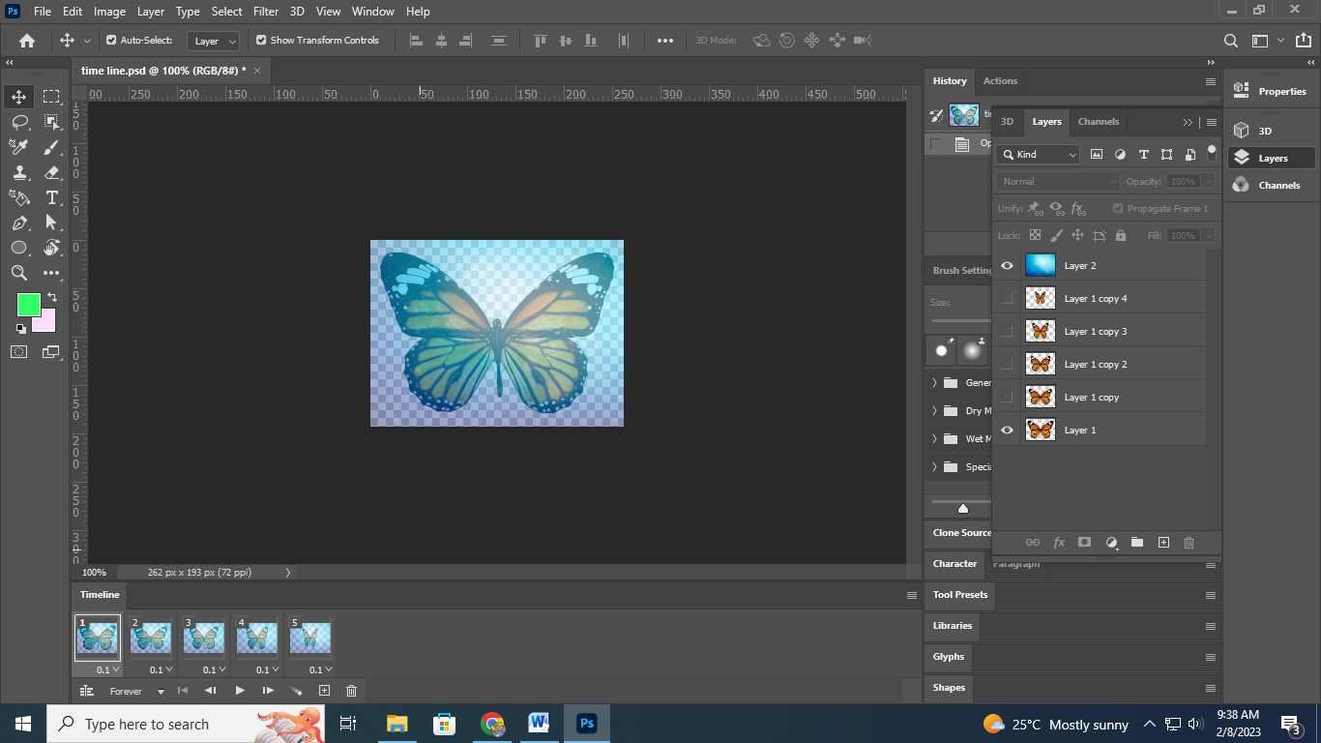

**Step 6:**Now make all layers visible for that respective frame.

