**Lab Cycle -1 : Adobe Photoshop**

**1.Create your own brochure:**

**Step1:** Set the size of your canvas

Here , Width=6 in

Height=4 in

**Step 2:** Set colour to CMYK colour

**Step 3:** Create new layer(s) according to your requirement for the background design.

**Step 4:** Merge the existing layers with the background

**Step 5:** Add rulers accordingly for the design required

Here, A tri fold as shown below

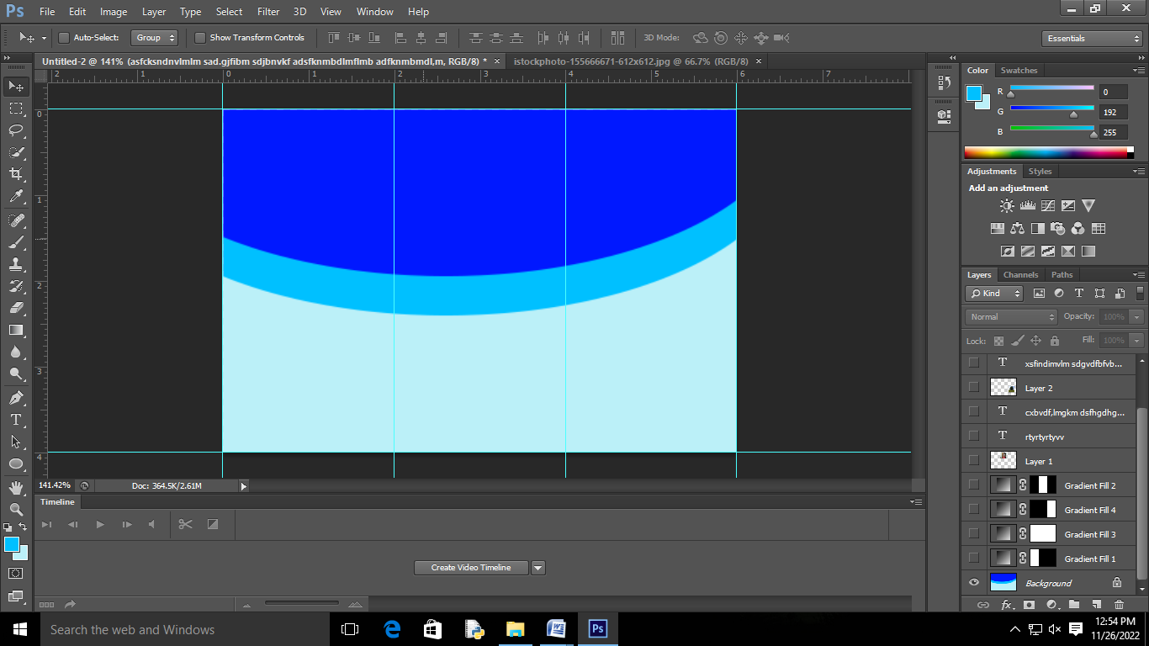

**Step 6:** Select Marqee tool And select a trisection and at the bottom click on fourth symbol from last and add gradient look at image below

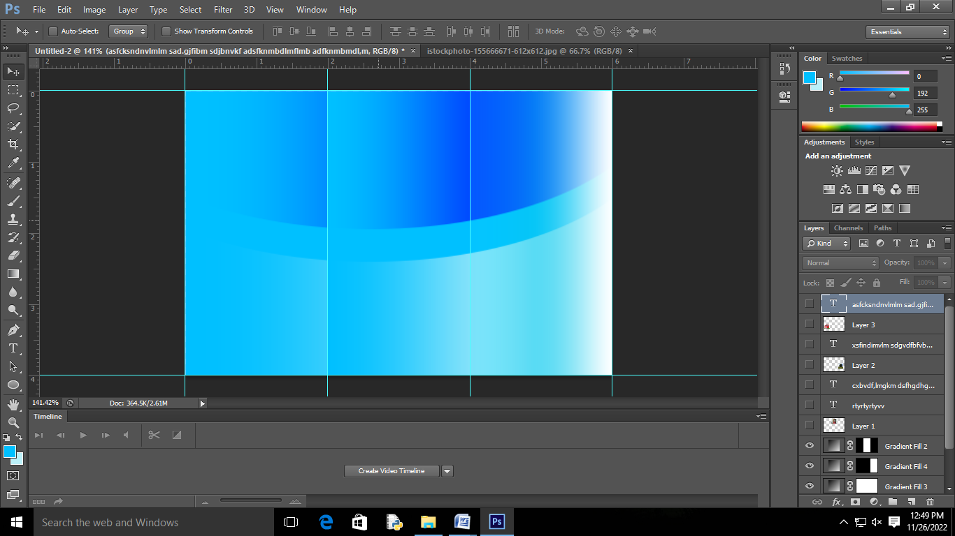

**Step 7:**  Press Ctrl+H for removing the guides and check for the appearance without the guide lines

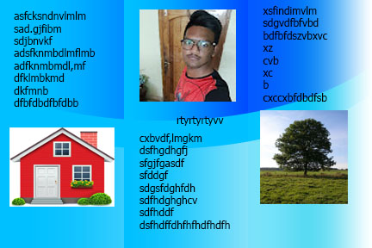**Step 8:** Add images and Text accordingly for your brochure as shown below

**Final result**