

**Project Name : Cake Shop Management System  
  
Course Name : Introduction To Database  
  
Course Instructor : SIFAT RAHMAN AHONA   
  
Section : D  
  
Group No : 10  
  
Group Members Name & ID :  
  
 Name ID  
  
1. Fahim, Solaem Abdullah 18-39146-3  
  
2.** Islam, Md. Tarikul ID 17-34408-1  
  
3. Momo Farhabi Mostafa 18-36766-1  
  
4. Arfatur Noor 18-39151-3

**Content List :**

* **Introduction**
* **Case Study**
* **ER Diagram**
* **Normalization**
* Table Creation
* Data Insertion
* Query Writing
* Conclusion
* **Introduction** : Cake Shop Management System is Totally Computer Based Software Application to Maintain Day to Day Transactions in a Cake Shop.This Software Helps to Stores All Cake Shop Items With Catergory And Sub-Category.  
  It Also Maintains Record Of Purchase And Sales. It Maintains Details of Supplier. This Application Generates Reports Of Purchase, Sales And Stock.The System Reflects Standard Structure So That Any Inventory Management System Can Implements This System Easily in Their Existing System.The System Works To Reduce Human Efforts. Due to Totally Computerized Occurance of Error is Less And Works Smothly.  
    
  It is User Friendly System.In Our Project (Cake Shop Management System) Was Created By Using The Concept Of DBMS
* Case Study : In a Cake Shop We Use Cake Shop Management System. A Cake Shop is Divided in Many Catagories. A Cake Shop Has many Branch and a branch has only one shop.the shop is identified by zip_code. The shop also stores name, phone, city . A branch is identified by b_id, b_nam, b_address, b_email. The Shop has many Manager With Manage m_id, m_name, m_phone, m_city, m_address, m_email and also many manager can work in many shop. A shop exactly one order are contain from a food item with its order_no, order_type, order_cus_id,order_quantity and a food item can contains only one order to identify a food item in a shop store f_no along with f_name, f_amount, f_quantity.A shop has many waiter with identified by w_id, w_name, w_city, w_phone, w_address. But only one waiter are working only one shop.Also a waiter can take many order at a time and many order is taken by exactly one waiter. A manager logs many order in that time a order is logs by exactly one manager. After eating the food items a customer pay exactly one bill with its b_no, b_email, date, vat, amount, time a bill also paid by only one customer. The customer is identified by cu_id, cu_name, cu_city, cu_adress, cu_phone. A bill is paid by ,many cashier and a cashier is receiving many bill. A cashier identified by c_id.a manager manage many waiter but a waiter is manage less than the one a manager. The shop also store cashier c_name, c_phone, c_age, c_city. In a shop there has many cashier but a cashier only can work exactly one shop. A cashier tells many information only one manager and a manager also tells the information to many cashier related to the shop.
* **ER Diagram :**

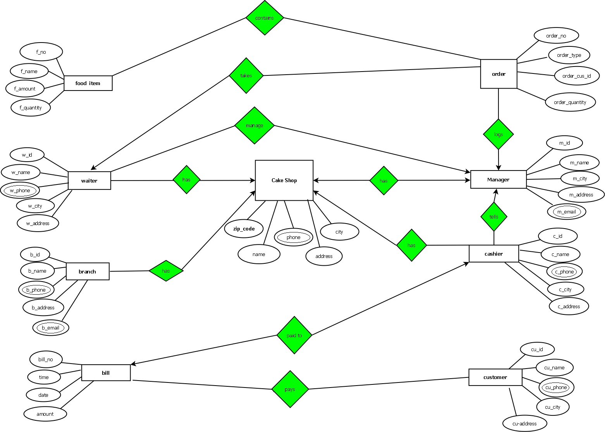

* **Normalization**Food Item**----------1----------Contains----------1----------** Order  
  Contains : (f_no,f_name,f_amount,f_quantity,order_no,order_type,order_cus_id,  
  order_quantity)1NF:
* No Multivalued Attributes  
    
  2NF:
* f-no,f_name,f_amount,f_quantity,order_no
* order-no,order_type, order_cu_id,order_quantity3NF:
* f-no,f_name,f_amount,f_quantity,order-no
* order-no,order_type, order_cu_id,order_quantityTable 1
* f-no,f_name,f_amount,f_quantity,order-no
* order-no,order_type, order_cu_id,order_quantity
* Waiter----------🡪----------Takes----------1----------Order  
    
    
  Takes (w-id,w_name,w_phone,w_city,w_address,order-no,order_type,order_cu_id,order_quantity)  
    
  1NF:
* w_phone is a Multivalued Attribute  
    
  2NF:
* w-id,w_name,w_phone,w_city,w_address
* order-no,order_type,order_cu_id,order_quantity,w-id  
    
  3NF:
* w-id,w_name,w_phone,ww-id
* order-no,order_type,order_cu_id,order_quantity,w-id
* ww-id,w_city,w_address  
    
  Table 2:
* w-id,w_name,w_phone,ww-id
* order-no,order_type,order_cu_id,order_quantity,w-id
* ww-id,w_city,w_address
* Waiter----------1----------Manage---------🡪----------Manager  
    
  Manage (w-id,w_name,w_phone,w_city,w_address,  
  m-id,m_name,m_email, m_city ,m_address, ,m_phone)  
    
  1NF:
* w_phone and m_email Multivalued Attributes  
    
  2NF:
* w-id,w_name,w_phone,w_city,w_address
* m-id,m_name,m_email, m_city ,m_address, ,m_phone,w-id  
    
  3NF:
* w-id,w_name,w_phone,ww-id
* m-id,m_name,m_email, mm-id,m_phone,w-id
* ww-id,w_city,w_address
* mm-id,m_city,m_address  
    
  Table 3:
* w-id,w_name,w_phone,ww-id
* m-id,m_name,m_email, mm-id,m_phone, w-id
* ww-id, w_city, w_address
* mm-id,m_city,m_address
* Waiter----------1----------Has---------🡪----------Cake Shop  
    
  Has ( w-id, w_name, w_phone, w_city, w_address, zip-code, name, phone, city, address )  
    
  1NF:
* Phone Multivalued Attribute  
    
  2NF:
* w-id, w_name, w_phone, w_city, w_address
* zip-code, name, phone, city, address, w-id  
    
  3NF:
* w-id, w_name, w_phone, ww-id
* zip-code, name, phone, ac-id, w-id
* ww-id, w_city, w_address
* ac-id, address, city  
    
    
  Table 4:
* w-id, w_name, w_phone, ww-id
* zip-code, name, phone, ac-id, w-id
* ww-id, w_city, w_address
* ac-id, address, city
* Cake Shop---------🡪-----------Has----------🡪-----------Manager  
    
  Has ( zip-code, name, phone, city, address, m-id, m_name, m_email, m_city, m_address, m_phone)  
    
  1NF:
* phone and m_email Multivalued Attributes  
    
  2NF:
* zip-code, name, phone, city, address
* m-id, m_name, m_email, m_city, m_address, m_phone
* zm-id, zip-code, m-id  
    
  3NF:
* zip-code, name, phone, ac-id
* m-id, m_name, m_email, mm-id, m_phone
* zm-id, zip-code, m-id
* ac-id, city, address
* mm-id, m_city, m_address  
    
  Table 5:
* zip-code, name, phone, ac-id
* m-id, m_name, m_email, mm-id, m_phone
* zm-id, zip-code, m-id
* ac-id, city, address
* mm-id, m_city, m_address
* Cake Shop---------🡪----------Has----------1----------Cashier  
    
  Has ( zip-code, name, phone, city, address, c-id, c_name, c_phone, c_city, c_address )  
    
  1NF:
* phone Multivalued Attribute  
    
  2NF:
* zip-code, name, phone, city, address, c-id
* c-id, c_name, c_phone, c_city, c_address  
    
  3NF:
* zip-code, name, phone, ac-id, c-id
* c-id, c_name, c_phone, cc-id
* ac-id, city, address
* cc-id, c_city, c_address  
    
  Table 6:
* zip-code, name, phone, ac-id, c-id
* c-id, c_name, c_phone, cc-id
* ac-id, city, address
* cc-id, c_city, c_address
* Manager---------🡪----------tells----------1----------Cashier  
    
  tells ( m-id, m_name, m_email, m_city, m_address, m_phone, c-id, c_name, c_phone, c_city, c_address )  
    
  1NF:
* m_email and m_phone Multivalued Address  
    
  2NF:
* m-id, m_name, m_email, m_city, m_address, m_phone, c-id
* c-id, c_name, c_phone, c_city, c_address  
    
  3NF:
* m-id, m_name, m_email,mm-id , m_phone, c-id
* c-id, c_name, c_phone, cc-id
* mm-id, m_city, m_address
* cc-id, c_city, c_address  
    
    
  Table 7:
* m-id, m_name, m_email,mm-id , m_phone, c-id
* c-id, c_name, c_phone, cc-id
* mm-id, m_city, m_address
* cc-id, c_city, c_address
* Bill---------🡪----------paid to---------🡪----------cashier  
    
  paid to ( bill-no, time, date, amount, c-id, c_name, c_phone, c_city, c_address )  
    
  1NF:
* c_phone Multivalued Attribute  
    
    
  2NF:
* bill-no, time, date, amount
* c-id, c_name, c_phone, c_city, c_address
* bc-id, bill-no, c_id  
    
  3NF:
* bill-no, time, date, amount
* c-id, c_name, c_phone, cc-id
* bc-id, bill-no, c_id  
    
    
  Table 8:
* bill-no, time, date, amount
* c-id, c_name, c_phone, cc-id
* bc-id, bill-no, c_id
* Bill----------🡪-----------pays-----------*-----------customer  
    
  pays ( bill-no, time, date, amount, cu-id, cu_name, cu_phone, cu_city, cu_address )  
    
  1NF: cu_phone Multivalued Attributes  
    
    
  2NF:
* bill-no, time, date, amount
* cu-id, cu_name, cu_phone, cu_city, cu_address, bill-no  
    
    
  3NF:
* bill-no, time, date, amount
* cu-id, cu_name, cu_phone, ccu-id, bill-no
* ccu-id, cu_city, cu_address  
    
    
  Table 9:
* bill-no, time, date, amount
* cu-id, cu_name, cu_phone, ccu-id, bill-no
* ccu-id, cu_city, cu_address
* Order----------1----------logs---------🡪----------Manager  
    
  logs ( order-no, order_type, order_cu_id, order_quantity, m-id, m_name, m_email, m_city, m_address, m_phone )  
    
    
  1NF:
* m_email Multivalued Attribute  
    
    
  2NF:
* order-no, order_type, order_cu_id, order_quantity
* m-id, m_name, m_email, m_city, m_address, m_phone, order-no  
    
    
  3NF:
* order-no, order_type, order_cu_id, order_quantity
* m-id, m_name, m_email, mm-id, m_phone, order-no
* mm-id, m_city, m_address

Table 10:

* order-no, order_type, order_cu_id, order_quantity
* m-id, m_name, m_email,mm-id, m_phone, order-no
* mm-id, m_city, m_address
* Total Table
* f-no,f_name,f_amount,f_quantity,order-no
* ~~order-no,order_type, order_cu_id,order_quantity~~
* w-id,w_name,w_phone,ww-id
* order-no, order_type, order_cu_id, order_quantity, w-id
* ww-id,w_city ,w_address
* ~~w-id, w_name, w_phone, ww-id~~
* m-id,m_name,m_email, m_phone, mm-id,, w-id
* ~~ww-id, w_city, w_address~~
* mm-id,m_city,m_address
* ~~w-id, w_name, w_phone, ww-id~~
* zip-code, name, phone, ac-id, w-id
* ~~ww-id, w_city, w_address~~
* ac-id, address, city
* ~~zip-code, name, phone, ac-id~~
* ~~m-id, m_name, m_email, mm-id, m_phone~~
* zm-id, zip-code, m-id
* ~~ac-id, city, address~~
* ~~mm-id, m_city, m_address~~
* zip-code, name, phone, ac-id, c-id
* c-id, c_name, c_phone, cc-id
* ~~ac-id, city, address~~
* cc-id, c_city, c_address
* m-id, m_name, m_email,mm-id , m_phone, c-id
* ~~c-id, c_name, c_phone, cc-id~~
* ~~mm-id, m_city, m_address~~
* ~~cc-id, c_city, c_address~~
* bill-no, time, date, amount
* ~~c-id, c_name, c_phone, cc-id~~
* bc-id, bill-no, c_id
* ~~bill-no, time, date, amount~~
* cu-id, cu_name, cu_phone, ccu-id, bill-no
* ccu-id, cu_city, cu_address
* ~~order-no, order_type, order_cu_id, order_quantity~~
* m-id, m_name, m_email, mm-id, m_phone, order-no
* ~~mm-id, m_city, m_address~~

Final Table:

* f-no,f_name,f_amount,f_quantity,order-no
* w-id,w_name,w_phone,ww-id
* order-no, order_type, order_cu_id, order_quantity, w-id
* ww-id,w_city ,w_address
* m-id,m_name,m_email, mm-id,m_phone, w-id
* mm-id,m_city,m_address
* zip-code, name, phone, ac-id, w-id
* ac-id, address, city
* zm-id, zip-code, m-id
* zip-code, name, phone, ac-id, c-id
* c-id, c_name, c_phone, cc-id
* cc-id, c_city, c_address
* m-id, m_name, m_email,mm-id , m_phone, c-id
* bill-no, time, date, amount
* bc-id, bill-no, c_id
* cu-id, cu_name, cu_phone, ccu-id, bill-no
* ccu-id, cu_city, cu_address
* m-id, m_name, m_email, mm-id, m_phone, order-no

**Table Creation** :  
  
  
create table order1

(

order_no number(20) constraint o_on_pk primary key,

order_type varchar2(20),

order_cu_id number(20),

order_quantity number(20),

w_id number(20) constraint o_w_fk references waiter(w_id)

)  
desc order1  
  
  
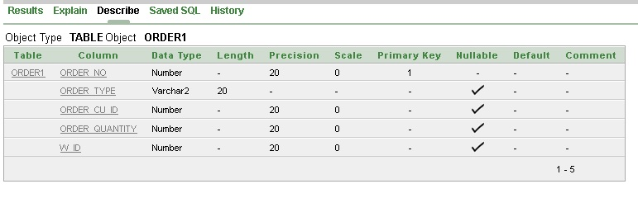

create table zm_id

(

zm_id number (20) constraint zm_id_pk primary key,

zip_code number (20) constraint zm_zip_fk references coffee_shop1(zip_code),

m_id number(20) constraint zm_mid_fk references manager3(m_id)

)

Desc zm_id  
  
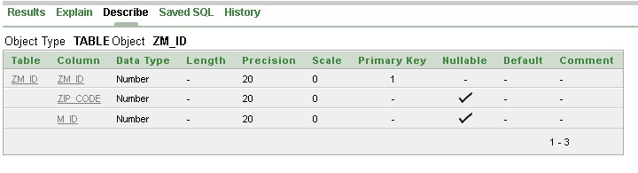

create table ww_id

(

ww_id varchar2(20) constraint ww_id_pk primary key,

w_city varchar2(20),

w_address varchar2(20)

)

Desc ww_id  
  
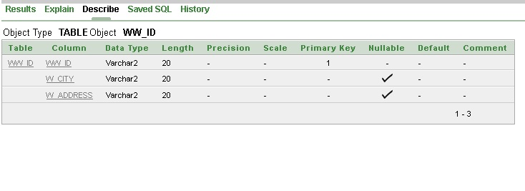

create table waiter

(

w_id number(20) constraint waiter_w_pk primary key,

w_name varchar2(20),

w_phone number(20),

ww_id varchar2(20) constraint waiter_ww_fk references ww_id(ww_id)

)

desc waiter  
  
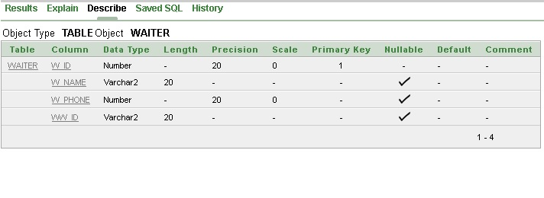

create table mm_id

(

mm_id number(20)constraint mm_id_pk primary key,

m_city varchar2(20),

m_address varchar2(20)

)

Desc mm_id  
  
  
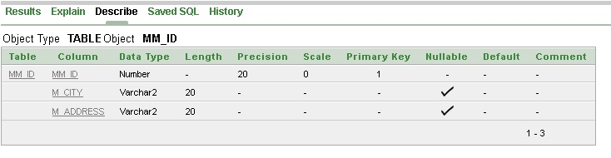

create table manager2

(

m_id number(20) constraint ma_mid_pk primary key,

m_name varchar2(20),

m_phone number(20),

m_email varchar2(20),

mm_id number(20) constraint ma_mid_fk references mm_id(mm_id),

order_no number(20) constraint ma_on_fk references order1(order_no)

)

desc manager2  
  
  
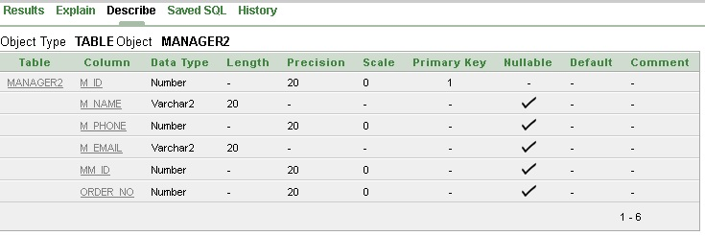

create table manager1

(

m_id number(20) constraint man_mid_pk primary key,

m_name varchar2(20),

m_phone number(20),

m_email varchar2(20),

mm_id number(20) constraint man_mid_fk references mm_id(mm_id),

c_id number(20) constraint man_cid_fk references cashier(c_id)

)

Desc manager1  
  
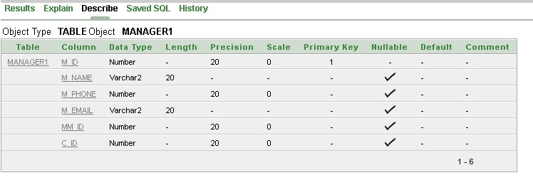

create table manager3

(

m_id number(20) constraint manager_mid_pk primary key,

m_name varchar2(20),

m_phone number(20),

m_email varchar2(20),

mm_id number(20) constraint manager_mid_fk references mm_id(mm_id),

w_id number(20) constraint manager_wid_fk references waiter(w_id)

)  
  
desc manager3  
  
  
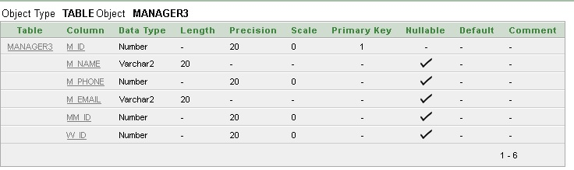

create table food_item

(

f_no number(20) constraint o_fn_pk primary key,

f_name varchar2(20),

f_amount number(20),

f_quantity number(20),

order_no number(20) constraint f_on_fk references order1(order_no)

)

Desc food_item

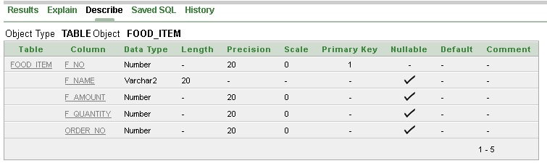

create table customer

(

cu_id number(20) constraint cus_cid_pk primary key,

cu_name varchar2(20),

cu_phone number(20),

ccu_id number(20) constraint cus_cu_fk references ccu_id(ccu_id),

bill_no number(20) constraint cus_bn_fk references bill(bill_no)

)

desc customer  
  
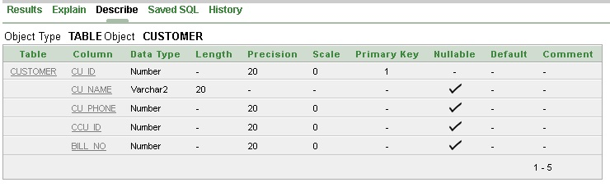

create table cake_shop1

(

zip_code number(20) constraint ca_zip_pk primary key,

phone number(20),

name varchar2(20),

ac_id number(20) constraint ca_acid_fk references ac_id(ac_id),

w_id number(20) constraint ca_wid_fk references waiter(w_id)

)

desc cake_shop1  
  
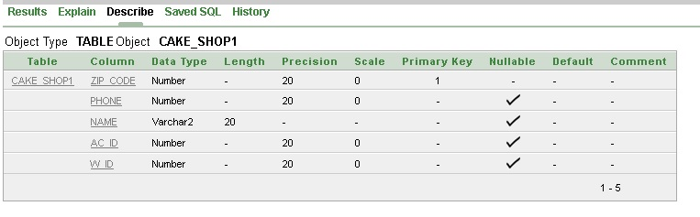

create table cake_shop

(

zip_code number(20) constraint cake_zip_pk primary key,

name varchar2(20),

phone number(20),

ac_id number(20) constraint cake_acid_fk references ac_id(ac_id),

c_id number(20) constraint cake_cid_fk references cashier(c_id)

)

desc cake_shop  
  
  
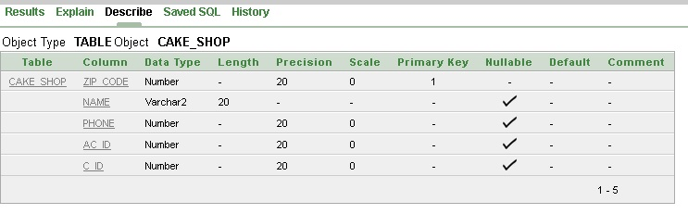

create table ccu_id

(

ccu_id number(20) constraint ccu_id_pk primary key,

cu_city varchar2(20),

cu_address varchar2(20)

)

Desc ccu_id  
  
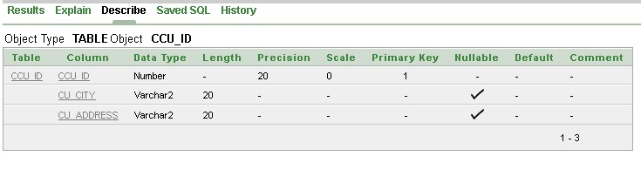

create table cc_id

(

cc_id number(20) constraint cc_id_pk primary key,

c_city varchar2(20),

c_address varchar2(20)

)

Desc cc_id  
  
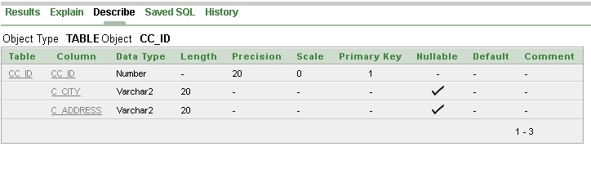

create table cashier

(

c_id number(20) constraint c_cid_pk primary key,

c_name varchar2(20),

c_phone number(20),

cc_id number(20) constraint c_ccid_fk references cc_id(cc_id)

)

desc cashier  
  
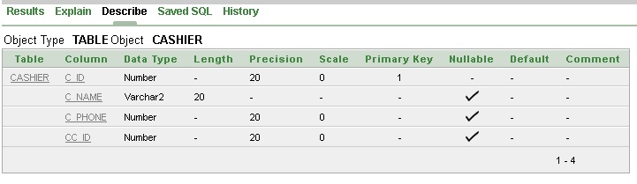

create table bill_customer

(

bc_id number(20) constraint bc_id_pk primary key,

bill_no number(20) constraint bc_bn_fk references bill(bill_no),

c_id number(20) constraint bc_cid_fk references cashier(c_id)

)

Desc bill_customer  
  
  
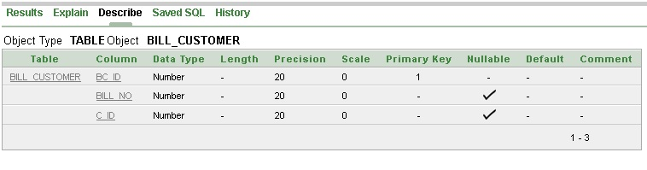

create table bill

(

bill_no number(20) constraint b_bno_pk primary key,

time number(20),

date_1 date,

amount number(20)

)

desc bill  
  
  
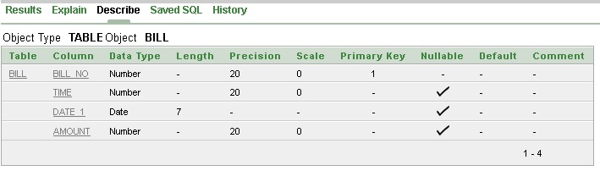

create table ac_id

(

ac_id number(20) constraint ac_id_pk primary key,

city varchar2(20),

address varchar2(20)

)

Desc ac_id  
  
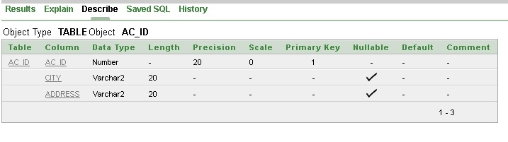

**Data Insertion :**  
  
insert into ww_id

(ww_id,w_city,w_address) values (1,'Dhaka','khilgaon')

(ww_id,w_city,w_address) values (2,'Dhaka','khilgaon')

(ww_id,w_city,w_address) values (3,'Dhaka','Basabo')

(ww_id,w_city,w_address) values (4,'Dhaka','Uttara')

(ww_id,w_city,w_address) values (5,'Dhaka','Uttara')

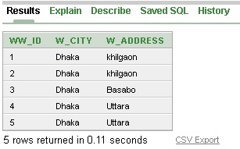

insert into waiter

(w_id,w_name,w_phone,ww_id) values (1001,'Fahad',01670000000,1)

(w_id,w_name,w_phone,ww_id) values (1002,'Farabi',0170000000,2)

(w_id,w_name,w_phone,ww_id) values (1003,'Fahim',01800000000,3)

(w_id,w_name,w_phone,ww_id) values (1004,'Sakib',01770000000,4)

(w_id,w_name,w_phone,ww_id) values (1005,'Abrar',01690000000,5)  
  
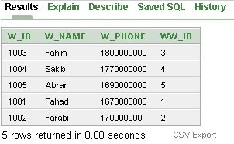

insert into order1

(order_no,order_type,order_cu_id,order_quantity,w_id)values(101,'Chocolate',01,1,1001)

(order_no,order_type,order_cu_id,order_quantity,w_id)values(102,'Chocolate',02,1,1002

(order_no,order_type,order_cu_id,order_quantity,w_id)values(103,'Strawberry',03,2,1003)

(order_no,order_type,order_cu_id,order_quantity,w_id)values(104,'Strawberry',04,1,1004)

(order_no,order_type,order_cu_id,order_quantity,w_id)values(105,'Strawberry',05,1,1005)  
  
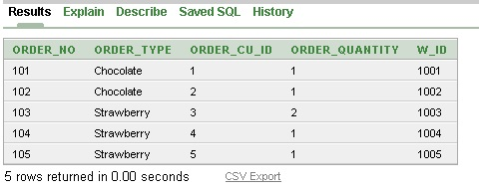

insert into food_item

(f_no,f_name,f_amount,f_quantity,order_no)values(3,'Black Forest',50,1,101)

(f_no,f_name,f_amount,f_quantity,order_no)values(4,'Chocolate Resbery',70,1,102)

(f_no,f_name,f_amount,f_quantity,order_no)values(6,'Biscuit Cake',55,2,103)

(f_no,f_name,f_amount,f_quantity,order_no)values(7,'Chocolate Italian',45,1,104)

(f_no,f_name,f_amount,f_quantity,order_no)values(8,'Genoise Cake',80,1,105)  
  
  
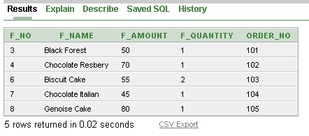

insert into mm_id

(mm_id,m_city,m_address)values(101,'Dhaka','Uttara')

(mm_id,m_city,m_address)values(102,'Dhaka','Uttara')

(mm_id,m_city,m_address)values(103,'Dhaka','Gulshan')

(mm_id,m_city,m_address)values(104,'Dhaka','Banani')

(mm_id,m_city,m_address)values(105,'Rajshahi','Rohanpur')  
  
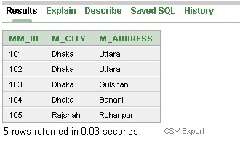  
  
  
insert into manager3

(m_id,m_name,m_phone,m_email,mm_id,w_id)values(01,'Rakib',0160000,'rakib@gmail.com',101,1001)

(m_id,m_name,m_phone,m_email,mm_id,w_id)values(02,'Niloy',0170000,'niloy@gmail.com',102,1002)

(m_id,m_name,m_phone,m_email,mm_id,w_id)values(03,'Rahi',0180000,'rahi@gmail.com',103,1003)

(m_id,m_name,m_phone,m_email,mm_id,w_id)values(04,'Nahid',0160000,'nahid@gmail.com',104,1004)

(m_id,m_name,m_phone,m_email,mm_id,w_id)values(05,'Mahi',0190000,'mahi@gmail.com',105,1005)  
  
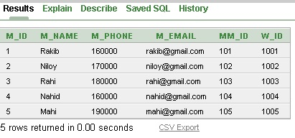  
  
  
  
  
insert into ac_id

(ac_id, city, address)values(01,'Khilgaon','Dhaka')  
(ac_id, city, address)values(02,'Basabo','Dhaka')  
(ac_id, city, address)values(03,'Basabo','Dhaka')  
(ac_id, city, address)values(04,'Basabo','Dhaka')  
(ac_id, city, address)values(05,'Basabo','Dhaka')  
  
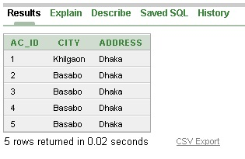  
  
insert into cake_shop1

(zip_code,phone,name,ac_id,w_id)values(1201,017000,'Eshna',01,1001)

(zip_code,phone,name,ac_id,w_id)values(1202,015000,'Nusrat',02,1002)

(zip_code,phone,name,ac_id,w_id)values(1203,016000,'Nishat',03,1003)

(zip_code,phone,name,ac_id,w_id)values(1204,017000,'Fabiha',04,1004)

(zip_code,phone,name,ac_id,w_id)values(1205,018000,'Simran',05,1005)  
  
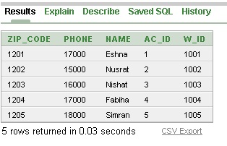  
  
  
  
  
  
  
insert into cc_id

(cc_id,c_city,c_address)values(01,'Dhaka','Uttara')

(cc_id,c_city,c_address)values(02,'Dhaka','Gulshan')

(cc_id,c_city,c_address)values(03,'Dhaka','Dhanmondi')

(cc_id,c_city,c_address)values(04,'Dhaka','Mirpur')

(cc_id,c_city,c_address)values(05,'Dhaka','Khilgaon')  
  
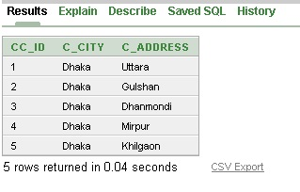

insert into cashier

(c_id,c_name,c_phone,cc_id)values(101,'Muna',019000,01)

(c_id,c_name,c_phone,cc_id)values(102,'Fariha',018000,02)

(c_id,c_name,c_phone,cc_id)values(103,'Isaba',017000,03)

(c_id,c_name,c_phone,cc_id)values(104,'Sarvia',016000,04)

(c_id,c_name,c_phone,cc_id)values(105,'Oishee',019000,05)  
  
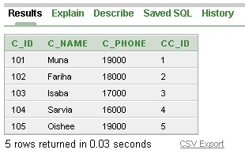  
  
  
insert into cake_shop

(zip_code,name,phone,ac_id,c_id)values(1201,'Eshna',019000,01,101)

(zip_code,name,phone,ac_id,c_id)values(1202,'Nusrat',017000,02,102)

(zip_code,name,phone,ac_id,c_id)values(1203,'Nishat',015000,03,103)

(zip_code,name,phone,ac_id,c_id)values(1204,'Fabiha',016000,04,104)

(zip_code,name,phone,ac_id,c_id)values(1205,'Simran',018000,05,105)  
  
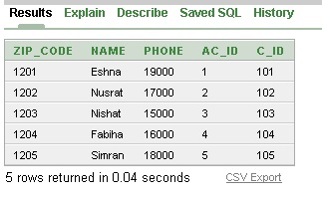  
  
  
insert into manager1

(m_id,m_name,m_phone,m_email,mm_id,c_id)values(01,'Rakib',0160000,'rakib@gmail.com',101,101)

(m_id,m_name,m_phone,m_email,mm_id,c_id)values(02,'Niloy',0170000,'niloy@gmail.com',102,102)

(m_id,m_name,m_phone,m_email,mm_id,c_id)values(03,'Rahi',0180000,'rahi@gmail.com',103,103)

(m_id,m_name,m_phone,m_email,mm_id,c_id)values(04,'Nahid',0160000,'nahid@gmail.com',104,104)

(m_id,m_name,m_phone,m_email,mm_id,c_id)values(05,'Mahi',0190000,'mahi@gmail.com',105,105)  
  
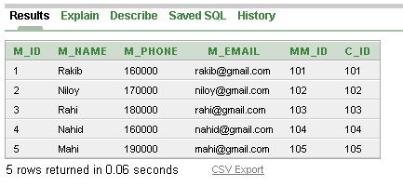  
  
  
  
insert into bill

(bill_no,time,date_1,amount)values(129,2.45,to_date('14/08/19','DD MM YYYY'),500)

(bill_no,time,date_1,amount)values(127,3.28,to_date('14/08/19','DD MM YYYY'),700)

(bill_no,time,date_1,amount)values(105,5.30,to_date('14/08/19','DD MM YYYY'),700)

(bill_no,time,date_1,amount)values(119,6.16,to_date('14/08/19','DD MM YYYY'),500)

(bill_no,time,date_1,amount)values(116,7.30,to_date('14/08/19','DD MM YYYY'),1000)  
  
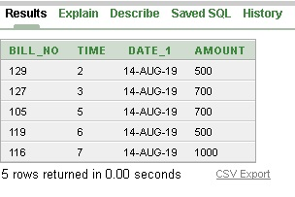  
  
  
insert into bill_customer

(bc_id,bill_no,c_id)values(01,129,101)

(bc_id,bill_no,c_id)values(02,127,102)

(bc_id,bill_no,c_id)values(03,105,103)

(bc_id,bill_no,c_id)values(04,119,104)

(bc_id,bill_no,c_id)values(05,116,105)  
  
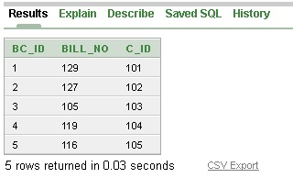  
  
  
insert into ccu_id

(ccu_id,cu_city,cu_address)values(101,'Dhaka','Rampura')

(ccu_id,cu_city,cu_address)values(102,'Dhaka','Khilgaon')

(ccu_id,cu_city,cu_address)values(103,'Dhaka','Basabo')

(ccu_id,cu_city,cu_address)values(104,'Dhaka','Uttara')

(ccu_id,cu_city,cu_address)values(105,'Dhaka','Dhanmondi')  
  
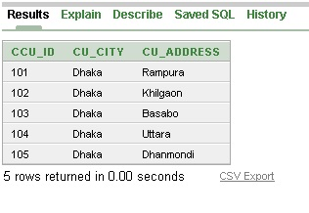  
  
insert into customer

(cu_id,cu_name,cu_phone,ccu_id,bill_no)values(01,'Bonna',016000,101,129)

(cu_id,cu_name,cu_phone,ccu_id,bill_no)values(02,'Akhy',017000,102,127)

(cu_id,cu_name,cu_phone,ccu_id,bill_no)values(03,'Ruponty',018000,103,105)

(cu_id,cu_name,cu_phone,ccu_id,bill_no)values(04,'Nourin',019000,104,119)

(cu_id,cu_name,cu_phone,ccu_id,bill_no)values(05,'Nowshin',016000,105,116)  
  
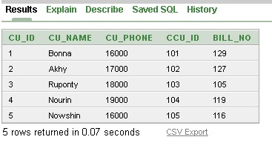

insert into manager2

(m_id,m_name,m_phone,m_email,mm_id,order_no)values(01,'Rakib',016000,'rakib@gmail.com',101,101)

(m_id,m_name,m_phone,m_email,mm_id,order_no)values(02,'Niloy',017000,'niloy@gmail.com',102,102)

(m_id,m_name,m_phone,m_email,mm_id,order_no)values(03,'Rahi',018000,'rahi@gmail.com',103,103)

(m_id,m_name,m_phone,m_email,mm_id,order_no)values(04,'Nahid',016000,'nahid@gmail.com',104,104)

(m_id,m_name,m_phone,m_email,mm_id,order_no)values(05,'Mahi',017000,'mahi@gmail.com',105,105)  
  
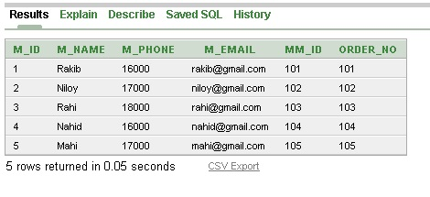  
  
insert into zm_id

(zm_id,zip_code,m_id)values(01,1201,01)

(zm_id,zip_code,m_id)values(02,1202,02)

(zm_id,zip_code,m_id)values(03,1203,03)

(zm_id,zip_code,m_id)values(04,1204,04)  
  
(zm_id,zip_code,m_id)values(05,1205,05)  
  
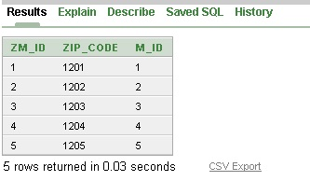  
**Query Writing :**

**Joining**1. Write a Query in SQL to Display the order no,ordertypes,waiterno,name from order1  
  
Ans :select o.order_no,o.order_type,w.w_id,w.w_name from order1 o,waiter w where o.w_id=w.w_id  
  
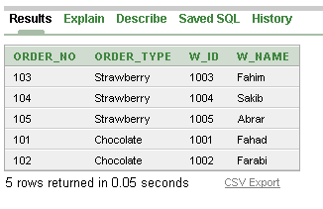  
  
2. Write a Query in SQL to Display manager no, manager name for all manager, waiter no, waiter name for all manager for waiters 1002 to 1009  
  
Ans: select m.m_id,m.m_name,w.w_id,w.w_name from manager3 m ,waiter w where m.w_id=w.w_id and w.w_id in (1002,1004)  
  
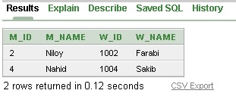  
  
  
  
  
  
  
  
3.Write a Query SQL to Display those manager who contain a letter ‘h’ to the managers name and also display their email,waitername,manager city  
  
Ans: select m.m_name,m.m_email,w.w_name,mm.m_city from manager2 m,waiterw,mm_id mm where m.mm_id=mm.mm_id and m.m_name like '%h%'  
  
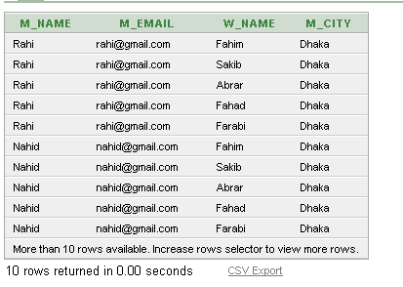  
  
**Sub Query :**1. Display the time,date for all bill where amount is more than the bill no 119 (bill table)  
  
Ans : select time ,date_1 from bill where amount>(select amount from bill where bill_no=119)  
  
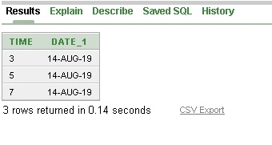  
  
  
  
  
  
  
  
  
  
2. Display food item no,name,order no for all foods where item amount is less than the average amount(food-item table)  
  
Ans: select f_no,f_name,order_no from food_item where f_amount<(select avg(f_amount) from food_item)  
  
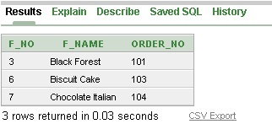  
  
3. Display time,date for all bill where amount is more than the maximum amount in bill no 105(bill table)   
  
Ans : select time,date_1 from bill where amount>(select max(amount) from bill where bill_no=105)  
  
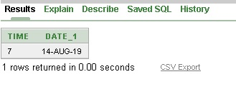  
  
**Group Func** :   
  
1. Display average amount of bill by their date ?  
  
ans : select avg(amount) from bill group by date_1  
  
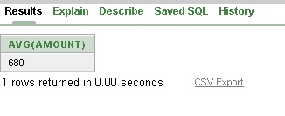  
  
  
  
  
  
  
2. Display sum of amount of all bill no and name the column as total amount ?  
  
ans. select sum(amount) as "Total Amount" from bill group by bill_no  
  
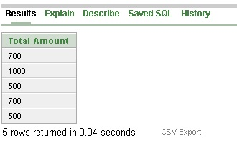  
  
 **View** :   
  
create a view cakeshop ,that contains details of cake_shop in cashier 103  
  
ans : create view cake_cid_103

as select zip_code,name,phone,ac_id,c_id from cake_shop where c_id=103

describe cake_cid_103  
  
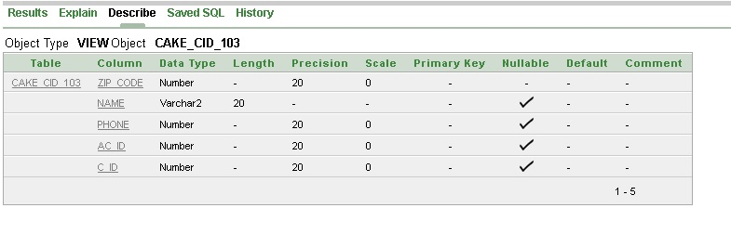  
  
  
  
  
  
  
**Conclusion :** After the efforts by all our group members we created out database managment project “Cake shop management system” Initially face some problems but then gradually we worked on it and was able to overcome that .Now, hopefully we will be able to create database system for different projects