ECSE 429 SESSION 2 NOTES - /todos Deep Validation and Robustness

CHARTER
Identify capabilities and areas of potential instability of the “rest api todo list manager”.
Identify documented and undocumented “rest api todo list manager” capabilities.
For each capability, create a script or small program to demonstrate the capability.
Exercise each capability identified with data typical to the intended use of the application.
Build
runTodoManagerRestAPI-1.5.5.jar
Area
/todos- JSON bodies; header negotiation checks
Environment
MacOS 15.6.1, Postman
START
22:00 06/10/2025
TESTER
Farhad Guliyev, 260961366, farhad.guliyev@mail.mcgill.ca
DURATION
45 minutes
TEST NOTES
TEST NOTES
22:00 (Prep) Restart server. GET /todos — Expect 200 & JSON; Observed: Correct behavior
22:03 POST /todos — A {"title":"S2-A","doneStatus":false,"description":"A_desc"} — 200/201; tidA=4
22:05 POST /todos — B {"title":"S2-B","doneStatus":true,"description":"B_desc"} — 200/201; tidB=5
22:07 POST /todos — C {"title":"S2-C","doneStatus":false,"description":"C_desc"} — 200/201; tidC=6
22:11 GET /todos?doneStatus=false&title=S2-C — Expect ONLY C. Observed: Correct Behavior
22:15 GET /todos?title=s2-a — Expect 0 (case-sensitive exact). Observed: todos []. Correct behavior
22:20 POST /todos/{id A} {"doneStatus":true} — Expect partial amend OK; title unchanged. Observed: Correct behavior
22:25 PUT /todos/{id B} {"doneStatus":false} — Expect 4xx. Observed: 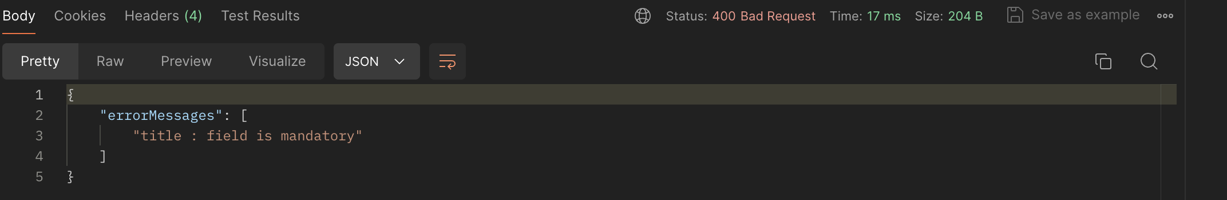
Issue: PUT requires title while POST accepts partial updates, docs say amend with fields provided.
22:30 POST /todos {"title":" ","doneStatus":false} — Expect 4xx (empty title). Observed:
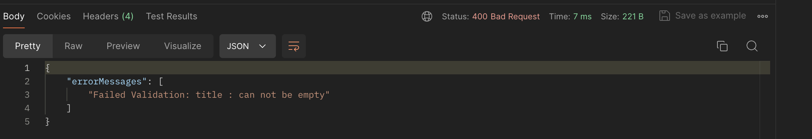
Correct behavior
22:35 POST /todos (JSON body, Content-Type: application/xml) — Expect 415. Observed:
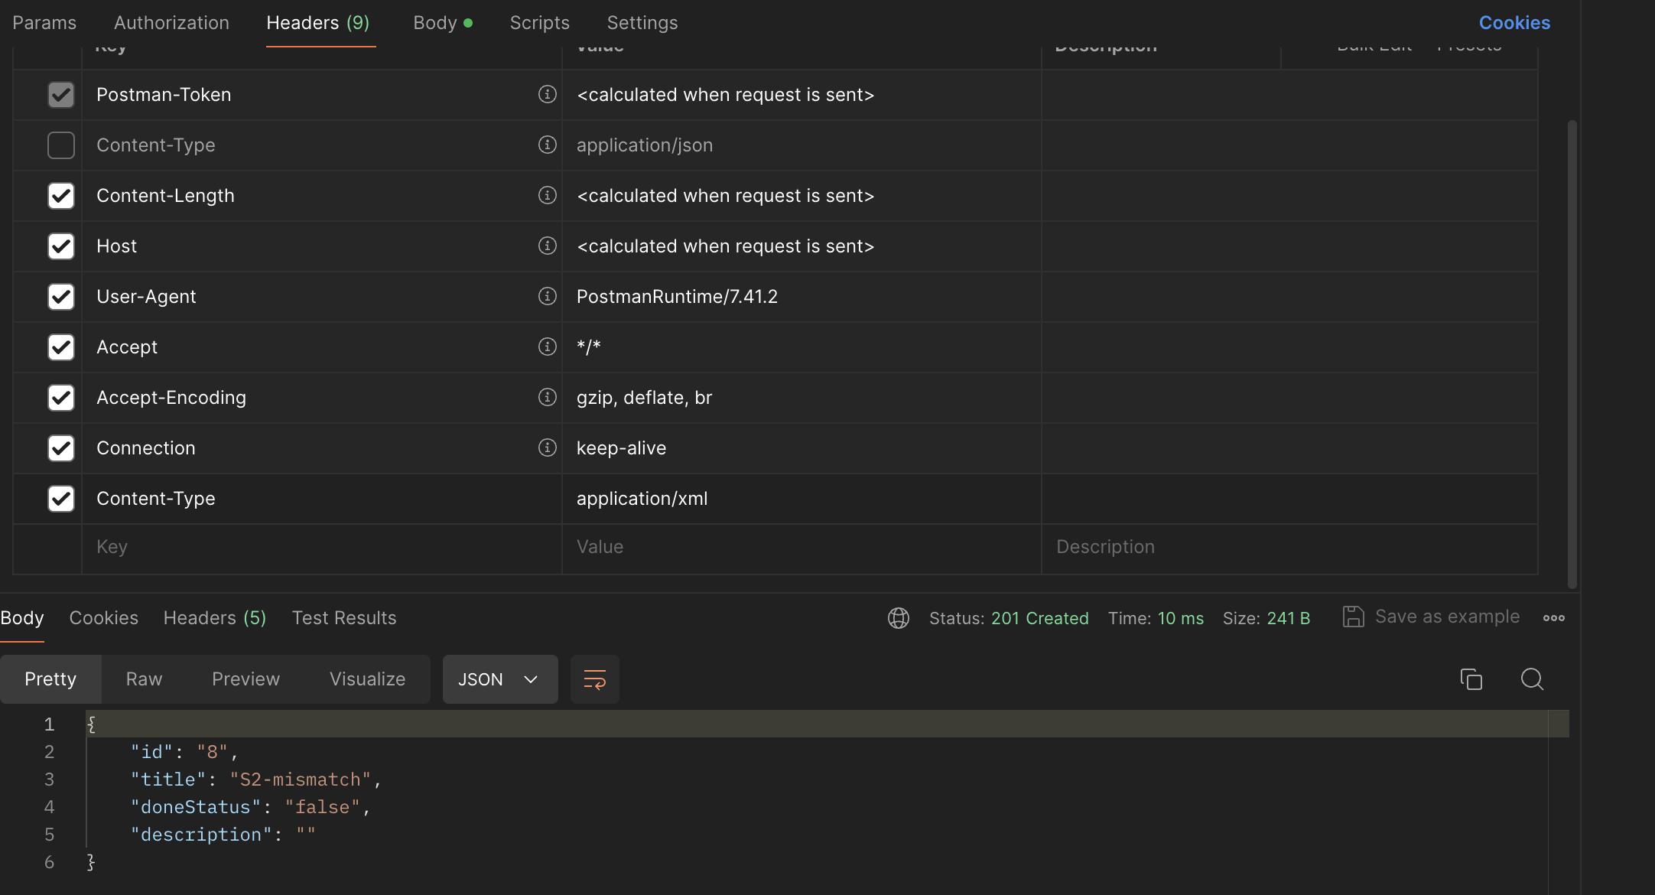
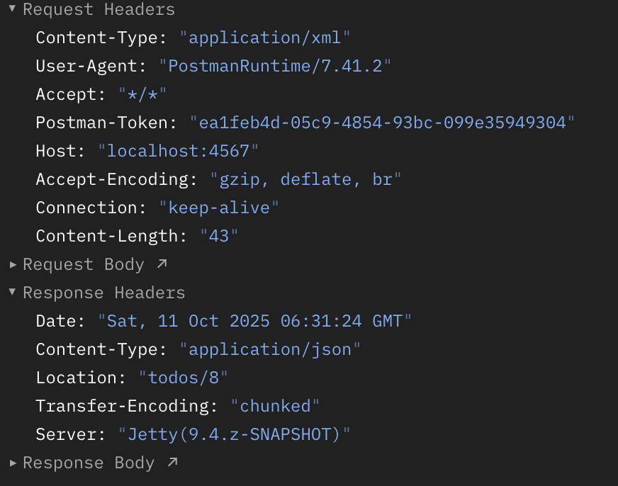
Issue: 201 Created; response Content-Type=application/json; id=8. (server accepts mismatched Content-Type).
22:38 GET /todos with Accept: text/plain — Expect 406 or ignore. Observed:
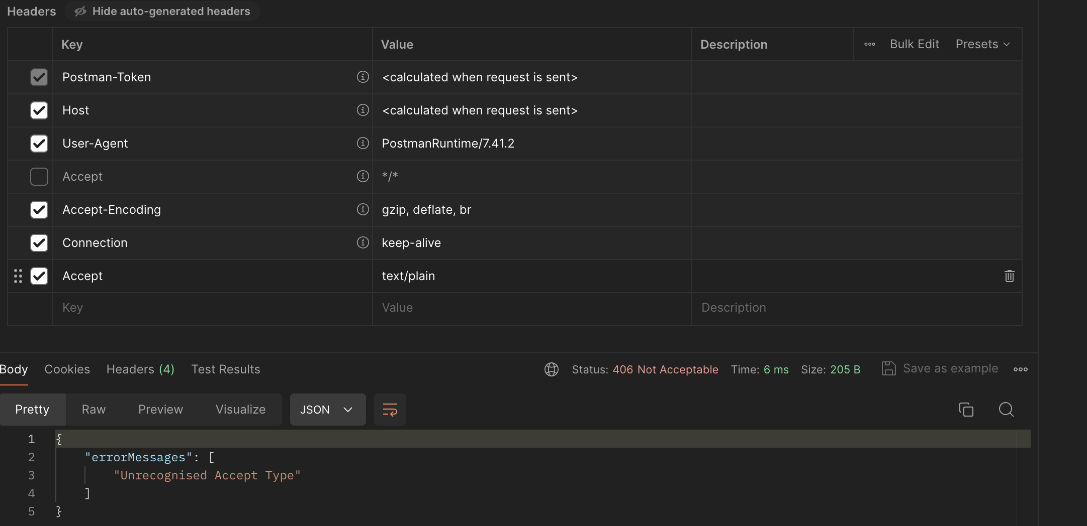
Correct behavior
22:45 PATCH /todos/{tidA} — Expect 405 (unsupported). Observed: Correct behavior
Ending session
Bugs Logged/Closed
None
Issues/Concerns
(I-01) PUT requires title while POST allows partial updates. PUT /todos/{id} with only doneStatus returned 400 "title : field is mandatory", whereas POST /todos/{id} amended doneStatus without needing title. Docs say both “amend … with the fields to amend.”
(I-02) Accepts mismatched Content-Type. POST /todos with JSON body but Content-Type: application/xml returned 201 Created and parsed JSON anyway. Expected 415.

List of Testing Ideas
- Multi-parameter filters with URL-encoded spaces and combined fields (e.g., title=S2-C&description=C_desc).
- Boundary lengths for title and description (very long strings), and whitespace-only variants.
Areas of Potential Risk
- API contract ambiguity on update semantics (POST vs PUT) may break clients that rely on partial updates.
- Lenient Content-Type parsing can hide integration errors and cause inconsistent behavior across clients.
- Unclear filter rules (case sensitivity / exact vs substring) can lead to missed or unexpected results in consumers.
Capabilities
- Multi-parameter filtering on /todos (e.g., doneStatus=false&title=S2-C).
- Partial amend via POST /todos/{id}; replace-style or stricter update via PUT /todos/{id}
- Validation rejects whitespace-only title.
- Accept header handling for unsupported types (Accept: text/plain handled without error per your note).
- Unsupported verb handling (PATCH /todos/{id} rejected).

Artifacts Referenced
Issue 1 – S2-I1.png
Issue 2 – S2-I2.png
All Api calls - ECSE429 Part A.postman_collection.json

