ECSE 429 SESSION 1 NOTES

CHARTER
Identify capabilities and areas of potential instability of the “REST API Todo List Manager”.
Identify documented and undocumented “REST API Todo List Manager” capabilities.
For each capability, create a script or small program to demonstrate the capability.
Exercise each capability with data typical to the intended use of the application.
Build
runTodoManagerRestAPI-1.5.5.jar
Area
Typical Scenarios – /todos CRUD & validation
Environment
MacOS 15.6.1, Postman
START
21:00 05/10/2025
TESTER
Farhad Guliyev, 260961366, farhad.guliyev@mail.mcgill.ca
DURATION
45 minutes
TEST NOTES
21:02 GET /todos — Expect 200 and JSON with todos[]. Observed: Correct behavior
21:05 POST /todos (valid JSON) — Expect 200/201 and created id. Observed: 200(correct) id=10
21:10 GET /todos/{id} — Expect 200; fields match. Observed: Correct behavior
21:15PUT /todos/{id} — Expect 200; re-GET confirms update. Observed: Correctly updated title.
21:20 DELETE /todos/{id} — Expect 200/204. Observed: Correct behavior
21:25 DELETE /todos/{id} (again) — Expect 4xx not found. Observed: 404 Not Found(Correct behavior)
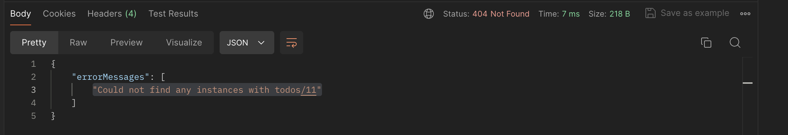
21:30 POST /todos (missing title) — Expect 4xx. Observed: 404 Bad Request(correct behavior)
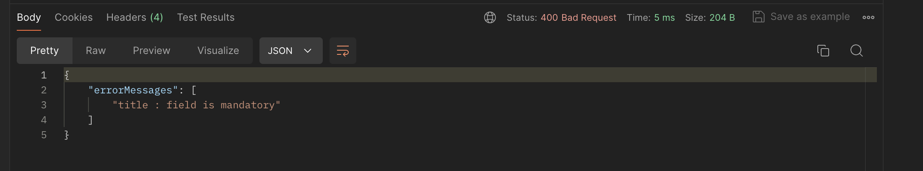
21:35 POST /todos (wrong types: title=123, doneStatus=true) — Expect 4xx. Observed: 201 Created (validation type mismatch issue detected). Converted 123(not string type) to 123.0 and accepted post.
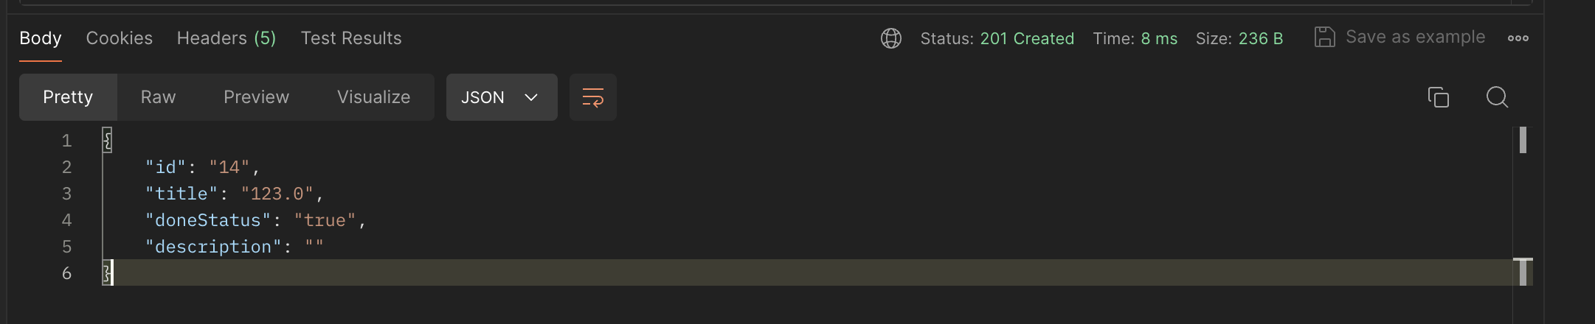
21:40GET /todos with Param doneStatus=false — Expect filtered results. Observed: Correct bwhavior
21:42 GET /todos with Accept: application/xml — Expect 200 + Content-Type: application/xml and <todos>…</todos> Observed: Correct behavior
21:45 GET /todos/9999 — Expect 404. Observed: Correct behavior
Bugs Logged
(1) Accepts non-string title; coerces number → POST /todos with {"title":123,"doneStatus":true} returned 201, body shows "title":"123.0". Expected: 4xx validation error. Status: Open.
Issues/Concerns
(1) Type inconsistency for doneStatus → Input must be boolean, but JSON responses often serialize as "true"/"false" (strings). Clarify docs/contract.
(2) Missing title returns 404 → POST /todos without title gave 404 (Not Found) rather than 400 (Bad Request). Semantics may confuse clients.
(3) In-memory data → Data resets on server restart; tests dependent on prior state may be flaky without setup/teardown.
List of Testing Ideas
(1) Mandatory fields matrix: blank/whitespace/very long title; missing/extra fields.
(2) More filters: title=, description=, multi-param (AND) queries.
(3) Relationship ops next session: /todos/:id/categories and /todos/:id/tasksof create/list/delete + bidirectionality checks.
(4) Content negotiation edges: conflicting headers (JSON body + Accept: application/xml), unknown Accept.
(5) Malformed JSON/XML and wrong Content-Type handling.
Areas of Potential Risk
(1) Validation leniency (type coercion) → corrupted data / client surprises.
(2) Status-code inconsistencies (404 vs 400) → error handling in client libraries may break.
(3) Contract drift (doneStatus boolean vs string in responses) → deserialization issues for strictly typed consumers.
Capabilities
CRUD on /todos (create/read/update/delete).
Filtering via query param (doneStatus=false).
Content negotiation via Accept: application/xml.
Error handling for non-existent IDs (GET /todos/9999 → 404).
Negative validation scenarios (missing title, wrong types).
Artifacts Referenced
Bug 1 – S1-B1.png
All Api calls - ECSE429 Part A.postman_collection.json

