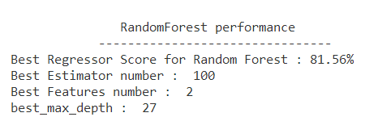



Best model : model 6 out of 320 models tested with score of 81.56 %

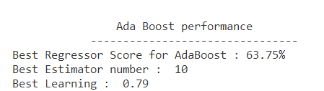

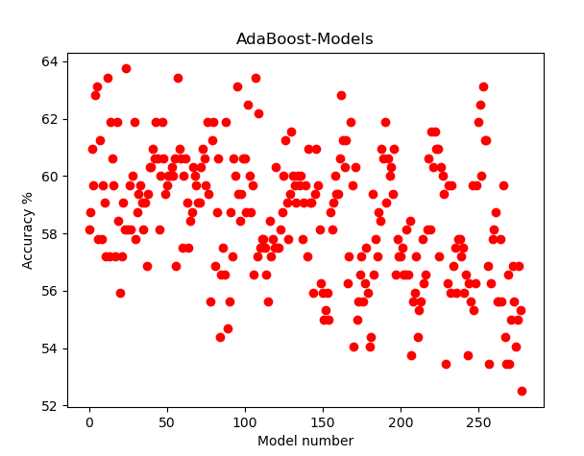

Best model : model 24 out of 279 models tested with score of 63.75 %

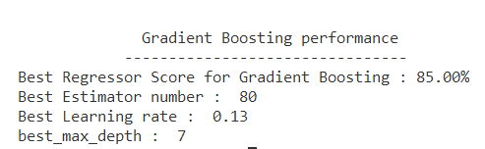

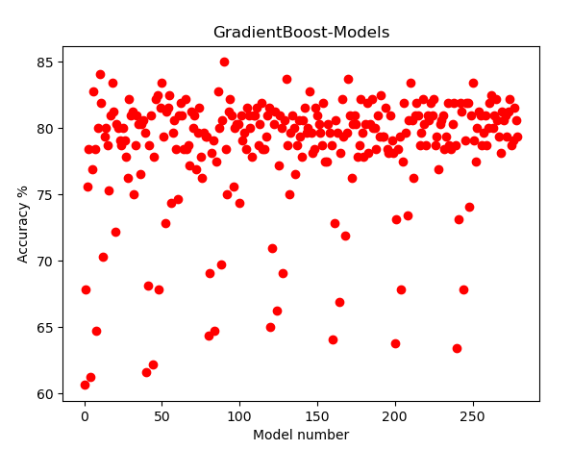

Best model : model 90 out of 280 models tested, with score of 85.0 %.