|  |  |
| --- | --- |
| OS - Shell Script  [2022] |  |
|  |  |
| [29.08.2022]  Techno India College of Technology  Authored by: Abu Taha Md Farhad  Roll: 31401221052  Reg No: 213141001210016 OF 2021-22  Stream: BCA 2nd year  Subject: Operating System Lab [BCAC392] |  |

# Write a shell script to find the length of an input string:

## Code:

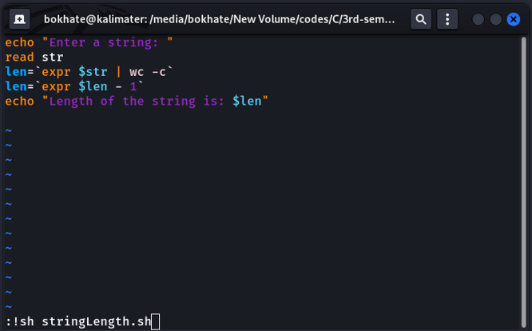

## Output:

## 

# Write a shell script to perform an arithmetic operation upon two inputs. The operation should also be input by the user.

## Code:

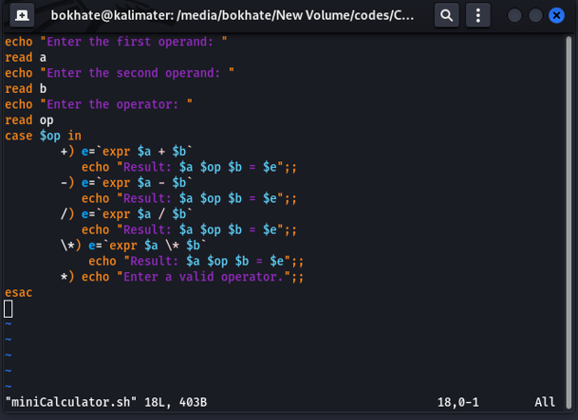

## Output:

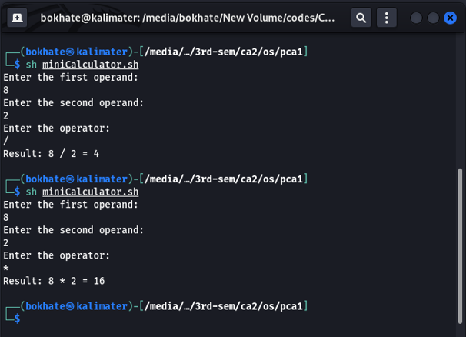

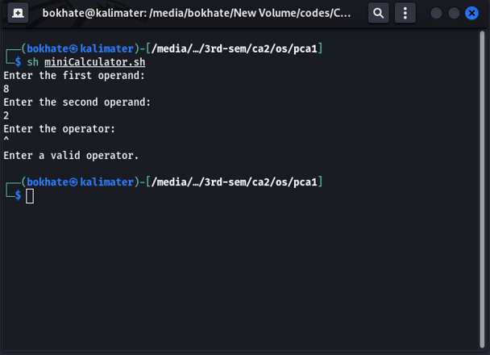

# Write a shell script to find out the smallest among 3 inputs.

## Code:

## 

## Output:

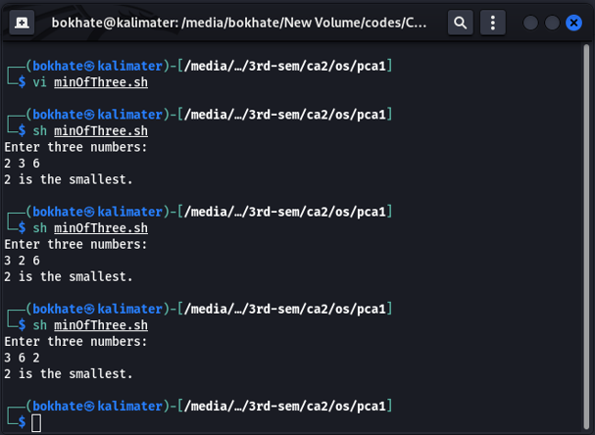

# Write a shell script to print all the multiplication table of a number input by the user.

## Code:

## 

## Output:

## 

# Write a shell script to generate the series of even numbers like 0,2,4,6….n (n is given by user):

## Code:

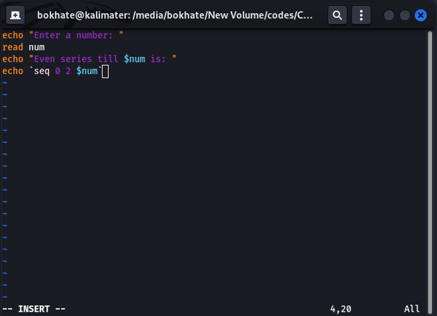

## Output:

