**ENEL441 Lab 2**

**Winter 2020**

**Dynamic models and responses**

**Objective**

The objective of this lab is to derive a transfer function model for a translational system and then calculate the system response based on various excitations. The working example for this purpose will be a simplified model of a vehicle suspension system.

**Method**

1. Analyze the simplified model of a car’s suspension system and determine the associated differential equations.   
2. Optimize one of the suspension parameters for the ‘best’ step response.   
3. Determine the response of the suspension system to a step response and a Gaussian shaped speed bump  
4. Produce a Simulink model of the suspension system

A simplified car suspension model can be created from the assumption at that all four wheels operate independently. Each wheel is associated with the quarter weight of the car body, a spring, a shock absorber, wheel mass, and an equivalent spring (compliance or stiffness) of the tire.

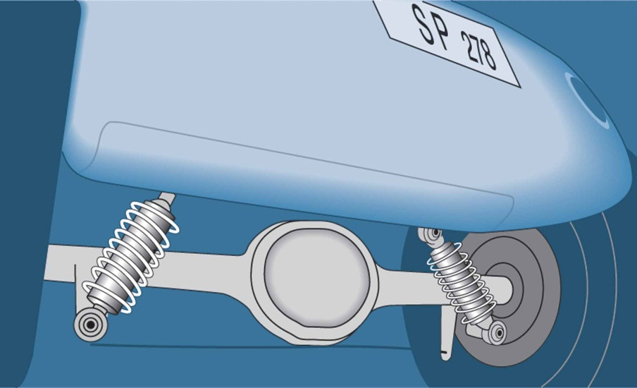

***Figure 1*** *Car suspension system*

To simplify the analysis of the car suspension we consider only one wheel and assume that this supports a quarter of the car body. A simplification made is the approximation that all of the four wheels of the car behave independently. Although highly simplified, it can provide an initial approximate simulation of the dynamics of the overall car suspension. The *quarter car model* of the simplified car suspension is shown in Figure 2. It is based on two inertial masses, the mass of the wheel and the mass of a quarter of the car chassis.

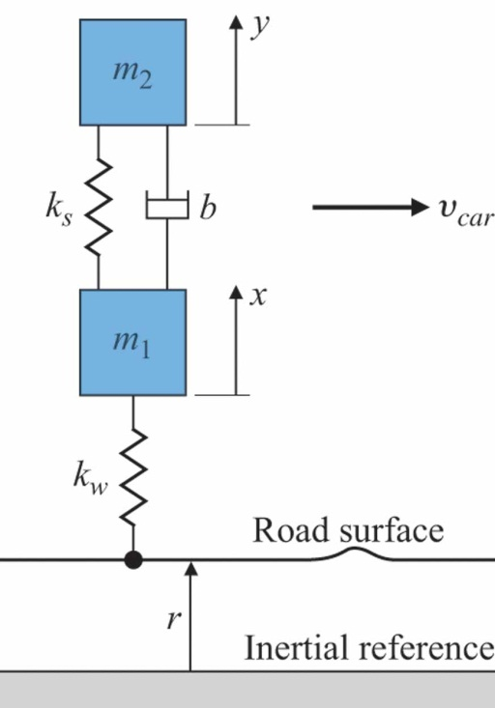

***Figure 2*** *Quarter car model of suspension system*

The following definitions are made:

- wheel center height relative to nominal position (pre-compressed)

- car height relative to wheel in nominal position (pre-compressed)

- height of road surface as a function of time (assume the car has a constant forward velocity)

- effective stiffness constant of tire/wheel

- stiffness constant of suspension spring

- damping coefficient of shock absorber

- mass of wheel

- quarter mass of car body or chassis (assuming that the mass is equally distributed across the four wheels)

It is assumed that when the car is in equilibrium that the tire and spring are pre-compressed and that this equilibrium point is taken as y=0 and x=0 when the height of the road surface, r is zero. Note also that the tire is always assumed to make contact with the road surface. Even in the speed bump the tire never leaves the road surface to become momentarily airborne.

We can determine the differential equations needed to define the system by splitting the simplified dynamic model into two free body diagrams, one for the tire mass and one for the chassis mass.

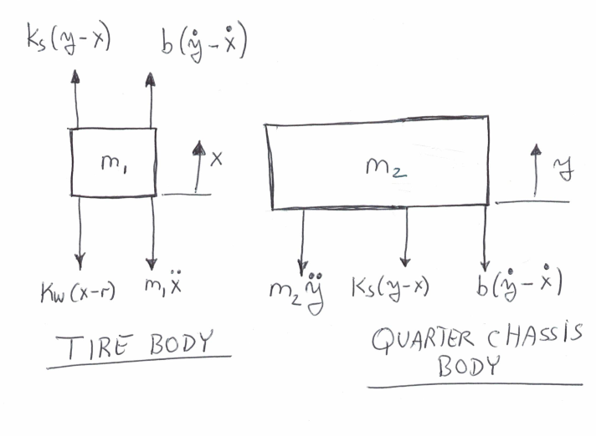

***Figure 3*** *Free body diagrams*

As the whole lab is built up from these free body diagrams, make sure you understand them and how they represent the simplified car suspension model.

The car is moving with a constant velocity of  such that the road surface height as seen by the tire is a function of time given by . Note that  should be a function of the distance along the road however, as is constant, the road height can be taken as a function of time, simplifying the overall model.

Based on the partitioned free body diagram, the ‘F=MA’ equations of motion for the quarter car model can be expressed as:

|  |  |
| --- | --- |
|  |  |

For this lab assume a state vector of



and that the independent input is the road surface of r(t). Let the output of the system be the vertical displacement of the car body denoted by the variable such that.The state space representation is therefore



where the matrices  comprise the state space representation.

The parameter values to be used in this lab are:



Also initially assume the parameter for the shock absorber damping of



These parameters will be varied in later parts.

**A)** Determine the state space equations for this system. That is, find the matrices such that



with  and the independent input being the road surface r(t).

**B)** Write a Matlab problem that will populate the system matrices, that you derived in the part A. Then generate a plot of the response of the four state variables to a step change in the road surface r(t). Use Matlab’s step() function to generate this. Show the matlab code and the four plots of the state variable step responses.

Do the plots make sense? Consider the transient and the steady state values of each of the state variables. Clearly a road step of 1 meter is of course too large to be realistic. However since the suspension system is assumed to be linear then there are not restrictions in this regard. Hence you can relate the step response from a 1cm step to be more realistic. State any other observations such as the transient responses and steady state values of x and y.

**C)** Reduce b in part B to . Now plot the step function of the state variable y(t). Explain the results that you see.

**D)** Repeat part B but now increase b to . Now plot the step function of the state variable y(t). Explain the results that you see. Answer the question as to why with all this damping both x(t) and y(t) have a large overshoot and oscillatory response.

**E)** Use your calculation procedure developed in the previous parts to determine the overshoot of the step response for y(t) for different values of damping b with all the other parameters remaining fixed. Complete the following table:

|  |  |
| --- | --- |
| b N sec/m | % overshoot |
| 2000 |  |
| 3000 |  |
| 4000 |  |
| 5000 |  |
| 6000 |  |
| 7000 |  |
| 8000 |  |

Note that you can measure the overshoot directly from the graph of the step response.

**(ans)**

**F)** In part E explain, based on intuition regarding the suspension system, why the damping cannot be optimized to reduce the overshoot to zero.

**(ans)**

**G)** Next it is desired to determine the response of the suspension system to a speed bump. The profile of the speed bump is given as

|  |  |
| --- | --- |
|  |  |

where h is the height of the bump and w is the approximate duration. to denotes the time at which the bump has maximum displacement. Write a Matlab script that generates a vector of uniformly spaced time samples and a vector of r(t) samples for the range of seconds, a time increment of seconds, h=0.1, w= 0.1 and  . Show a plot of r(t) as a function of t based on your calculated r and t vectors. Show your Matlab code.

**(ans)**

**H)** Use the Matlab command of lsim() to determine the response of the suspension system to the speed bump r(t). Show the Matlab plot of the responses for b=4300 and b=1000 Nsec per m. Before using lsim(), look up the help file (doc lsim) to get information on this routine. Basically it takes a state space system generated by ss() with a given input and generates an output.

**(ans)**

**I)** The objective of this part is to generate a modular simulation of the car suspension system. The point of the modular simulation is that the detailed model of an overall system can be divided into simpler subsystems or modules that can be developed and tested independently. A good way of dividing the system into subsystem components is based on the set of free body diagrams. In the present example, the tire and body modules are therefore convenient subsystems based on the free body diagrams of Figure 3. The Simulink model will have the form as shown in Figure 4. Here dx and dy denote  and  respectively.



***Figure 4*** *Hierarchical Simulink model with subsystems for the car and tire*

Design the tire and car spring modules as separate subsystems. The *subsystem* block is in the ‘commonly used blocks’ sub-library of Simulink. The ‘to workspace’ block allows for the Simulink signals to be moved back into the matlab workspace where they can be graphed. The time sampled signal of r(t) can be generated as in the previous parts and read into the Simulink model. Try to compare the Simulink output of y(t) and compare this with the result of **part E** with b=2000 Nsec per m.

The output of this part should be the tire and car spring subsystems with a description of how they work based on the pair of DEQ`s related to the body diagrams. The response of y(t) for the speed-bump with the parameters as given. Finally a comment on the comparison of y(t) computed by Simulink and the outcome of part **E** should be given.