Release Note

Billing System Software

Version 6.01

Overview: | This software is an online approval system. This is created based on Material Requisition, all types of Bill, IOU, Advance and Conveyance. The users of this software are all employees of the companies under PNL.
Date of release: | 21st Dec 2016
Features: | - Material Requisition  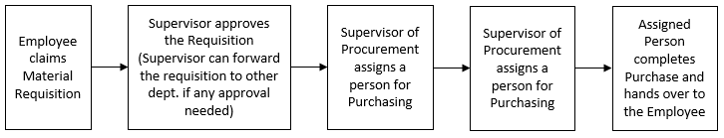  - Bill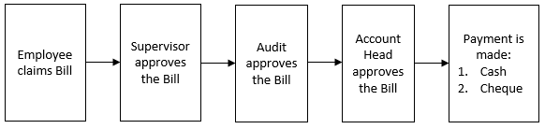  - IOU  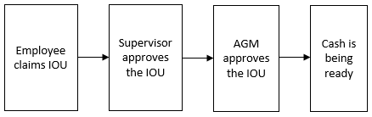  - Advance  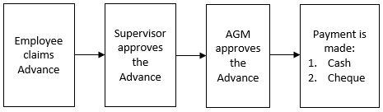  - Conveyance  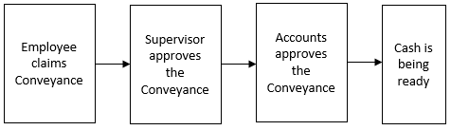
Features Details: | - Material Requisition: It is an online document prepared by the department, requesting to procurement department in case of new materials are needed. This is the basic steps of Material Requisition.  - Employee claims Material Requisition. Fields are:  - Request Date  - Request by  - Company  - Location  - Item Name  - Quantity in hand  - Quantity Required  - Unit  - Contact Person Details  - Reason for Request  - Requisition goes to supervisor for approval. Supervisor is generally the department head. General, supervisor approval is enough for procurement. But according to material nature supervisor can forward to following person:  - IT Head: If IT related Material Requisition.  - HR Head: If HR Permission Needed.  - Director Sir: IF Director Permission Needed  - Then procurement approval. Procurement head approve the requisition. Currently for Chittagong it goes to Sr. Manager, commercial for Chittagong office and GM, Administration (Dhaka) for Dhaka office.  - Then procurement authority assigned a person for purchase. The person is under procurement department.  - Assigned person do the procurement process which is out of scope of this application.  - Bill:  - Vendor Bill: A vendor bill is an invoice received for products and services that the company purchases through PO. Based on bill amount vendor bill approval authority differs as follows:  - Vendor Bill less than 10,000 TK: steps of this type vendor bill.  - Employee claim Vendor Bill; Fields are:  - Employee ID  - Billing ID  - Billing Date  - Company Name  - Bill Description  - Vendor Code  - Vendor Name  - PO No  - PO Date  - GR No  - GR Date  - IV No  - IV Date  - TDS  - VDS  - Asset No  - Payment Type  - Advance  - Net Pay  - Supervisor (Department Head) approval  - Audit approval  - Account Head approval  - Payment process. Based on payment type these steps can be divided into parts.  - Cash payment: Cash is ready.  - Cheque payment: Assigned Cheque date by Finance and then Cheque payment is ready.  - Vendor Bill between 10,000tk and 50,000tk: steps of this type vendor bill.  - Employee claim Vendor Bill  - Supervisor approval (Department Head)  - GM Approval: Currently this goes to following persons:  - Audit approval  - Account Head approval  - Payment process: Based on payment type these steps can be divided into parts.  - Cash payment: Cash is ready.  - Cheque payment: Assigned Cheque date by Finance and then Cheque payment is ready.  - Vendor Bill equal 50,000tk or above: steps of this type vendor bill.  - Employee claim Vendor Bill  - Supervisor approval  - GM Approval: Currently this goes to following persons  - Director approval  - Audit approval  - Account Head approval  - Payment process: Based on payment type these steps can be divided into parts.  - Cash payment: Cash is ready.  - Cheque payment: Assigned Cheque date by Finance and then Cheque payment is ready.  Note: In every step, the bill can be send back to previous steps for further verification / correction.  - General Bill: For example, tour bill, breakfast bill, launch bill, labor bill, transport bill etc. Any bill which is not against PO is also subject to this bill.Based on bill amount general bill have following approval methods:  - General Bill less than 10,000 TK: steps of this type general bill.  - Employee claim General Bill. Fields are:  - Location  - Billing ID  - Employee ID  - Billing Date  - Company Name  - Locations  - Bill Description  - Payment Type  - Net Pay  - Supervisor approval (Department Head)  - Audit approval: This step is not required if general bill claim as PASC bill. (PEDROLLO Associate Service Center Bill).  - Account cost allocation.  - Account Head approval: This step is not required if the bill is claimed from Dhaka H/O Location.  - Payment process: Based on payment type these steps can be divided into parts.  - Cash payment: Cash is ready.  - Cheque payment:Assigned Cheque date by Finance and then Cheque payment is ready.  - General Bill between 10,000tk and 50,000tk: steps of this type general bill.  - Employee claim General Bill  - Supervisor approval (Department Head)  - GM approval: This step is not required if general bill claim as Recurring bill (Periodically Bill).  - Audit approval: This step is not required if general bill claim as PASC bill. (PEDROLLO Associate Service Center Bill).  - Account cost allocation.  - Account Head approval: This step is not required if the bill is claimed from Dhaka H/O Location.  - Payment process: Based on payment type these steps can be divided into parts.  - Cash payment: Cash is ready.  - Cheque payment: Assigned Cheque date by Finance and then Cheque payment is ready.  - General Bill equal 50,000tk or above: steps of this type general bill.  - Employee claim General Bill  - Supervisor approval (Department Head)  - GM approval: This step is not required if general bill claim as Recurring bill (Periodically Bill).  - Director Approval: This step is not required if general bill claim as Recurring bill (Periodically Bill).  - Audit approval: This step is not required if general bill claim as PASC bill. (PEDROLLO Associate Service Center Bill).  - Account cost allocation.  - Account Head approval: This step is not required if the bill is claimed from Dhaka H/O Location.  - Payment process: Based on payment type these steps can be divided into parts.  - Cash payment: Cash is ready.  - Cheque payment: Assigned Cheque date by Finance and then Cheque payment is ready.  Note: In every step, the bill can be send back to previous steps for further verification / correction.  - Distribution Bill: Cost of deliver water pumps to dealer by the distribution department.  - Distribution Bill less than 10,000 TK: steps of this type distribution bill.  - Employee claim Distribution Bill.Fields are:  - Billing ID  - Employee ID  - Billing Date  - Company Name  - Locations  - Bill Description  - Pump Model  - Quantity  - Reference No  - Payment Type  - Net Pay  - Supervisor approval (Department Head)  - Audit approval  - Account Head approval  - Payment process: Based on payment type these steps can be divided into parts.  - Cash payment: Cash is ready.  - Cheque payment: Assigned Cheque date by Finance and then Cheque payment is ready.  - Distribution Bill between 10,000tk and 50,000tk: steps of this type distribution bill.  - Employee claim Distribution Bill  - Supervisor approval (Department Head)  - GM approval  - Audit approval  - Account Head approval  - Payment process: Based on payment type these steps can be divided into parts.  - Cash payment: Cash is ready.  - Cheque payment:Assigned Cheque date by Finance and then Cheque payment is ready.  - Distribution Bill equal 50,000tk or above: steps of this type distribution bill.  - Employee claim Distribution Bill  - Supervisor approval (Department Head)  - GM approval  - Director Sir approval  - Audit approval  - Account Head approval  - Payment process: Based on payment type these steps can be divided into parts.  - Cash payment: Cash is ready.  - Cheque payment:Assigned Cheque date by Finance and then Cheque payment is ready.  Note: In every step, the bill can be send back to previous steps for further verification / correction.  - IOU: I Owed You. Steps of this process in billing system are following:  - Employee claim IOU.Fields are:  - Request Date  - Company  - Particular  - Amount  - Purpose  - Supervisor Approval (Department Head)  - Accounts AGM Approval  - Cash is ready  - Advance: If the bill has to pay advance. Steps of this process in billing system are following:  - Employee claim Advance. Fields are:  - Advance ID  - Location  - Employee ID  - Employee Name  - Advance Date  - Company Name  - Advance Details  - Advance Amount  - Supervisor Approval (Department Head)  - Accounts AGM Approval  - Account cost allocation  - Payment process: Based on payment type these steps can be divided into parts.  - Cash payment: Cash is ready.  - Cheque payment:Assigned Cheque date by Finance and then Cheque payment is ready.  - Conveyance: payment system is weekly basis. Steps are following:  - Employee claim Conveyance. Fields are:  - Employee Id  - Company Name  - Journey Date  - Purpose  - From  - To  - Mode of Transport  - Amount  - Reporting To  - Supervisor approval (Department Head)  - Account cost allocation and approval  - Cash is ready
Technical Features: | - PHP v5.2.9-2  - Apache v2.2.11  - MySQL v5.1.33  - Clint: Mozilla Firefox (Preferable), Chrome  - Resolution: Laptop / Desktop Screen  - User must operate this software using Local IP to check all types of attached copy, otherwise need to use VPN to operate this using Real IP.

