**The Busy Professional**

**Name:** Daniel Carter

**Age:** 34

**Gender:** Male

**Occupation:** Marketing Manager

Daniel is a career-driven professional working in a fast-paced industry. He often has early morning meetings, client presentations, and networking events after work. With little time to spare, he values any efficiency in his daily routine.

**Challenges:**

* Struggles deciding on stylish but yet professional outfits to wear in the morning quickly.
* Finds it difficult to put together an outfit for social networking events.

**Goal**

* Wants a quick way to get personalized outfit suggestions that fit his busy schedule.
* Wants to ensure a hassle-free way to maintain a polished, professional appearance.

**The College Student**

**Name:** Emily Johnson

**Age:** 21

**Gender:** Female

**Occupation:** College Student

Emily is an outgoing college student who enjoys experimenting with new outfits but has a limited budget. She wants her outfits to be functional and stylish when attending lectures, working a part-time job, or hanging out with friends.

**Challenges:**

* Struggles to create new outfits without buying new clothes.
* Wants to use what she owns to the fullest. Maximize what she owns.
* Needs to balance comfort for long study sessions with trendy looks

**Goal:**

* Wants personalized outfit suggestions suitable for different occasions
* Wants to avoid outfit repetition.
* Needs to maintain a budget-friendly yet stylish wardrobe.

**The Frequent Traveler**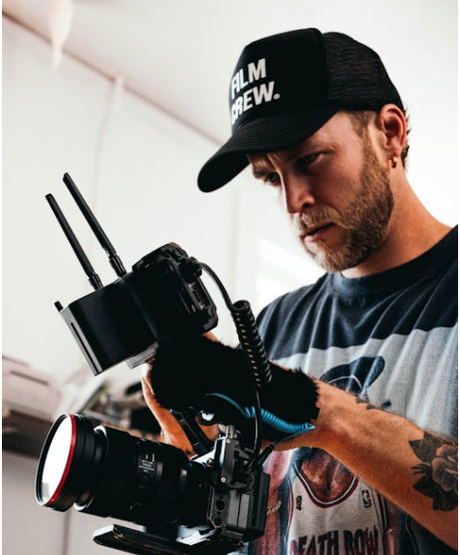

**Name:** Alex Torres

**Age:** 29

**Gender:** Male

**Occupation:** Travel Content Creator

Alex is always on the move, visiting new destinations and capturing content for his travel vlog. His schedule and work require him to pack efficiently, be ready for different climates and occasions, and look good for his viewers.

**Challenges:**

* Packing for multiple destinations while keeping luggage light**.**
* Struggles with finding outfits that balance comfort, style, and practicality.
* Needs his outfits to be well suited for social media content and brand collaborations.

**Goals:**

* Wants an easy way to put together outfits based on weather and itinerary.
* Wants to optimize suitcase space by multiple outfit suggestions based on limited clothes.
* Wants to avoid last-minute shopping by tracking his wardrobe digitally.