MedBridge: A Dual Answerability Gate for Hallucination-Resistant Local Retrieval-Augmented Clinical Guidance
Vijay Aravindh S.  [TO BE FILLED: department]  [TO BE FILLED: university]  [TO BE FILLED: city], India  [TO BE FILLED: email] | Mohammad Farhan Rashid  [TO BE FILLED: department]  [TO BE FILLED: university]  [TO BE FILLED: city], India  [TO BE FILLED: email] | Maheswari S.  [TO BE FILLED: department]  [TO BE FILLED: university]  [TO BE FILLED: city], India  [TO BE FILLED: email]

Abstract—In patient-facing care, a fluent answer to a question the evidence does not cover is a safety risk, yet standard retrieval-augmented generation (RAG) answers every question. MedBridge, a local assistant for hypertension and cardiovascular care, makes answerability an explicit, auditable decision: a deterministic emergency fast-path, a Context Gate that asks for missing personal facts and, after hybrid retrieval, an Evidence Gate that decides whether to answer, generalise, abstain or escalate. On 198 test conversations of the synthetic MedBridge-HalluBench, with a 4B-parameter open-weight model and an LLM judge from another model family, the dual gate lowered the response-level hallucination rate to 37.2% [31.4, 43.5] from 72.8% for vanilla RAG and 67.8% for prompt-only safety, and the unsafe-answer rate on unanswerable turns to 15.2% from 84.8% and 62.1% (exact McNemar, Holm-adjusted p ≤ 2.8×10⁻⁹). The gain came mostly from selective abstention: coverage of answerable turns fell from 98.1% to 73.1%, and responses with clinical claims were hallucinated as often as before. A post-generation grounding verifier lowered hallucination further, to 21.3% (p = 4.9×10⁻⁹), mainly by shortening answers (2.21 against 4.18 claims per response, unsupported-claim ratio unchanged) and at a further cost in coverage (67.6%), without significantly reducing unsafe answers; a calibrated Evidence Gate had no measurable effect. A second, NLI-based judge, stopped early, scored only ungated outputs (agreement κ = 0.68 per response, 0.36 per claim).
Index Terms—Retrieval-augmented generation, hallucination, abstention, clinical decision support, hypertension, large language models, patient safety

I. Introduction
Hypertension is a major, largely preventable driver of cardiovascular disease, and many affected adults remain undiagnosed, untreated or uncontrolled [1]; in India, a national survey found it in roughly one adult in three [2]. Between visits, many patients now ask conversational AI about their readings, medicines and lifestyle. Large language models (LLMs) hold considerable clinical knowledge [3] but also make confident statements that no source supports, usually called hallucinations [4].
Retrieval-augmented generation (RAG) conditions the model on passages from a trusted corpus [5] and has improved medical question answering [6], but a standard RAG pipeline answers whatever the quality of the match. Three routine situations defeat it: the safe answer depends on facts the patient has not given (a dose change for an unnamed medicine); the question falls outside the evidence (a drug that does not exist, a false premise, a dose no guideline states, a non-cardiac topic); or the message describes an emergency, where a long reply only delays care. Asking the generator to “say when it does not know” leaves the decision to the component most prone to over-confidence, although knowing when not to answer is a distinct capability [7].
MedBridge instead makes answerability an explicit, logged decision taken at fixed points around retrieval: deterministic rules handle emergencies before any model call, a Context Gate (Gate 1) judges before retrieval whether a clarifying question is needed, and an Evidence Gate (Gate 2) judges after retrieval whether the passages support a specific answer, only general information or nothing. Refusals and escalations bypass the generator, and all models run locally. Our contributions are:
1) the Dual Answerability Gate, a five-action routing architecture (ANSWER, SOFT-ASK, GENERALIZE, ABSTAIN, ESCALATE) that separates missing context from missing evidence, with a deterministic emergency override;
2) two extensions evaluated as variants, a calibrated Evidence Gate and a conservative post-generation grounding verifier (“Gate 3”), the latter now enabled by default;
3) MedBridge-HalluBench, a synthetic benchmark of casual, multi-turn patient questions labelled with the expected safe behaviour, and a paired ten-condition evaluation;
4) a fully local implementation (FastAPI, PostgreSQL, Qdrant, Ollama) designed for a 6 GB laptop GPU (code release after the patent decision).

II. Related Work
Grounding and verification. Self-RAG fine-tunes a generator to decide when to retrieve and whether its output is supported [8], and Corrective RAG scores retrieved documents and replaces them when confidence is low [9]. Post-hoc methods such as RARR retrieve evidence per claim and revise unsupported content [10]; FActScore measures factual precision over atomic facts [11]. These need a trained generator, answer every input or act only after generation; MedBridge decides before generation, and its Gate 3 uses the post-hoc idea only to make an output more conservative.
Abstention. Selective classification rejects inputs below a confidence threshold calibrated to bound the risk on accepted ones [12]. Such methods give one answer-or-refuse signal; MedBridge separates missing context (ask) from insufficient evidence (generalise or abstain) and adds escalation.
Evaluation and prior art. MultiMedQA and MIRAGE consist mainly of exam-style questions that all expect an answer [3], [6]; our benchmark labels each turn with the expected behaviour, including asking, abstaining and escalating. Because LLM judges can favour their own generations [13], our judge comes from another model family. Patents cover clarifying questions for ambiguous queries [14] and RAG-based clinical decision support over curated guidelines [15]; none we reviewed combines a pre-retrieval context gate, a post-retrieval evidence gate and a deterministic emergency override.

III. The MedBridge Method
MedBridge answers patient questions on hypertension and cardiovascular care from guidelines and never diagnoses or prescribes. Each turn passes through the pipeline of Fig. 1 and ends in one of five actions: ANSWER (a specific, cited answer), SOFT-ASK (a clarifying question), GENERALIZE (general guideline information, marked as such), ABSTAIN (a pre-vetted refusal) or ESCALATE (an emergency template).
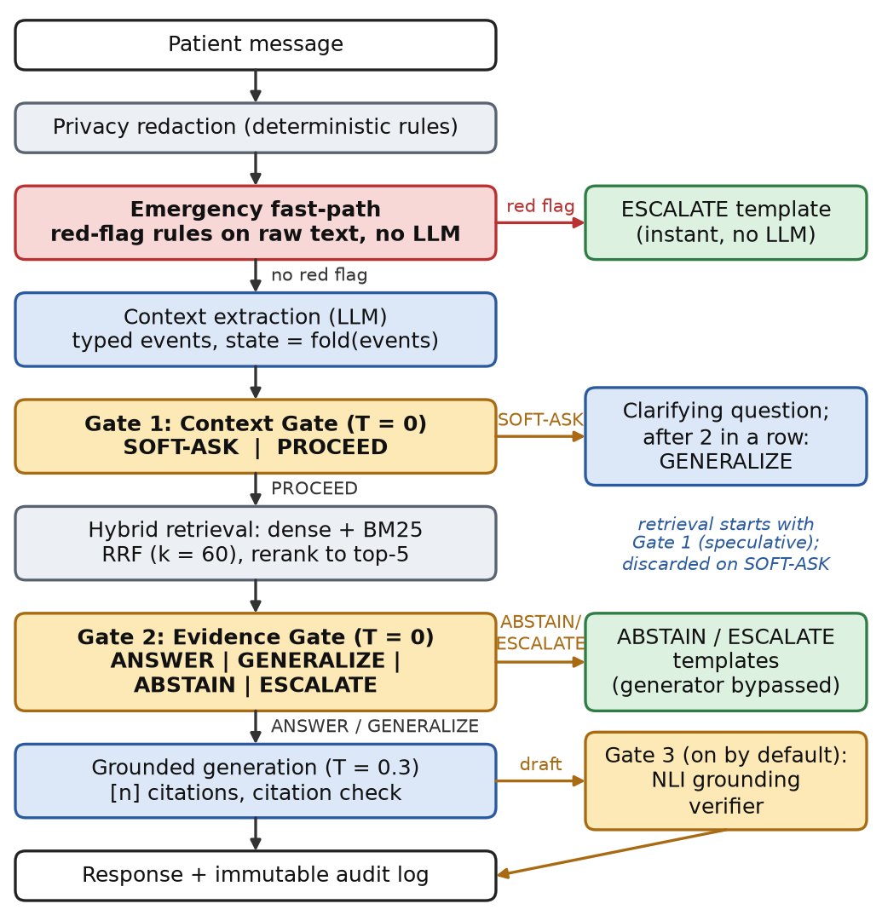
Fig. 1. The MedBridge routing pipeline. Gates 1 and 2 are LLM decisions at temperature 0; emergency, refusal and escalation outputs contain no generated text. Gate 3 (V2 in the study) has been on by default since the study.
Design principles. Every answerability decision and its rationale go to an append-only audit log; emergency triage, refusal and escalation texts and the patient state are deterministic; LLM decisions are narrow JSON-schema classifications at temperature 0 (seed 42); and failures degrade safely (Gate 1 to PROCEED, Gate 2 to GENERALIZE, the generator to a template).

A. Emergency Fast-Path and Patient State
Before any model call, a rule-based classifier parses blood-pressure readings in many written forms and escalates at a systolic pressure of at least 180 or a diastolic pressure of at least 120 mmHg (stricter than the 2025 AHA/ACC guideline [16], as a patient-facing tool cannot rule out organ damage) and on red-flag symptoms (chest pain, stroke signs, fainting, severe breathlessness), with filters for negation, informational questions and dated history; since nothing later can overrule it, this path favours recall. Otherwise an extractor LLM turns the redacted text into typed delta events (reading, medication, symptom, demographic, laboratory result) and a search query; the snapshot is a deterministic fold over stored events, so one faulty extraction cannot overwrite earlier facts.

B. Gate 1: Context Gate
Gate 1 sees the snapshot and the message and returns PROCEED or SOFT-ASK with missing fields from a fixed vocabulary (current medicines, a recent reading, age, ...). It may ask only when the question concerns the patient’s own cardiovascular care and an unknown personal fact would change the safe answer; general, out-of-scope, fabricated and false-premise questions proceed, as more context cannot make them answerable. On SOFT-ASK the generator phrases a short question; a third consecutive request forces GENERALIZE and skips Gate 2.

C. Hybrid Retrieval
The knowledge base holds 27 freely accessible documents from 10 organisations, mainly clinical guidelines such as [16], in 2,747 chunks of at most 400 tokens. Dense (bge-small-en-v1.5 [17]) and BM25 rankings are fused by reciprocal rank fusion with k = 60 [18], and a MiniLM cross-encoder reranks the top 20 candidates to the top 5; retrieval runs concurrently with Gate 1. On 70 labelled queries, fusion had the highest mean reciprocal rank (0.740 [0.650, 0.825] against 0.677 [0.584, 0.766] for dense retrieval; overlapping intervals, not tested), while reranking did not help and slightly lowered both point estimates (nDCG@5 0.657 [0.569, 0.740] with, 0.688 [0.600, 0.771] without); we keep it because it is cheap (about 0.2–0.3 s per warm turn) and feeds V1.

D. Gate 2: Evidence Gate
Gate 2 sees the five chunks, the snapshot and the patient’s own words and applies the first matching rule. ESCALATE: an emergency happening now that the fast-path missed. ABSTAIN: a question outside cardiovascular care; irrelevant or thin evidence; a named drug or product absent from the evidence; a dose or number the evidence does not state; paediatric or pregnancy medicine decisions the evidence does not cover. GENERALIZE: evidence covering the topic only in general terms, or a false premise the evidence contradicts (the answer corrects it). ANSWER: evidence that addresses this question directly for this patient; when torn, the gate prefers GENERALIZE. A unit test keeps benchmark names and turns out of the few-shot examples.

E. Generation and Output Control
For ANSWER and GENERALIZE a grounded generator (temperature 0.3) writes from the evidence only and ends every clinical-fact sentence with the index of its supporting chunk. A server-side check removes markers that point to no retrieved chunk and downgrades an ANSWER without a valid citation to GENERALIZE. Against prompt injection, the patient’s text sits in an <untrusted_​user_​input> element with tag-like sequences escaped, and the evidence in <clinical_evidence>.

F. Extensions V1 and V2
V1 (calibrated Evidence Gate) runs Gate 2 on three deterministic permutations of the evidence order and takes the majority action, breaking ties towards the more conservative one; thresholds on the top reranker score and on the share of the question’s salient entities found in the evidence can then lower ANSWER to GENERALIZE, or either to ABSTAIN.
V2 (“Gate 3”) checks each claim sentence of a draft with an NLI cross-encoder against the chunks it cites (all retrieved chunks when it cites none) and can only make an output more conservative: unsupported sentences are removed while their share stays within a threshold τ; above it, or (since commit 16e594b, after the study) when every claim is unsupported, an ANSWER is regenerated as GENERALIZE and checked again, and otherwise the ABSTAIN template is returned; a failed verifier delivers the unchecked draft. Its NLI model differs from the NLI judge’s, but its thresholds are tuned against the LLM judge’s verdicts. Development-split calibration left only V1’s reranker threshold for ANSWER active and set τ = 1.0 for V2 (a fallback: no τ kept 85% of C5’s coverage), so in the study V2 only deleted unsupported sentences, and a draft that deletion would have left empty was delivered unchanged.

IV. Experimental Setup

A. MedBridge-HalluBench
The benchmark contains 247 synthetic conversations with 298 patient turns, 43 of them multi-turn; no real patient data are used. Most messages are casual; others use Indian English, typos or clinical wording. Six categories each target a safe behaviour: a cited answer (answerable items), a clarifying question first (missing context, including loop-breaker tests), general information (general topics), abstention or correction (unanswerable in-domain items: fabricated drugs and treatments, false premises, doses the guidelines do not state, paediatric and pregnancy questions), abstention (out-of-domain items) and escalation (emergencies, including colloquial red flags). Each turn has a gold action and a set of acceptable actions (strict and lenient scoring). A stratified 20% development split (seed 42; 49 conversations) serves only model selection and calibration; results use the 198 test conversations (239 turns).

B. Conditions
Ten conditions are compared: C0, the application model without retrieval; C1, vanilla RAG; C1G, RAG with the production generator prompt; C2, vanilla RAG whose prompt asks, in prose, for the behaviour the gates enforce; C3, Context Gate only; C4, Evidence Gate only; C5, MedBridge with both gates; and the extensions V1 (C5 with the calibrated Gate 2), V2 (C5 with Gate 3) and V12 (both). All share the application model; all but C0 also share the corpus, the retrieval stack, the emergency fast-path and the small-talk handler. C3 to C5 differ from C1G only by their gates, so C1G anchors the gate effects, while C1 and C2 are the baselines of the decision rule. Identical LLM requests are cached by model digest, so paired conditions differ only in pipeline structure and prompt.

C. Models
One application model serves the extractor, both gates and the generator. Run as C5 on the development split, qwen3.5:4b routed about as accurately as qwen3:8b [19] (strict accuracy 69.5% [56.9, 79.7] against 71.2% [58.6, 81.2]; exact McNemar p = 1.00) and ahead of gemma3:4b [20] (40.7% [29.1, 53.4]), so we use qwen3.5:4b (4.2B parameters, Q4_K_M), which is faster (median development turn 10.3 against 16.0 s) and whose 3.3 GB of weights should, unlike qwen3:8b’s 5.2 GB, fit a 6 GB laptop GPU (not measured: every run used Ollama on an Apple M5 with 24 GB).

D. Hallucination Judges
The LLM judge, gemma3:12b [20], is larger than the application model and from another family. At temperature 0 it splits each response into atomic clinical claims [11], leaving out greetings, questions and generic referral advice, and labels each claim SUPPORTED, UNSUPPORTED or CONTRADICTED under a strict rubric (only an explicit statement or a direct paraphrase counts). Each claim is labelled against the three passages a cross-encoder ranks highest in a pool of the condition’s chunks and the production retriever’s top three for the claim, so C0, which retrieves nothing, is still judged against evidence (from a smaller pool). Blind to condition and category but given each item’s reference notes, it also classifies the behaviour and flags accepted false premises, endorsed fabricated entities and unsupported doses.
The NLI judge scores the same claims against the same passages with nli-deberta-v3-base [21] (maximum entailment over three-sentence windows), with thresholds calibrated on the development split to agree with the LLM judge, so the two are not independent. To save compute, the project owner stopped it early after C0, C1, C1G and 76 C2 responses (no gated condition), so it serves only to measure agreement; all primary metrics and tests use the LLM judge.

E. Metrics and Statistics
The primary outcomes are the response-level hallucination rate (responses with at least one unsupported or contradicted claim) and the unsafe-answer rate on unanswerable items (a specific answer, a raised flag or an unsupported claim). Secondary outcomes include the unsupported-claim ratio, coverage and over-abstention on answerable items, routing accuracy and emergency recall. The unit is the item-turn; proportions carry Wilson 95% intervals [22]. Exact McNemar tests [23] compare C5 with C0 to C4, each variant with C5, and C5 with C1G, with Holm correction within each family and outcome [24]; Cochran’s Q tests C0 to C5 jointly [25]. Effect sizes are paired risk differences and odds ratios; judge agreement is Cohen’s κ [26].
A decision rule fixed before the study makes the variants the fallback if C5 does not significantly reduce (Holm-adjusted p < 0.05) the hallucination or unsafe-answer rate against both C1 and C2. All thresholds (NLI judge, V1, V2) are calibrated on C5’s development-split runs before any test run. Turns in which a component fell back to a default after an error are excluded from headline metrics (the analysis refuses to run if they exceed 5% of any condition’s turns).

V. Results

A. Hallucination and Unsafe Answers
Of the 239 test turns per condition, three in all fell back to a default after an error (one each in C0, V1 and V12) and are excluded, and the LLM judge failed on two non-medical C0 replies. Table I lists the primary outcomes with the paired test of each condition against C5.
TABLE I
Primary outcomes on the test split (LLM judge) and paired exact McNemar tests against C5
Cond. | Halluc. % [95% CI] | p | Unsafe % [95% CI] | p | Cov. % | Abst. %
C0 | 96.6 [93.5, 98.3] | 5.1×10⁻⁴⁰ | 93.7 [84.8, 97.5] | 1.8×10⁻¹⁴ | 99.1 | 3.2
C1 | 72.8 [66.8, 78.1] | 5.4×10⁻¹⁶ | 84.8 [74.3, 91.6] | 1.1×10⁻¹³ | 98.1 | 15.2
C1G | 74.1 [68.2, 79.2] | 2.8×10⁻²⁰ | 80.3 [69.2, 88.1] | 2.6×10⁻¹² | 97.2 | 19.7
C2 | 67.8 [61.6, 73.4] | 5.6×10⁻¹³ | 62.1 [50.1, 72.9] | 2.8×10⁻⁹ | 89.8 | 37.9
C3 | 57.3 [51.0, 63.4] | 4.9×10⁻¹⁰ | 65.2 [53.1, 75.5] | 4.2×10⁻⁹ | 83.3 | 19.7
C4 | 43.5 [37.4, 49.9] | 0.0059 | 16.7 [9.6, 27.4] | 1.00 | 77.8 | 83.3
C5 | 37.2 [31.4, 43.5] | — | 15.2 [8.4, 25.7] | — | 73.1 | 69.7
V1 | 36.6 [30.7, 42.8] | 0.73 | 13.6 [7.3, 23.9] | 1.00 | 72.0 | 71.2
V2 | 21.3 [16.6, 27.0] | 4.9×10⁻⁹ | 10.6 [5.2, 20.3] | 0.75 | 67.6 | 74.2
V12 | 20.2 [15.6, 25.7] | 1.2×10⁻⁸ | 9.1 [4.2, 18.4] | 0.66 | 69.2 | 75.8
Source: evaluation/results/summary.json. Halluc.: 239 judged turns (C0: 236, V1: 238, V12: 238); Unsafe and Abst. (appropriate abstention): 66 unanswerable turns (C0: 63); Cov. (coverage): 108 answerable turns (V1: 107, V12: 107). p: exact McNemar test against C5, Holm-adjusted within each family and outcome (C5 vs C0 to C4; V1, V2, V12 vs C5); C5 vs C1G unadjusted.
The dual gate (C5) produced a hallucinated response in 37.2% [31.4, 43.5] of turns, against 72.8% for vanilla RAG (C1), 67.8% for prompt-only safety (C2) and 96.6% for the direct LLM (C0). On unanswerable turns its unsafe-answer rate was 15.2% [8.4, 25.7], against 84.8% (C1) and 62.1% (C2). The NLI judge, which scored C0, C1 and C1G completely and no gated condition, rated them at least as harshly (97.0%, 81.2% and 81.2% for C0, C1 and C1G).

B. Paired Tests and the Decision Rule
C5 reduced hallucination by 35.6 percentage points (pp) against C1 (odds ratio 0.15) and by 30.5 pp against C2, and unsafe answers by 69.7 and 47.0 pp, with Holm-adjusted p ≤ 2.8×10⁻⁹ in all four tests (all McNemar p-values below are Holm-adjusted), so the fallback of our decision rule is not triggered. Cochran’s Q confirms that C0 to C5 (C1G not included) differ on both outcomes (Q = 291.3 and 158.5, df = 5, n = 236 and 63 complete cases, p < 10⁻³⁰). In sensitivity analyses (no C1, C2 or C5 turn was degraded, so including degraded turns changes none of the four tests), all four tests stay significant when the 10 test items resembling few-shot examples of earlier prompt versions are removed (C5 vs C1 hallucination: p = 1.3×10⁻¹³) and per item instead of per turn (p = 1.1×10⁻¹¹), and both hallucination tests when the non-clinical claim filter is disabled.

C. Where the Reduction Comes From
The gates lowered the rate mainly by producing fewer responses with clinical content, not better-grounded ones (Fig. 2). C5 returned clinical claims in 105 of 239 turns, against 206 for C1, but among those responses the hallucination rate was unchanged (84.8% against 84.5%), and the pooled unsupported-claim ratios overlap (0.263 [0.222, 0.308] against 0.297 [0.264, 0.331]). The price is coverage: C5 answered 73.1% of answerable turns against 98.1% for C1, and abstained on 16.7%.
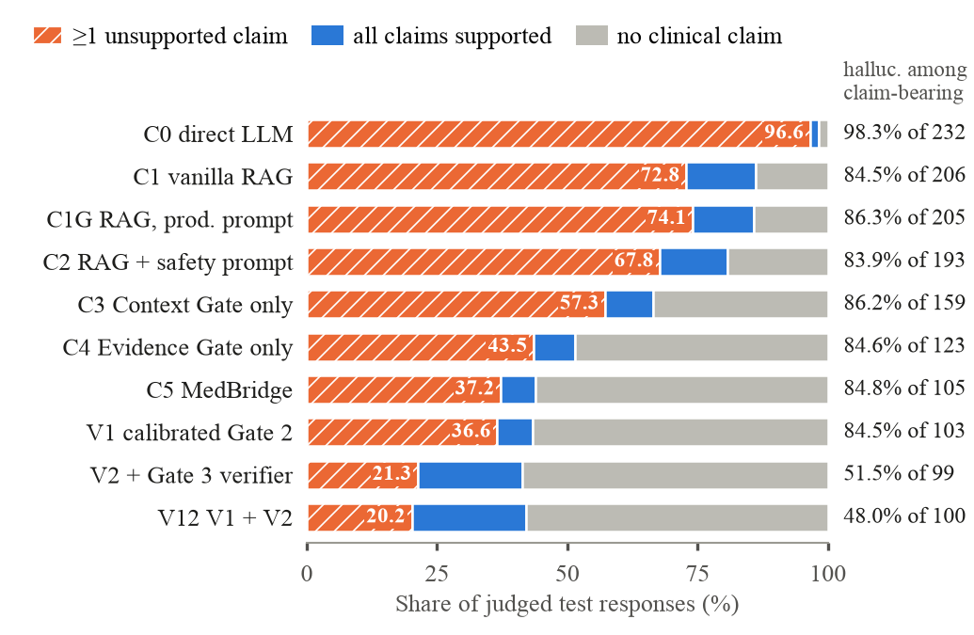
Fig. 2. Composition of the judged test responses (LLM judge). Hatched: response-level hallucination rate; right column: hallucination rate among responses with clinical claims.

D. Gate Ablation and Variants
With the production prompt but no gates, C1G hallucinated about as often as C1 (74.1%); against this anchor, C5 lowered hallucination by 36.8 pp (p = 2.8×10⁻²⁰) and unsafe answers by 65.2 pp (p = 2.6×10⁻¹²), so the effect is due to the gates, not to the prompt. Descriptively (not tested), Gate 1 alone (C3) lowered unsafe answers only to 65.2% (from 80.3%), Gate 2 alone (C4) to 16.7%. Adding Gate 1 to Gate 2 (C5 vs C4) reduced hallucination by a further 6.3 pp (p = 0.0059), but not significantly per item (p = 0.12) or on unsafe answers (p = 1.0), and lowered appropriate abstention (69.7% against 83.3%), as Gate 1 turned some abstentions into clarifications.
V1 had no measurable effect (−0.8 pp, p = 0.73) and was about 1.6 times slower (imputed study latency, relative only). V2 lowered hallucination to 21.3% [16.6, 27.0] (−15.9 pp [−20.9, −10.8], p = 4.9×10⁻⁹) and, with V12, which includes it, was the only condition with a clearly lower rate among claim-bearing responses (51.5% and 48.0%, against 83.9–86.3% for every other condition with retrieval; not tested). Its unsafe-answer reduction was not significant (10.6% against 15.2%, p = 0.75); it answered fewer answerable turns (67.6%, not tested) and its responses carried fewer claims (2.21 against 4.18), while its unsupported-claim ratio stayed within C5’s interval (0.240 [0.185, 0.299]), so V2 lowered the response-level rate largely by shortening answers, not by better supporting the remaining claims; on the development split its sentence verdicts agreed only weakly with the LLM judge’s (κ = 0.25, 87 sentences). V12 behaved like V2 (20.2%); the two were not compared directly.

E. Routing, Emergencies and Judge Agreement
C5 chose the gold action in 59.0% of turns (78.7% counting acceptable actions; macro-F1 0.62); its weakest boundary is ANSWER versus GENERALIZE (ANSWER recall 0.45). In every condition with the fast-path, all 24 emergency turns were escalated and no other turn was. On the 790 ungated responses that both judges scored, response-level agreement was substantial (κ = 0.683 [0.613, 0.753]), but claim-level agreement over 8,265 claims was only fair (κ = 0.364 [0.344, 0.384]): the NLI judge labelled 2,606 claims CONTRADICTED, the LLM judge 25.

VI. Discussion
What the gates do. The dual gate makes the system safer by deciding when not to answer, not by making its answers more faithful: it declines, generalises or asks more often, but the clinical content it lets through is hallucinated as often as without gates (Fig. 2). This is selective abstention [12] at a cost of about a quarter of the answerable turns. Asking for the same behaviour in prose (C2) achieves much less (appropriate abstention 37.9% against 69.7% for C5). Most of the benefit comes from the Evidence Gate; Gate 1, although designed to let unanswerable questions proceed, asked for clarification on 11 of the 66 unanswerable C5 turns and adds only a small, fragile reduction: the gates differ in kind (asking versus declining) more than in effect.
Failure modes. In C5, Gate 1 proceeded on 12 turns that needed a clarifying question, mostly by reading personal questions (“what blood pressure should I be aiming for?”) as general ones (three, where the patient declines to give details, are debatable), and Gate 2 chose ANSWER on 4 missing-context turns. Of the 10 remaining unsafe answers, 9 came through GENERALIZE, five of them correctly routed false-premise questions whose general reply still carried an unsupported claim. The dominant problem is generation itself, which citation validation cannot catch and V2 targets.
Post-study changes. The dual gate stays the core of MedBridge, and V1 stays off. Because V2 significantly reduced hallucination, Gate 3 is now enabled by default (a decision taken after the study, outside the pre-specified rule, that accepts V2’s lower coverage) with its development-calibrated thresholds (θ = 0.2, τ = 1.0; commit 7a3bc67), and since commit 16e594b it withdraws a draft whose every claim is unsupported instead of delivering it unchanged (in the V2 test runs, 16 turns, 13 of them judged hallucinated; not re-measured). Deleting sentences has a usability cost, the coverage side of the trade-off measured in Section V (fewer claims, lower coverage): after the study, “My blood pressure was 145/92 this morning. Is that high?” lost five of its six claims at θ = 0.2, and as the remaining sentence had no citation, the citation rule made it a one-sentence GENERALIZE; stripped answers can also start mid-thought (remedies: Section VIII). A live brand-versus-generic test (RABBITS, 60 pairs, 120 items, Gate 3 off in both runs) exposed fragile brand names. A fix (commit 02d9774, re-run at fb38cf6) gives the extractor, both gates and the generator lexicon notes mapping brands to generic ingredients, adds a deterministic current-medication backstop and filters drug names in the search query; action consistency rose from 48.3% to 80.0% (Indian brands 45.0% to 80.0%) and stored-generic agreement from 3.3% to 100.0%. A live 19-payload prompt-injection suite passed every check before and after the fix (after it with Gate 3 on).

VII. Limitations and Ethics
Limitations. Judges. Every result for a gated condition rests on one automatic judge; the NLI judge scored only ungated outputs, and the human labels are pending. The LLM judge labels restated user facts and generic hedges as unsupported, which inflates absolute rates in every condition (paired comparisons are less affected), and template responses count as free of hallucination, so response-level rates mix abstention with grounding. Benchmark. HalluBench is synthetic, drafted by the team with the help of an AI assistant and not reviewed by clinicians. With only 66 unanswerable test turns the unsafe-answer intervals are wide, and the paired tests treat turns of a conversation as independent, which the item-level analysis only partly addresses. Protocol. Each condition ran once, with one application model, judge and hardware platform; V2’s thresholds were chosen on 59 development turns to agree with the same LLM judge that scored the test split; C3 and C4 against C1G and V12 against V2 were not tested. Provenance. C0–C5 and V1 ran almost entirely at commit 82359eb, C1G partly at 085eb53, and V2, V12 and the rest of C1G at 3f58b59, which only adds a process-wide PyTorch inference lock (Gate 3 and the reranker had crashed the MPS backend when run concurrently); every run had uncommitted changes. The brand-name fix (02d9774), the Gate 3 default (7a3bc67) and its withdrawal rule (16e594b) came later, so the deployed system is not the evaluated one: RABBITS was re-run after the fix with Gate 3 off, and the withdrawal rule is unmeasured. The corpus is English, without an Indian national guideline; the emergency rules were developed on the team’s own cases; and the system has not been evaluated with patients.
Ethics and privacy. MedBridge is a research prototype for health information, not a medical device: it does not diagnose or prescribe and refers treatment decisions and emergencies to professionals. No human participants or real patient records were involved. [TO BE FILLED: institutional ethics statement, if the venue requires one.] Inference stays local, sessions are encrypted with per-session keys and identifiers are redacted before any model call or storage, but redaction is a safeguard, not a guarantee (strict span recall 0.744 on a blind held-out set). The design has India’s Digital Personal Data Protection Act in mind [27], without a compliance assessment.

VIII. Conclusion
MedBridge treats answerability as a first-class decision in patient-facing clinical RAG, and its riskiest outcomes involve no generated text. On MedBridge-HalluBench, with a local 4B model, the dual gate significantly reduced hallucinated and unsafe answers against vanilla RAG and prompt-only safety, mostly by abstaining where evidence falls short; a grounding verifier, now enabled by default, reduced hallucination further, mostly by shortening answers and at some cost in coverage, without a significant reduction in unsafe answers. These results rest on one LLM judge for the gated conditions and a synthetic benchmark. Future work includes the second judge, the human annotation, clinician review of the benchmark, re-measuring the post-study changes, rewriting rather than deleting unsupported sentences with a stronger, re-calibrated verifier, held-out evaluation of the emergency rules, Indian-language and Indian guideline coverage, and a supervised patient pilot.

Acknowledgment
[TO BE FILLED: thanks to the department, institution and anyone who helped, and funding if any.] Parts of the software, the benchmark items and the first draft of this manuscript were prepared with the help of an AI coding assistant (Claude, Anthropic). The authors reviewed, revised and take full responsibility for all content. [TO BE FILLED: check this disclosure against the AI-use policy of the chosen venue.]

References
[1] World Health Organization, "Global report on hypertension: the race against a silent killer," World Health Organization, Geneva, ISBN 978-92-4-008106-2, 2023. [Online]. Available: https://www.who.int/publications/i/item/9789240081062
[2] R. M. Anjana et al., "Metabolic non-communicable disease health report of India: the ICMR-INDIAB national cross-sectional study (ICMR-INDIAB-17)," The Lancet Diabetes & Endocrinology, vol. 11, no. 7, pp. 474–489, 2023. doi: 10.1016/S2213-8587(23)00119-5.
[3] K. Singhal et al., "Large language models encode clinical knowledge," Nature, vol. 620, no. 7972, pp. 172–180, 2023. doi: 10.1038/s41586-023-06291-2.
[4] Z. Ji et al., "Survey of Hallucination in Natural Language Generation," ACM Computing Surveys, vol. 55, no. 12, pp. 1–38, 2023. doi: 10.1145/3571730.
[5] P. Lewis et al., "Retrieval-Augmented Generation for Knowledge-Intensive NLP Tasks," in Advances in Neural Information Processing Systems 33 (NeurIPS 2020), 2020, pp. 9459–9474. arXiv:2005.11401.
[6] G. Xiong, Q. Jin, Z. Lu, and A. Zhang, "Benchmarking Retrieval-Augmented Generation for Medicine," in Proc. Findings of the Association for Computational Linguistics: ACL 2024, 2024, pp. 6233–6251. doi: 10.18653/v1/2024.findings-acl.372.
[7] B. Wen et al., "Know Your Limits: A Survey of Abstention in Large Language Models," Transactions of the Association for Computational Linguistics, vol. 13, pp. 529–556, 2025. doi: 10.1162/tacl_a_00754.
[8] A. Asai, Z. Wu, Y. Wang, A. Sil, and H. Hajishirzi, "Self-RAG: Learning to Retrieve, Generate, and Critique through Self-Reflection," in Proc. International Conference on Learning Representations (ICLR 2024), 2024, pp. 9112–9141. arXiv:2310.11511.
[9] S.-Q. Yan, J.-C. Gu, Y. Zhu, and Z.-H. Ling, "Corrective Retrieval Augmented Generation," arXiv preprint arXiv:2401.15884, 2024. doi: 10.48550/arXiv.2401.15884.
[10] L. Gao et al., "RARR: Researching and Revising What Language Models Say, Using Language Models," in Proceedings of the 61st Annual Meeting of the Association for Computational Linguistics (Volume 1: Long Papers), 2023, pp. 16477–16508. doi: 10.18653/v1/2023.acl-long.910.
[11] S. Min et al., "FActScore: Fine-grained Atomic Evaluation of Factual Precision in Long Form Text Generation," in Proceedings of the 2023 Conference on Empirical Methods in Natural Language Processing, 2023, pp. 12076–12100. doi: 10.18653/v1/2023.emnlp-main.741.
[12] Y. Geifman and R. El-Yaniv, "Selective Classification for Deep Neural Networks," in Advances in Neural Information Processing Systems 30 (NIPS 2017), 2017. arXiv:1705.08500.
[13] L. Zheng et al., "Judging LLM-as-a-Judge with MT-Bench and Chatbot Arena," in Advances in Neural Information Processing Systems 36 (NeurIPS 2023), Datasets and Benchmarks Track, 2023, pp. 46595–46623. doi: 10.52202/075280-2020.
[14] J. Zhang, K. Das, and S. Kumar, "Disambiguity in large language models," U.S. Patent 12,038,918 B1, Jul. 16, 2024. Assignee: Intuit Inc. [Online]. Available: https://patents.google.com/patent/US12038918B1/en
[15] D. W. Paul Jr. and G. Ramsey, "Systems and methods for improving retrieval-augmented generation in clinical decision support," U.S. Patent 12,243,646 B1, Mar. 4, 2025. Assignee: Glass Health Inc. [Online]. Available: https://patents.google.com/patent/US12243646B1/en
[16] D. W. Jones et al., "2025 AHA/​ACC/​AANP/​AAPA/​ABC/​ACCP/​ACPM/​AGS/​AMA/​ASPC/​NMA/​PCNA/​SGIM Guideline for the Prevention, Detection, Evaluation and Management of High Blood Pressure in Adults: A Report of the American College of Cardiology/American Heart Association Joint Committee on Clinical Practice Guidelines," Hypertension, vol. 82, no. 10, pp. e212–e316, 2025. doi: 10.1161/HYP.0000000000000249.
[17] S. Xiao, Z. Liu, P. Zhang, N. Muennighoff, D. Lian, and J.-Y. Nie, "C-Pack: Packed Resources For General Chinese Embeddings," in Proceedings of the 47th International ACM SIGIR Conference on Research and Development in Information Retrieval (SIGIR '24), 2024, pp. 641–649. doi: 10.1145/3626772.3657878.
[18] G. V. Cormack, C. L. A. Clarke, and S. Buettcher, "Reciprocal rank fusion outperforms condorcet and individual rank learning methods," in Proceedings of the 32nd International ACM SIGIR Conference on Research and Development in Information Retrieval (SIGIR '09), 2009, pp. 758–759. doi: 10.1145/1571941.1572114.
[19] A. Yang et al., "Qwen3 Technical Report," arXiv preprint arXiv:2505.09388, 2025. doi: 10.48550/arXiv.2505.09388.
[20] Gemma Team et al., "Gemma 3 Technical Report," arXiv preprint arXiv:2503.19786, 2025. doi: 10.48550/arXiv.2503.19786.
[21] P. He, J. Gao, and W. Chen, "DeBERTaV3: Improving DeBERTa using ELECTRA-Style Pre-Training with Gradient-Disentangled Embedding Sharing," in Proc. International Conference on Learning Representations (ICLR 2023), 2023. arXiv:2111.09543.
[22] E. B. Wilson, "Probable Inference, the Law of Succession, and Statistical Inference," Journal of the American Statistical Association, vol. 22, no. 158, pp. 209–212, 1927. doi: 10.1080/01621459.1927.10502953.
[23] Q. McNemar, "Note on the Sampling Error of the Difference Between Correlated Proportions or Percentages," Psychometrika, vol. 12, no. 2, pp. 153–157, 1947. doi: 10.1007/BF02295996.
[24] S. Holm, "A Simple Sequentially Rejective Multiple Test Procedure," Scandinavian Journal of Statistics, vol. 6, no. 2, pp. 65–70, 1979.
[25] W. G. Cochran, "The Comparison of Percentages in Matched Samples," Biometrika, vol. 37, no. 3-4, pp. 256–266, 1950. doi: 10.1093/biomet/37.3-4.256.
[26] J. Cohen, "A Coefficient of Agreement for Nominal Scales," Educational and Psychological Measurement, vol. 20, no. 1, pp. 37–46, 1960. doi: 10.1177/001316446002000104.
[27] Parliament of India, "The Digital Personal Data Protection Act, 2023 (No. 22 of 2023)," The Gazette of India, Extraordinary, Part II, Section 1, No. 25; Ministry of Law and Justice (Legislative Department), New Delhi, 2023. [Online]. Available: https://www.meity.gov.in/static/uploads/2024/06/2bf1f0e9f04e6fb4f8fef35e82c42aa5.pdf

