Name : Farhan Ali

20p-0019

Sec 6C

Lab 3

Task1 : KNN implementation:

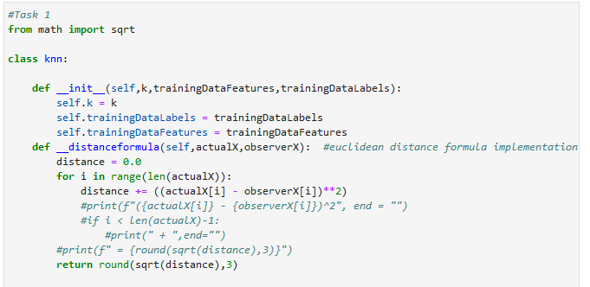

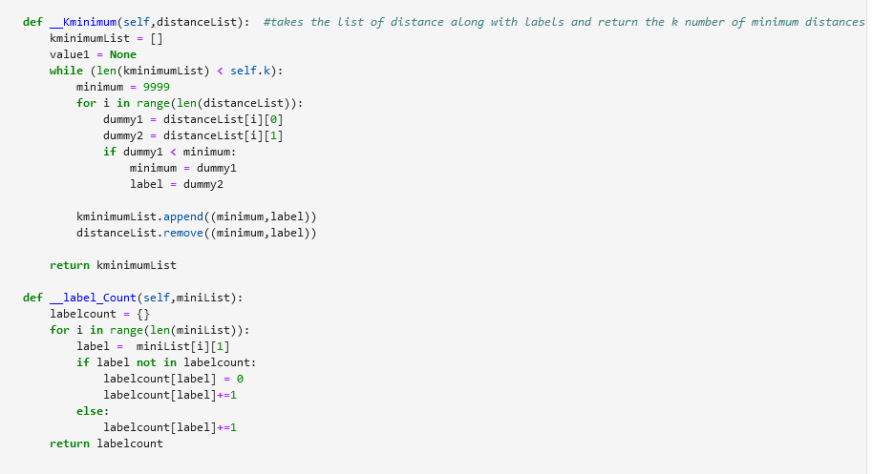

**Task#2:**

