

**Web Design & Development**

**Submitted By: Muhammad Farhan Ghani**

**Submitted To:** **Mr Rehaan**

**Subject:**  **web design & development**

**Roll No:**  **SP20M2BB001**

**Depart:**  **BS Computer Science Evening A**

**(Assignment)**  
  
**What is Python?**  
Python is a popular programming language. It was created by Guido van Rossum, and released in 1991.  
It is used for:  
 • web development (server-side),  
 • software development,  
 • mathematics,  
 • system scripting.  
**What can Python do?**  
Python can be used on a server to create web applications.  
Python can be used alongside software to create workflows.  
Python can connect to database systems. It can also read and modify files.  
Python can be used to handle big data and perform complex mathematics.  
Python can be used for rapid prototyping, or for production-ready software development.

**Why Python?**  
Python works on different platforms (Windows, Mac, Linux, Raspberry Pi, etc).  
Python has a simple syntax similar to the English language.

Python has syntax that allows developers to write programs with fewer lines than some other  
programming languages.  
Python runs on an interpreter system, meaning that code can be executed as soon as it is written. This  
means that prototyping can be very quick.  
Python can be treated in a procedural way, an object-oriented way or a functional way  
**Python Syntax compared to other programming languages**  
• Python was designed for readability, and has some similarities to the English language with  
influence from mathematics.  
• Python uses new lines to complete a command, as opposed to other programming languages  
which often use semicolons or parentheses.  
• Python relies on indentation, using whitespace, to define scope; such as the scope of loops,  
functions and classes. Other programming languages often use curly-brackets for this purpose.

**Example:**

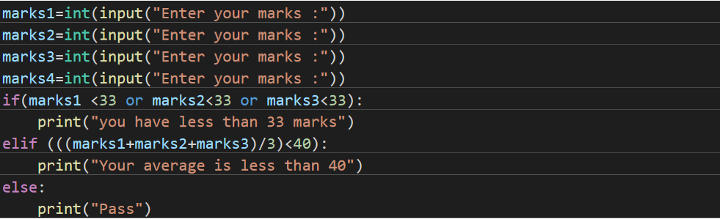

**Modules:**  
In Python, Modules are simply files with the “. py” extension containing Python code that can be  
imported inside another Python Program. In simple terms, we can consider a module to be the same as  
a code library or a file that contains a set of functions that you want to include in your application. To  
create a module, we have to save the code that we wish in a file with the file extension “.py”. Then, the  
name of the Python file becomes the name of the module.  
**For Example,**  
In this program, a function is created with the name “welcome” and save this file with the  
name mymodule.py i.e. name of the file, and with the extension “.py”.

We saved the following code in a file named mymodule.py  
def. welcome (name):  
print("Hello, " + name +"  
**IF-Else Statement:**  
In computer programming, we use the if statement to run a block code only when a certain  
condition is met.  
For example, assigning grades (A, B, C) based on marks obtained by a student.  
 1. if the percentage is above 90, assign grade A  
 2. if the percentage is above 75, assign grade B  
 3. if the percentage is above 65, assign grade C  
In Python, there are three forms of the if...else statement.  
 1. if statement  
 2. if...else statement  
 3. if...elif...else statement

**Example:**

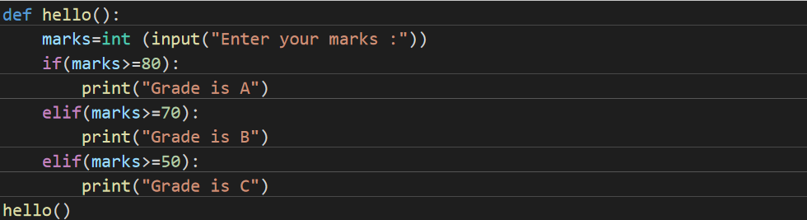

**Getting value from user:**

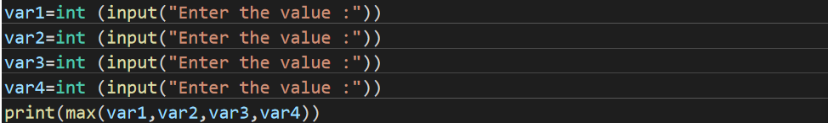

**Comments:**

In computer programming, comments are hints that we use to make our code more understandable.  
Comments are completely ignored by the interpreter. They are meant for fellow programmers.

For example,  
# declare and initialize two variables  
num1 = 6  
num2 = 9  
# print the output  
print('This is output')  
Here, we have used the following comments,  
declare and initialize two variables  
print the output  
**Types of Comments in Python**:  
In Python, there are two types of comments:  
 1. single-line comment  
 2. multi-line comment  
**Single-line Comment in Python**  
A single-line comment starts and ends in the same line. We use the # symbol to write a single-line comment.  
**For example,**  
# create a variable  
name = 'Eric Cartman'  
# print the value  
print(name)  
Run Code  
Output

Here, we have created two single-line comments:  
# create a variable  
# print the value  
**Multi-line Comment in Python**  
Python doesn't offer a separate way to write multiline comments. However, there are other ways to get  
around this issue.  
We can use # at the beginning of each line of comment on multiple lines.

**For example,**  
 # This is a long comment  
 # and it extends  
 # to multiple lines  
Here, each line is treated as a single comment, and all of them are ignored.  
Another way of doing this is to use triple quotes, either ''' or """.  
These triple quotes are generally used for multi-line strings. But if we do not assign it to any variable or function, we can use it as a comment.  
The interpreter ignores the string that is not assigned to any variable or function.  
Let's see an example,  
''' This is also a  
perfect example of  
multi-line comments '''  
Here, the multiline string isn't assigned to any variable, so it is ignored by the interpreter. Even though it  
is not technically a multiline comment, it can be used as one.  
**What is PIP?**  
PIP is a package manager for Python packages, or modules if you like.

**What is a Package?**  
A package contains all the files you need for a module.  
Modules are Python code libraries you can include in your project.

**Python Variable**  
Variables are the most important aspect of any programming language including python. In simple words, variables are names given to memory locations. The values stored in these memory locations can be altered throughout the programming life cycle. Variables are stored in the main memory and are generally required to carry forward various processes and transactions. Since we are talking about memory allocated to variables, it is quite obvious that once the variables are defined they will get associated with a physical address in the main memory. If we start accessing these values by physical addresses, the code will get complicated and that is why the addresses are associated with variable names.  
**Python Variable Types**  
 • Numbers.  
 • String.  
 • List.  
 • Tuple.  
**Strings**  
Strings are Arrays  
Like many other popular programming languages, strings in Python are arrays of bytes representing unicode characters. However, Python does not have a character data type, a single character is simply a string with a length of 1. Square brackets can be used to access elements of the string.For example, "hello" is a string containing a sequence of characters 'h' , 'e' , 'l' , 'l' , and 'o'  
**List**  
Lists are used to store multiple items in a single variable.

A list is an ordered data structure with elements separated by a comma and enclosed within square brackets. For example, list1 and list2 shown below contains a single type of data. Here, list1 has integers while list2 has strings. In Python, list and tuple are a class of data structures that can store one or more  
objects or values.  
Lists are one of 4 built-in data types in Python used to store collections of data, the other 3 are Tuple, Set, and Dictionary, all with different qualities and usage.  
Lists are created using square brackets:  
**Example**  
Create a List:  
thislist = ["apple", "banana", "cherry"]  
print(thislist)



**Tuple**

Tuples are used to store multiple items in a single variable. Tuple is one of 4 built-in data types in Python used to store collections of data, the other 3 are List, Set, and Dictionary, all with different qualities and usage. A tuple is a collection which is ordered and unchangeable.  
A tuple in Python is similar to a list. The difference between the two is that we cannot change the elements of a tuple once it is assigned whereas we can change the elements of a list.  
**Creating a Tuple**  
A tuple is created by placing all the items (elements) inside parentheses (), separated by commas. The parentheses are optional, however, it is a good practice to use them.  
A tuple can have any number of items and they may be of different types (integer, float, list, string, etc.).  
**Example**  
# Different types of tuples  
# Empty tuple  
my_tuple = ()

print(my_tuple)  
# Tuple having integers  
my_tuple = (1, 2, 3)  
print(my_tuple)  
# tuple with mixed datatypes  
my_tuple = (1, "Hello", 3.4)  
print(my_tuple)  
# nested tuple  
my_tuple = ("mouse", [8, 4, 6], (1, 2, 3))  
print(my_tuple)

**Dictionary**  
Dictionaries are used to store data values in key:value pairs.  
A dictionary is a collection which is ordered*, changeable and do not allow duplicates.  
**Dictionary Items**  
Dictionary items are ordered, changeable, and does not allow duplicates.  
Dictionary items are presented in key:value pairs, and can be referred to by using the key name.  
**Ordered or Unordered?**  
Dictionaries are changeable, meaning that we can change, add or remove items after the dictionary has  
been created.  
**Changeable**  
Dictionaries are changeable, meaning that we can change, add or remove items after the dictionary has  
been created.

**Example**  
Create and print a dictionary:

thisdict = {  
"brand": "Ford",  
"model": "Mustang",  
"year": 1964  
}  
print(thisdict)  
**Create a dictionary in Python**  
Here's how we can create a dictionary in Python.  
capital_city = {"Nepal": "Kathmandu", "Italy": "Rome", "England": "London"}  
print(capital_city)  
Run Code  
Output  
{'Nepal': 'Kathmandu', 'Italy': 'Rome', 'England': 'London'}