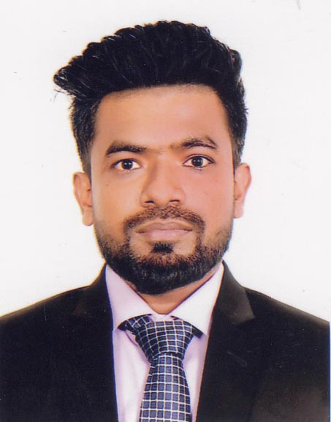

CURRICULUM VITAE
Of
MD. REDWAN

Mailing Address:

House No: 40, Road No: 09, South Baridhara
(DIT Project), Merul Badda, Dhaka-1212.
Contact: 01749423104
E-mail: tonmoy6060@gmail.com

Career Objective:
To obtain a full-time position where I can demonstrate my skills and improve my capabilities. To succeed in an environment of growth and excellence and earn a job satisfaction and Self-development and help me achieve personal as well as organizational goals.

Academic Qualification:
M.Sc in Computer Science and Engineering (Ongoing)
Major in Software Engineering.
United International University.

B.Sc. in Information Technology
Department : Information Technology
Thesis Title : Bengali Text to Speech Synthesis using Long-Short Term Memory
Obtained Result : 2.83 in a scale of 4.00
Passing Year : February 2020
Name of Institution : University of Information Technology & Sciences

Higher Secondary Certificate (H.S.C)
Name of Institution : Queen Mary College
Group : Science
Board : Dhaka
Obtained Result : 5.00 in a scale of 5.00
Passing Year : 13 August 2014

Secondary School Certificate (S.S.C)
Name of Institution : Chhengarchar Model High School
Group : Science
Board : Comilla
Obtained Result : 3.88 in a scale of 5.00
Passing Year : 7 May, 2012

EMPLOYMENT HISTORY:
Software Support Executive
15 October to 31 March, 2021
Dynamic Software Ltd.
Address: 238/1, Outer Circular Road, Maruf Market, 2nd Floor, Mowchak More, Dhaka-1217.

RESPONSIBILITIES:
Communication with clients. Client support requests and complaints about the phone, online, or directly face to face. Resolve hardware, software, and connectivity problems and determining the source of computer problems, and providing solutions accordingly. Installing and configuring computer hardware, operating systems, and applications. Conduct proper Installation, Maintenance
ACADEMIC PROJECT:

- Credit Card Fraud Detection Using Machine Learning
- Face Detection Using Python
- Handwritten Digit Recognition Using Machine Learning Algorithms
- Twitter User Gender Classification
TECHNICAL SKILL:

- Programming Language: C, JAVA.
- Load Testing : Jmeter, Selenium
- Performance Testing : loader.io
- API Testing : Postman
- Website Designing : HTML, CSS, PHP
- Database Management System : Oracle, MySQL

AREAS Of INTEREST:

- Web Development.
- Networking.
- Wireless Networking.
- Cloud Computing & Distributed System.
- Software Testing
- IoT
- Blockchain

Computer skills:

Efficient in Microsoft Office programs like MS Word, MS Excel, MS Access, MS PowerPoint, and Internet Browsing.

Personal Details:

Full Name | : | Md. Redwan
Father’s Name | : | Md. Shahid Ullah
Mother’s Name | : | Firoja Begum
Date of birth | : | 20/12/1996
Marital Status | : | Single
Religion | : | Islam
Citizenship | : | Bangladeshi by birth
Gender | : | Male
Height | : | 5 Feet 6 Inch.
Permanent Address | : | Village: Thakchurchar, PO: Changerchar Bazar,  Upazilla: Motlab Uttar, District: Chandpur
Present Address | : | House # 40, Road # 09, DIT Project,  Merul Badda, Dhaka-1212.

TRAINING SUMMARY:

Name of Training | Institute
Career and Opportunity Management – Creation & Innovation | HRD Foundation Bangladesh
Workshop on scientific documents writing using OVERLEAF | UITS
JavaScript, Bootstrap, & PHP – Certification Beginners | udemy
IT Essentials | Cisco
The Fundamentals of Digital Marketing | Google Digital Garage
Project Management and Appraisal Process | a2i Programme
Networking Academy Learn-A-Thon 2020 | Cisco

SPECIAL SKILLS:
- Leadership, Communication, Collaboration and Time Management.
- Organized and coordinated
- Self- motivated and dependable.
- Reliable, trustfully, carefully & hardly.
- Excellent team working skills.
- Trustworthy.
- Follow-up skills.
- Willingness to learn and continuously strive to build knowledge and skills.

Extra-Curricular Activities:
Secured Position in Primary (class V) & Junior (class VIII) Scholarship Examination.

Language Proficiency:

Language | Reading | Writing | Speaking
English | High | High | Medium
Bengali | Native | Native | Native

Reference:

Name | Name
1. Md. Al Shayokh  Position :  - Asst. Professor & chairman of the Department  - University of Information Technology & Sciences  - Cell : 01688701038  - E-mail : al.shayokh@utis.edu.bd | 2. Md. Mynoddin  Position :  - Lecturer, Department of CSE  - Rangamati Science & Technology University  - Cell : 01920984265  - E-mail: mynoddin@rmstu.edu.bd

declaration:
I, the undersigned; hereby declare that the above information is true and I will be responsible for any wrong information.

Yours Sincerely,


Date: 8/15/2021

