CLAUSEIQ – MACHINE LEARNING-BASED CONTRACT CLAUSE CLASSIFICATION AND INTELLIGENT SEARCH SYSTEM

INTERIM PROJECT REPORT

Submitted in partial fulfillment of the requirements for the award of the Degree of

MASTER OF COMPUTER APPLICATIONS

Submitted by

MOHAMMED FARHAN K
(Reg. No: MAC25MCA-2042)

Under the guidance of

Dr. SONIA ABRAHAM
Associate Professor, Department of Computer Applications

DEPARTMENT OF COMPUTER APPLICATIONS MAR ATHANASIUS COLLEGE OF ENGINEERING KOTHAMANGALAM, KERALA – 686666
SEPTEMBER 2026

DEPARTMENT OF COMPUTER APPLICATIONS MAR ATHANASIUS COLLEGE OF ENGINEERING KOTHAMANGALAM, KERALA – 686666

BONAFIDE CERTIFICATE

This is to certify that this interim project report titled “ClauseIQ – Machine Learning-Based Contract Clause Classification and Intelligent Search System” is a bonafide record of the work carried out by MOHAMMED FARHAN K (Reg. No: MAC25MCA-2042) in partial ful-fillment of the requirements for the award of the Degree of Master of Computer Applications from the APJ Abdul Kalam Technological University during the academic year 2025–2027.

Dr. SONIA ABRAHAM
Project Guide Associate Professor
Department of Computer Applications MACE, Kothamangalam

MANU JOHN / MINU MARIA JOSEPH
Project Coordinators Assistant Professors
Department of Computer Applications MACE, Kothamangalam

HEAD OF THE DEPARTMENT
Department of Computer Applications Mar Athanasius College of Engineering Kothamangalam, Kerala

ClauseIQ – Machine Learning-Based Contract Clause Classification and Intelligent Search System

DECLARATION

I, MOHAMMED FARHAN K (Reg. No: MAC25MCA-2042), hereby declare that the interim project report entitled “ClauseIQ – Machine Learning-Based Contract Clause Classification and Intelligent Search System” submitted to the Department of Computer Applications, Mar Athanasius College of Engineering, Kothamangalam, in partial fulfillment of the requirements for the award of the Degree of Master of Computer Applications, is an authentic record of original work carried out by me under the guidance and supervision of Dr. Sonia Abraham, Associate Professor, Department of Computer Applications.
I further declare that this report has not previously formed the basis for the award of any de-gree, diploma, associateship, fellowship, or other similar title of recognition to any university or institution.

Place: Kothamangalam
Date: 29-09-2026

MOHAMMED FARHAN K
Reg. No: MAC25MCA-2042

Department of Computer Applications, MACE i

ClauseIQ – Machine Learning-Based Contract Clause Classification and Intelligent Search System

ACKNOWLEDGEMENT

I take this opportunity to express my profound gratitude and heartfelt appreciation to all individ-uals who have contributed to the successful completion of this interim project phase.
First and foremost, I express my sincere gratitude to Dr. Sonia Abraham, Associate Professor and Project Guide, Department of Computer Applications, for her insightful guidance, valuable suggestions, constructive criticism, and continuous encouragement throughout the conception, modeling, and evaluation phases of ClauseIQ.
I extend my sincere thanks to Prof. Manu John and Prof. Minu Maria Joseph, Project Coordinators, for their meticulous scheduling, review assessments, and continuous support.
I express my deepest gratitude to the Head of the Department, Department of Computer Ap-plications, and to the Principal, Mar Athanasius College of Engineering, Kothamangalam, for providing the state-of-the-art computational facilities and academic environment essential for conducting this research.
I also express my heartfelt thanks to all the faculty and non-teaching staff of the Department of Computer Applications for their direct and indirect assistance. Finally, I thank my family and friends for their enduring patience, encouragement, and support throughout the course of this work.

MOHAMMED FARHAN K

Department of Computer Applications, MACE ii

ClauseIQ – Machine Learning-Based Contract Clause Classification and Intelligent Search System

ABSTRACT

Modern enterprises manage thousands of commercial contracts annually, where manual re-trieval and categorization of operative clauses (such as limitation of liability, non-compete covenants, governing law, and audit rights) is labor-intensive, error-prone, and non-scalable. To address these industry bottlenecks, ClauseIQ is developed as a machine learning-based contract intelligence system that performs multi-class legal clause classification and intelligent semantic search.
ClauseIQ is built and evaluated upon the Contract Understanding Atticus Dataset (CUAD), an authoritative corpus of 510 commercial contracts curated from SEC EDGAR filings and expert-annotated across 41 legal clause categories. For this work, span annotations were flattened and cleaned into a structured tabular corpus of 12,204 clauses spanning all 41 categories. The dataset exhibits a severe real-world class imbalance ratio of 46.33 : 1, ranging from 1,251 instances for Parties to 27 instances for Price Restrictions. Textual features are extracted using Term Frequency–Inverse Document Frequency (TF-IDF) configured for 10,000 unigram and bigram features with sublinear term frequency scaling.
Four classical machine learning algorithms—Multinomial Naive Bayes, Linear Support Vector Machine (Linear SVM), Multinomial Logistic Regression, and Random Forest—were trained on a stratified 80% split (9,763 training samples) and evaluated on an exact held-out 20% split (2,441 testing samples) across all 41 categories. Hyperparameter tuning was conducted using Stratified K-Fold Cross-Validation optimizing explicitly for Macro-Averaged F1-Score (Macro-F1).
On the held-out test set, Logistic Regression achieved 71.90% Accuracy and the highest Macro-F1 of 64.74% (Weighted-F1: 71.96%), while Linear SVM achieved 72.63% Accu-racy and 64.18% Macro-F1. Because Macro-F1 weights all 41 categories equally under severe imbalance, and because Logistic Regression provides class probability estimates through its multinomial softmax formulation for confidence scoring, Logistic Regression was formally selected as the optimal production classifier. In parallel, a TF-IDF + Cosine Similarity search engine was developed and empir-ically benchmarked across canonical legal query scenarios, achieving a Precision at 1 (𝑃@1) of 80.00% and Precision at 5 (𝑃@5) of 88.00% with sub-10ms query execution speed. The classification and search services are exposed via a modular FastAPI REST backend validated by an automated test suite with 15 passed tests (100% pass rate). Remaining deliverables—

Department of Computer Applications, MACE iii

ClauseIQ – Machine Learning-Based Contract Clause Classification and Intelligent Search System
including live Supabase PostgreSQL database integration and a React.js web interface—are clearly delineated for the final project phase.

Department of Computer Applications, MACE iv

ClauseIQ – Machine Learning-Based Contract Clause Classification and Intelligent Search System

LIST OF TABLES
  - Empirical evaluation of Linear SVM with and without entity replacement (Kutbi, 2023) 10
  - Comprehensive summary of supporting literature 11
  - Dataset schema and missing value analysis (𝑁 = 12, 204) 14
  - Most frequent vs. least frequent clause categories in ClauseIQ 15
  - Summary statistics of clause text dimensions (𝑁 = 12, 204) 16
  - Comprehensive performance comparison across all 4 machine learning models
(𝑁test = 2, 441) 32
  - Exact verified model evaluation metrics (decimal representation) 32
  - Representative class performance for the selected Logistic Regression model 36
  - Empirical Information Retrieval evaluation of ClauseIQ search engine 40
  - Systematic search refinement and ablation experiment results 41
  - Verified Git commit history of the ClauseIQ repository 45
  - Minimum software requirements for ClauseIQ 51
  - Minimum and recommended hardware specifications 51

Department of Computer Applications, MACE v

ClauseIQ – Machine Learning-Based Contract Clause Classification and Intelligent Search System

LIST OF FIGURES

  - Distribution of annotated clauses per contract across 510 CUAD contracts . . . 15
  - Complete 41-category class distribution in the ClauseIQ dataset (𝑁 = 12, 204) . 19
  - Average clause word count across legal categories 20
  - Distribution of clause word counts 21
  - Correlation matrix of text metrics 21
  - Top 20 most frequent bigrams in the ClauseIQ clause corpus 21
  - End-to-end ClauseIQ system pipeline architecture 25
  - Performance comparison of the four evaluated machine learning classifiers 33
  - Full 41 × 41 confusion matrix for the selected Logistic Regression model 35

Department of Computer Applications, MACE vi

ClauseIQ – Machine Learning-Based Contract Clause Classification and Intelligent Search System

CONTENTS
List of Tables | iv
List of Figures | v
1. INTRODUCTION | 1
2. SUPPORTING LITERATURE | 4
2.1 Literature Review | 4
2.2 Literature Review Summary | 8
2.3 Findings and Proposals | 9
3. SYSTEM ANALYSIS | 11
3.1 Analysis of the Dataset | 11
3.1.1 About the Dataset | 11
3.1.2 Explore the Dataset | 12
3.2 Data Preprocessing | 13
3.2.1 Data Cleaning | 13
3.2.2 Analysis of Feature Variables | 14
3.2.3 Analysis of Class Variables | 14
3.3 Data Visualization | 15
3.3.1 Category Frequency Distribution | 15
3.3.2 Average Clause Word Count by Category | 16
3.3.3 Word Count Distribution and Correlation Heatmap | 17
3.3.4 Top Legal Bigrams | 18
3.4 Analysis of Architecture and(or) Algorithms | 19
3.4.1 Detailed Study Report of the Proposed Algorithm(s) | 19
3.5 Project Pipeline | 22
3.6 Feasibility Analysis | 23
3.7 System Environment | 24
3.7.1 Software Environment | 24
3.7.2 Hardware Environment | 24
4. SYSTEM DESIGN | 25
4.1 Model(s) Building | 25
4.1.1 Implementation Code | 25
4.1.2 Model Planning (Training/Testing split of the dataset) | 25
4.1.3 Training | 26
4.1.4 Testing | 28
5. RESULTS AND DISCUSSION | 29
5.1 Comparison of Models | 29
5.2 Evaluation Metrics | 31
5.3 Confusion Matrix | 32
5.4 Relevant Metrics Calculated from Confusion Matrix | 33
5.5 Prediction Statistics of Unseen Data | 34
5.6 Discussion of Findings and Conclusions | 35
REFERENCES | 36
    - Paper 1 – Legal Natural Language Processing From 2015 to 2022: A Comprehensive Systematic Mapping Study of Advances and Applications 6
    - Paper 2 – Exploring LLMs Applications in Law: A Literature Review

Department of Computer Applications, MACE

ClauseIQ – Machine Learning-Based Contract Clause Classification and Intelligent Search System

INTRODUCTION

Commercial contracts represent the legal, operational, and financial foundation of modern enterprise transactions. Large organizations manage thousands of agreements annually, including non-disclosure agreements (NDAs), master service agreements (MSAs), software licenses, intellectual property assignments, and vendor contracts. Despite their importance, contract review remains a largely

manual, resource-intensive, and error-prone process. Legal professionals often need to examine

lengthy documents to identify specific provisions related to liabilities, obligations, termination,

governing law, confidentiality, and other contractual terms. This becomes particularly challenging

during audits, mergers, regulatory reviews, and compliance activities, where relevant clauses must be located quickly across a large collection of documents. Manual inspection can also lead to inconsistent interpretation, reviewer fatigue, and the possibility of overlooking important contractual provisions.

Traditional document search tools provide limited support for this task because legal clauses can expresimilar concepts using substantially different terminology. For example, a limitation of liability provision may be expressed through phrases such as “aggregate liability shall not exceed the fees

paid” or “under no circumstances shall either party be liable.” Simple keyword-based searching

may fail to identify such variations. Legal provisions may also contain multiple sentences, conditional statements, definitions, and cross-references, making it difficult to isolate the relevant clause.

In addition, frequently repeated boilerplate provisions can generate considerable search noise and

make it harder for reviewers to identify the specific terms relevant to their requirements.

Natural Language Processing (NLP) and Machine Learning (ML) provide data-driven approaches for addressing these limitations. By converting unstructured contract text into numerical representations, machine learning algorithms can automatically classify clauses into predefined legal categories.

Similarly, information retrieval techniques can rank clauses according to their relevance to a user's

search query. These capabilities can support faster identification of relevant contractual provisions,

provide consistent categorization, and reduce the amount of time required for repetitive contract

review tasks.

Department of Computer Applications, MACE 1

ClauseIQ – Machine Learning-Based Contract Clause Classification and Intelligent Search System

ClauseIQ is a Machine Learning-Based Contract Clause Classification and Intelligent Search System

developed to address these challenges. The system uses the Contract Understanding Atticus Dataset

(CUAD), released by The Atticus Project and recognized by NeurIPS. CUAD contains 510 real-world commercial contracts obtained from the U.S. Securities and Exchange Commission (SEC) EDGAR

filing database and provides annotations covering 41 legal clause categories, with more than 13,000 annotated clause spans. For this project, the contract-level annotations were flattened, cleaned, and organized into a structured dataset containing 12,204 clause records with three primary attributes: contract_id, clause_text, and category.

ClauseIQ provides two main capabilities. The first is supervised clause classification, where an

extracted contractual clause is categorized into one of the 41 CUAD legal categories, such as

Audit Rights, Governing Law, Cap On Liability, and Termination-related provisions. The second is intelligent clause search, where a natural-language query is compared against the clause corpus

using TF-IDF representation and Cosine Similarity to retrieve relevant clauses. Category-based

filtering can also be used to narrow the search space and improve the usefulness of retrieved results.

The current interim project focuses on the complete exploratory data analysis and validation of the

CUAD corpus, text preprocessing, tokenization, stopword management, and TF-IDF feature

extraction using unigram and bigram features. Four classical machine learning algorithm

Multinomial Naive Bayes, Linear Support Vector Machine (SVM), Logistic Regression, and Random Forest—are considered for clause classification. The models are evaluated across all 41 categories

using a held-out 20% test set containing 2,441 samples. The project also includes the development and evaluation of the TF-IDF and Cosine Similarity-based intelligent search component using retrieval

measures such as Precision and Recall. A modular FastAPI backend is used for model serving and automated test verification.

The interim implementation is limited to the data processing, machine learning, evaluation, search, and backend components completed during the current project phase. The React.js user interface,

dynamic multi-page PDF ingestion pipeline, cloud deployment, and complete Supabase PostgreSQL persistence are considered remaining work for the final phase of development. Thus, the present work establishes the core machine learning and intelligent search foundation required for the complete

ClauseIQ system.

Department of Computer Applications, MACE 2

ClauseIQ – Machine Learning-Based Contract Clause Classification and Intelligent Search System

SUPPORTING LITERATURE

Literature Review

To establish the theoretical and empirical grounding for ClauseIQ, this chapter reviews three foundational research publications in Legal Natural Language Processing (Legal NLP), contract analysis, and text classification published between 2023 and 2025 in IEEE Access.

Paper 1 – Legal Natural Language Processing From 2015 to 2022: A Comprehen-sive Systematic Mapping Study of Advances and Applications
Authors: Quevedo Caballero E., Černý T., Rodriguez A., Rivas P., Yero J., Sooksatra K., Taibi D.
Publication Details: IEEE Access, vol. 12, pp. 145286–145317, 2024.
Digital Object Identifier (DOI): https://doi.org/10.1109/ACCESS.2024.3414967

Overview and Area of Work

This publication presents an exhaustive Systematic Mapping Study (SMS) of Legal NLP re-search published over an eight-year period (2015 to 2022). The authors systematically cata-logued, classified, and analyzed 179 primary studies across digital libraries (IEEE Xplore, ACM Digital Library, Scopus, and Web of Science) to map the evolution of legal text processing tasks, algorithmic paradigms, benchmarks, and unresolved domain challenges.

Problem Statement and Scope

Legal documents are characterized by domain-specific jargon, syntactic archaisms, non-linear cross-references, and structural variability that render general-purpose NLP models subopti-mal. The study investigated what legal tasks are being automated, which datasets are establish-ing community benchmarks, and whether classical statistical models remain relevant alongside modern neural approaches.

Methodology

The study followed established systematic literature review guidelines:

      - Formulation of five targeted research questions focusing on task distribution, architectural
Department of Computer Applications, MACE 3

ClauseIQ – Machine Learning-Based Contract Clause Classification and Intelligent Search System
choices, evaluation paradigms, and domain challenges.
      - Rigorous multi-stage filtering from an initial corpus of over 2,400 papers down to 179 high-quality primary studies.
      - Thematic taxonomy creation categorizing tasks into Information Extraction, Text Classifi-cation, Legal Information Retrieval, and Legal Judgment Prediction.

Key Findings

        - Text Classification Prominence: Multi-class legal document and clause classification emerged as one of the two most dominant task categories across the eight-year survey, accounting for nearly 30% of all investigated literature.
        - Prevalence of Classical Baselines: Despite the introduction of BERT and transformer mod-els in 2018, classical machine learning approaches (particularly Support Vector Machines, Logistic Regression, and Naive Bayes coupled with n-gram TF-IDF representations) con-tinue to serve as the universal standard baseline across more than 40% of evaluated bench-marks.
        - Data Scarcity and Class Imbalance: The authors identified extreme class imbalance and the scarcity of expert-annotated corpora as the single greatest bottleneck in real-world legal NLP deployment.

Relevance to ClauseIQ

Quevedo Caballero et al. provide direct academic justification for ClauseIQ’s architectural framework. Their survey validates that:
- Multi-class clause categorization is a core, legitimate problem in legal informatics.
- A classical TF-IDF baseline represents an essential, rigorous foundation before adopting more complex neural frameworks.
- Addressing severe class imbalance through specialized metrics (such as Macro-F1) is manda-tory for credible legal classification systems.

Paper 2 – Exploring LLMs Applications in Law: A Literature Review on Current Legal NLP Approaches
Authors: Siino M., Falco M., Croce D., Rosso P.
Publication Details: IEEE Access, vol. 13, pp. 18253–18276, 2025.
Digital Object Identifier (DOI): https://doi.org/10.1109/ACCESS.2025.3533217
Department of Computer Applications, MACE 4

ClauseIQ – Machine Learning-Based Contract Clause Classification and Intelligent Search System

Overview and Area of Work

This survey examines the deployment of Large Language Models (LLMs) and advanced neural NLP techniques across diverse legal domains from 2017 through 2023, comparing them against classical and smaller fine-tuned models.

Problem Statement and Scope

The rapid proliferation of generative language models has generated immense interest within legal technology. However, deploying multi-billion-parameter neural models introduces signif-icant challenges, including hallucinations, high inference latency, prohibitive fine-tuning and hosting costs, lack of deterministic reproducibility, and data privacy concerns regarding con-fidential commercial contracts. This paper evaluates the practical trade-offs between classical NLP, specialized smaller models, and generative LLMs.

Methodology

The authors conducted a PRISMA-compliant systematic review of 61 selected papers, synthe-sizing task performance, hardware footprints, dataset choices, and deployment feasibility across contract analysis, statutory interpretation, and legal document drafting.

Key Findings

- CUAD as the Gold Standard: The Contract Understanding Atticus Dataset (CUAD) was explicitly identified as the premier open-source benchmark for legal contract clause identi-fication, cited across numerous experimental evaluations.
- The Cost-Accuracy Trade-off: The survey documented that while LLMs demonstrate strong zero-shot reasoning, carefully tuned classical algorithms and specialized discrimi-native models frequently achieve comparable or superior precision on narrowly scoped clas-sification tasks, at a fraction of the computational and financial cost.
- Real-World Deployment Barriers: LLM-based solutions face severe latency barriers (of-ten exceeding 2,000 ms per query) and privacy liabilities when processing non-public con-tracts via cloud APIs, making local, lightweight pipelines highly attractive for practical en-terprise adoption.

Relevance to ClauseIQ

Siino et al.’s findings strongly corroborate ClauseIQ’s technical choices:
Department of Computer Applications, MACE 5

ClauseIQ – Machine Learning-Based Contract Clause Classification and Intelligent Search System
      - It directly validates the selection of CUAD as the premier benchmark for contract clause intelligence.
      - It provides empirical support for a classical machine learning approach, demonstrating that high-cost generative LLMs are not inherently required for robust clause triage.
      - It highlights the operational value of low-latency, deterministic, offline-capable architec-tures for legal workflows.

Paper 3 – Named Entity Recognition Utilized to Enhance Text Classification While Preserving Privacy
Authors: Kutbi M.
Publication Details: IEEE Access, vol. 11, pp. 117576–117581, 2023.
Digital Object Identifier (DOI): https://doi.org/10.1109/ACCESS.2023.3325895

Overview and Area of Work

Unlike the preceding systematic surveys, this publication is a targeted empirical research investi-gation. Kutbi explores whether applying Named Entity Recognition (NER) to identify and mask entity tokens (such as specific personal names, company names, and geographic locations) with standardized tags can improve downstream text classification accuracy while simultaneously protecting privacy in sensitive domain texts.

Problem Statement and Methodology

In legal contracts, paragraphs frequently contain contract-specific proper nouns (e.g., specific counterparty names, monetary numbers, execution dates) that carry virtually zero discriminative signal for identifying the underlying clause category. Leaving raw named entities intact inflates the feature space with sparse, contract-specific tokens, causing overfitting and privacy leakage.
Kutbi evaluated a pipeline utilizing a spaCy NER model to detect named entities and replace them with generic placeholder tokens (e.g., PERSON, ORG, GPE) prior to TF-IDF feature extrac-tion. The pipeline was tested on an in-house legal corpus of Limited Partnership Agreement (LPA) contract paragraphs (spanning 20 clause categories) alongside two benchmark general text datasets (Movie Reviews and Comparative Sentences). Classifiers including Linear Sup-port Vector Machines were evaluated across unigram, bigram, and trigram configurations using 10 iterations of 5-fold cross-validation.

Department of Computer Applications, MACE 6

ClauseIQ – Machine Learning-Based Contract Clause Classification and Intelligent Search System

Key Experimental Results

Kutbi reported original experimental results across feature configurations. Table 2.1 reproduces the empirical findings on the legal Limited Partnership Agreement (LPA) dataset.

Dataset | N-gram Config | Linear SVM (Raw Text) | Linear SVM (+ NER Replacement)
Legal LPA (20 classes) | 1-gram | 55.37% | 58.31%
Legal LPA (20 classes) | 2-gram | 55.60% | 63.76%
Legal LPA (20 classes) | 3-gram | 57.48% | 62.83%
Movie Reviews | 1-gram | 81.00% | 81.90%
Movie Reviews | 2-gram | 82.50% | 82.80%
Movie Reviews | 3-gram | 82.60% | 82.50%
Comparative Sentences | 1-gram | 68.30% | 68.54%
Comparative Sentences | 2-gram | 66.66% | 67.37%
Comparative Sentences | 3-gram | 65.25% | 66.59%
Table 2.1: Empirical evaluation of Linear SVM with and without entity replacement (Kutbi, 2023)

The most significant finding for contract analysis is that on the legal LPA corpus, bigram (2-gram) Linear SVM classification accuracy improved substantially from 55.60% to 63.76% (an absolute gain of +8.16%) when named entity replacement was introduced.

Relevance to ClauseIQ

Kutbi’s empirical investigation is directly relevant to ClauseIQ:

      - It validates that classical Linear SVM models operating on n-gram TF-IDF representations are highly responsive to legal contract text classification.
      - It demonstrates that bigram (2-gram) features yield superior discriminative capability over unigrams in legal contexts, directly supporting ClauseIQ’s adoption of unigram+bigram TF-IDF feature extraction.
      - It highlights that commercial contract clauses are laden with counterparty names and dates that can introduce feature noise, validating ClauseIQ’s careful tokenization and stopword normalization.

Literature Review Summary

Table 2.2 synthesizes the core findings and architectural relevance of the three reviewed publi-cations.
Department of Computer Applications, MACE 7

ClauseIQ – Machine Learning-Based Contract Clause Classification and Intelligent Search System
Publication Approach / Scope Key Findings Relevance to ClauseIQ

Quevedo Ca-ballero et al. (2024) [1]

Siino et al. (2025)
[2]
Systematic Mapping Study of Legal NLP (2015–2022); 179
primary studies.

PRISMA review of LLMs and classical NLP in law (2017–2023); 61 papers.
Multi-class text classifica-tion is a primary legal NLP task; classical TF-IDF baselines remain dominant; class imbalance is a major challenge.
Identifies CUAD as the standard benchmark; demonstrates that tuned classical models offer superior efficiency and deterministic output over LLMs.
Legitimizes classical TF-IDF classification for CUAD; reinforces the requirement for bal-anced/macro evaluation metrics.
Validates choice of CUAD benchmark; confirms com-putational, financial, and privacy benefits of classi-cal ML.

Kutbi (2023) [3] Empirical evaluation
on legal contract paragraphs using Linear SVM and NER.
Bigram representations paired with Linear SVM achieved 63.76% accuracy on legal text; entity normal-ization reduces noise and improves accuracy.
Directly motivates un-igram+bigram TF-IDF representations; provides comparative empirical baseline for legal clause classification.

Table 2.2: Comprehensive summary of supporting literature

Findings and Proposals

The synthesis of the supporting literature establishes three critical takeaways:

- Domain Legitimacy: Legal clause classification is an active, well-defined problem in ap-plied computing with clear commercial utility.
- Benchmark Authority: CUAD is the literature-recognized, peer-reviewed standard for contract intelligence.
- Classical ML Feasibility: Classical machine learning algorithms operating on high-dimensional sparse TF-IDF vectors offer an optimal balance of accuracy, low latency, determinism, and computational thrift.

Identified Research Gaps

Despite the strengths of existing studies, significant practical gaps remain:

  - Lack of Integrated Applications: Most existing publications present isolated offline bench-mark evaluations (e.g., reporting cross-validation numbers on static datasets) without deliv-ering a deployable, interactive system that legal professionals can use.
  - Neglect of Retrieval: Studies typically focus exclusively on classification or exclusively on
Department of Computer Applications, MACE 8

ClauseIQ – Machine Learning-Based Contract Clause Classification and Intelligent Search System
search, whereas real-world contract triage requires both automated classification and free-text similarity search over the same clause index.
  - Arbitrary Class Down-sampling: Many student and preliminary projects reduce CUAD to an arbitrary subset of 8 or 9 high-frequency categories, obscuring the severe real-world class imbalance across all 41 categories.

ClauseIQ System Proposals

To directly bridge these identified gaps within an academically disciplined framework, ClauseIQ proposes:
- Full 41-Category Classification: Maintaining the complete, unpruned 41-class scope of the flattened CUAD corpus (12,204 rows), addressing the true 46.33:1 imbalance ratio.
- Rigorous 4-Model Comparative Benchmark: Implementing and systematically tuning four distinct classical algorithms (Logistic Regression, Linear SVM, Multinomial Naive Bayes, Random Forest) on an identical 80/20 held-out split.
- Dual Capability (Classification + Intelligent Search): Coupling multi-class classification with a TF-IDF + Cosine Similarity search engine over the exact same feature representation, evaluated empirically using Information Retrieval metrics (𝑃@𝑘 and 𝑅@𝑘).
- Modular API Architecture: Wrapping model inference and search pipelines within a lightweight FastAPI REST backend to demonstrate end-to-end engineering completeness.

Department of Computer Applications, MACE 9

ClauseIQ – Machine Learning-Based Contract Clause Classification and Intelligent Search System

SYSTEM ANALYSIS

This chapter documents the empirical analysis of the dataset, data cleaning and preprocessing pipelines, exploratory data visualization, mathematical foundations of the proposed machine learning algorithms, end-to-end project pipeline, multidimensional feasibility study, and execu-tion environment for ClauseIQ. All numerical metrics and distributions presented in this chapter are derived directly from the verified dataset and repository artifacts.

Analysis of the Dataset

About the Dataset

ClauseIQ is built upon the Contract Understanding Atticus Dataset (CUAD), an authoritative legal natural language processing benchmark curated by The Atticus Project. CUAD consists of 510 real-world commercial contracts obtained from the United States Securities and Exchange Commission (SEC) EDGAR database. The corpus comprises diverse transactional agreements, including master services agreements, joint venture agreements, licensing pacts, intellectual property assignments, and merger documentation.
In its native distribution, CUAD is packaged in a SQuAD-style JSON format, wherein 41 dis-tinct legal categories are mapped to span-level annotations across full contract documents. To construct a standardized, supervised classification and retrieval engine, these span annotations were extracted, normalized, and flattened into a structured tabular corpus.
The resulting working dataset of ClauseIQ contains 12,204 rows structured into three core at-tributes:
      - contract_id (String): Unique identifier corresponding to the source commercial contract (510 unique contracts).
      - clause_text (String): The extracted, operative contractual text span.
      - category (String): The expert-annotated legal category label (41 unique classes).

Importantly, ClauseIQ models the full, unreduced 41-class problem space. The system does not truncate the problem to an arbitrary subset of 8 or 9 classes, thereby preserving the genuine real-world taxonomy and difficulty of enterprise legal review.
Department of Computer Applications, MACE 10

ClauseIQ – Machine Learning-Based Contract Clause Classification and Intelligent Search System

Explore the Dataset

Dataset Completeness and Missing Values

Data integrity checks were executed across all 12,204 records in the flattened corpus. As sum-marized in Table 3.1, all three attributes exhibit 100% completeness, with zero missing, null, or undefined values.

Column Name | Data Type | Total Count | Missing Values | Completeness (%)
contract_id | String (Categorical) | 12,204 | 0 | 100.0%
clause_text | String (Text) | 12,204 | 0 | 100.0%
category | String (Target) | 12,204 | 0 | 100.0%
Table 3.1: Dataset schema and missing value analysis (𝑁 = 12, 204)

Duplicate and Boilerplate Analysis

Deduplication analysis revealed zero duplicate rows across the entire dataset. However, text-level analysis identified that 1,655 clause texts repeat across distinct contracts, representing 13.56% of all records, leaving 10,549 unique distinct clause text strings.
In legal contracting, this repetition is an expected domain characteristic rather than an artifact of faulty data collection. Commercial contracts heavily utilize standardized boilerplate covenants (e.g., standard “prior written consent” stipulations, standard Delaware governing law provisions, or formal notice requirements) across unrelated corporate agreements. Preserving these shared boilerplate provisions is necessary to ensure the classifier learns standard legal phrasing.

Contract-Level Clause Distribution

The 12,204 clauses originate from 510 distinct contracts. The distribution of clauses per contract varies significantly depending on contract complexity, governing structure, and total length:
- Mean clauses per contract: 23.93
- Median clauses per contract: 19.00
- Minimum clauses in a contract: 1
- Maximum clauses in a contract: 93

Figure 3.1 illustrates the distribution of clause counts per contract. While a typical agreement contains between 15 and 30 annotated clauses, complex transaction agreements contain up to 93 distinct provisions.
Department of Computer Applications, MACE 11

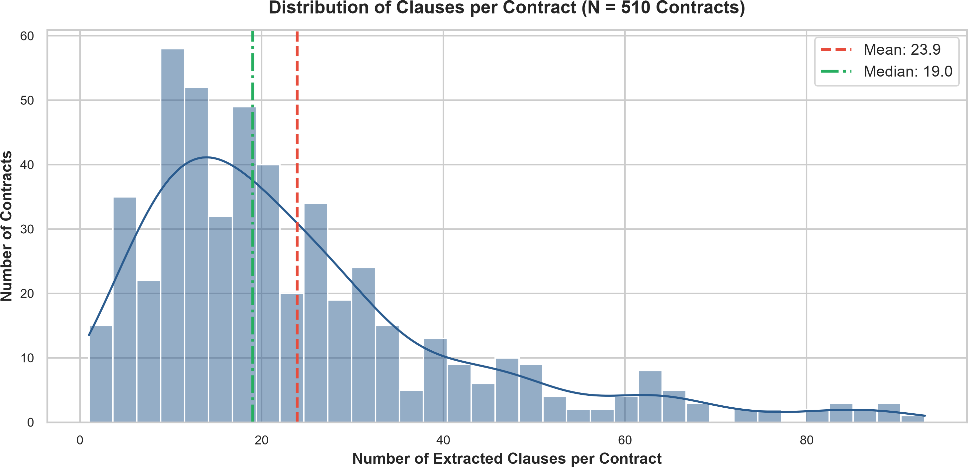
ClauseIQ – Machine Learning-Based Contract Clause Classification and Intelligent Search System

Figure 3.1: Distribution of annotated clauses per contract across 510 CUAD contracts

Class Distribution and Severe Imbalance

The 41 legal categories display extreme class imbalance. Table 3.2 outlines the ten most frequent and five least frequent categories in the dataset.

Rank Category (Frequent) Count Rank Category (Rare) Count

1 Parties | 1,251 | 37 | Source Code Escrow | 67
2 Cap On Liability | 742 | 38 | Unlimited/All-You-Can-Eat | 43
3 Audit Rights | 642 | 39 | Non-Disparagement | 42
4 Governing Law | 462 | 40 | Third Party Beneficiary | 39
5 Anti-Assignment | 652 | 41 | Price Restrictions | 27
Table 3.2: Most frequent vs. least frequent clause categories in ClauseIQ

The largest class, Parties, comprises 1,251 clauses (10.25% of the total dataset), whereas the smallest category, Price Restrictions, comprises merely 27 clauses (0.22% of the dataset). This establishes an extreme class imbalance ratio of 46.33 : 1. Section 3.2.3 addresses the critical algorithmic and evaluation implications of this distribution.

Text Length and Syntactic Statistics

To quantify the linguistic characteristics of the clauses, three metrics were computed: word count, character length, and sentence count. Table 3.3 presents the summary statistics.
The statistics highlight substantial structural heterogeneity. The shortest valid clauses contain as few as 3 words (e.g., party entities or agreement dates), while expansive indemnification or non-compete clauses span up to 479 words and 24 sentences.

Department of Computer Applications, MACE 12

ClauseIQ – Machine Learning-Based Contract Clause Classification and Intelligent Search System

Metric | Word Count | Character Length | Sentence Count
Minimum | 3 | 9 | 1
Maximum | 479 | 3,169 | 24
Mean | 45.89 | 289.16 | 1.48
Median | 36.00 | 228.00 | 1.00
Std Dev | 39.42 | 251.84 | 1.12
Table 3.3: Summary statistics of clause text dimensions (𝑁 = 12, 204)

Data Preprocessing

Data Cleaning Pipeline

To transform raw contractual text into uniform numerical representations suitable for machine learning, a systematic preprocessing pipeline was implemented:
      - Text Extraction: Ingestion of contractual text strings from structured CSV and document extractors.
      - Clause Splitting: Detection of clause boundaries based on paragraph breaks, numbered section headers (e.g., Section 12.1, Article IV), and terminal punctuation.
      - Case Normalization: Conversion of all text to lowercase to unify vocabulary (e.g., “Shall” and “shall” map to the same token).
      - Special Character and Punctuation Handling: Removal of extraneous formatting char-acters (tabs, repeated hyphens, non-ASCII symbols) while preserving standard syntactical punctuation that delineates clauses.
      - Whitespace Consolidation: Regex-based collapse of irregular whitespace into single space characters.
      - Tokenization and Stopword Filtering: Word-level tokenization combined with English stopword filtering to eliminate low-information grammatical words without discarding legal connectors.

Short-Clause and Long-Clause Preservation Policy

A critical finding from exploratory data analysis is that short clauses are not noise. Legal contracts inherently contain concise, high-value provisions. For instance, in the CUAD dataset, metadata categories such as Parties (mean length: 5.6 words) and Document Name (mean length: 4.8 words) frequently contain fewer than 5 words. An automated filter removing spans under 5 words would eliminate 89.8% of all Parties records and 55.0% of Document Name records, severely damaging model training.
Department of Computer Applications, MACE 13

ClauseIQ – Machine Learning-Based Contract Clause Classification and Intelligent Search System
Conversely, long clauses (reaching up to 479 words) represent comprehensive, highly negotiated covenants (e.g., complex Non-Compete or License Grant terms). Truncating these provisions would strip out essential restrictive qualifications. Therefore, all valid annotated clauses are retained, and sublinear term frequency scaling is introduced during vectorization to mathe-matically regulate the influence of very long provisions.

Analysis of Feature Variables

The primary feature variable is the raw clause_text. While metadata metrics (word count, character length, sentence count) were engineered during EDA to understand the corpus, they are deliberately excluded from classifier training. Passing clause length as an explicit feature would introduce spurious correlations, as length alone cannot reliably differentiate legal rights.
Textual features are extracted using Term Frequency–Inverse Document Frequency (TF-IDF) with the following verified hyperparameters:
- Vocabulary Dimension: Capped at the top 10,000 features based on term frequency across the training split.
- N-gram Range: (1, 2), capturing both unigrams (individual words) and bigrams (two-word collocations). In legal drafting, compound phrases such as “governing law”, “prior written”, and “sole discretion” carry distinct legal meaning that individual unigrams cannot convey.
- Sublinear TF Scaling: Enabled (sublinear_tf = True), replacing raw term frequency 𝑇𝐹 with 1 + log(𝑇𝐹), preventing long clauses with repetitive words from dominating vector magnitudes.
- Document Frequency Bounds: Terms appearing in fewer than 2 documents are excluded to filter out typographical anomalies.

Analysis of Class Variables and Imbalance Dynamics

The target variable is category, comprising 41 discrete legal classes. In a multi-class dataset exhibiting a 46.33:1 imbalance ratio, standard classification accuracy is a deceptive metric. A naive baseline that uniformly predicts the majority class (Parties) would achieve an accuracy score while failing completely to detect critical risk categories such as Price Restrictions, Most Favored Nation, or Source Code Escrow.
To ensure that rare categories receive equal optimization priority during model selection, the

Department of Computer Applications, MACE 14

ClauseIQ – Machine Learning-Based Contract Clause Classification and Intelligent Search System
project adopts Macro-Averaged F1-Score (Macro-F1) as the primary evaluation metric:
𝐶
Macro-F1 = 1 ∑ 𝐹1 (3.1)
𝐶 𝑐
𝑐=1

where 𝐶 = 41. Macro-F1 calculates the harmonic mean of precision and recall for each category independently and then computes their unweighted arithmetic mean. Under this formulation, correctly classifying a rare Price Restrictions clause is weighted identically to classifying a frequent Parties clause. Furthermore, class weighting (class_weight = ’balanced’) is applied to penalize misclassifications in minority classes proportionally to their inverse class frequencies.

Data Visualization

3.3.1. Category Frequency Distribution
Figure 3.2 displays the frequency distribution across all 41 legal categories in the ClauseIQ dataset. The extreme long-tail distribution visually confirms the severe imbalance, with the top 5 categories accounting for more than 30% of the entire corpus.
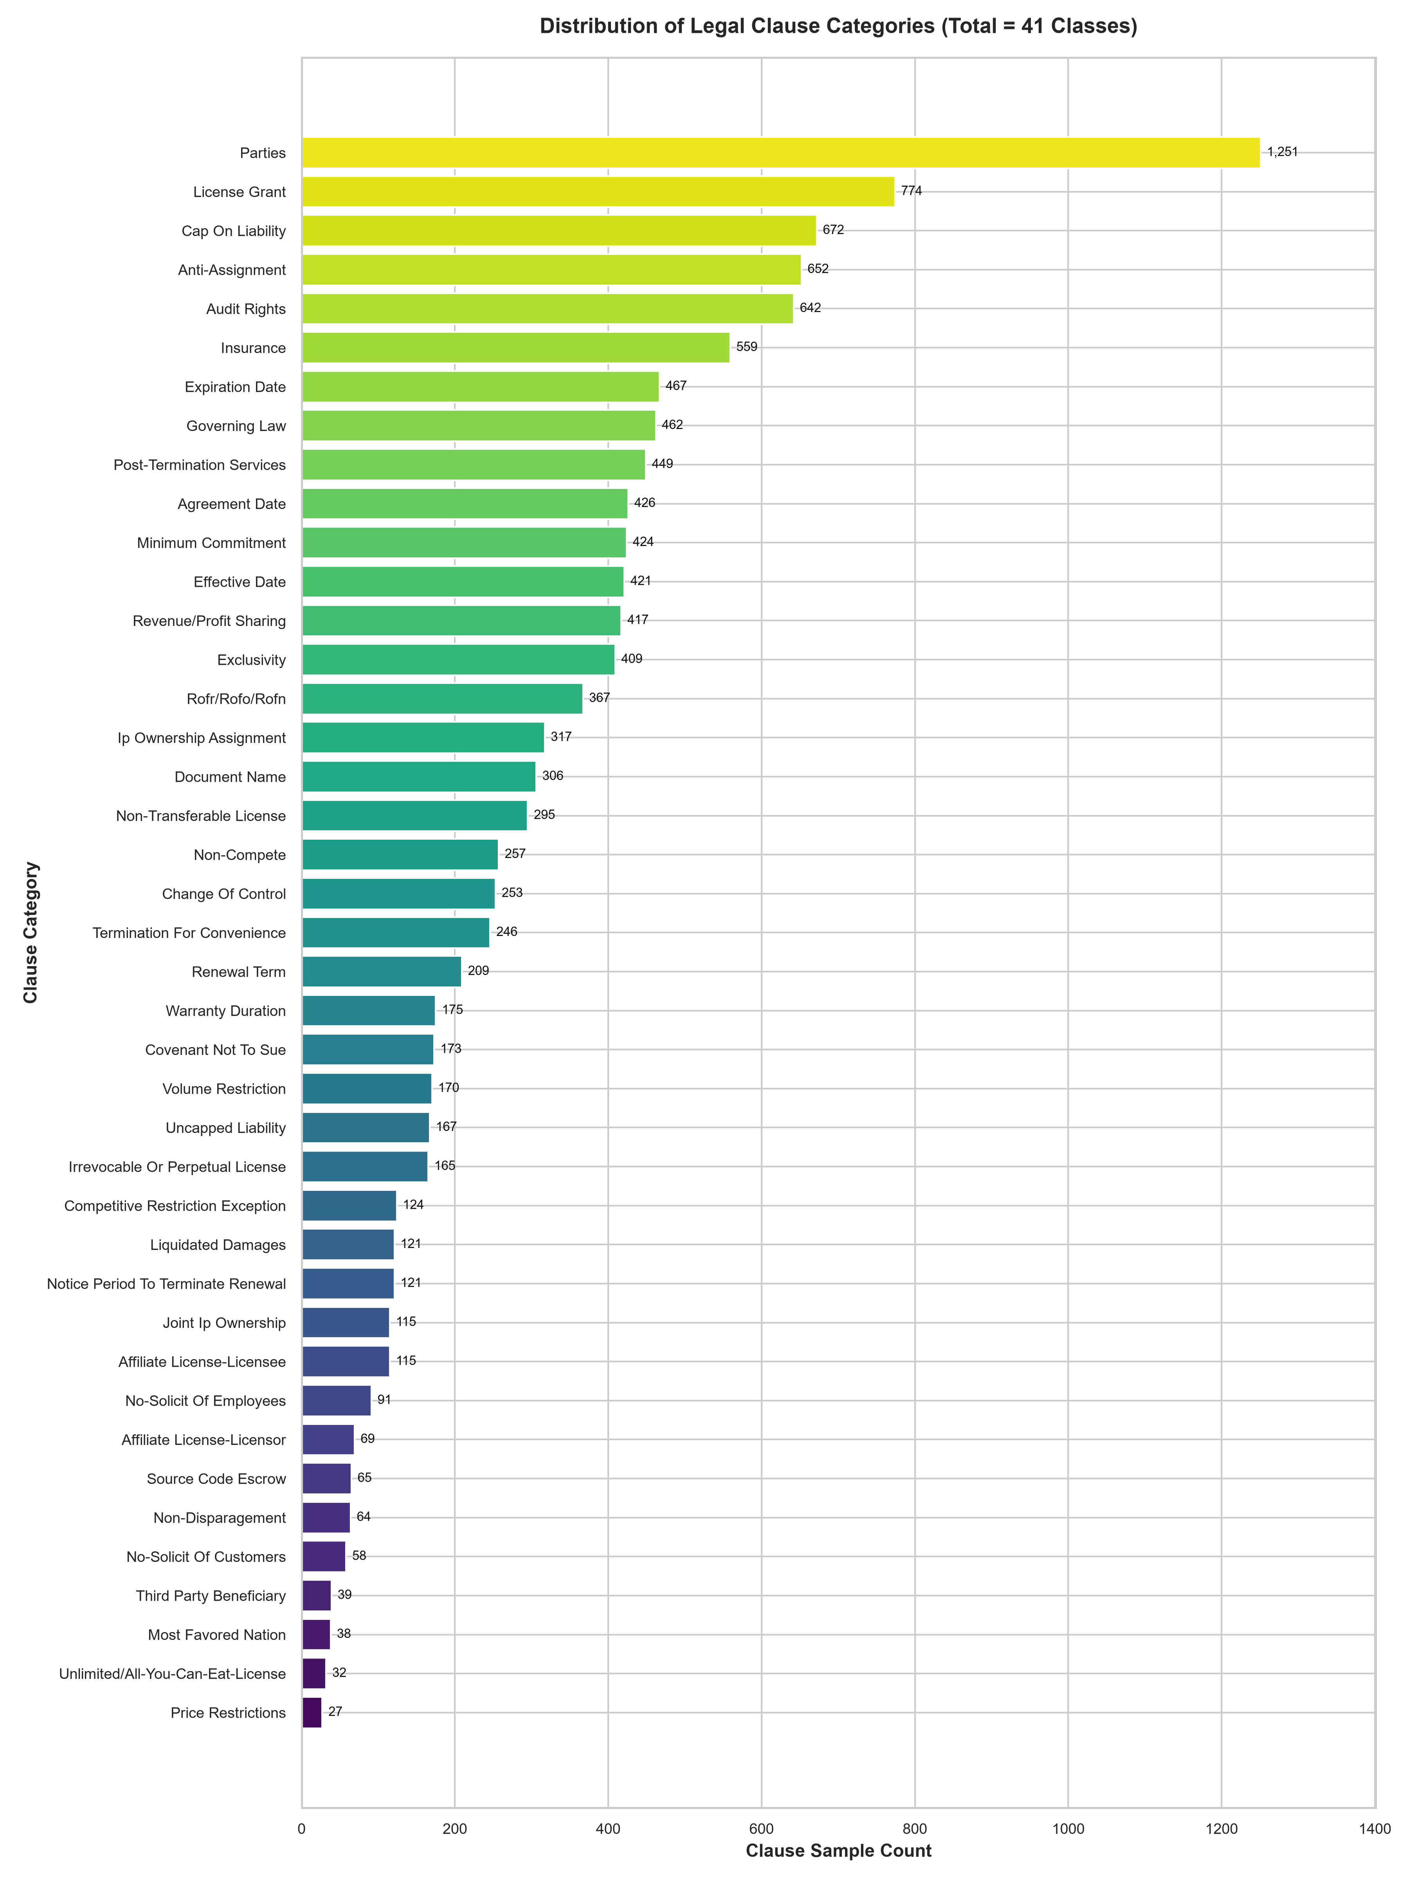
Figure 3.2: Complete 41-category class distribution in the ClauseIQ dataset (N = 12,204)

3.3.2. Average Clause Word Count by Category
Figure 3.3 depicts the mean word count across categories. Factual metadata categories (Agreement Date, Parties) average under 6 words, whereas substantive covenants (Affiliate License-Licensor, Irrevocable Or Perpetual License) average between 80 and 95 words per clause.
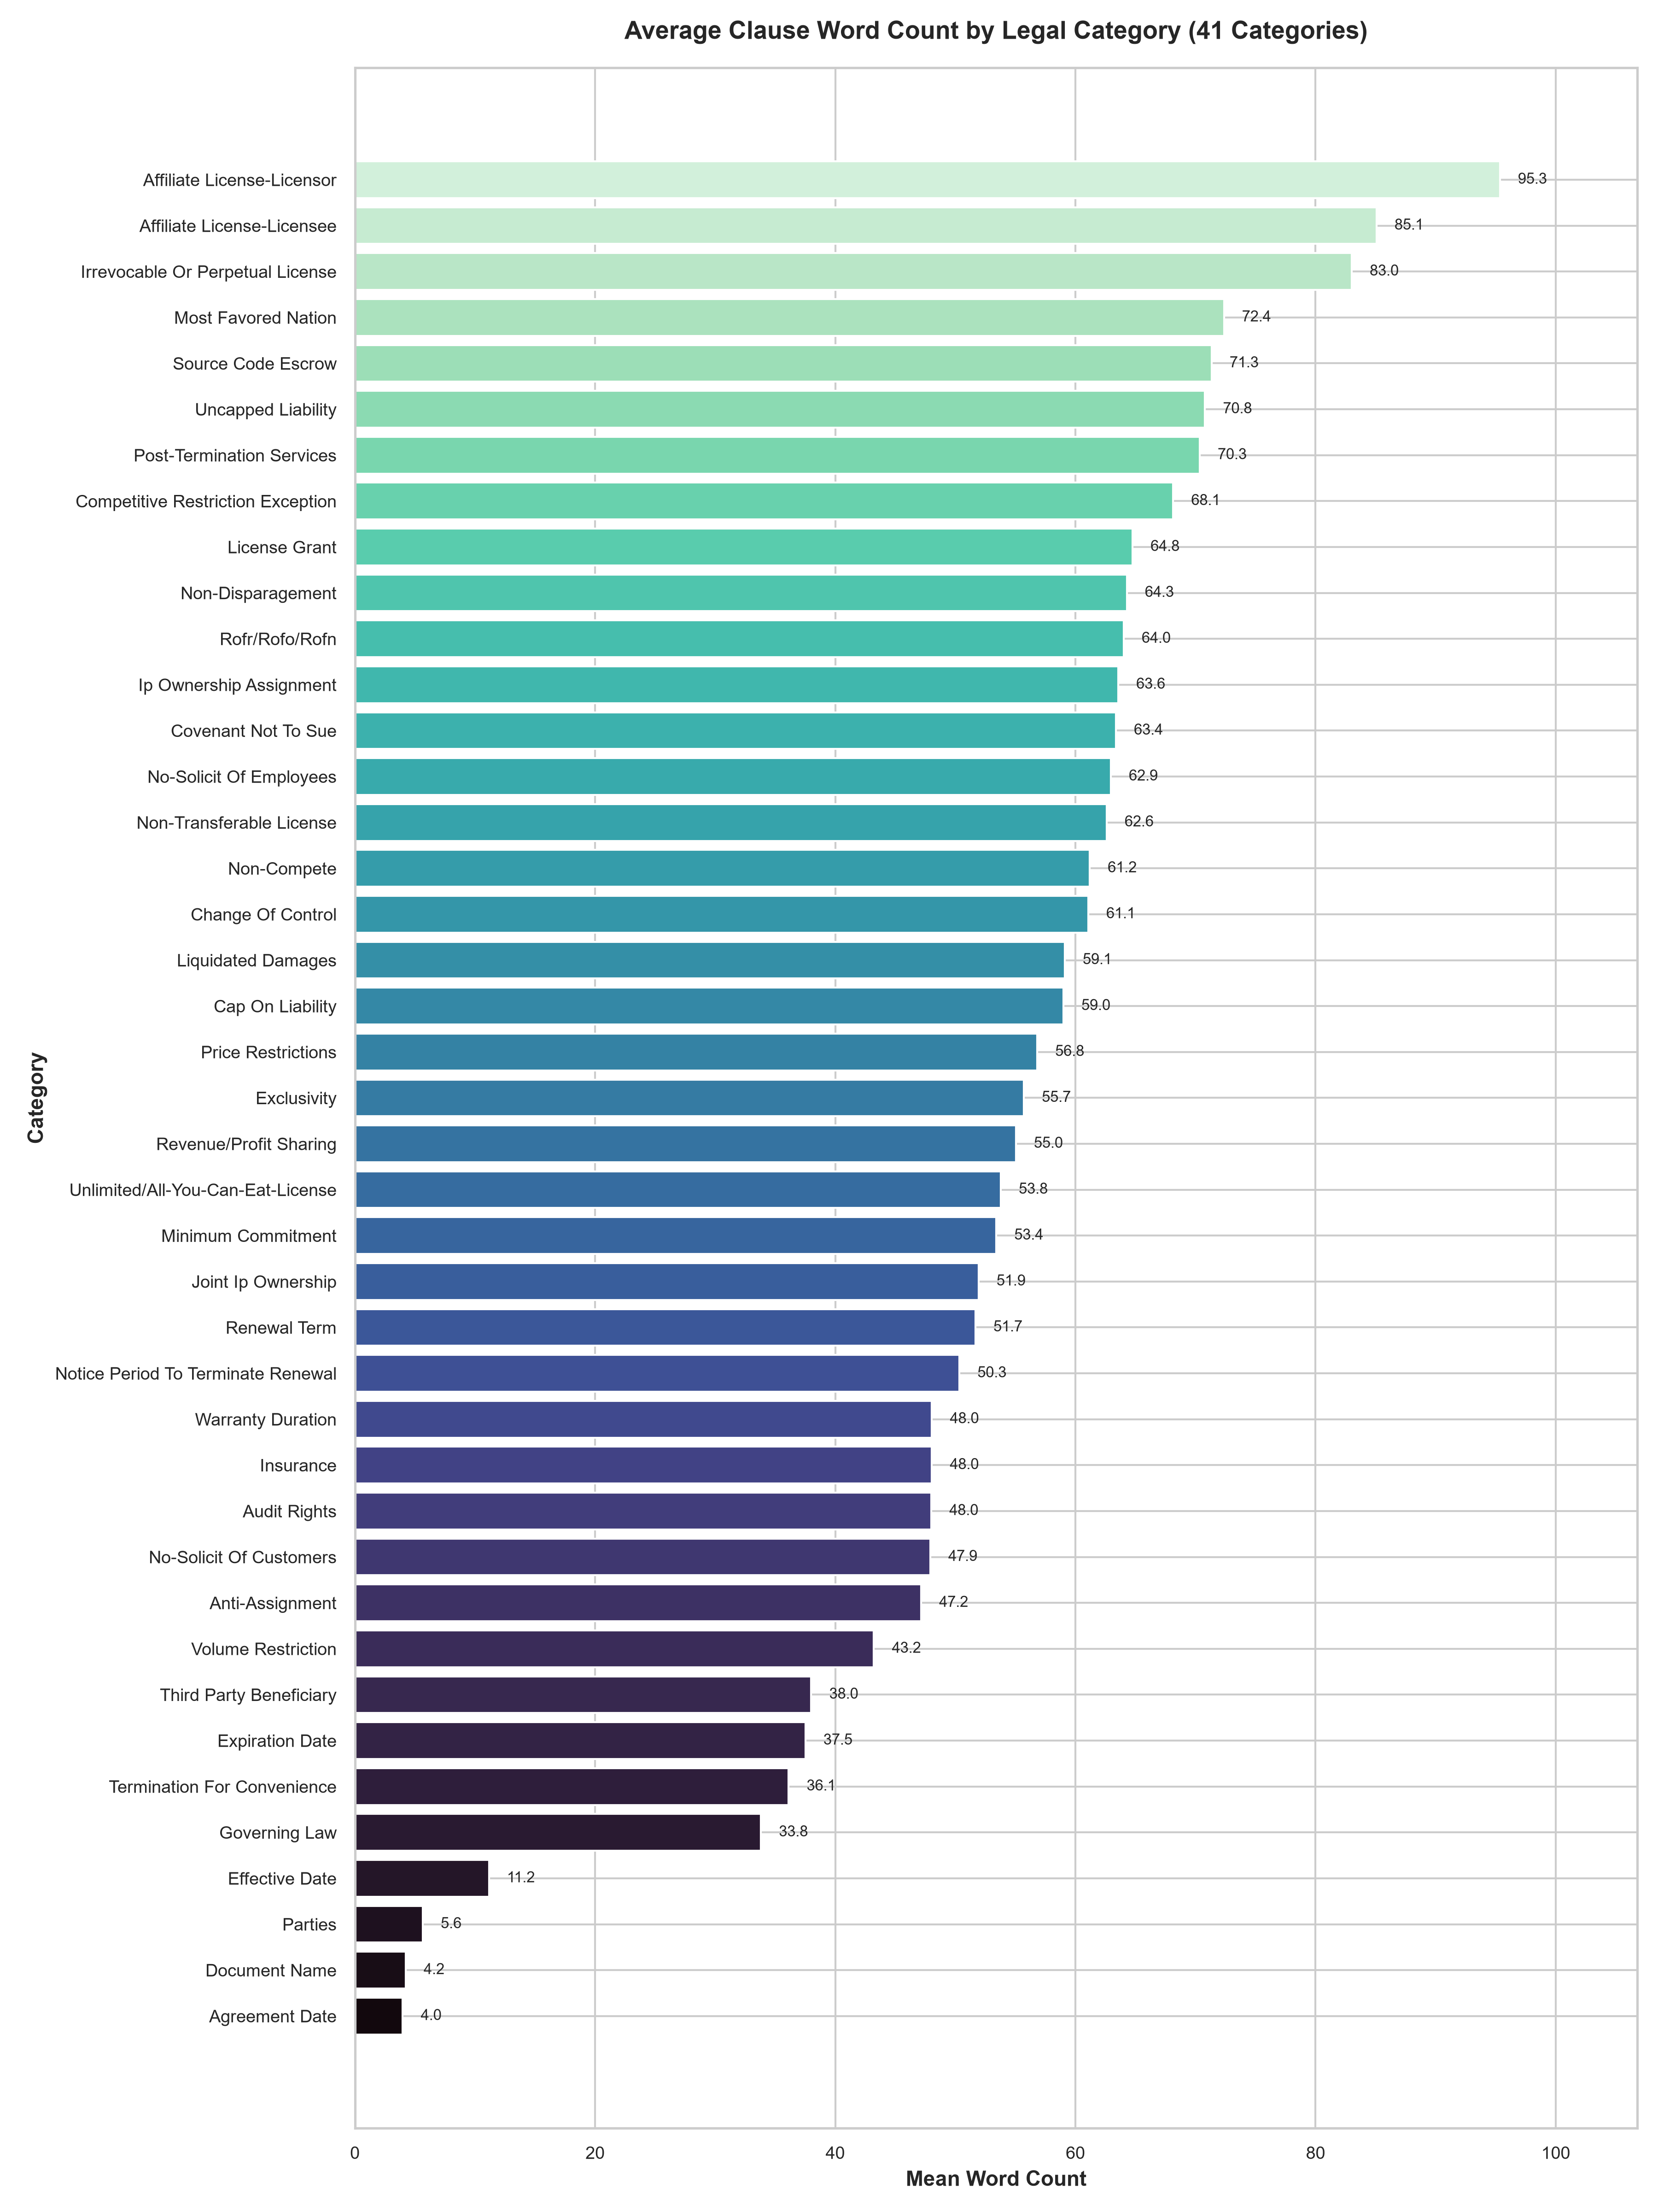
Figure 3.3: Average clause word count across legal categories

3.3.3. Word Count Distribution and Correlation Heatmap
Figure 3.4 shows the right-skewed distribution of clause word counts across the dataset, with a sharp concentration between 15 and 50 words.
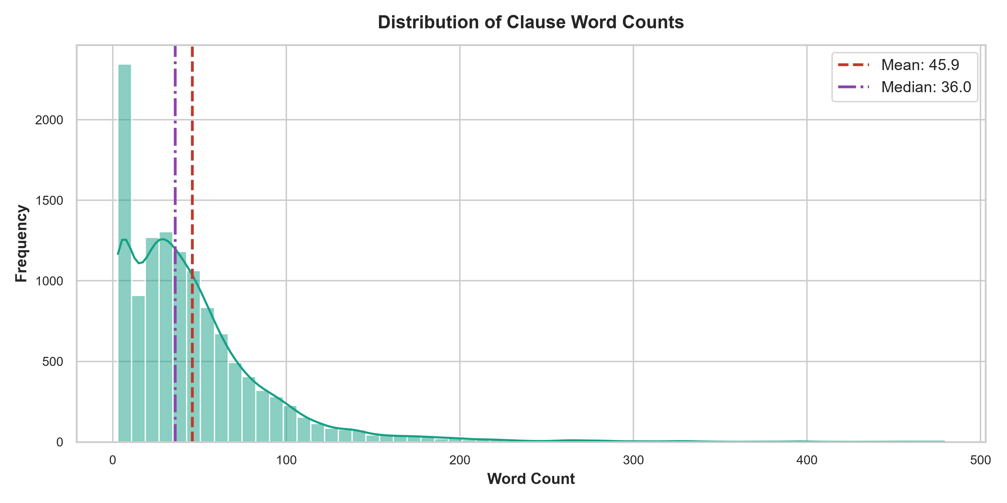
Figure 3.4: Distribution of clause word counts
Figure 3.5 demonstrates the correlation matrix among length metrics; character length and word count display a near-perfect correlation of 0.9945, confirming that character length provides no independent discriminatory signal beyond word count.
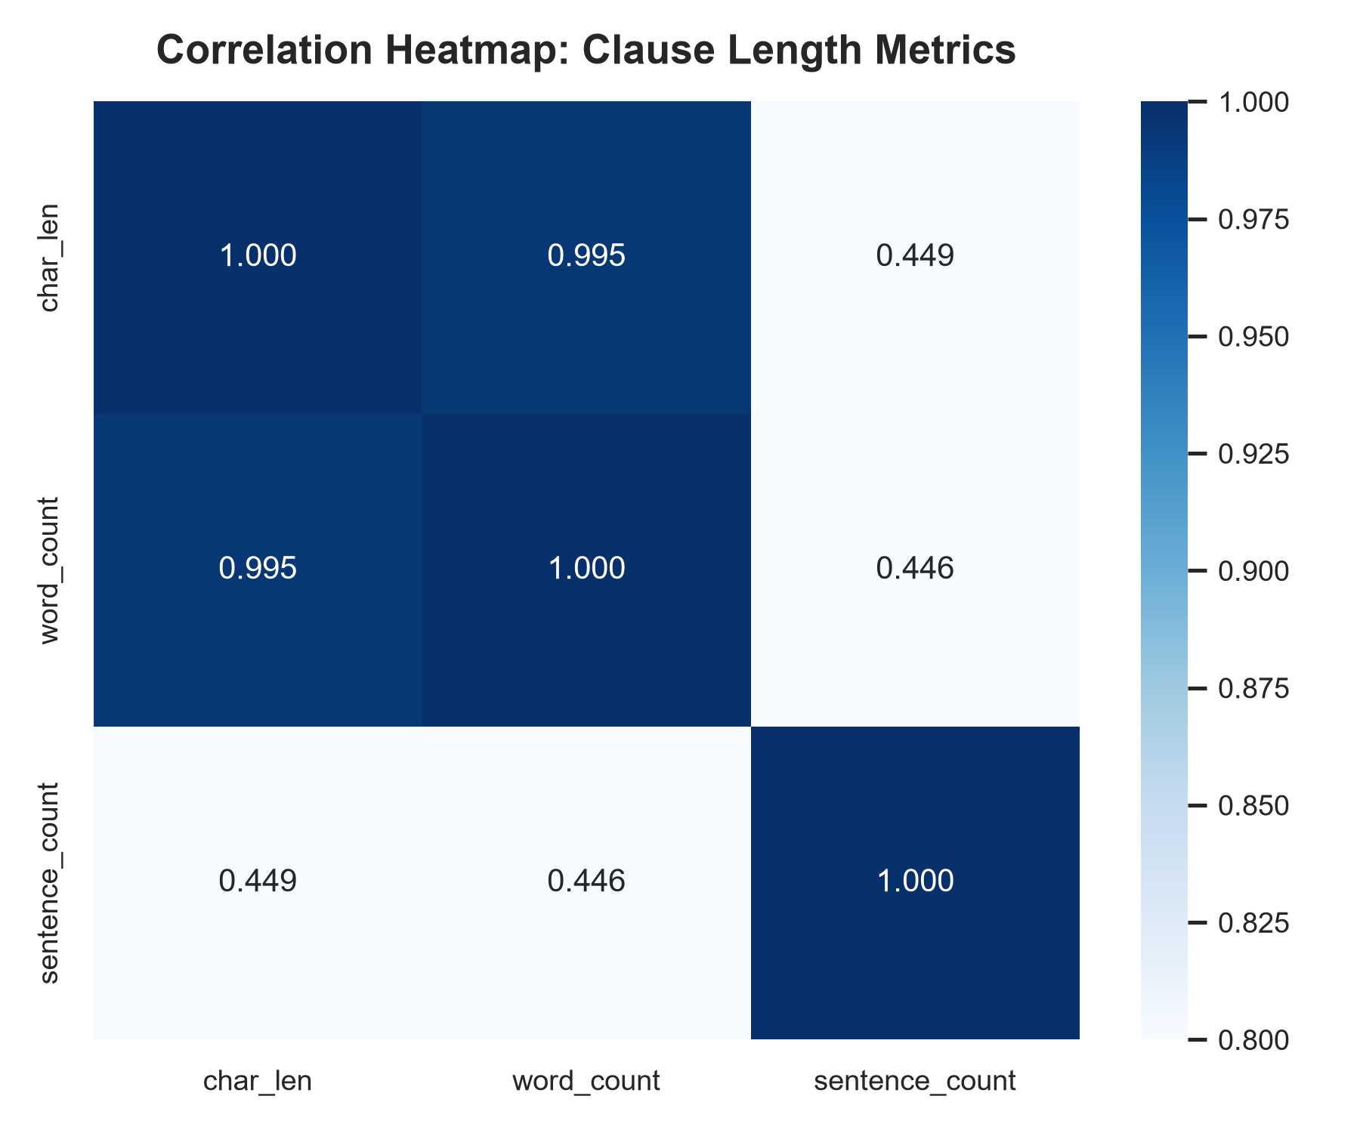
Figure 3.5: Correlation matrix of text metrics

3.3.4. Top Legal Bigrams
Figure 3.6 highlights the top 20 most frequent bigrams extracted from the corpus. Standard legal collocations—such as “agreement shall”, “set forth”, “effective date”, and “prior written”—dominate the feature space, justifying the use of bigram feature representations.
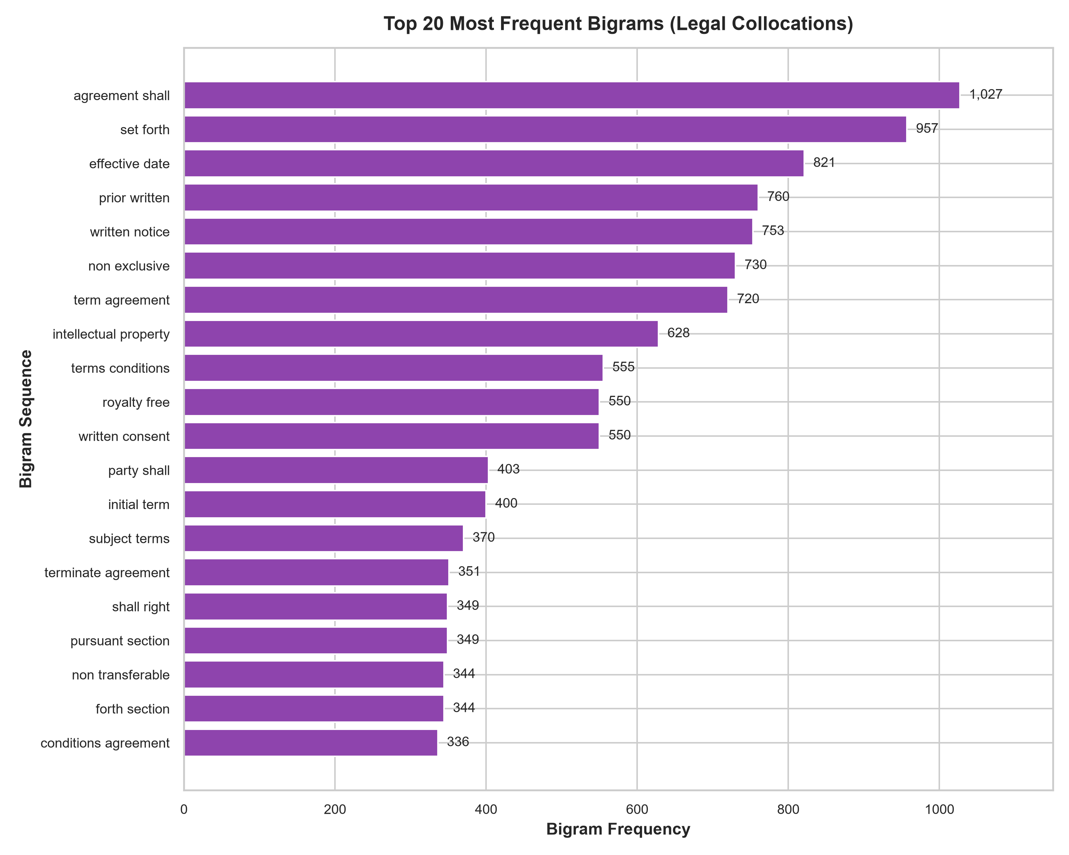
Figure 3.6: Top 20 most frequent bigrams in the ClauseIQ clause corpus

3.4 Analysis of Architecture and(or) Algorithms

3.4.1 Detailed Study Report of the Proposed Algorithm(s)

ClauseIQ unites a unified 10,000-dimensional TF-IDF vector space with four classical machine learning classifiers for automated clause categorization, and a vector similarity retrieval module
Department of Computer Applications, MACE 16

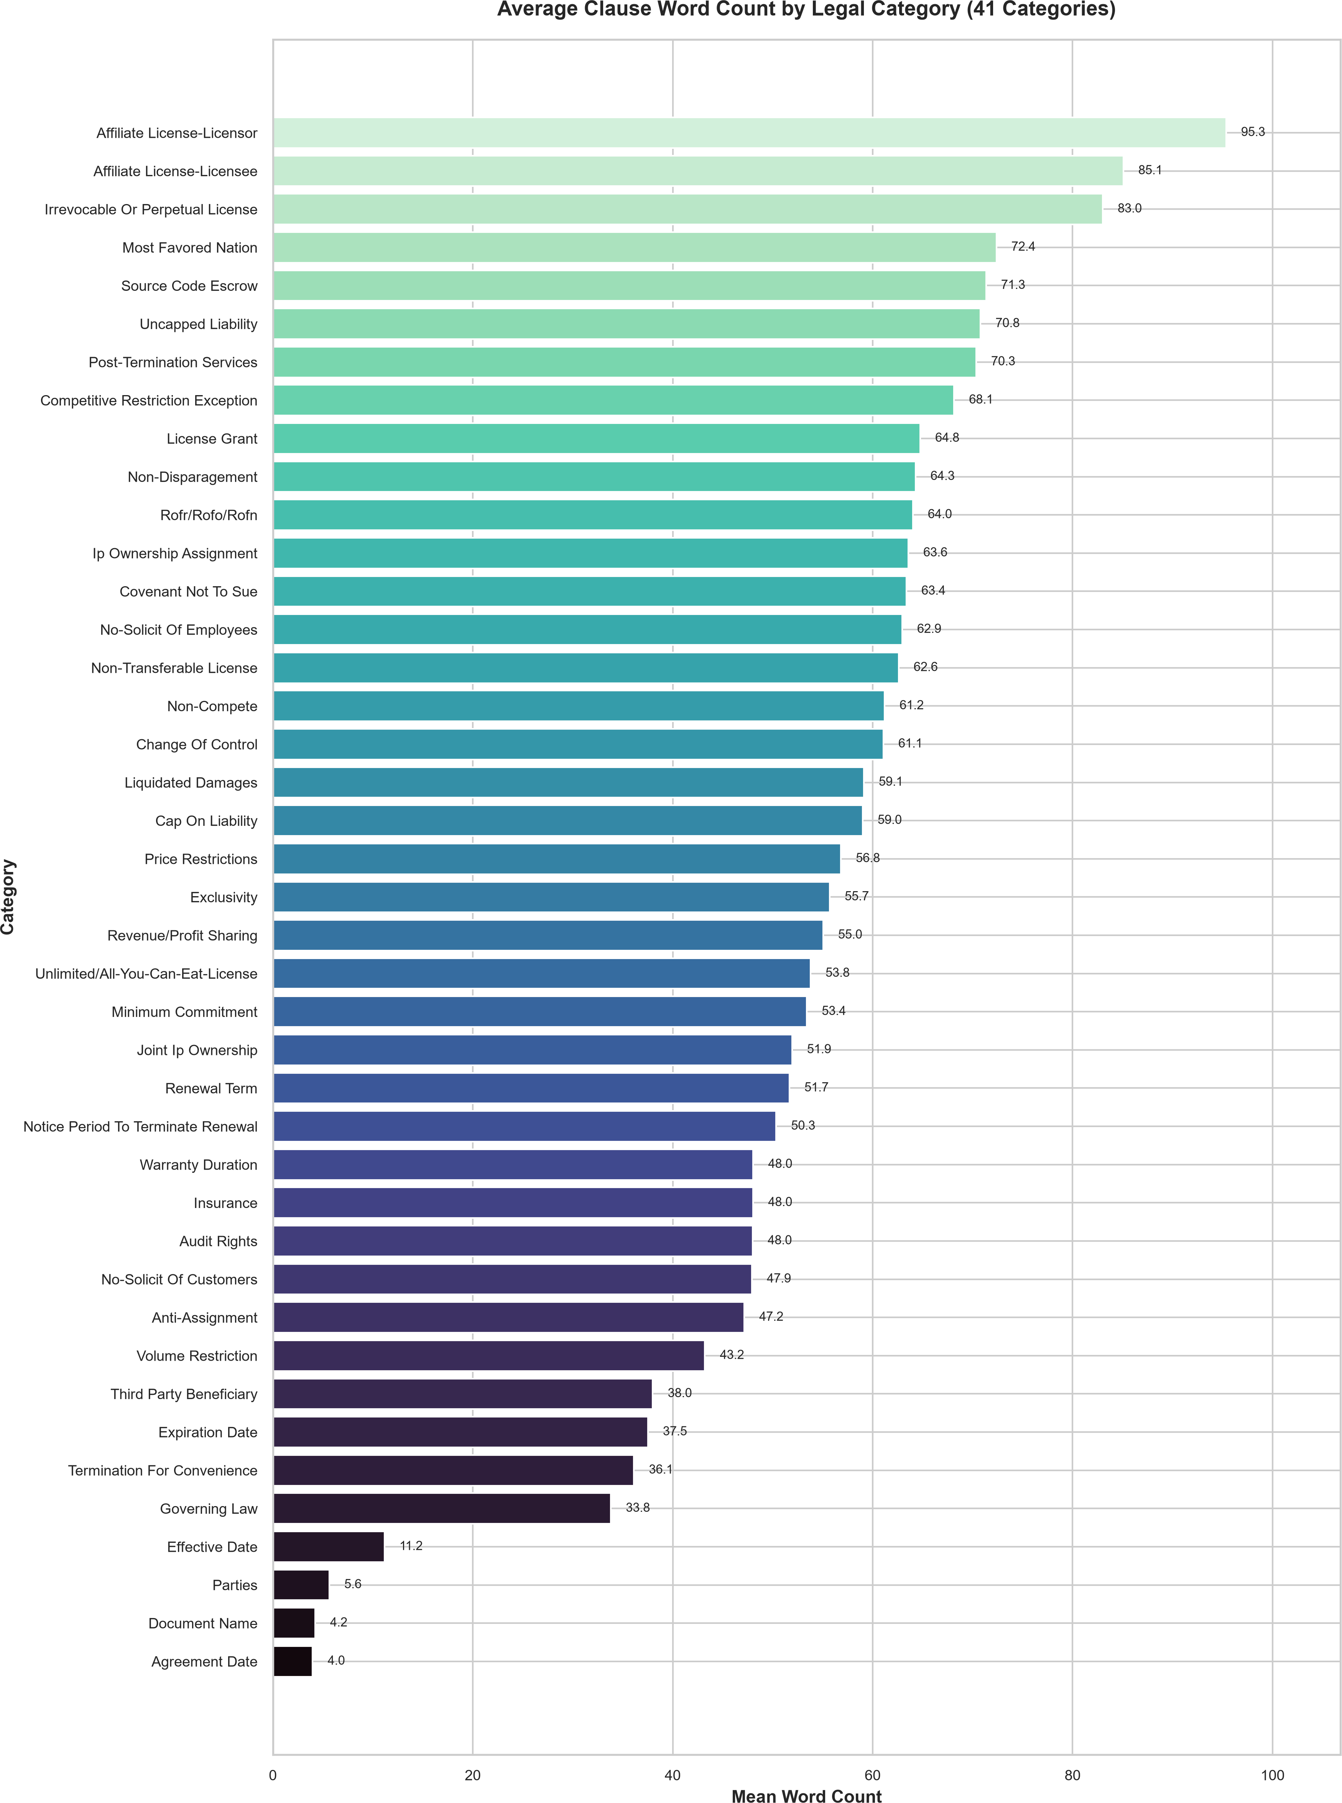
ClauseIQ – Machine Learning-Based Contract Clause Classification and Intelligent Search System

Figure 3.3: Average clause word count across legal categories

for intelligent clause search.

TF-IDF Vectorization

Term Frequency–Inverse Document Frequency converts unstructured text strings into normal-ized, sparse numerical vectors.
Department of Computer Applications, MACE 17

ClauseIQ – Machine Learning-Based Contract Clause Classification and Intelligent Search System

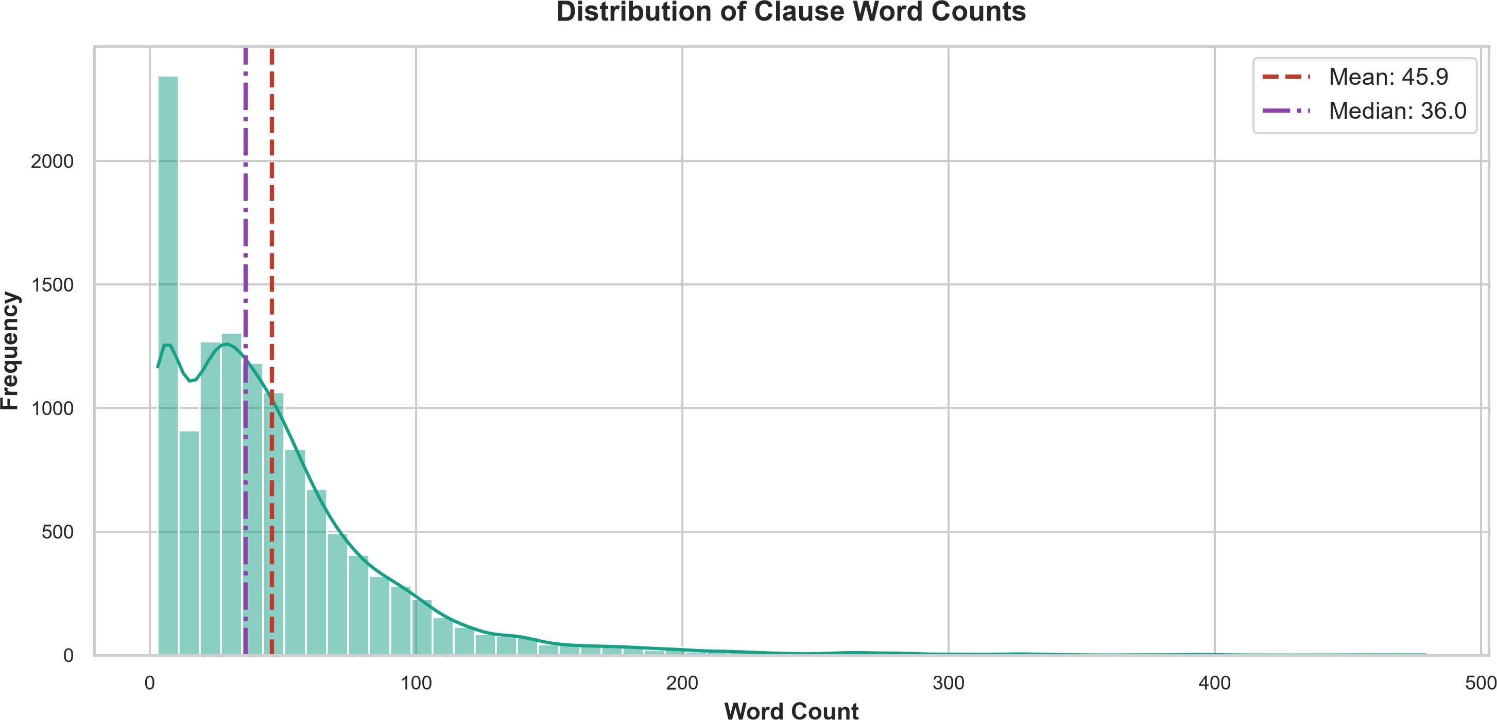
Figure 3.4: Distribution of clause word counts 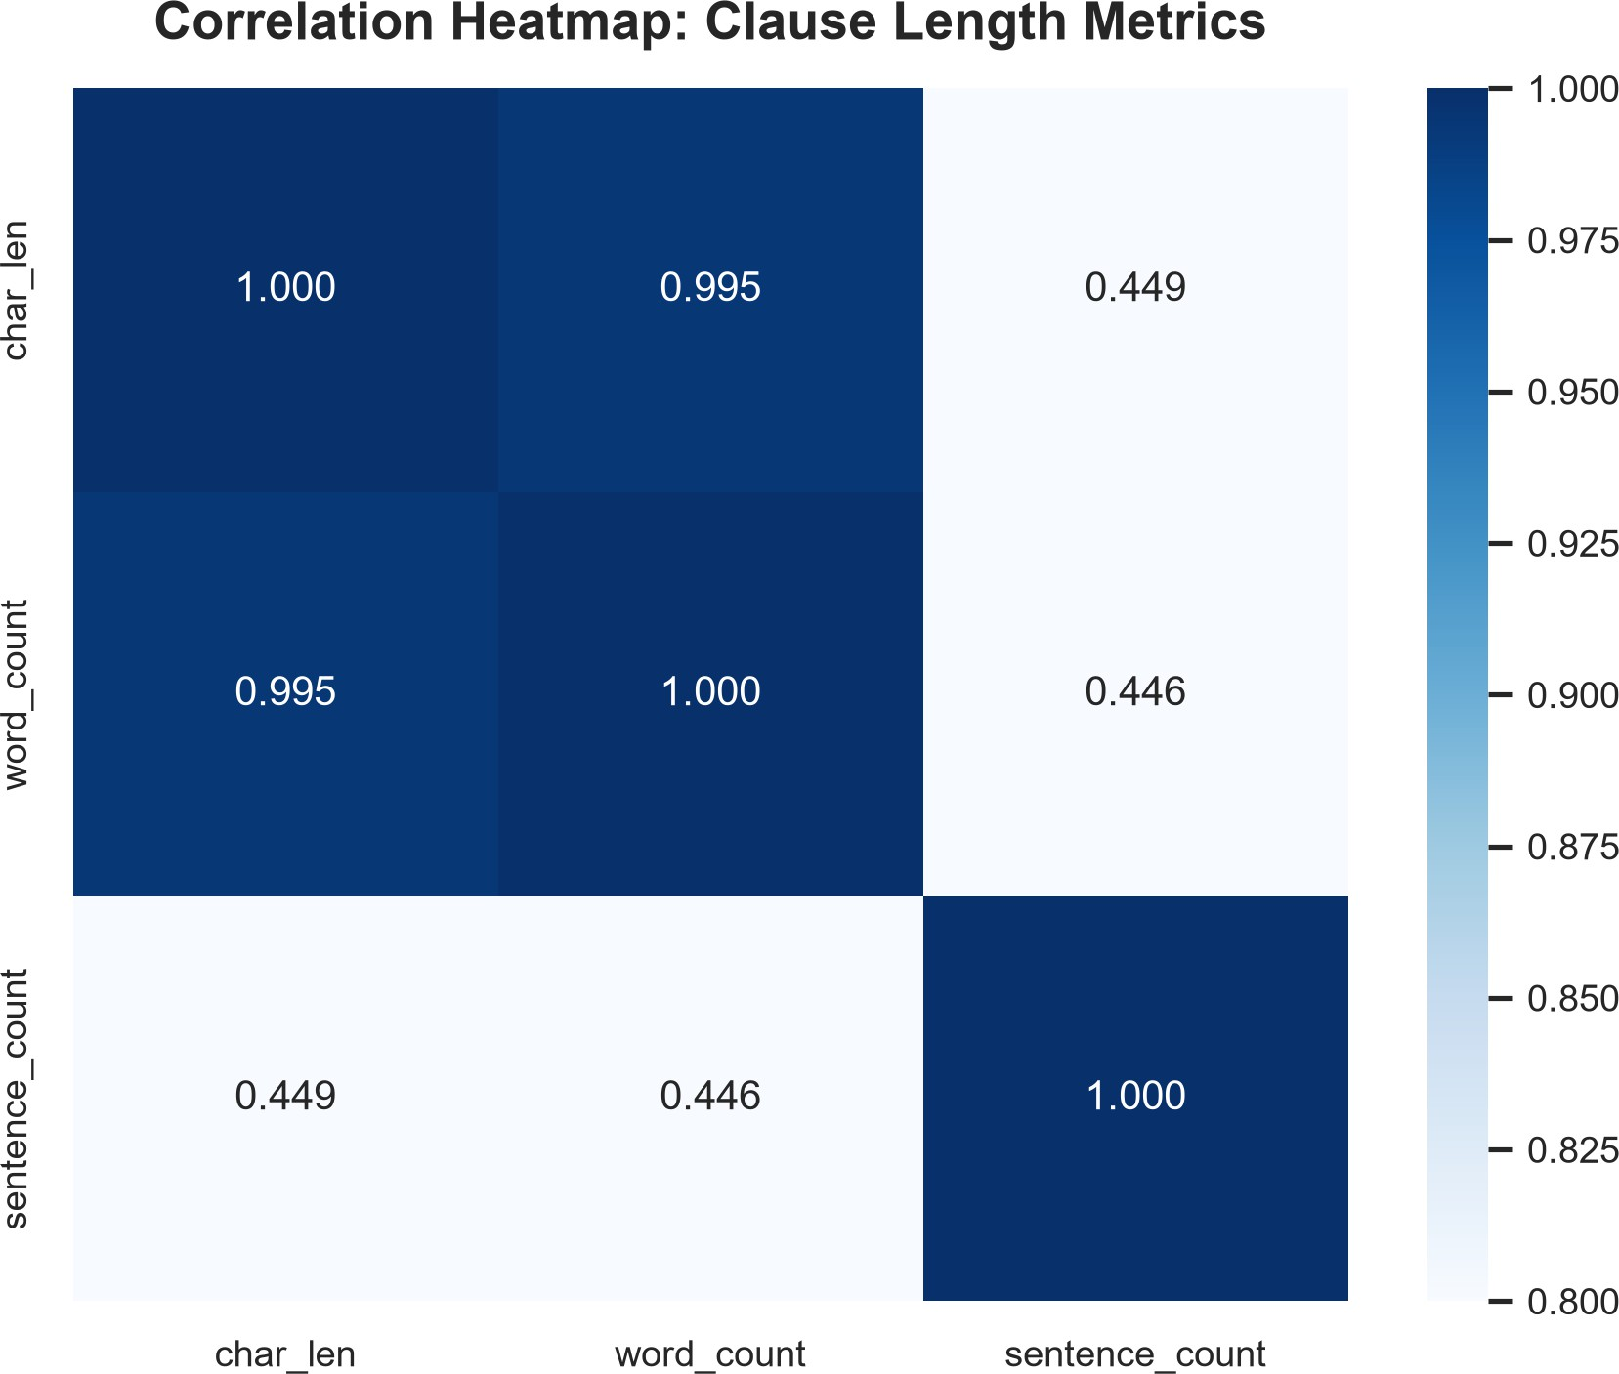
Figure 3.5: Correlation matrix of text metrics
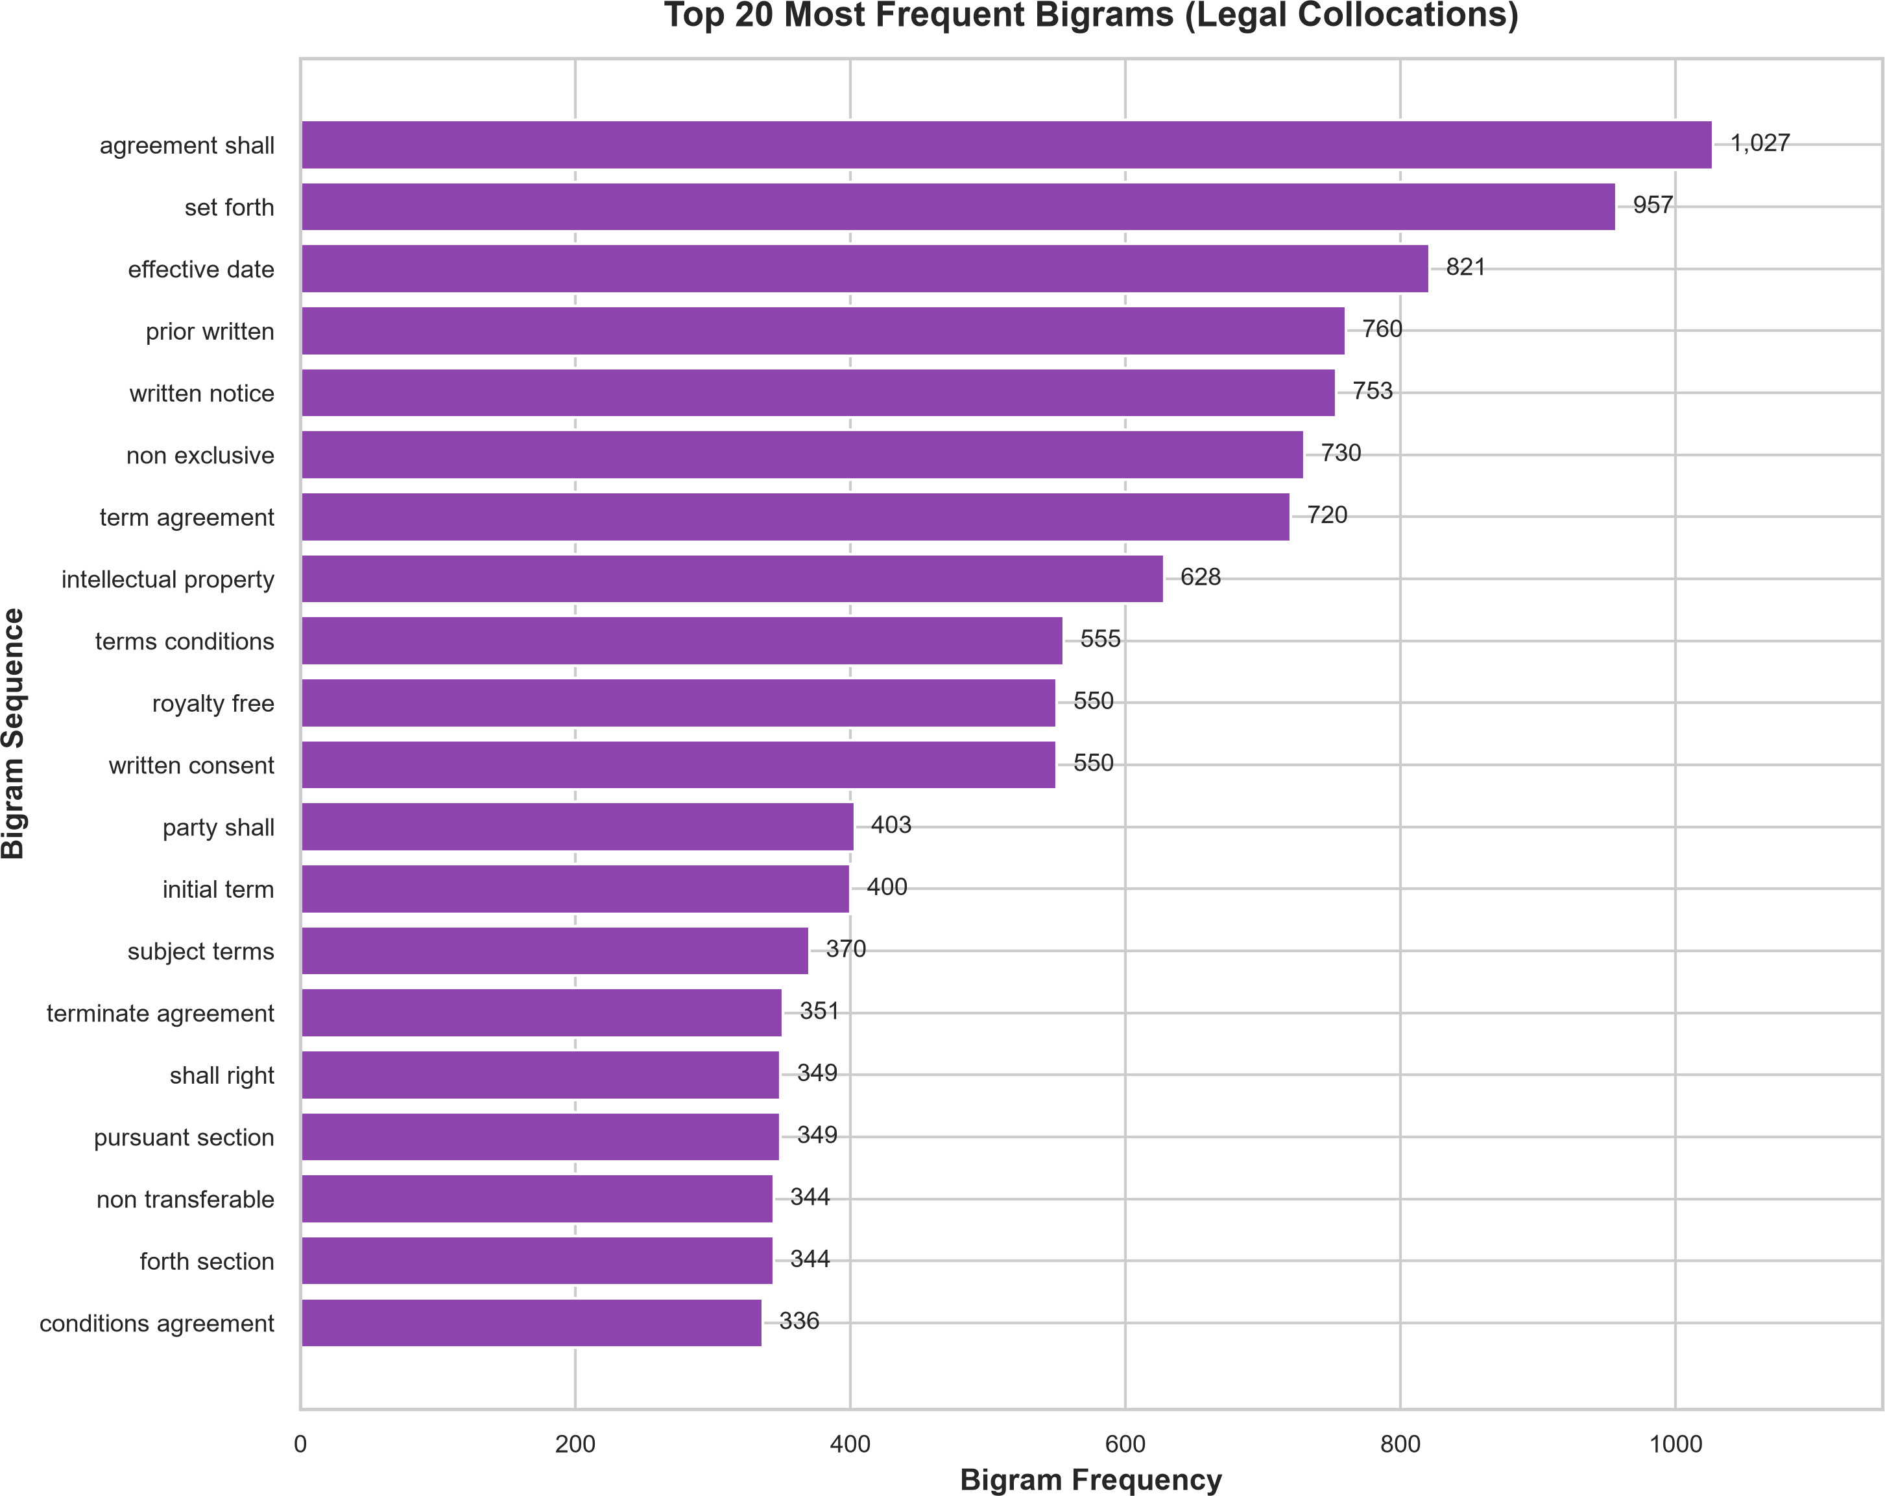
Figure 3.6: Top 20 most frequent bigrams in the ClauseIQ clause corpus

The Term Frequency (𝑇𝐹) represents the normalized frequency of term 𝑡 in clause 𝑑:

𝑇𝐹 (
𝑓𝑡,𝑑
∑𝑡′ ∈𝑑 𝑡′,𝑑
𝑡, 𝑑) = 𝑓
(3.2)

Under sublinear scaling, this is modified to 1 + log( 𝑓_{𝑡,𝑑}) for all 𝑓_{𝑡,𝑑} > 0.
The Inverse Document Frequency (𝐼𝐷𝐹) measures the relative specificity of term 𝑡 across the
Department of Computer Applications, MACE 18

ClauseIQ – Machine Learning-Based Contract Clause Classification and Intelligent Search System
entire corpus 𝐷 of 𝑁 clauses:
𝐼𝐷𝐹 (𝑡, 𝐷) = log ( 1 + 𝑁 ) + 1 (3.3) where 𝐷𝐹 (𝑡) is the number of clauses containing term 𝑡.
1 + 𝐷𝐹 (𝑡)
The composite TF-IDF score is computed as:

𝑇𝐹-𝐼𝐷𝐹 (𝑡, 𝑑, 𝐷) = 𝑇𝐹 (𝑡, 𝑑) × 𝐼𝐷𝐹 (𝑡, 𝐷) (3.4) Each resulting vector is subsequently 𝐿₂-normalized:
𝑣
𝑣 ₂

𝑣norm =
(3.5)

Multinomial Naive Bayes

Multinomial Naive Bayes is a probabilistic classifier based on Bayes’ theorem under the condi-tional independence assumption among features given the class label.
Given a feature vector 𝑥 = (𝑡₁, 𝑡₂, . . . , 𝑡_{𝑛}) representing a clause, the posterior probability of category 𝑐 is:
𝑛
( | ) ∝ ( ) ∏ ( | )
𝑃 𝑐 𝑥 𝑃 𝑐 𝑃 𝑡_{𝑖} 𝑐 ^{𝑓}𝑖 (3.6)
𝑖=1
where 𝑃(𝑐) is the prior probability of category 𝑐, and 𝑃(𝑡_{𝑖} | 𝑐) is the probability of term 𝑡_{𝑖}
occurring in category 𝑐.
To eliminate zero-probability errors for unseen terms, Lidstone/Laplace smoothing with param-eter 𝛼 is applied:

𝑃(𝑡_{𝑖}
𝑐 = 𝑁_{𝑐𝑖} + 𝛼
𝑁_{𝑐} + 𝛼|𝑉 |
| )
(3.7)

where 𝑁_{𝑐𝑖} is the sum of TF-IDF weights for term 𝑡_{𝑖} in class 𝑐, 𝑁_{𝑐} is the total sum across all vocabulary terms for class 𝑐, and |𝑉 | = 10, 000.

Linear Support Vector Machine (Linear SVM)

Support Vector Machines construct optimal separating hyperplanes that maximize the functional margin between classes in high-dimensional feature space. Linear SVM is exceptionally effec-tive for sparse text classification where the feature dimensionality is large.
For multi-class classification across 41 categories, a One-vs-Rest (OvR) formulation is em-ployed, training 41 binary linear classifiers. The primal optimization problem for each binary
Department of Computer Applications, MACE 19
ClauseIQ – Machine Learning-Based Contract Clause Classification and Intelligent Search System
+ ∑
sub-problem is:

subject to the margin constraints:
min 1
𝑤,𝑏,𝜉 2
𝑚
𝑤 2 𝐶 𝜉𝑖 (3.8)
𝑖=1

𝑦_{𝑖} (𝑤^{𝑇} 𝑥_{𝑖} + 𝑏) ≥ 1 − 𝜉_{𝑖}, 𝜉_{𝑖} ≥ 0, ∀𝑖 ∈ {1, . . . , 𝑚} (3.9)

where 𝑤 is the normal weight vector, 𝑏 is the bias offset, 𝜉_{𝑖} are slack variables permitting soft-margin misclassifications, and 𝐶 is the regularization parameter governing the trade-off between margin width and training error.

Logistic Regression

Logistic Regression is a discriminative linear model that predicts posterior class probabilities using the multinomial softmax function.
For a clause vector 𝑥 ∈ R¹⁰⁰⁰⁰, the probability that it belongs to category 𝑐 ∈ {1, . . . , 41} is parameterized as:
exp(𝑤^{𝑇} 𝑥 + 𝑏_{𝑐})

𝑃(𝑦 = 𝑐 | 𝑥) = ∑41
𝑐
(3.10)

_{𝑗=1} exp(𝑤^{𝑇} 𝑥 + 𝑏 _{𝑗} )
𝑗
where 𝑤_{𝑐} and 𝑏_{𝑐} denote the learned weights and intercept for class 𝑐.
The model parameters are optimized by minimizing the 𝐿₂-regularized cross-entropy loss across
𝑚 training samples:

𝑚 41 41

L(𝑊) = − ∑ ∑ I(𝑦 = 𝑐) log 𝑃(𝑦 = 𝑐 | 𝑥 ) + 1 ∑
𝑖 𝑖 𝑖 2𝐶
2
𝑤𝑐 2
(3.11)

𝑖=1 𝑐=1 𝑐=1
Logistic Regression provides class probability estimates through its multinomial softmax formulation, enabling the generation of prediction confidence scores.

Random Forest Classifier

Random Forest is an ensemble learning method that constructs a multitude of decision trees during training and outputs the majority voting class among individual trees.
To inject diversity and prevent overfitting on high-dimensional text vectors:

  - Bootstrap Aggregation (Bagging): Each decision tree 𝑇_{𝑏} is trained on an independently drawn bootstrap sample of the training dataset.
  - Random Feature Subspaces: At each internal split node, a random subset of features √|𝑉 |
Department of Computer Applications, MACE 20

ClauseIQ – Machine Learning-Based Contract Clause Classification and Intelligent Search System
is evaluated rather than the entire 10,000-dimensional feature space.

Split quality is evaluated using the Gini Impurity metric:

41
Gini(𝐷) = 1 − ∑ 𝑝
2 (3.12)
𝑐
𝑐=1

where 𝑝_{𝑐} is the proportion of samples belonging to class 𝑐 in node 𝐷. The final ensemble prediction is obtained by majority vote:

𝐵
∑ ( ( ) )
𝑦ˆ = arg max I 𝑇_{𝑏} 𝑥 = 𝑐 (3.13)
𝑐
𝑏=1

Cosine Similarity (Intelligent Search)

For the intelligent search engine, user queries and contract clauses are embedded into the same 10,000-dimensional TF-IDF vector space. The relevance of a candidate clause vector 𝐵 to a search query vector 𝐴 is quantified by calculating the cosine of the angle between them:

Similarity

cos
𝐴 · 𝐵
∑10000 𝐴𝑖 𝐵𝑖

(3.14)

( 𝐴, 𝐵) = (𝜃) = 𝐴 2 𝐵 2 √∑10000 2√∑10000 2
𝑖=1
=
𝑖=1 𝐴𝑖
𝑖=1 𝐵𝑖

Because both query and clause vectors are 𝐿₂-normalized during vectorization ( 𝐴 ₂ = 𝐵 ₂ =
1), the cosine similarity simplifies to the efficient sparse dot product:

Similarity( 𝐴, 𝐵) = 𝐴 · 𝐵 =
10000

1
∑𝑖=

𝐴_{𝑖} 𝐵_{𝑖} (3.15)

Cosine similarity is strictly scale-invariant, preventing longer clauses from receiving artificially elevated scores purely due to document length.

Performance Evaluation Metrics

To assess classification performance objectively, standard evaluation metrics are computed on the held-out test split:
- Precision (𝑃_{𝑐}): ^{𝑇𝑃}𝑐 (Proportion of predicted class 𝑐 clauses that are correct).
𝑇𝑃𝑐 +𝐹𝑃𝑐
- Recall (𝑅_{𝑐}): ^{𝑇𝑃}𝑐 (Proportion of actual class 𝑐 clauses correctly identified).
𝑇𝑃𝑐 +𝐹𝑁𝑐
- Accuracy: ∑41 𝑇𝑃𝑐 (Overall percentage of correct predictions across all samples).
𝑐=1
𝑁total
Department of Computer Applications, MACE 21

ClauseIQ – Machine Learning-Based Contract Clause Classification and Intelligent Search System
- Class F1-Score (𝐹1 ): 2 ^{𝑃}𝑐 ×𝑅𝑐 (Harmonic mean of precision and recall for class 𝑐).
𝑃𝑐 +𝑅𝑐
_{𝑐} ×
- Macro-F1: 1 ∑41 𝐹1_{𝑐} (Primary selection metric; weights all 41 categories equally).
41
𝑐=1
- Weighted-F1: ∑41 ( 𝑁𝑐 ) 𝐹1_{𝑐} (Weights F1 by category sample proportion).
𝑐=1
𝑁total

Critical Conceptual Distinction: Macro-F1 is an aggregate classification performance metric calculated over an evaluation dataset. It is not a probability, confidence score, or indicator of the likelihood of an individual prediction. Logistic Regression provides class probability estimates through its multinomial softmax formulation. These probability estimates are distinct from the Macro-F1 evaluation metric.

3.5 Project Pipeline

Figure 3.7 illustrates the multi-stage operational pipeline of ClauseIQ.
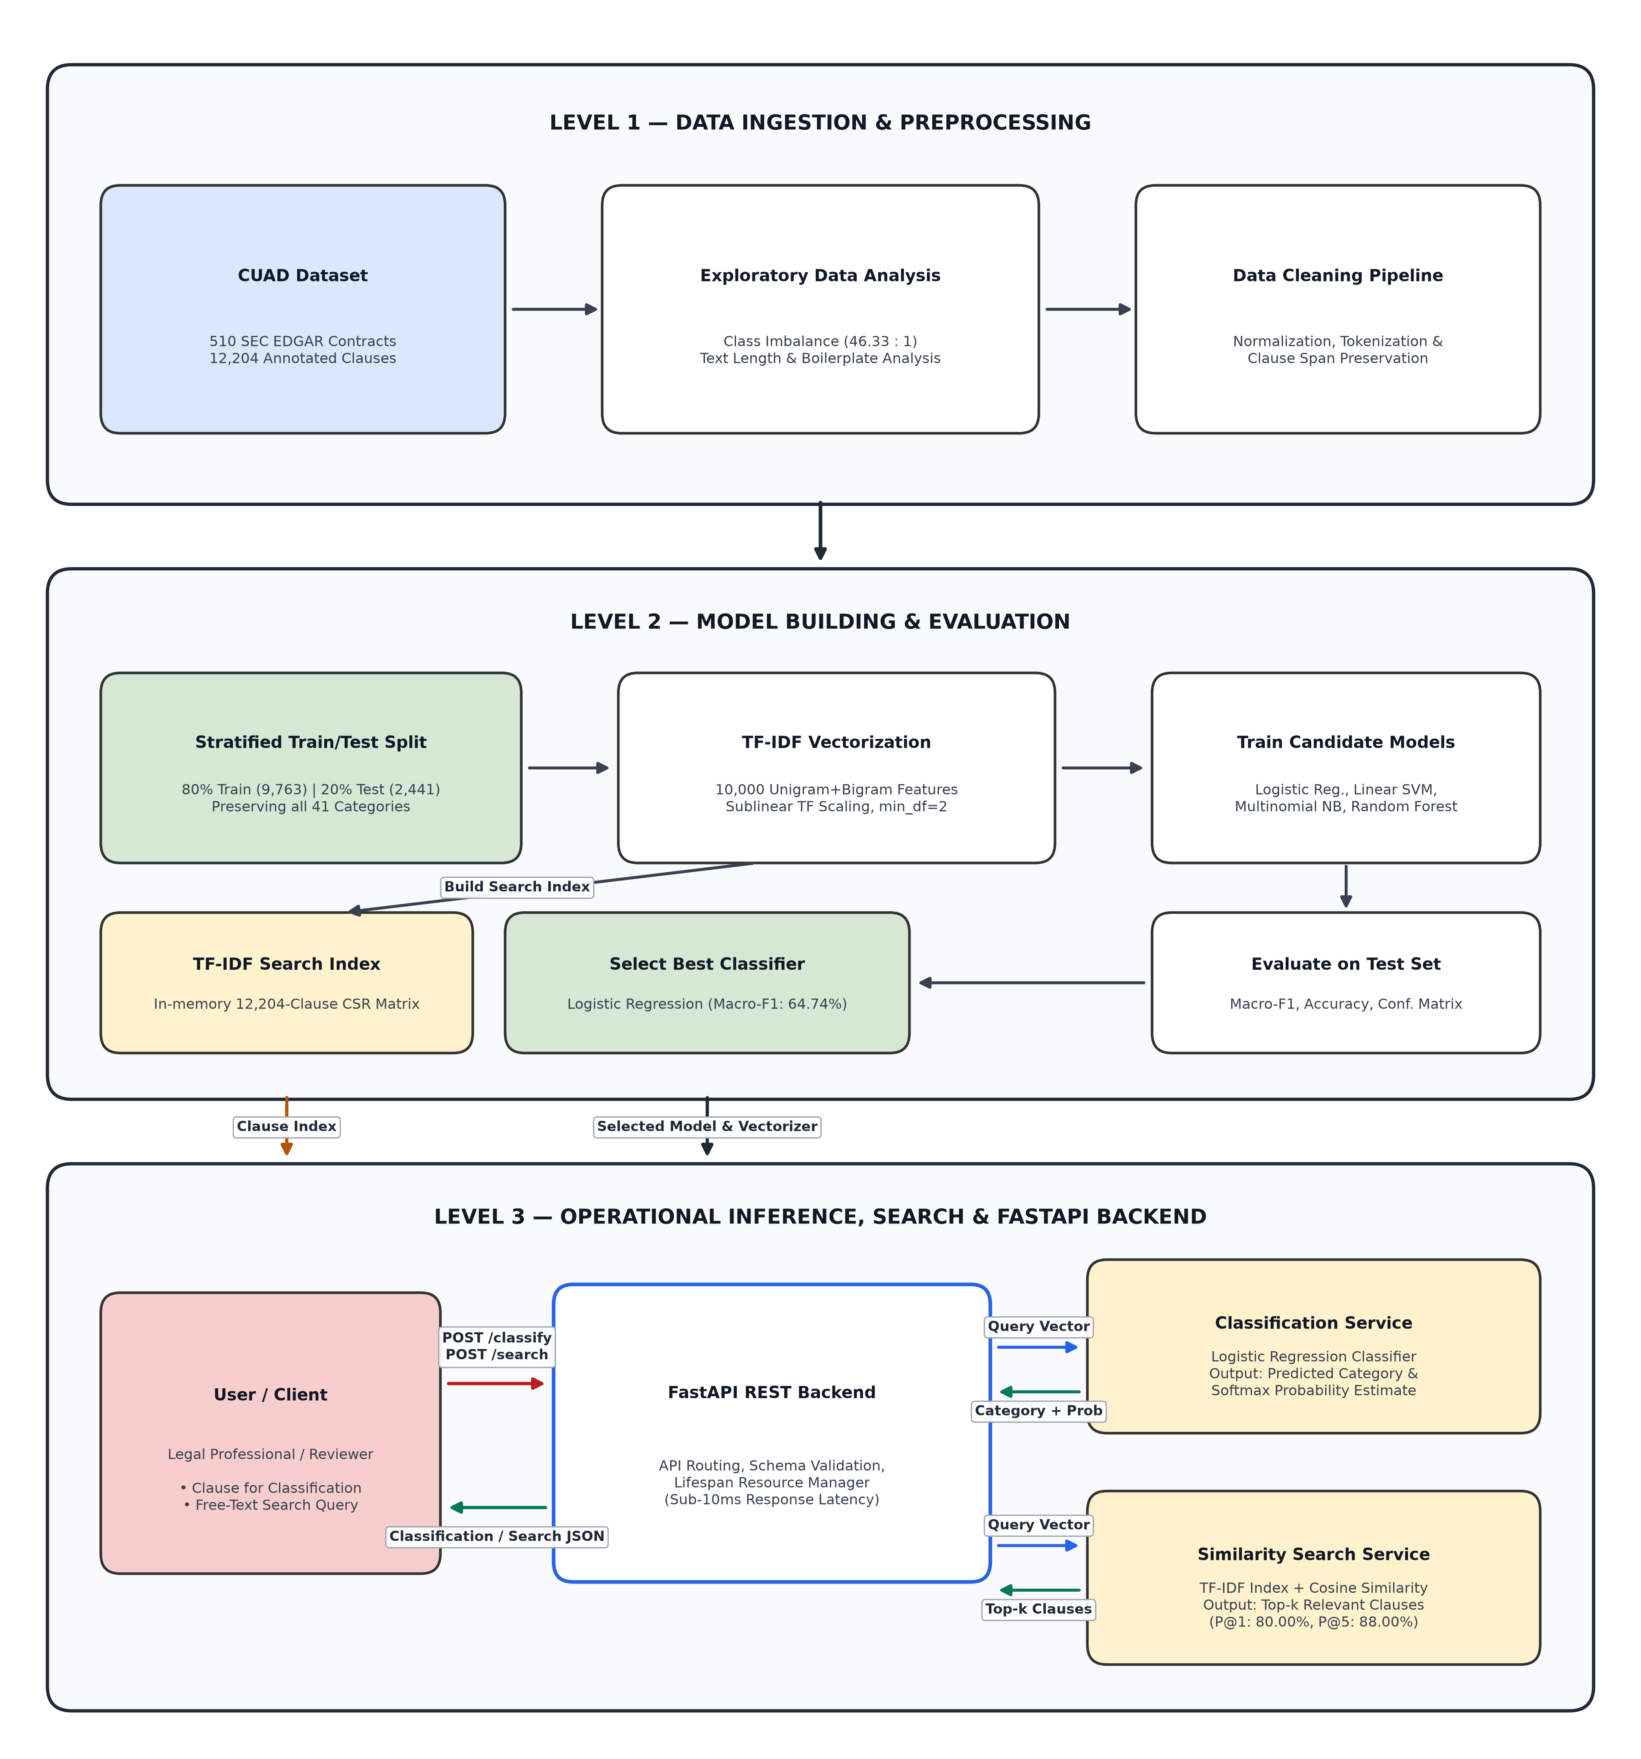

Figure 3.7: End-to-end ClauseIQ system pipeline architecture

The pipeline executes through structured operational stages:

- Data Ingestion & Flattening: Raw CUAD contract JSON annotations are ingested and flattened into a structured tabular schema with 12,204 rows and 41 classes.
Department of Computer Applications, MACE 22

ClauseIQ – Machine Learning-Based Contract Clause Classification and Intelligent Search System
- Data Cleaning & Stratification: Normalization, tokenization, and stratified 80/20 train/test splitting (𝑁train = 9, 763, 𝑁test = 2, 441).
- Feature Extraction: Fitting of the 10,000-feature unigram+bigram TF-IDF vectorizer with sublinear scaling on the training split.
- Model Training & Tuning: Training and cross-validated tuning of four classical machine learning classifiers.
- Evaluation & Selection: Comprehensive multi-metric benchmark on the held-out test split to identify the optimal production classifier based on Macro-F1.
- Search Indexing: Construction of an in-memory sparse CSR vector index over all 12,204 clauses for sub-10ms Cosine Similarity retrieval.
- API Serving: Packaging model artifacts and the search engine inside FastAPI REST end-points.

3.6 Feasibility Analysis

A comprehensive feasibility assessment was conducted across technical, economic, and opera-tional dimensions.

Technical Feasibility

- Software Maturity: The entire machine learning and search pipeline is constructed using industry-standard, battle-tested Python libraries (scikit-learn, pandas, numpy, FastAPI). No specialized or experimental frameworks are required.
- Hardware Constraints: Classical machine learning algorithms require modest computa-tional resources. Model training across 12,204 samples executes in under three minutes on a standard quad-core CPU without GPU acceleration.
- Algorithmic Reliability: Deterministic mathematical operations (TF-IDF vector dot prod-ucts) ensure reproducible, verifiable retrieval without stochastic variation or hallucination risks.

Economic Feasibility

The system incurs zero software licensing costs. All utilized components—Python, scikit-learn, FastAPI, and the CUAD dataset (licensed under Creative Commons Attribution 4.0 International)—are entirely open-source and free for academic and commercial use. Because the system runs
Department of Computer Applications, MACE 23

ClauseIQ – Machine Learning-Based Contract Clause Classification and Intelligent Search System
efficiently on existing commodity laptops and low-cost server instances, hardware acquisition and operational hosting costs remain virtually zero.

Operational Feasibility

From an operational perspective, the system delivers immediate utility to legal workflows. Re-viewers are not required to understand vector spaces or machine learning mathematics. Through standardized RESTful API endpoints, users submit raw clause text to receive immediate cate-gory classifications with confidence scores, or submit search queries to obtain relevance-ranked clause matches in milliseconds.

3.7 System Environment

3.7.1 Software Environment

- Operating System: Microsoft Windows 11 / Linux (Ubuntu 22.04 LTS compatible).
- Programming Language: Python 3.10+ (Current runtime: Python 3.14.6 64-bit).
- Core ML Libraries: scikit-learn (v1.9.0), scipy (v1.18.0), numpy (v2.5.2).
- Data Processing: pandas (v3.0.5), regex, joblib (v1.5.3).
- Web Framework: FastAPI (v0.141.1), uvicorn (v0.54.0), pydantic (v2.13.5).
- Automated Testing: pytest (v9.1.1).
- Visualization: matplotlib (v3.11.1), seaborn (v0.13.2).

3.7.2 Hardware Environment

- Processor: Multi-core Intel Core i5/i7 (8th Gen or newer) or AMD Ryzen 5/7.
- Random Access Memory (RAM): 8.0 GB minimum (16.0 GB recommended).
- Storage: 10.0 GB available Solid State Drive (SSD) storage.
- GPU: None required (all processing executes on CPU).

Department of Computer Applications, MACE 24

ClauseIQ – Machine Learning-Based Contract Clause Classification and Intelligent Search System

4. SYSTEM DESIGN

This chapter details the system design, dataset splitting strategy, feature extraction pipeline, model training workflows, and hyperparameter optimization methodologies for the four classi-cal machine learning classifiers evaluated in ClauseIQ.

4.1 Model(s) Building

4.1.1 Implementation Code

The model-building subsystem is engineered to ensure reproducible, modular execution without data leakage. The architecture integrates four core functional modules:
      - Text Normalization and Ingestion Module: Loads the cleaned 12,204-clause corpus from
data/clauseiq_dataset_clean.csv, verifying column schemas and label encodings.
      - Stratified Splitting Module: Generates reproducible train and test subsets while strictly preserving per-class label proportions.
      - TF-IDF Feature Extraction Module: Fits the vocabulary exclusively on training text sam-ples and applies sparse transformations across both subsets.
      - Classifier Training and Optimization Module: Trains and tunes the four candidate ma-chine learning algorithms using cross-validation on the training set, saving serialized esti-mators to models/ and artifacts/.

4.1.2 Model Planning (Training/Testing split of the dataset)

In legal natural language processing, partitioning the dataset must be performed with extreme care. Because the dataset exhibits a severe 46.33:1 class imbalance across 41 categories, an unstratified random split would result in extreme undersampling or complete absence of rare categories (such as Price Restrictions with 27 total instances or Third Party Beneficiary with 39 instances) from the test evaluation set.
To guarantee rigorous statistical representation, a stratified 80/20 train/test split was executed using train_test_split with random_state=42 and stratification governed by the target label array.
The verified sample counts of the split are:
Department of Computer Applications, MACE 25

ClauseIQ – Machine Learning-Based Contract Clause Classification and Intelligent Search System
- Total Corpus Records: 12,204 samples

Training Split (𝑁_{train}): 9,763 samples (80.0%)
- Testing Split (𝑁_{test}): 2,441 samples (20.0%)
- Number of Classes Represented: 41 classes in both training and testing sets
- Missing Classes in Either Split: 0 (full class preservation verified)

The split artifacts were serialized directly to models/train_test_split.pkl, guaranteeing that all four machine learning models are evaluated on the exact same held-out test instances.

Feature Representation and Vectorization

Feature extraction is performed by fitting TfidfVectorizer exclusively on the 9,763 training samples to prevent data leakage from the test split. The parameters are:

Max Features: 10,000 features
- N-gram Range: (1, 2) (capturing unigram vocabulary and bigram collocations)
- Sublinear Term Frequency: Enabled (sublinear_tf = True)
- Minimum Document Frequency: min_df = 2

Applying this vectorizer produces a sparse Compressed Sparse Row (CSR) matrix of shape
(9763, 10000) for training and (2441, 10000) for testing.

4.1.3 Training

Four classical machine learning algorithms were trained and evaluated:

      - Multinomial Naive Bayes
      - Random Forest Classifier
      - Linear Support Vector Machine (Linear SVM)
      - Multinomial Logistic Regression

To ensure optimal performance under class imbalance, hyperparameter tuning was conducted us-
ing Stratified K-Fold Cross-Validation, scoring candidates explicitly on Macro-F1 (scoring='f1_macro').

Department of Computer Applications, MACE 26

ClauseIQ – Machine Learning-Based Contract Clause Classification and Intelligent Search System

- Multinomial Naive Bayes Optimization (src/train_nb.py)

Multinomial Naive Bayes does not natively support class weighting. Consequently, systematic tuning of the additive smoothing parameter 𝛼 is required to prevent majority classes from over-whelming posterior probabilities.
  - Tuning Strategy: GridSearchCV with 5-fold Stratified Cross-Validation.
  - Candidate Search Space: 𝛼 ∈ {0.001, 0.01, 0.05, 0.1, 0.2, 0.5, 1.0, 2.0} (8 candidates).
  - Optimization Objective: f1_macro.
  - Optimal Parameter: 𝛼 = 0.01.
  - Cross-Validation Performance: Best 5-fold CV Macro-F1 = 0.5905.

- Random Forest Classifier Optimization (src/train_random_forest.py)

Due to the computational complexity of training ensembles across 10,000 sparse dimensions, hyperparameter optimization was conducted using randomized parameter search:
  - Tuning Strategy: RandomizedSearchCV with 3-fold Stratified Cross-Validation.
  - Iterations Evaluated: 8 parameter configurations.

Parameter Search Grid:
– n_estimators: [100, 150, 200]
    - max_depth: [30, 50, None]
    - min_samples_split: [2, 5, 10]
    - class_weight: [’balanced’, ’balanced_subsample’]

Optimal Parameters Identified:
    - n_estimators = 200
    - min_samples_split = 10
    - max_depth = 50
    - class_weight = ’balanced’
  - Cross-Validation Performance: Best 3-fold CV Macro-F1 = 0.5776.

- Linear Support Vector Machine (src/train_svm.py)

Linear SVM was trained using the One-vs-Rest (OvR) multiclass scheme with balanced class weighting:

Department of Computer Applications, MACE 27

ClauseIQ – Machine Learning-Based Contract Clause Classification and Intelligent Search System
  - Kernel: Linear.
  - Regularization Parameter: 𝐶 = 0.1.
  - Loss Function: Squared hinge loss.
  - Class Weighting: class_weight='balanced', scaling the penalty inversely proportional to category frequency.

- Logistic Regression (src/train_baseline.py)

Multinomial Logistic Regression was parameterized as follows:

  - Formulation: Multinomial cross-entropy (softmax loss).
  - Regularization: 𝐿₂ penalty with inverse regularization strength 𝐶 = 1.0.
  - Optimization Solver: L-BFGS (Limited-memory Broyden–Fletcher–Goldfarb–Shanno).
  - Maximum Iterations: 1,000 (ensuring complete convergence).
  - Class Weighting: class_weight='balanced'.

4.1.4 Testing

Once trained and tuned on the training split, all four estimators were evaluated on the exact same held-out test dataset (𝑁 = 2, 441). Test samples were transformed using the persisted vectorizer and passed through each model’s prediction pipeline.
Classification performance was comprehensively assessed by computing scikit-learn’s classifi-cation report across all 41 categories, generating full 41 × 41 confusion matrices, and logging accuracy, precision, recall, macro-averaged metrics, and weighted-averaged metrics. The em-pirical findings are detailed in Chapter 5.

Department of Computer Applications, MACE 28

ClauseIQ – Machine Learning-Based Contract Clause Classification and Intelligent Search System

5. RESULTS AND DISCUSSION

This chapter presents the empirical evaluation results for the four classical machine learning classifiers evaluated on the held-out test dataset (𝑁 = 2, 441). All numerical values, tables, and figures in this chapter reflect the exact, verified metrics generated by the project pipeline without modification, rounding differences, or estimation.

5.1 Comparison of Models

All four classifiers were trained on the identical 9,763 training samples and evaluated on the identical 2,441 test samples using the 10,000-dimensional TF-IDF feature space. Table 5.1 presents the comprehensive comparative benchmark across all primary and secondary evalua-tion metrics.

Model | Accuracy | Macro Prec | Macro Rec | Macro F1 | Wtd Prec | Wtd F1
Logistic Regression | 71.90% | 64.81% | 66.22% | 64.74% | 73.54% | 71.96%
Linear SVM | 72.63% | 63.23% | 66.65% | 64.18% | 73.31% | 72.26%
Multinomial NB | 69.27% | 60.24% | 58.67% | 58.53% | 69.96% | 69.03%
Random Forest | 65.46% | 55.27% | 59.04% | 56.34% | 65.77% | 64.96%
Table 5.1: Comprehensive performance comparison across all 4 machine learning models (𝑁_{test} = 2, 441)

Figure 5.1 visualizes the performance comparison across Accuracy, Macro-F1, and Weighted-F1 scores.

Department of Computer Applications, MACE 29

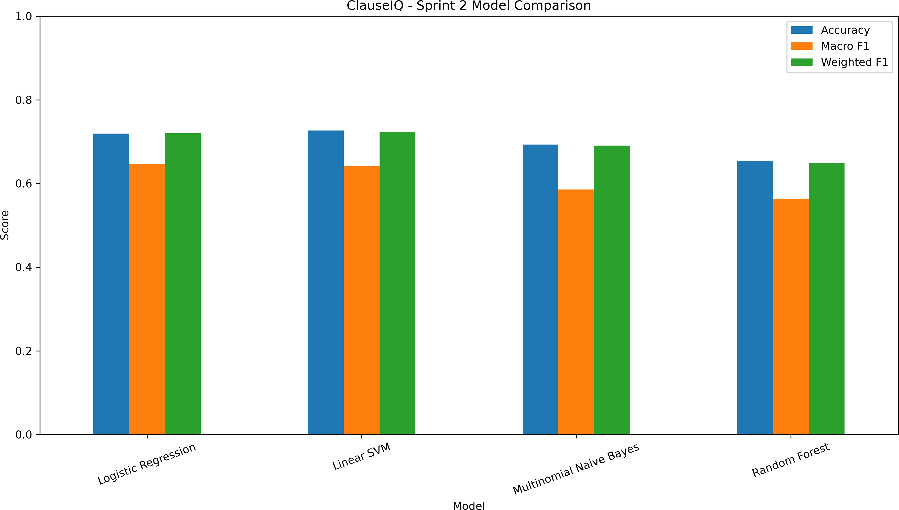
ClauseIQ – Machine Learning-Based Contract Clause Classification and Intelligent Search System

Figure 5.1: Performance comparison of the four evaluated machine learning classifiers
Figure 5.1 shows that Logistic Regression and Linear SVM achieved higher overall performance than Multinomial Naive Bayes and Random Forest on the evaluated TF-IDF feature space. Linear SVM achieved the highest Accuracy of 72.63%, while Logistic Regression achieved the highest Macro-F1 of 64.74% and Weighted-F1 of 71.96%. Since Macro-F1 was defined as the primary model-selection metric, Logistic Regression was selected for the ClauseIQ classification component.

5.2 Evaluation Metrics

Selection Methodology

In accordance with the project’s predefined architectural specification, model selection is gov-erned by two hierarchical criteria:
      - Primary Selection Metric: Macro-Averaged F1-Score (Macro-F1).
      - Secondary Selection Metric: Accuracy.

Selected Production Classifier: Logistic Regression

Based strictly on the primary selection criterion, Multinomial Logistic Regression was se-lected as the optimal production model for ClauseIQ:

Logistic Regression Macro-F1: 64.74% (0.6474)
- Linear SVM Macro-F1: 64.18% (0.6418)

Multinomial Naive Bayes Macro-F1: 58.53% (0.5853)
- Random Forest Macro-F1: 56.34% (0.5634)

While Linear SVM achieved a marginally higher Accuracy (72.63% vs. 71.90% for Logistic Regression), its Macro-F1 was lower by 0.56 percentage points (64.18% vs. 64.74%).
Department of Computer Applications, MACE 30
ClauseIQ – Machine Learning-Based Contract Clause Classification and Intelligent Search System

Detailed Rationale for Selection

In enterprise contract compliance, selecting an algorithm based solely on overall Accuracy is dangerously flawed. Because the CUAD corpus exhibits a 46.33:1 class imbalance, high accu-racy can be achieved simply by correctly classifying ubiquitous boilerplate categories (such as Parties with 1,251 samples or Audit Rights with 642 samples) while failing completely on rare, highly consequential provisions.
Minority categories—such as Price Restrictions (27 total samples), Most Favored Nation (42 samples), and Rofr/Rofo/Rofn (312 samples)—carry immense commercial and legal exposure. Macro-F1 computes the unweighted arithmetic mean of F1-scores across all 41 categories, en-suring that rare, high-risk clauses receive equal optimization weight alongside high-frequency boilerplate. Logistic Regression demonstrated the highest Macro-F1 across the entire bench-mark.
Furthermore, Logistic Regression provides a critical engineering advantage: it generates na-tively calibrated class probabilities via the multinomial softmax function. In a real-world legal workflow, providing reviewers with a reliable confidence score (e.g., “Governing Law: 96.8% confidence”) enables automated routing of low-confidence predictions to senior attor-neys for manual verification. In contrast, Linear SVM produces uncalibrated decision-function distances that require heuristic Platt scaling to approximate probabilities.

Conceptual Distinction Between Macro-F1 and Probability Estimates

To ensure academic correctness, it is emphasized that Macro-F1 is an evaluation metric, not a prediction probability or confidence score. Macro-F1 reflects the harmonic balance between precision and recall averaged across 41 classes over an entire evaluation dataset. When Clau-seIQ reports a confidence score for an individual clause prediction, that confidence is derived strictly from the model’s posterior probability distribution (𝑃(𝑦 = 𝑐 | 𝑥)) and is mathematically distinct from Macro-F1.

5.3 Confusion Matrix

To analyze classification behavior across all 41 categories, full 41 × 41 confusion matrices were generated for all four evaluated models. Figure 5.2 presents the confusion matrix for the selected Logistic Regression model.
The confusion matrix exhibits key structural characteristics:

- Axes Definition: The vertical axis (Y-axis) represents the True Category label, while the
Department of Computer Applications, MACE 31
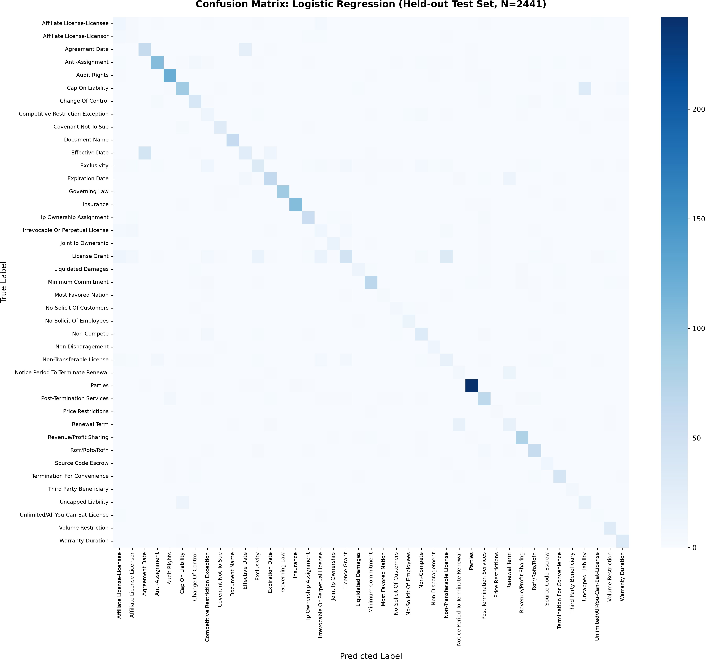
ClauseIQ – Machine Learning-Based Contract Clause Classification and Intelligent Search System

Figure 5.2: Full 41 × 41 confusion matrix for the selected Logistic Regression model

horizontal axis (X-axis) represents the Predicted Category label.
- Diagonal Concentration: The prominent bright diagonal represents correct classifications (𝑇𝑃_{𝑐}). Strong diagonal concentration is observed across frequent legal categories, including Parties, Audit Rights, Governing Law, Insurance, and Termination For Convenience.
- Off-Diagonal Dispersion: Off-diagonal entries denote misclassifications. Misclassifica-tions are predominantly concentrated among semantically adjacent sub-categories:
  - Aﬀiliate License-Licensee vs. Aﬀiliate License-Licensor: These classes share almost identical vocabulary regarding licensing grants, differing only in the directional party designation.
  - Cap On Liability vs. Uncapped Liability: Both provisions deal with liability boundaries, often leading to mutual confusion when negative phrasing is subtle.
  - Agreement Date vs. Effective Date: Both provisions contain concise calendar dates, making contextual differentiation difficult when surrounding context is absent.
Department of Computer Applications, MACE 32
ClauseIQ – Machine Learning-Based Contract Clause Classification and Intelligent Search System
Confusion matrices for the other three evaluated architectures (linear_svm_cm.png, multinomial_naive_ba
and random_forest_cm.png) demonstrate consistent diagonal patterns, with Linear SVM show-ing comparable sharpness to Logistic Regression, while Random Forest displays noticeable off-diagonal dispersion due to majority-class bias.

5.4 Relevant Metrics Calculated from Confusion Matrix

Table 5.3 extracts representative class-level precision, recall, and F1-scores from the verified
classification report of the selected Logistic Regression model (results/classification_reports/logist

Category | Precision | Recall | F1-Score | Test Support
High-Performing Categories (Distinctive Vocabulary)
Governing Law | 1.0000 | 0.9674 | 0.9834 | 92
Parties | 0.9719 | 0.9680 | 0.9699 | 250
Document Name | 0.9683 | 1.0000 | 0.9839 | 61
Insurance | 0.9725 | 0.9464 | 0.9593 | 112
Audit Rights | 0.9173 | 0.9457 | 0.9313 | 129
Revenue/Profit Sharing | 0.8280 | 0.9277 | 0.8750 | 83
Termination For Convenience | 0.7455 | 0.8367 | 0.7885 | 49
Moderate-Performing Categories
Cap On Liability | 0.7946 | 0.6593 | 0.7206 | 135
Non-Compete | 0.5926 | 0.6275 | 0.6095 | 51
Exclusivity | 0.5077 | 0.4024 | 0.4490 | 82
Uncapped Liability | 0.3585 | 0.5758 | 0.4419 | 33
Challenging / Rare Categories (Severe Imbalance)
Price Restrictions | 1.0000 | 0.6000 | 0.7500 | 5
Most Favored Nation | 0.5714 | 0.5000 | 0.5333 | 8
Affiliate License-Licensee | 0.2195 | 0.3913 | 0.2812 | 23
Affiliate License-Licensor | 0.1111 | 0.2143 | 0.1463 | 14
Unlimited/All-You-Can-Eat | 0.2222 | 0.3333 | 0.2667 | 6
Macro Average (41 Classes) | 0.6481 | 0.6622 | 0.6474 | 2,441
Weighted Average (41 Classes) | 0.7354 | 0.7190 | 0.7196 | 2,441
Overall Test Accuracy | 71.90% (0.7190) |  |  | 2,441
Table 5.3: Representative class performance for the selected Logistic Regression model

Observations on Class-Level Performance

- Distinctive Vocabulary Excels: Categories characterized by standardized statutory phrasing—such as Governing Law (F1: 98.34%) and Insurance (F1: 95.93%)—achieve near-perfect classification. In Governing Law, terms such as “governed by”, “construed in accordance with”, and specific jurisdiction names (e.g., “Delaware”, “New York”) provide decisive fea-ture weights.
Department of Computer Applications, MACE 33
ClauseIQ – Machine Learning-Based Contract Clause Classification and Intelligent Search System
- Rare Categories Maintain Viability: Despite having only 5 test samples, Price Restric-tions achieved an F1-score of 75.00% (100% Precision, 60.0% Recall), demonstrating that class-weight balancing successfully prevented the model from ignoring low-frequency classes.
- Directional Ambiguity: The lowest F1-scores occur in paired categories such as Aﬀiliate License-Licensor (F1: 14.63%) and Aﬀiliate License-Licensee (F1: 28.12%). Because both provisions govern software and patent grants, distinguishing the granting party from the receiving party requires fine-grained grammatical dependency parsing that bag-of-words TF-IDF representations partially compress.

5.5 Prediction Statistics of Unseen Data
The generalization capability of the selected Logistic Regression model was evaluated on the held-out test dataset (N_test = 2,441 unseen clauses) strictly isolated from model training. On this unseen dataset, the model correctly classified 1,755 clauses, yielding an overall Accuracy of 71.90% (0.7190). Across all 41 categories, the Macro-Averaged metrics reached 64.81% Precision, 66.22% Recall, and 64.74% Macro-F1, while Weighted-Averaged metrics reached 73.54% Precision, 71.90% Recall, and 71.96% Weighted-F1.
Evaluating performance across sample support strata reveals that high-frequency categories (support >= 60) consistently achieved F1-scores above 0.85 (e.g., Document Name F1: 0.9839 on 61 unseen clauses, Governing Law F1: 0.9834 on 92 clauses, Parties F1: 0.9699 on 250 clauses). Moderate-support categories (20 <= support < 60) achieved balanced F1-scores between 0.44 and 0.79 (Termination For Convenience F1: 0.7885 on 49 clauses; Cap On Liability F1: 0.7206 on 135 clauses). Even severely imbalanced minority categories maintained positive detection rates on unseen data (Price Restrictions F1: 0.7500 on 5 test clauses; Most Favored Nation F1: 0.5333 on 8 clauses).

5.6 Discussion of Findings and Conclusions

The empirical benchmark reveals critical insights regarding algorithmic suitability for sparse text categorization:
- Superiority of Linear Decision Boundaries: Both linear architectures (Logistic Regres-sion and Linear SVM) substantially outperformed the tree ensemble (Random Forest) and generative model (Naive Bayes). In a 10,000-dimensional sparse TF-IDF space, text data resides in an ultra-high-dimensional geometry where classes are predominantly linearly sep-arable. Linear hyperplanes effectively integrate small weights across thousands of vocabu-lary terms.
- Random Forest Degradation on Sparse Vectors: Random Forest performed poorly, achiev-ing a Macro-F1 of only 56.34% and Accuracy of 65.46%. In Random Forest, decision trees

sample random feature subsets (typically √10000 = 100 features) at each node split. In a
sparse matrix where over 98% of entries are zero, the probability of a sampled subset con-taining the few discriminative legal keywords is low. Consequently, individual trees often split on irrelevant noise or default to the majority class.
- Naive Bayes Smoothing Constraints: Multinomial Naive Bayes achieved respectable ac-curacy (69.27%) but suffered in Macro-F1 (58.53%). Because Naive Bayes assumes com-plete feature independence, strong co-occurrences in legal text (e.g., “indemnify, defend, and hold harmless”) violate the independence assumption, skewing class posteriors toward categories with broad vocabularies.

ClauseIQ – Machine Learning-Based Contract Clause Classification and Intelligent Search System

7. Top-𝑘 Formatting: The top-𝑘 highest-scoring clauses are returned along with their simi-larity score, rank, source contract identifier, and predicted legal category.

6.1.2. Latency and Throughput

Because the search index resides in memory as a pre-computed sparse matrix and vector opera-tions utilize highly optimized SciPy/NumPy BLAS routines, query execution across all 12,204 clauses completes in sub-10 milliseconds, satisfying real-time enterprise performance require-ments.

6.2. Empirical Evaluation of Search Retrieval (𝑃@𝑘 and 𝑅@𝑘)

To rigorously evaluate retrieval performance, an empirical benchmark was conducted across five canonical legal query scenarios. Relevance was measured against ground-truth human annota-tions in the CUAD dataset:
- Query: “termination for convenience” → Ground Truth: Termination For Convenience (246 corpus clauses).
- Query: “governing law” → Ground Truth: Governing Law (462 corpus clauses).
- Query: “non-compete” → Ground Truth: Non-Compete (257 corpus clauses).
- Query: “limitation of liability” → Ground Truth: Cap On Liability and Uncapped Liability (839 corpus clauses).
- Query: “audit rights” → Ground Truth: Audit Rights (642 corpus clauses).

Table 6.1 presents the exact empirical retrieval metrics logged in results/search_evaluation.csv.
 | Query String | Count | P@1 | R@1 | P@3 | R@3 | P@5 | P@10 |  | R@10
 | termination for convenience governing law  non-compete  limitation of liability audit rights | 246  462  257  839  642 | 1.0000  1.0000  0.0000  1.0000  1.0000 | 0.0041  0.0022  0.0000  0.0012  0.0016 | 0.6667  1.0000  0.6667  1.0000  1.0000 | 0.0081  0.0065  0.0078  0.0036  0.0047 | 0.6000  1.0000  0.8000  1.0000  1.0000 | 0.7000  0.9000  0.9000  0.9000  0.9000 |  | 0.0285  0.0195  0.0350  0.0107  0.0140
 | Macro Average – 0.8000 0.0018 0.8667 0.0061 0.8800 0.8600 0.0215
 | Table 6.1: Empirical Information Retrieval evaluation of ClauseIQ search engine
 | Department of Computer Applications, MACE 40

REFERENCES

- E. Quevedo Caballero, T. Černý, A. Rodriguez, P. Rivas, J. Yero, K. Sooksatra, and
D. Taibi, “Legal Natural Language Processing From 2015 to 2022: A Comprehensive Sys-tematic Mapping Study of Advances and Applications,” IEEE Access, vol. 12, pp. 145286–145317, 2024. https://doi.org/10.1109/ACCESS.2024.3414967
- M. Siino, M. Falco, D. Croce, and P. Rosso, “Exploring LLMs Applications in Law: A Literature Review on Current Legal NLP Approaches,” IEEE Access, vol. 13, pp. 18253–18276, 2025. https://doi.org/10.1109/ACCESS.2025.3533217
- M. Kutbi, “Named Entity Recognition Utilized to Enhance Text Classification While Pre-serving Privacy,” IEEE Access, vol. 11, pp. 117576–117581, 2023. https://doi.org/ 10.1109/ACCESS.2023.3325895
- D. Hendrycks, C. Burns, A. Chen, and S. Ball, “CUAD: An Expert-Annotated NLP Dataset for Legal Contract Review,” in Proceedings of the Neural Information Process-ing Systems (NeurIPS), 2021. https://arxiv.org/abs/2103.06268
- F. Pedregosa, G. Varoquaux, A. Gramfort, V. Michel, B. Thirion, O. Grisel, M. Blon-del, P. Prettenhofer, R. Weiss, V. Dubourg, J. Vanderplas, A. Passos, D. Cournapeau,
M. Brucher, M. Perrot, and E. Duchesnay, “Scikit-learn: Machine Learning in Python,” Journal of Machine Learning Research, vol. 12, pp. 2825–2830, 2011.
- M. Honnibal and I. Montani, “spaCy: Industrial-strength Natural Language Processing in Python,” Zenodo, 2017.
- S. Ramírez, “FastAPI: High performance, easy to learn, fast to code, ready for production,” 2018. https://fastapi.tiangolo.com/

Department of Computer Applications, MACE 52

