Paragraph 1
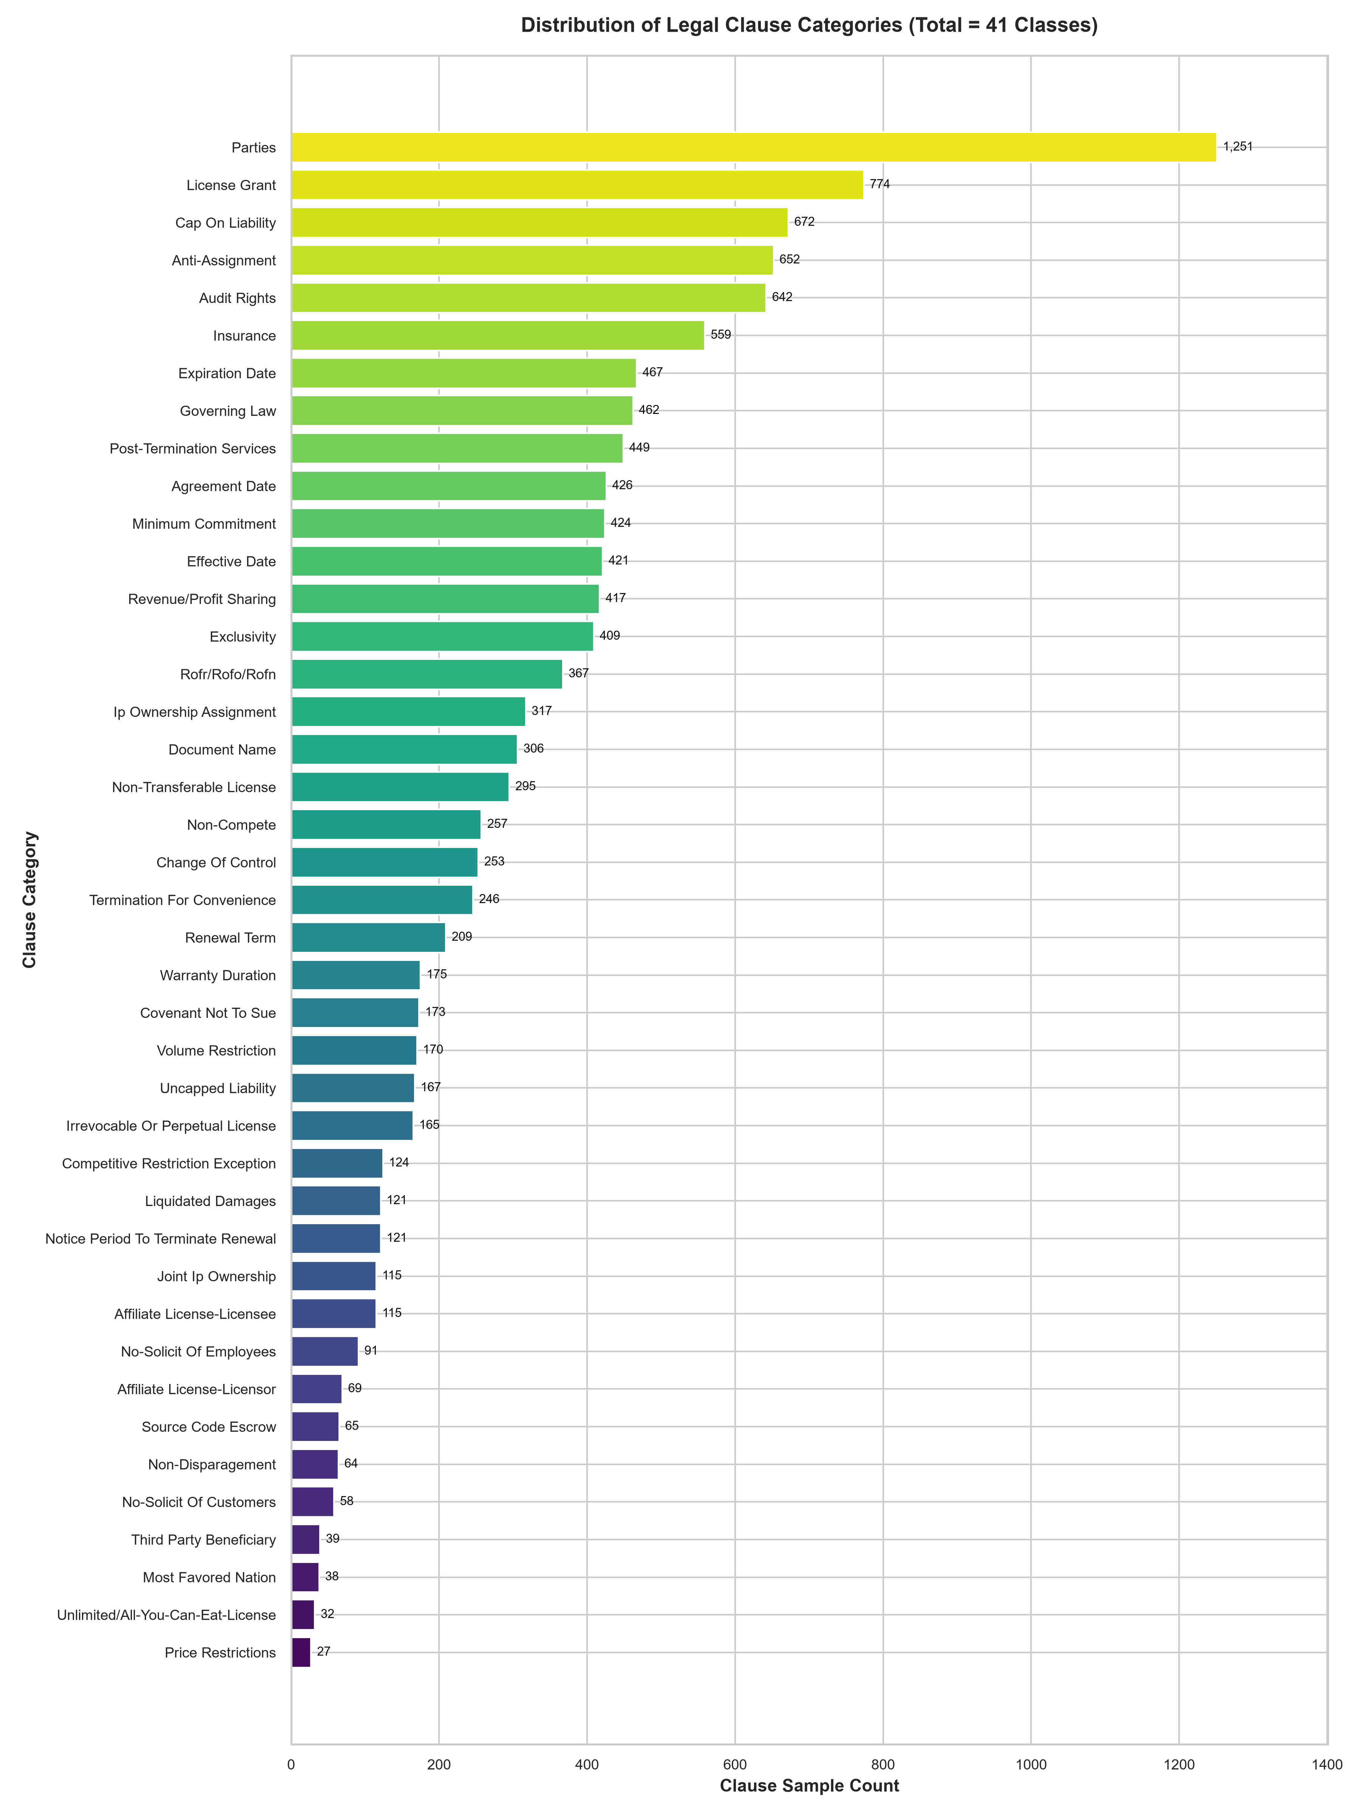
Figure 3.2: Complete 41-category class distribution

