Entropy-Gated Contrastive Decoding: Mitigating Visual Inertia and Multimodal Hallucinations in Vision-Language Models

Abstract
Vision-Language Models answer relational questions about objects well below their recognition accuracy. On the relation subset of the AMBER benchmark, most mainstream systems score near 0.7 accuracy, and the errors follow a measurable pattern: cross-attention settles on the earliest salient objects, the grounding signal decays as decoding proceeds, and pre-trained language priors finish the answer. We call this mechanism Visual Inertia and target it at decoding time. We present Entropy-Gated Contrastive Decoding (EGCD), a training-free inference framework, calibrated once per model on a small tuning split, that decides per query. Before decoding starts, EGCD computes the Shannon entropy of the first-token distribution. Low entropy means the model has already resolved the query, and standard greedy decoding proceeds. An entropy spike signals conflict between visual evidence and the language prior, and routes the query to a counterfactual contrastive pathway: a second forward pass omits the image, an Adaptive Plausibility Constraint bounds the contrast to plausible tokens, and the isolated language prior is subtracted from the expert logits. On 1,664 binary relation questions from AMBER, with the threshold picked on a tuning split and every result reported on the held-out half, we evaluate seven open-weight models. EGCD raises the biased architectures over their greedy baselines: Qwen2-VL-2B from 71.50% to 80.89% balanced accuracy, Phi-3-Vision-4.2B from 70.18% to 77.50%, and SmolVLM2-2.2B from 63.80% to 68.07%. On structurally sound models such as LLaVA-1.5-7B, where universal contrastive decoding collapses balanced accuracy to 63.06%, the gate stays idle and returns the baseline exactly. Gating on predictive uncertainty turns contrastive decoding into a conditional, architecture-aware intervention: applied where it heals, withheld where it harms.

1. Introduction
Large Vision-Language Models integrate visual perception with autoregressive text generation (Liu et al., 2023) and caption images, answer questions, and follow multimodal instructions with high fluency. Their record on fine-grained spatial and relational reasoning is far weaker. On the relation subset of AMBER, most mainstream models score near 0.7 accuracy on questions that ask whether two objects touch, align, or support each other, and even the strongest systems misjudge contact and alignment between objects (Wang et al., 2023). Perturbation studies expose the same weakness from another side. When Shin et al. (2026) rotated images or corrupted them with noise, relational accuracy dropped across open and closed models alike, while object recognition barely moved. Layout probes tell a matching story: faced with compositional structure, models lean on non-visual shortcuts instead of reading the scene (Brown et al., 2025; Chen et al., 2024). Mistakes of this kind are made while the answer is being generated, not at the point of perception, so a fix has to operate inside decoding.
We adopt the name Gong et al. (2026) use for this mechanism: Visual Inertia. What happens during decoding is that cross-attention latches onto whichever regions stood out in the first few generation steps and then stops moving. Grounding fades from that point on, and the fixed priors of the language backbone take over the remaining steps. By the time an answer token is chosen, the secondary object the question is actually asking about has effectively dropped out of the computation. The model says No to anything that feels uncertain, or defaults to stereotypical object co-occurrences (Yin et al., 2025).
The standard tool against distribution-level hallucination is Contrastive Decoding, which contrasts an expert distribution with a weaker amateur and subtracts the difference (Leng et al., 2024). Applied uniformly, it has a documented failure mode: much of its benchmark gain comes from a blunt yes-ward shift of the output distribution and, under sampling, from a truncation that collapses decoding into greedy search (Yin et al., 2025); a recent reproducibility study reaches the same conclusion across models and decoding regimes (Bendre et al., 2026). Hidden-state interventions steer activations directly and avoid the logit arithmetic, but they can entangle unrelated features and disturb the natural generation behavior of the model (Su et al., 2025; Zhang et al., 2026). What is missing is a way to apply the correction only where the failure actually occurs, and to leave every other query untouched.
We propose Entropy-Gated Contrastive Decoding (EGCD), a training-free, zero-shot routing framework built around one observation: the conflict between visual evidence and language prior is visible in the first-token distribution before decoding starts. The router reads the Shannon entropy of that distribution. Low entropy means the model is confident and its priors are safe to trust. A sharp entropy spike marks vision-text conflict and activates a counterfactual contrastive pass that isolates the language prior and subtracts it, bounded by an Adaptive Plausibility Constraint. One statistic, computed by the standard forward pass anyway, decides whether the intervention runs at all. The same gate that heals biased architectures stays idle on structurally sound ones, which no uniform scheme can do. Our contributions are as follows:
- An operationalization of Visual Inertia (Gong et al., 2026) as a decoding-time signal. We take their attention-stagnation account and reduce it to a measurable probe: the first-token distribution, where entropy separates correct from incorrect answers on every model with per-item data (AUC 0.62 to 0.75). This is what motivates intervention at decoding time.
- EGCD, a training-free routing mechanism that uses first-token Shannon entropy as a real-time conflict probe and triggers counterfactual contrastive decoding only under active vision-text conflict. The gate adds no parameters, requires no sampling, and reads a statistic the standard pass computes anyway.
- A cross-architecture study on AMBER showing that contrastive interventions should be conditional: EGCD lifts balanced accuracy by up to 9.39 points on biased architectures and stays idle on structurally sound ones, avoiding the 13.7-point collapse that universal contrastive decoding inflicts on naturally balanced models.

The remainder of this paper is organized as follows. Section 2 reviews related work on visual inertia, contrastive decoding, and uncertainty-based routing. Section 3 introduces our proposed methodology, detailing the entropy gate and the counterfactual contrastive pathway. Section 4 describes the experimental setup, including the AMBER benchmark, models, and baselines. Section 5 presents the results and analysis across seven vision-language models. Finally, Section 6 concludes the paper and outlines limitations and future work.

2. Related Work

2.1 Visual Inertia and Relational Hallucinations
Hallucination benchmarks have moved well beyond simple object-existence checks. POPE samples object presence in a balanced way (Li et al., 2023b); CHAIR counts invented objects in captions (Rohrbach et al., 2018); MME spans perceptual and cognitive tasks (Fu et al., 2025); and AMBER adds a discriminative relation subset of 1,664 image-text pairs (Wang et al., 2023). Of all these tasks, relational queries are where models struggle most. The task needs two objects bound together and a predicate checked between them, which is precisely the computation that attention stagnation breaks. The evidence has piled up from several directions: rotation and noise destroy relational accuracy even while recognition survives (Shin et al., 2026), spatial benchmarks keep catching shortcut heuristics that skip grounded binding (Brown et al., 2025; Chen et al., 2024), and survey-level treatments still count compositional failure among the open problems of vision-language modeling (Bordes et al., 2024).
Gong et al. (2026) call this mechanism Visual Inertia: attention to semantically critical regions settles early and then stays fixed, so the model never inspects the secondary objects that a relational query targets. Their counterfactual experiment is straightforward. An inertia-inducing intervention reduces visual activeness from 41.52 to 19.24 and the relation score from 63.96 to 47.25, which is the largest decline among their controls. Two consequences follow for intervention design. First, uniform attention amplification cannot help, because scaling a settled map only reinforces the settlement (Gong et al., 2026; Chen et al., 2026). Second, once the visual signal freezes, unimodal language priors dominate the deeper layers; this dominance has now been traced to specific FFN modules (Guo et al., 2026) and is the target of prior-suppression decoding methods (Ren et al., 2026; Min et al., 2025). EGCD is designed around both of these points: it avoids uniform attention amplification and directly counteracts the language-prior dominance at decoding time.

2.2 Contrastive Decoding and Hidden-State Interventions
Contrastive decoding was first introduced for open-ended text generation, where an expert distribution is contrasted with the output of a weaker amateur model (Li et al., 2023a; Su and Xu, 2022). Visual Contrastive Decoding (VCD) adapted this idea to hallucination research by using a Gaussian-noised image as the amateur, with an Adaptive Plausibility Constraint (APC) that restricts the contrast to plausible tokens (Leng et al., 2024). Subsequent variants have replaced the amateur with instruction distractors (Wang et al., 2024), shallow-layer estimates (Huo et al., 2025), counterfactual masks (Xiao and Zhou, 2026), or an omitted visual prompt (Favero et al., 2024). More recent work modulates the contrast adaptively based on query type or entropy (Im et al., 2025; Huang et al., 2026).
The uniform application of this recipe has a documented failure mode. Yin et al. (2025) show that the reported POPE gains of contrastive methods come largely from a yes-ward shift in the output distribution, and that under sampling, the APC degrades decoding into an approximation of greedy search; a spurious prompt adjustment can reproduce the same numbers. A reproducibility study by Bendre et al. (2026) extends this critique across multiple models and decoding regimes. Hidden-state interventions take a different approach by editing activations rather than logits, including layer-wise logit contrast (Chuang et al., 2024), bidirectional activation steering (Su et al., 2025), and selective interventions that attempt to leave the token distribution intact (Wang et al., 2025; Zhang et al., 2026). However, steering signals can entangle unrelated features and shift the model away from its natural generation behavior. EGCD operates at the logit level, runs only under detected conflict, and decodes greedily, which closes off the sampling-collapse route to spurious gains by construction. Section 5 evaluates both under one protocol and shows that where a method damages a model, and where it does nothing, both depend on the amateur and on the model.

2.3 Uncertainty Estimation and Dual-Process Routing
Dual-process theories split cognition into a fast, automatic mode and a slower, deliberate one (Wason and Evans, 1974; Kahneman, 2011), and the same split now runs through reasoning research on LLMs (Li et al., 2025). DynaThink, for instance, routes a question to fast thinking only when sampled chains agree and the majority answer needs the fewest reasoning steps (Pan et al., 2024); HaluSearch interleaves fast and slow search to cut hallucination (Cheng et al., 2025). The catch is that both routers verify by sampling. Computing the routing signal costs more than producing the answer it guards.
Octopus is the closest prior work to ours. It learns a per-step router that picks among contrastive variants through a trained decision token (Suo et al., 2025). The learned router covers more cases, but it needs a preference-optimization stage and pays overhead at every token. Probing studies suggest cheaper routes: linear probes pull structured information out of intermediate representations (Alain and Bengio, 2016), and tuned lenses recover latent predictions layer by layer (Belrose et al., 2023). EGCD uses none of this. It routes once per query, on the Shannon entropy of a single first-token distribution the standard forward pass already produces. The gate itself is free, and the intervention budget goes only where conflict is detected.

3. Methodology
This section formalizes EGCD: the notation, the gate, and the corrective pathway. Figure 1 traces a relational query through both routes to the final response.
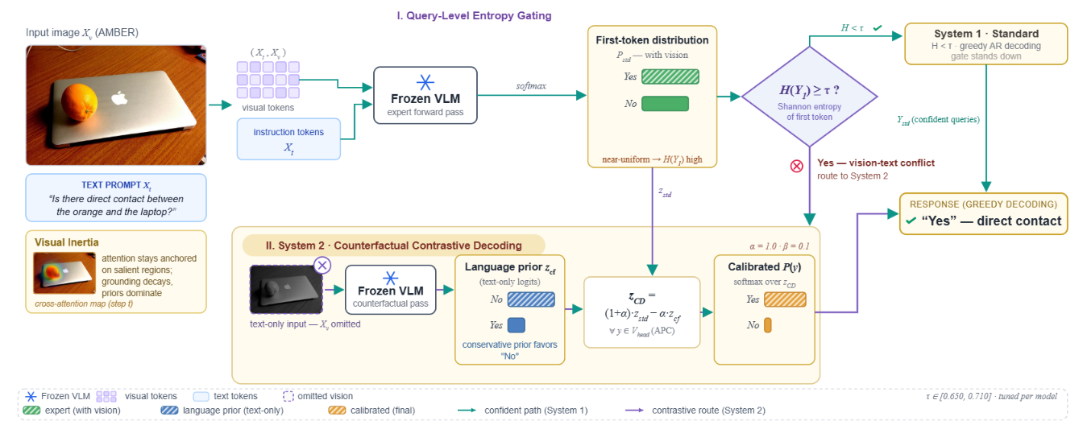
Figure 1: Overview of Entropy-Gated Contrastive Decoding. A relational query enters the frozen VLM; the first-token entropy $H\left(Y_{1}\right)$ is compared against $τ$, and the query is routed to System 1 (greedy decoding) or System 2 (counterfactual contrastive decoding with APC; $α=1.0$, $β=0.1$).

3.1 Problem Formulation and Visual Inertia
Let $θ$ denote the parameters of a model, frozen at inference time, and let $V$ denote its vocabulary. The input is a tuple $\left(X_{v} , { X}_{t}\right)$ of a visual scene and a text prompt, and autoregressive decoding produces $Y=\left(y_{1} , … , y_{T}\right)$. At step $t$ the standard expert multimodal pass assigns
$$P_{\text{std}}\left(y_{t} , ∣ , X_{v}X_{t}Y_{<t}\right)=\text{softmax}\left(z_{\text{std}}\left(y_{t}\right)\right)$$
where $z_{\text{std}}\left(y_{t}\right)$ collects the vocabulary logits of that forward pass.
Visual Inertia (Gong et al., 2026) is the failure mode we target. The spatial cross-attention map stays anchored to early salient objects as decoding proceeds, so the grounding signal decays and the statistical language prior takes over the next-token distribution. In binary relation tasks the decoder defaults to conservative answers and stereotypical co-occurrences (Yin et al., 2025). The substitution is measurable: it shows up as probability placed on answer tokens that the image does not support. A correction has to fire exactly when this substitution happens, and stay quiet otherwise.

3.2 Query-Level Entropy Gating and Dual-Process Routing
Penalizing logits at every step taxes queries that need no help, so we treat decoding as a dual-process system (Kahneman, 2011) and route once, at the query level. The probe is the Shannon entropy (Shannon, 1948) of the first-token distribution over the vocabulary $V$:
$$H(Y_{1}) = - Σ_{y∈V} P_{std}(y_{t} ∣ X_{v}, X_{t}) log P_{std}(y_{t} ∣ X_{v}, X_{t})$$
A peaky distribution yields low entropy. When language priors and visual evidence diverge at the relational decision point, probability mass diffuses across candidates and entropy spikes. Binary relation questions make this especially convenient: the very first token the model emits is the answer, so the whole vision-text contest is settled inside this one distribution.
A hard threshold τ divides the two regimes. A query with H($Y_{1}$) < τ counts as settled: its priors are safe to trust, and System 1 answers it with standard greedy decoding, giving $Y_{std}$. When H($Y_{1}$) ≥ τ, the entropy spike signals vision-text conflict, and the query is routed to the corrective System 2 pathway, which returns $Y_{CD}$. Because the gate reads a forward-pass statistic that System 1 already computes, checking the gate adds no overhead. The only additional cost, one counterfactual forward pass, is incurred only by queries that actually route to System 2.

3.3 Counterfactual Isolation and Adaptive Plausibility Constraint
System 2 isolates the language prior through a counterfactual forward pass that removes the visual input entirely (Favero et al., 2024):
$$z_{cf}(y_{t}) = {logit}_{θ}(y_{t} ∣ X_{t}, Y_{<t})$$
The vector z_{cf} represents the unimodal bias at the current decoding step, defined as the logits the language backbone assigns when no visual input is provided. Subtracting it raw can amplify tail tokens, because a strongly negative prior logit becomes a large positive score after subtraction, which invites ungrammatical output. Following VCD (Leng et al., 2024), we bound the contrast to an adaptive plausibility set:
$$V_{head}(Y_{<t}) = \{ y ∈ V : P_{std}(y_{t} ∣ X_{v}, X_{t}, Y_{<t}) ≥ β \max_{w∈V} P_{std}(w_{t} ∣ X_{v}, X_{t}, Y_{<t}) \}$$
For every plausible token, the contrastive logits combine the expert and counterfactual terms; all other tokens are truncated to negative infinity:
$$z_{CD}(y_{t}) = (1 + α) z_{std}(y_{t}) - α z_{cf}(y_{t}), ∀ y_{t} ∈ V_{head}$$
where α controls the penalty strength. The calibrated distribution is the softmax over this truncated space, and Y_{CD} is decoded greedily. Because System 2 never samples, the truncation cannot manufacture greedy-search gains of the kind documented under sampling decoders (Yin et al., 2025; Bendre et al., 2026); the contrast acts only where the gate detected conflict. Algorithm 1 summarizes the full procedure.
Algorithm 1: Entropy-Gated Contrastive Decoding (EGCD)
Require: Frozen VLM $p_{θ}$ with logit function $z_{θ}$
Require: Multimodal input $(X_{v}, X_{t})$
Require: Entropy threshold $τ$, contrastive strength $α$, plausibility threshold $β$
Require: Maximum decoding length $T$

1: $P_{std} ← \text{softmax}(z_{θ}(y_{1} ∣ X_{v}, X_{t}))$
2: $H(Y_{1}) ← - Σ_{y∈V} P_{std}(y) \text{log} P_{std}(y)$
3: if $H(Y_{1}) < τ$ then
4: $y_{t} ← \text{argmax} p_{θ}(y_{t} ∣ X_{v}, X_{t}, Y_{<t}) \text{for} t = 1 … T$
5: return $Y_{std}$
6: else
7: for $t = 1$ to $T$ do
8: $z_{std} ← z_{θ}(y_{t} ∣ X_{v}, X_{t}, Y_{<t}) ; P_{std} ← \text{softmax}(z_{std})$
9: $z_{cf}(y_{t}) ← z_{θ}(y_{t} ∣ X_{t}, Y_{<t})$
10: $V_{head} ← \{ y ∈ V : P_{std}(y) ≥ β · {\text{max}}_{w} P_{std}(w) \}$
11: $z_{CD}(y) ← (1 + α) z_{std}(y) - α z_{cf}(y) \text{for} y ∈ V_{head}; -∞ \text{otherwise}$
12: $y_{t} ← \text{argmax} \text{softmax}(z_{CD})$
13: if $y_{t} = ⟨\text{EOS}⟩$ then break
14: end for
15: return $Y_{CD}$
16: end if

4. Experimental Setup

4.1 Evaluation Benchmark
We evaluate on the AMBER benchmark (Wang et al., 2023), restricted to its Discriminative-Relation subset: 1,664 image-text pairs of binary Yes/No questions about spatial alignment and physical contact. Existence suites such as POPE (Li et al., 2023b) and captioning metrics such as CHAIR (Rohrbach et al., 2018) rarely stress relational binding, and AMBER's authors report affirmative bias across mainstream models, with Yes-ratios exceeding No-ratios for nearly every evaluated system. The subset is balanced by construction, its annotated objects stay outside common visual-instruction tuning corpora, and relational verification requires shifting attention to secondary objects, which makes it a direct probe of Visual Inertia. Scoring well on this subset requires reading the relation out of the image, which is the property we need from a test bed.

4.2 Target Vision-Language Models
The suite spans seven open-weight models from four architectural families. Qwen2-VL-2B and Qwen2.5-VL-7B use native dynamic resolution and multimodal rotary position embeddings (Bai et al., 2025). SmolVLM2-2.2B continues the Idefics lineage in a compact form (Marafioti et al., 2025; Laurençon et al., 2024), alongside Idefics2-8B itself (Laurençon et al., 2024). LLaVA-1.5-7B and LLaVA-v1.6-Mistral-7B pair CLIP vision encoders with Vicuna and Mistral backbones through MLP projection layers (Liu et al., 2023; Liu et al., 2024). Phi-3-Vision-4.2B completes the suite (Abdin et al., 2024). Because the encoders, connectors, and language backbones all differ across this suite, we can examine how architecture conditions the response to decoding interventions.

4.3 Evaluation Metrics
Recall is computed on the positive split of the benchmark, where the ground-truth relation holds and the model must answer Yes. Specificity is computed on the negative, hallucination-prone slice, where the stated relation is false and an affirmative shortcut earns nothing (Yin et al., 2025). With True Positives defined as correct Yes answers to true relations, False Negatives as unjustified No answers to true relations, False Positives as hallucinated Yes answers to false relations, and True Negatives as correct No answers to false relations, the metrics are:
$$Recall = \frac{True Positives}{True Positives + False Negatives}$$
$$Specificity = \frac{True Negatives}{True Negatives + False Positives}$$
Balanced Accuracy is the mean of Recall and Specificity (Brodersen et al., 2010), one term from each split:
$$Balanced Accuracy = \frac{Recall + Specificity}{2}$$
Only a method that restores visual grounding moves both terms at once.

4.4 Baseline Configurations and Implementation Constraints
All runs are zero-shot, half-precision, greedy decoding with temperature zero for reproducibility. EGCD uses $α=1.0$ and $β=0.1$, the defaults established for visual contrastive decoding (Leng et al., 2024). The gate threshold is the one design choice that varies per model. We split the 1,664 relation pairs into a tuning half (831 pairs) and a held-out half (833 pairs), select the threshold on the tuning half over the grid [0.550, 0.750] in steps of 0.01, and report every number in this paper on the held-out half; the split is fixed and identical for all models. We compare five decoding regimes per model: the greedy baseline, universal CD+APC applied at every step, EGCD, and two published universal baselines, VCD and SID (Section 2.2), applied at every step with the same α and β.

5. Results and Analysis
The evaluation covers 1,664 relational pairs across seven models in zero-shot, half-precision settings. We report three axes: gains on biased architectures, the boundary of contrastive interventions, and the dynamics of the gate itself. Throughout, EGCD denotes the gated method at its per-model operating point τ*, universal CD+APC denotes the same contrastive arithmetic applied at every step of every query, and Baseline denotes plain greedy decoding.

5.1 Quantitative Relational Grounding Results
Table 1 summarizes the five decoding regimes. Recall and Specificity each cover one split of the benchmark, so Balanced Accuracy is the arithmetic mean of the true-positive and true-negative rates. Three patterns stand out. Biased models improve sharply under EGCD. Balanced models are damaged by universal CD+APC, in one case catastrophically. On the held-out split EGCD never falls below its baseline, and it matches universal CD+APC wherever CD helps.
Table 1: Held-out results under five decoding regimes. EGCD uses the per-model threshold selected on the tuning half; VCD and SID are applied at every decoding step with the same α and β as CD+APC.
Model | Regime | Recall (%) | Specificity (%) | Bal. Acc. (%)
Qwen2-VL-2B | Greedy baseline | 49.39 | 93.62 | 71.50
Qwen2-VL-2B | Universal CD+APC | 76.43 | 79.13 | 77.78
Qwen2-VL-2B | EGCD (ours)  τ = 0.70 | 75.41 | 86.38 | 80.89
Qwen2-VL-2B | VCD | 49.39 | 93.62 | 71.50
Qwen2-VL-2B | SID | 49.39 | 93.62 | 71.50
Phi-3-Vision-4.2B | Greedy baseline | 48.77 | 91.59 | 70.18
Phi-3-Vision-4.2B | Universal CD+APC | 76.02 | 78.84 | 77.43
Phi-3-Vision-4.2B | EGCD (ours)  τ = 0.62 | 71.52 | 83.48 | 77.50
Phi-3-Vision-4.2B | VCD | 44.47 | 92.17 | 68.32
Phi-3-Vision-4.2B | SID | 45.70 | 93.91 | 69.80
SmolVLM2-2.2B | Greedy baseline | 33.40 | 94.20 | 63.80
SmolVLM2-2.2B | Universal CD+APC | 51.02 | 84.93 | 67.98
SmolVLM2-2.2B | EGCD (ours)  τ = 0.68 | 49.18 | 86.96 | 68.07
SmolVLM2-2.2B | VCD | 57.38 | 84.06 | 70.72
SmolVLM2-2.2B | SID | 35.04 | 93.91 | 64.48
Qwen2.5-VL-7B | Greedy baseline | 62.30 | 99.42 | 80.86
Qwen2.5-VL-7B | Universal CD+APC | 69.47 | 96.23 | 82.85
Qwen2.5-VL-7B | EGCD (ours)  τ = 0.65 | 67.01 | 98.55 | 82.78
Qwen2.5-VL-7B | VCD | 61.27 | 98.55 | 79.91
Qwen2.5-VL-7B | SID | 62.09 | 99.42 | 80.76
Idefics2-8B | Greedy baseline | 74.18 | 91.88 | 83.03
Idefics2-8B | Universal CD+APC | 73.77 | 92.17 | 82.97
Idefics2-8B | EGCD (ours)  τ = 0.69 | 73.98 | 92.17 | 83.07
Idefics2-8B | VCD | 75.41 | 89.57 | 82.49
Idefics2-8B | SID | 74.18 | 91.88 | 83.03
LLaVA-1.5-7B | Greedy baseline | 75.00 | 78.55 | 76.78
LLaVA-1.5-7B | Universal CD+APC | 29.30 | 96.81 | 63.06
LLaVA-1.5-7B | EGCD (ours)  τ = 0.70 | 75.00 | 78.55 | 76.78
LLaVA-1.5-7B | VCD | 76.84 | 75.07 | 75.96
LLaVA-1.5-7B | SID | 75.00 | 78.55 | 76.78
LLaVA-v1.6-Mistral-7B | Greedy baseline | 78.36 | 93.76 | 86.06
LLaVA-v1.6-Mistral-7B | Universal CD+APC | 64.92 | 86.36 | 75.64
LLaVA-v1.6-Mistral-7B | EGCD (ours)  τ = 0.71 | 78.36 | 93.76 | 86.06
LLaVA-v1.6-Mistral-7B | VCD | 79.51 | 91.30 | 85.41
LLaVA-v1.6-Mistral-7B | SID | 79.51 | 94.20 | 86.86

Figure 2 plots the balanced-accuracy comparison. On Qwen2-VL-2B, EGCD adds 9.39 points over greedy decoding and 3.11 over universal CD+APC, the only gain over CD that survives a McNemar test on paired items (p = 0.002); Phi-3-Vision-4.2B gains 7.31; on Phi-3-Vision-4.2B, SmolVLM2-2.2B and Idefics2-8B the gap to CD sits inside sampling noise (p > 0.99). The VCD and SID rows underline the same point from the outside. VCD, whose amateur is a noised image, is the strongest single method on SmolVLM2-2.2B (70.72, p = 0.032 over universal CD+APC), yet on Qwen2-VL-2B, where the headroom is largest, it does not change a single held-out answer; SID, whose amateur is the model's own shallow layer, stays within 0.7 points of the greedy baseline on every model with paired held-out data and flips no answer at all on Qwen2-VL-2B, Idefics2-8B, or LLaVA-1.5-7B. A universal amateur helps where its bias happens to match the model's failure mode and is inert where it does not; the gate is what ties the corrective pathway to the queries that need it.
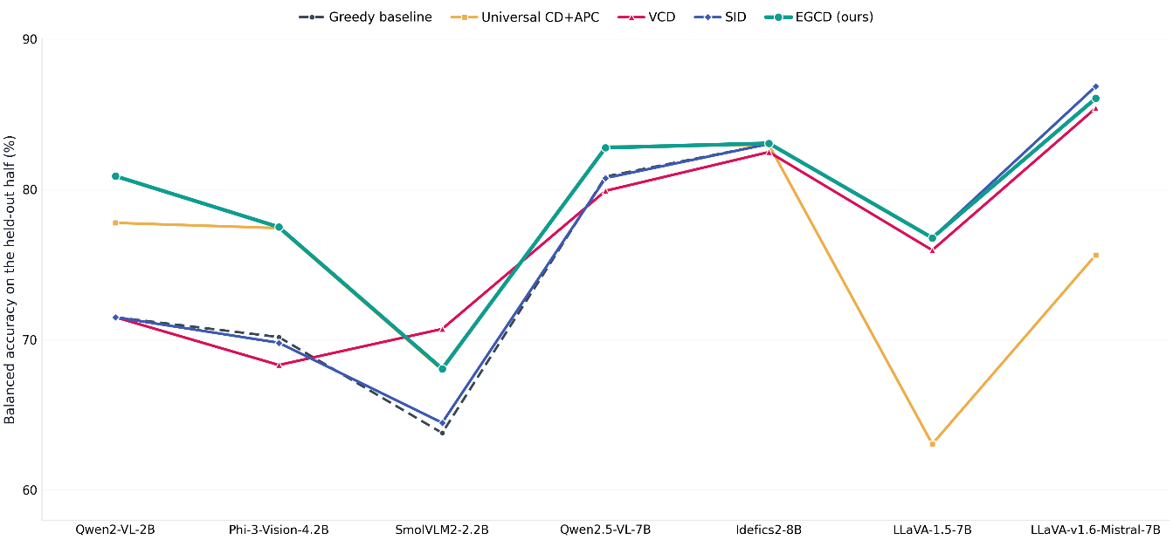

Figure 2: Balanced accuracy on the held-out half for the seven models under greedy decoding, Universal CD+APC, VCD, SID, and EGCD, ordered by EGCD's gain over greedy decoding.

5.2 Resolving Visual Inertia in Biased Architectures
SmolVLM2-2.2B and Qwen2-VL-2B start with baseline recalls of 33.40% and 49.39%, respectively. In both cases, cross-attention stagnates and language priors dominate, so the models answer No to relations that actually hold. Universal CD+APC corrects this bias by shifting the output distribution in the opposite direction. On Qwen2-VL-2B, Recall climbs to 76.43%, but Specificity falls from 93.62% to 79.13%. The shift is one-sided, and it leaves the generation manifold unstable. Recall comes back, but the model has traded one bias for another, and every answer now comes out of a distorted distribution. Figure 3 traces the net effect of this trade-off on balanced accuracy.
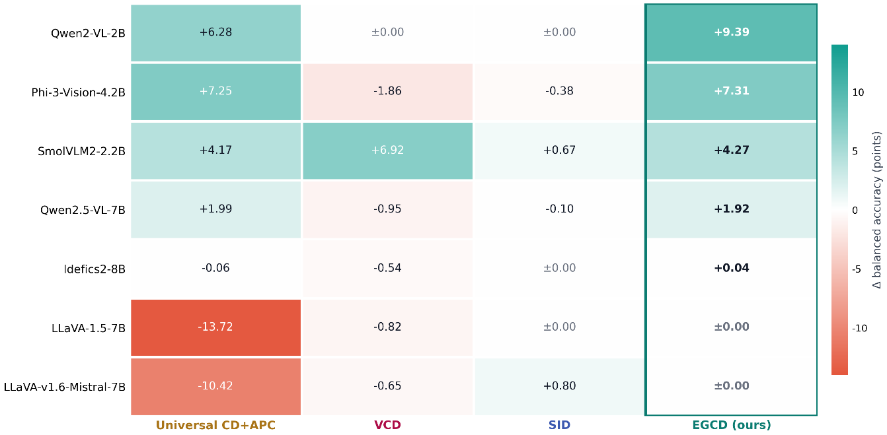
Figure 3: Change in balanced accuracy relative to greedy decoding, per model and method: Universal CD+APC buys its gains with a 10–14 point collapse on the sound models, while EGCD keeps the gains without the collapse.

The gate makes the recall–specificity trade less costly rather than removing it. At the selected threshold, Qwen2-VL-2B reaches 80.89% balanced accuracy, with Recall at 75.41% and Specificity at 86.38%: Recall ends up about a point short of universal CD (76.43%) while Specificity falls far less (CD drops to 79.13%). SmolVLM2 peaks at its threshold with 68.07%, getting back suppressed visual evidence without giving up Specificity. Figure 4 compares Recall and Specificity for the four bias-affected models under all five decoding regimes.
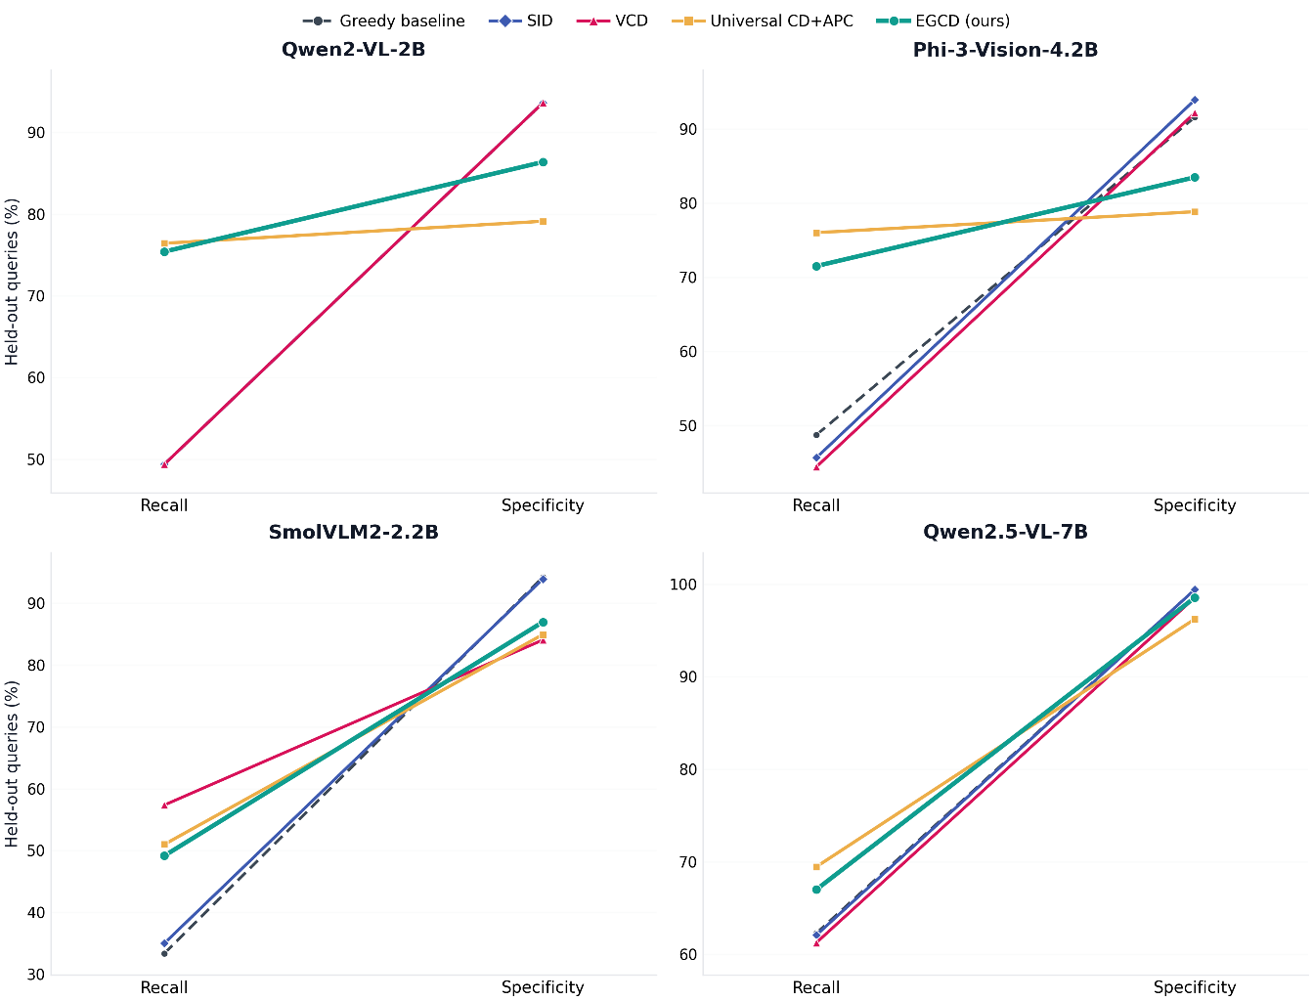
Figure 4: Recall and Specificity on the held-out half for the four bias-affected models, where Universal CD+APC buys its recall by spending specificity and EGCD recovers most of the recall at a fraction of the specificity cost.
Figure 5 sweeps τ over [0.550, 0.750] for the four bias-affected architectures. Each curve rises above both reference lines, hits a peak (τ* = 0.70, 0.62, 0.68, and 0.65 for Qwen2-VL-2B, Phi-3-Vision-4.2B, SmolVLM2-2.2B, and Qwen2.5-VL-7B), and then falls back toward baseline once τ moves past the entropy mass of genuine conflicts.
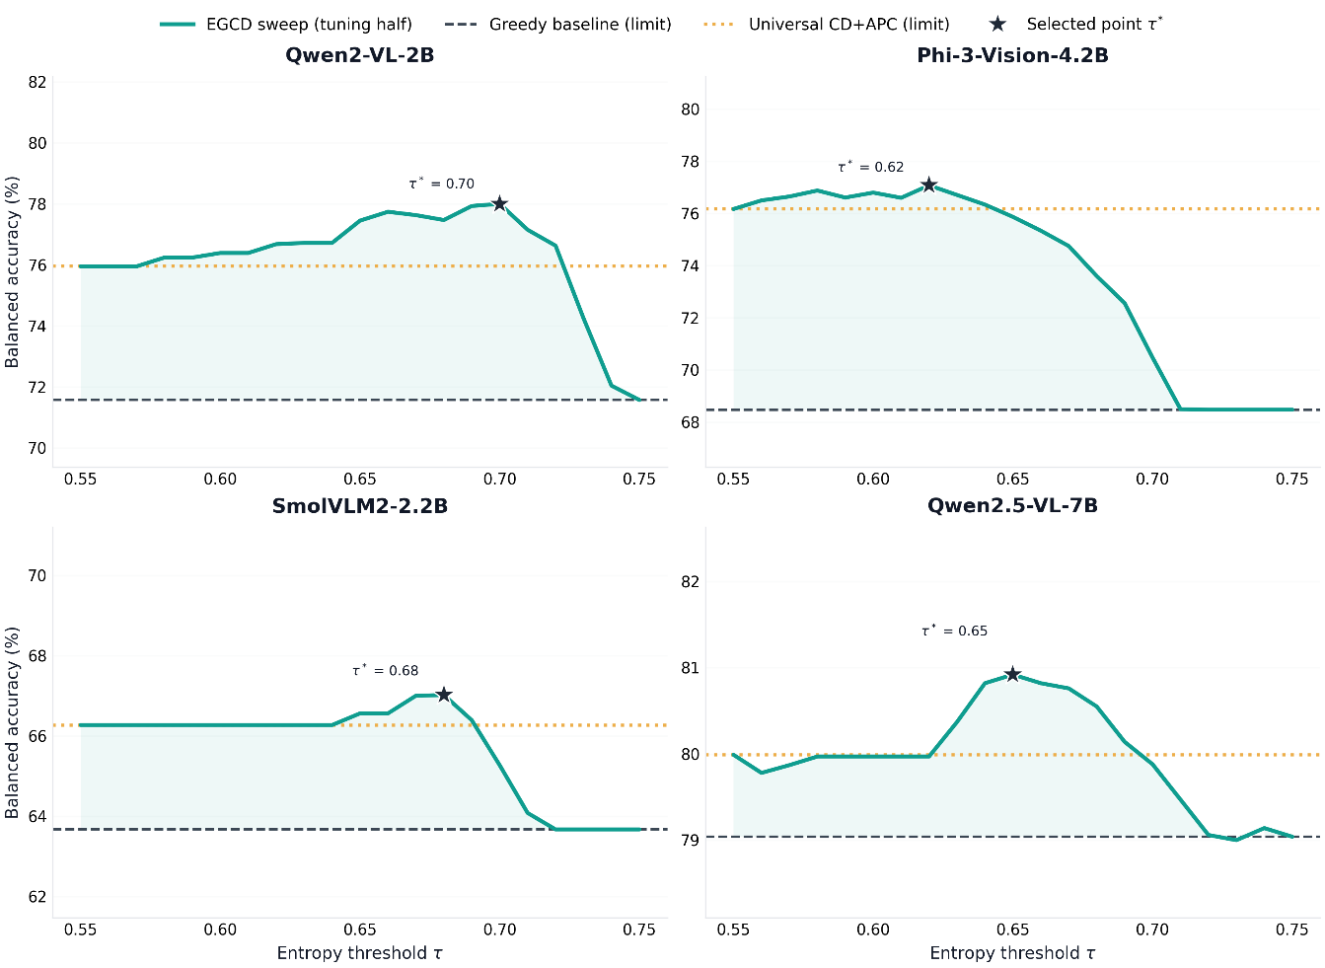
Figure 5: Balanced accuracy across the entropy-threshold sweep on the tuning half for the four bias-affected models; the star marks each model's selected threshold τ*.

5.3 The Architectural Boundary of Contrastive Interventions
Contrastive decoding is not a universal tool. LLaVA-1.5-7B and LLaVA-v1.6-Mistral-7B start with recalls of 75.00% and 78.36%, which indicates that their connectors produce visual tokens that already compete on equal terms with text. Universal CD+APC damages exactly these models: on LLaVA-1.5-7B, balanced accuracy falls to 63.06% with Recall dropping to 29.30%, and on LLaVA-v1.6-Mistral-7B it drops by 10.42 points. We refer to this as Contrastive Overcompensation. In a model that is already balanced, subtracting a vision-free amateur over-penalizes the syntactic and structural priors that the model still relies on, and recall suffers as a result. The same arithmetic that improves Qwen2-VL-2B ends up removing corrections that a balanced model was already making correctly.
The gate handles this distinction without any explicit instruction. Balanced models maintain compact first-token distributions, entropy rarely crosses τ, and the gate does not activate. As a result, EGCD preserves 76.78% on LLaVA-1.5-7B and 86.06% on LLaVA-v1.6-Mistral-7B, identical to greedy decoding. Figure 6 shows the sweep for the structurally sound architectures: Idefics2-8B stays within a 0.7-point band across the entire range and does not differ from either regime (p > 0.99), and LLaVA-1.5-7B returns its baseline exactly. The router treats the contrastive pass as conditional rather than mandatory, and at the selected operating points the output matches the baseline whenever no conflict is present.
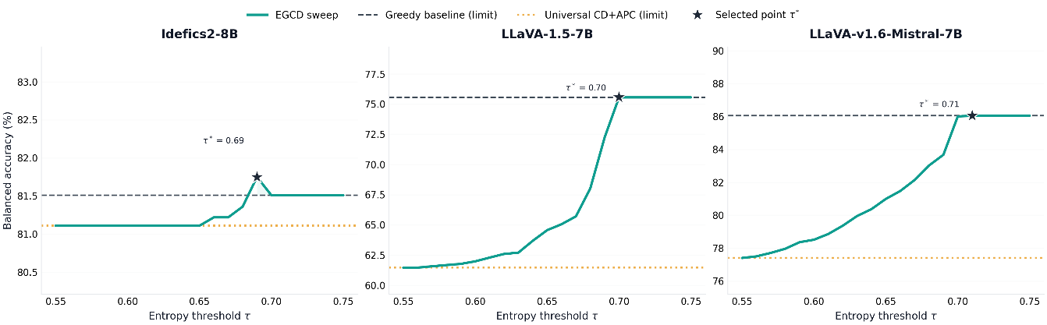Figure 6: The same sweep for the three structurally sound models, where EGCD tracks the greedy baseline everywhere while Universal CD+APC falls up to 14 points below it.

5.4 First-Token Entropy and Gating Threshold Dynamics
The sweep shows what the routing decision is actually doing. For Qwen2-VL-2B, balanced accuracy climbs to its peak at the selected threshold, which Table 1 evaluates on the held-out half, as more uncertain queries get sent to System 2 (Figure 5). Beyond 0.710 the curve slides back down toward the 71.50% baseline: a gate set too high lets real conflicts through, and Visual Inertia survives untouched. The response traces a hill, and where the summit sits tracks each model's entropy distribution, which is why no single τ can serve all seven models.
The flat side of the pattern belongs to the structurally sound models. Idefics2-8B never leaves a 0.7-point band anywhere in the sweep (Figure 6), which says its first-token entropy stays under the conflict threshold in normal operation, so the costlier contrastive pass runs only when there is genuine trouble. Figure 7 maps the full sweep for all seven models, and the complete tuning-half numbers are given in Appendix A. Together the two views show a gate that prices the intervention correctly in both directions: it pays for contrast where conflict exists and declines to pay where none does, holding both fluency and inference cost steady.
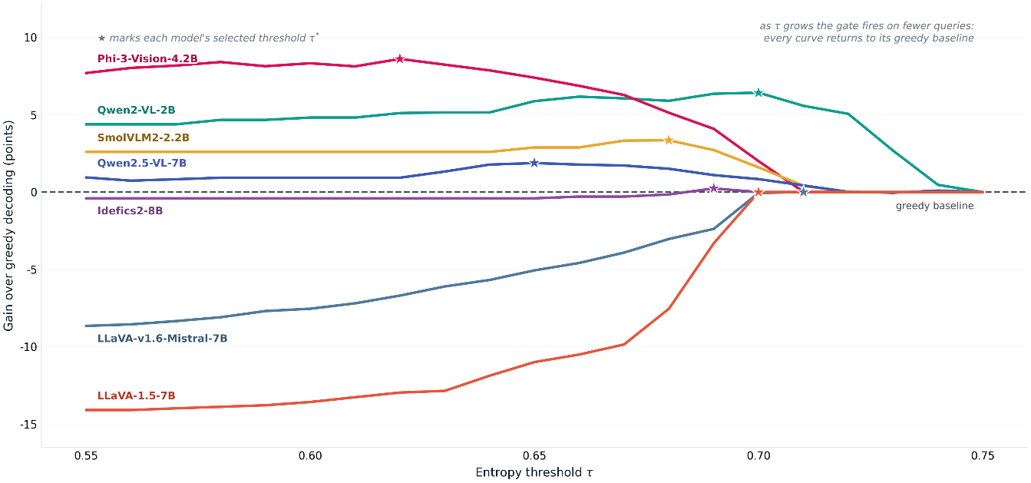
Figure 7: Gain over greedy decoding across the entropy-threshold sweep for all seven models: every curve returns to zero as τ grows, and on the sound models a loose threshold costs up to 14 points.
The gate routes 40.9% of held-out queries on Qwen2-VL-2B, 38.8% on Phi-3-Vision-4.2B, 28.2% on SmolVLM2-2.2B, 13.2% on Qwen2.5-VL-7B, 2.2% on Idefics2-8B and none on LLaVA-1.5-7B. Shuffled routing at the same rate recovers only part of the gain (64.96 against 68.07 on SmolVLM2-2.2B, 74.04 against 80.89 on Qwen2-VL-2B, 72.97 against 77.50 on Phi-3-Vision-4.2B), so most of the improvement comes from choosing the right queries rather than from intervening often.

6. Conclusion and Future Work

6.1 Summary of Contributions
This paper treats relational hallucination as a decoding failure with a traceable mechanism behind it, Visual Inertia: cross-attention settles on its first targets, grounding decays with every token generated, and the language priors end up writing the answer (Gong et al., 2026). EGCD answers it with a query-level entropy gate that fires a counterfactual contrastive pass only where vision-text conflict is active, bounded by an Adaptive Plausibility Constraint and decoded greedily.
Across the seven models on AMBER's relation subset, the gate separated the suite without being told which was which. The biased architectures gained, Qwen2-VL-2B by 9.39 points and Phi-3-Vision-4.2B by 7.31, and without the specificity loss that universal CD leaves behind. The structurally sound models kept their numbers: universal CD had pushed LLaVA-1.5-7B down to 63.06%, while EGCD handed back its 76.78% baseline unchanged. One shared threshold for the whole suite keeps most of the gains on the biased models but gives up the idle-gate safety on LLaVA-1.5-7B, where a suite-wide τ = 0.69 drops balanced accuracy to 73.19 against the 76.78 baseline. What comes out is a conditional, architecture-aware use of contrastive decoding, applied where it helps and withheld where it would do damage.

6.2 Limitations and Future Work
Several extensions look worth the effort. The first is calibration-free gating: entropy percentiles estimated on the fly, or one shared threshold fitted across a model family, would remove the per-model sweep that τ* currently requires. Open-ended generation is the second and harder target, since the first-token distribution no longer concentrates the whole decision in one place and some form of step-level probe would be needed. The third is routing inside reasoning models: Octopus learns per-step strategy selection (Suo et al., 2025), dual-process search keeps spreading through chain-of-thought systems (Cheng et al., 2025; Li et al., 2025), and a training-free entropy signal is a natural candidate for deciding when those pipelines should slow down and think twice.

References
Abdin, M., Jacobs, S. A., Awan, A. A., et al. (2024). Phi-3 technical report: A highly capable language model locally on your phone. arXiv preprint arXiv:2404.14219.
Alain, G., and Bengio, Y. (2016). Understanding intermediate layers using linear classifier probes. arXiv preprint arXiv:1610.01644.
Bai, S., Chen, K., Liu, X., Wang, J., Ge, W., Song, S., Dang, K., Wang, P., Wang, S., Tang, J., et al. (2025). Qwen2.5-VL technical report. arXiv preprint arXiv:2502.13923.
Belrose, N., Furman, Z., Smith, L., Halawi, D., Ostrovsky, I., McKinney, L., Biderman, S., and Steinhardt, J. (2023). Eliciting latent predictions from transformers with the tuned lens. arXiv preprint arXiv:2303.08112.
Bendre, A., Gupta, G., Grover, K., et al. (2026). Rethinking CD: A reproducibility study and extension on the ineffectiveness of contrastive decoding at mitigating object hallucinations in MLLMs. arXiv preprint arXiv:2607.25196.
Bordes, F., Balestriero, R., and LeCun, Y. (2024). Towards understanding the limitations of vision-language models. In Proceedings of the IEEE/CVF Conference on Computer Vision and Pattern Recognition (CVPR).
Brodersen, K. H., Ong, C. S., Stephan, K. E., and Buhmann, J. M. (2010). The balanced accuracy and its posterior distribution. In 2010 20th International Conference on Pattern Recognition, pp. 3121-3124.
Brown, E., Yang, J., Yang, S., Fergus, R., and Xie, S. (2025). From hallucination to grounding: Diagnosing visual spatial intelligence via CRISP. arXiv preprint arXiv:2511.04655.
Chen, X., Xu, C., and Zhou, D. (2026). Mitigating object hallucinations in vision-language models through region-aware attention recalibration. arXiv preprint arXiv:2605.24957.
Chen, Y., Li, L., Yu, L., El Kholy, A., Ahmed, F., Gan, Z., Cheng, Y., and Liu, J. (2024). SpatialVLM: Endowing vision-language models with spatial reasoning capabilities. In Proceedings of the IEEE/CVF Conference on Computer Vision and Pattern Recognition (CVPR).
Cheng, X., Li, J., Zhao, W. X., and Wen, J.-R. (2025). Think more, hallucinate less: Mitigating hallucinations via dual process of fast and slow thinking. In Findings of the Association for Computational Linguistics: ACL 2025, pp. 7979-7990.
Chuang, Y.-S., Xie, Y., Luo, H., Kim, Y., Glass, J., and He, P. (2024). DoLa: Decoding by contrasting layers improves factuality in large language models. In International Conference on Learning Representations (ICLR).
Favero, A., Zancato, L., et al. (2024). Multi-modal hallucination control by visual information grounding. In Proceedings of the IEEE/CVF Conference on Computer Vision and Pattern Recognition (CVPR).
Fu, C., Chen, P., Shen, Y., Qin, Y., Zhang, M., Lin, X., Yang, J., Zheng, X., Li, K., Sun, X., et al. (2025). MME: A comprehensive evaluation benchmark for multimodal large language models. International Journal of Computer Vision, pp. 1-24.
Gong, B., Zheng, Y., Kong, F., Zhou, J., and Lu, J. (2026). Attention at rest stays at rest: Breaking visual inertia for cognitive hallucination mitigation. arXiv preprint arXiv:2604.01989.
Guo, Y., Tang, K., Lin, F., Sun, Y., Zhang, D., Wang, W., Cong, L. W., and Zhang, S. (2026). FADE: Mitigating hallucinations by reducing language-prior dominance in large vision-language models. arXiv preprint arXiv:2606.29431.
Huang, X., Zhang, K., and Luo, Z. (2026). CHASD: Language increment-calibrated contrastive decoding against hallucination in LVLMs. arXiv preprint arXiv:2605.23344.
Huo, F., Xu, W., Zhang, Z., Wang, H., Chen, Z., and Zhao, P. (2025). Self-introspective decoding: Alleviating hallucinations for large vision-language models. In International Conference on Learning Representations (ICLR).
Im, S., Park, J., and Choi, Y. (2025). Self-Aug: Query and entropy adaptive decoding for large vision-language models. In Proceedings of the International Conference on Learning Representations (ICLR).
Kahneman, D. (2011). Thinking, Fast and Slow. Farrar, Straus and Giroux, New York.
Laurencon, H., Saulnier, L., Tronchon, L., et al. (2024). What matters when building vision-language models? arXiv preprint arXiv:2405.02246.
Leng, S., Zhang, H., Chen, G., Li, X., Lu, S., Miao, C., and Bing, L. (2024). Mitigating object hallucinations in large vision-language models through visual contrastive decoding. In Proceedings of the IEEE/CVF Conference on Computer Vision and Pattern Recognition (CVPR), pp. 13872-13882.
Li, J., Dong, L., and Wei, F. (2025). From System 1 to System 2: A survey of reasoning large language models. arXiv preprint arXiv:2502.17419.
Li, X. L., Holtzman, A., Fried, D., Liang, P., Eisner, J., Hashimoto, T., Zettlemoyer, L., and Lewis, M. (2023a). Contrastive decoding: Open-ended text generation as optimization. In Proceedings of the 61st Annual Meeting of the Association for Computational Linguistics (ACL), pp. 12286-12312.
Li, Y., Du, Y., Zhou, K., Wang, J., Zhao, W. X., and Wen, J.-R. (2023b). Evaluating object hallucination in large vision-language models. In Proceedings of EMNLP.
Liu, H., Li, C., Wu, Q., and Lee, Y. J. (2023). Visual instruction tuning. In Advances in Neural Information Processing Systems (NeurIPS).
Liu, H., Li, C., Li, Y., and Lee, Y. J. (2024). Improved baselines with visual instruction tuning. In Proceedings of the IEEE/CVF Conference on Computer Vision and Pattern Recognition (CVPR).
Marafioti, A., Zohar, O., et al. (2025). SmolVLM: Redefining small and efficient multimodal models. arXiv preprint arXiv:2504.05299.
Min, B., Zhao, H., and Zhang, X. (2025). Mitigating hallucinations in large vision-language models via summary-guided decoding. In Findings of the Association for Computational Linguistics: NAACL 2025, pp. 4183-4198.
Pan, J., Zhang, Y., Zhang, C., Liu, Z., Wang, H., and Li, H. (2024). DynaThink: Fast or slow? A dynamic decision-making framework for large language models. In Proceedings of the 2024 Conference on Empirical Methods in Natural Language Processing (EMNLP), pp. 14686-14695.
Ren, Z., Shen, C., and Li, Y. (2026). NoLan: Mitigating object hallucinations in large vision-language models via dynamic suppression of language priors. arXiv preprint arXiv:2602.22144.
Rohrbach, A., Hendricks, L. A., Burns, K., Chattopadhyay, P., Saenko, K., and Darrell, T. (2018). Object hallucination in image captioning. In Proceedings of EMNLP, pp. 4035-4045.
Shannon, C. E. (1948). A mathematical theory of communication. Bell System Technical Journal, 27(3), 379-423.
Shin, P. W., Sridhar, A. N., Devarapalli, L. S., Zhang, R., Sampson, J., and Narayanan, V. (2026). When relations break: Analyzing relation hallucination in vision-language model under rotation and noise. arXiv preprint arXiv:2605.05045.
Su, Y., and Xu, J. (2022). An empirical study on contrastive search and contrastive decoding for open-ended text generation. arXiv preprint arXiv:2211.10797.
Su, Y., Wang, Z., and Zhang, M. (2025). Activation steering decoding: Mitigating hallucination in large vision-language models through bidirectional hidden state intervention. In Proceedings of ACL 2025, pp. 12964-12974.
Suo, W., Zhang, L., Sun, M., Wu, L. Y., Wang, P., and Zhang, Y. (2025). Octopus: Alleviating hallucination via dynamic contrastive decoding. arXiv preprint arXiv:2503.00361.
Wang, J., Wang, Y., Xu, G., et al. (2023). AMBER: An LLM-free multi-dimensional benchmark for MLLMs hallucination evaluation. arXiv preprint arXiv:2311.07397.
Wang, X., Pan, J., Ding, L., and Biemann, C. (2024). Mitigating hallucinations in large vision-language models with instruction contrastive decoding. arXiv preprint arXiv:2403.18715.
Wang, Y., Chen, H., et al. (2025). ContextFocus: Activation steering for contextual faithfulness in large language models. arXiv preprint arXiv:2601.04131.
Wason, P. C., and Evans, J. S. B. (1974). Dual processes in reasoning? Cognition, 3(2), 141-154.
Xiao, Z., and Zhou, T. (2026). MACD: Model-aware contrastive decoding via counterfactual data. In International Conference on Learning Representations (ICLR).
Yin, H., Si, G., and Wang, Z. (2025). The mirage of performance gains: Why contrastive decoding fails to mitigate object hallucinations in MLLMs? arXiv preprint arXiv:2504.10020.
Zhang, Y., Wang, Z., Zhang, X., et al. (2026). Mitigating entangled steering in large vision-language models for hallucination reduction. arXiv preprint arXiv:2604.07914.

Appendix A: Complete Entropy-Threshold Sweep Results
This appendix reports the balanced accuracy of the entropy-threshold sweep on the tuning half. It is the selection record: each model's peak here is the operating point τ* that Section 5 evaluates on the held-out half. Six of the seven models are listed; LLaVA-v1.6-Mistral-7B is absent because its sweep is the earlier full-set run, which Table 1 and Figure 6 carry (daggered) until its re-run. The selected thresholds are 0.700 (Qwen2-VL-2B), 0.620 (Phi-3-Vision-4.2B), 0.680 (SmolVLM2-2.2B), 0.650 (Qwen2.5-VL-7B), 0.690 (Idefics2-8B), and 0.700 (LLaVA-1.5-7B); Recall and Specificity at each operating point appear in Table 1. Figure A1 renders the held-out results of Table 1 as three heatmaps and Figure A2 summarizes the gain each selected threshold buys.
Table A1: Balanced accuracy (%) across the entropy-threshold sweep on the tuning half for the six models with tuning-half sweeps; each model's peak on this grid is its selected operating point τ*, evaluated on the held-out half in Table 1.
Τ | Qwen2-VL-2B | Phi-3-Vision-4.2B | SmolVLM2-2.2B | Qwen2.5-VL-7B | Idefics2-8B | LLaVA-1.5-7B
0.55 | 75.95 | 76.17 | 66.27 | 79.99 | 81.11 | 61.47
0.56 | 75.95 | 76.50 | 66.27 | 79.78 | 81.11 | 61.47
0.57 | 75.95 | 76.65 | 66.27 | 79.87 | 81.11 | 61.58
0.58 | 76.24 | 76.88 | 66.27 | 79.97 | 81.11 | 61.68
0.59 | 76.24 | 76.61 | 66.27 | 79.97 | 81.11 | 61.78
0.60 | 76.39 | 76.80 | 66.27 | 79.97 | 81.11 | 61.99
0.61 | 76.39 | 76.60 | 66.27 | 79.97 | 81.11 | 62.30
0.62 | 76.68 | 77.08 | 66.27 | 79.97 | 81.11 | 62.60
0.63 | 76.72 | 76.71 | 66.27 | 80.37 | 81.11 | 62.71
0.64 | 76.72 | 76.34 | 66.27 | 80.82 | 81.11 | 63.69
0.65 | 77.45 | 75.87 | 66.56 | 80.92 | 81.11 | 64.57
0.66 | 77.74 | 75.34 | 66.56 | 80.82 | 81.22 | 65.06
0.67 | 77.63 | 74.75 | 67.00 | 80.76 | 81.22 | 65.71
0.68 | 77.47 | 73.60 | 67.02 | 80.55 | 81.36 | 68.02
0.69 | 77.93 | 72.56 | 66.39 | 80.14 | 81.75 | 72.25
0.70 | 78.00 | 70.47 | 65.27 | 79.88 | 81.51 | 75.56
0.71 | 77.15 | 68.49 | 64.08 | 79.47 | 81.51 | 75.56
0.72 | 76.63 | 68.47 | 63.67 | 79.06 | 81.51 | 75.56
0.73 | 74.25 | 68.47 | 63.67 | 79.00 | 81.51 | 75.56
0.74 | 72.04 | 68.47 | 63.67 | 79.14 | 81.51 | 75.56
0.75 | 71.57 | 68.47 | 63.67 | 79.04 | 81.51 | 75.56

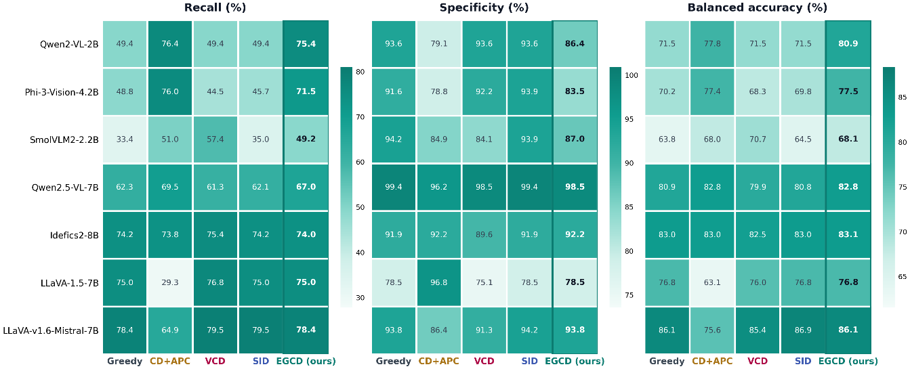
Figure A1: The tuning-half sweep grid of Table A1 rendered as a heatmap, with darker cells marking higher balanced accuracy; the dashed end columns are the gate-always-active (CD+APC) and gate-inactive (greedy) limits.

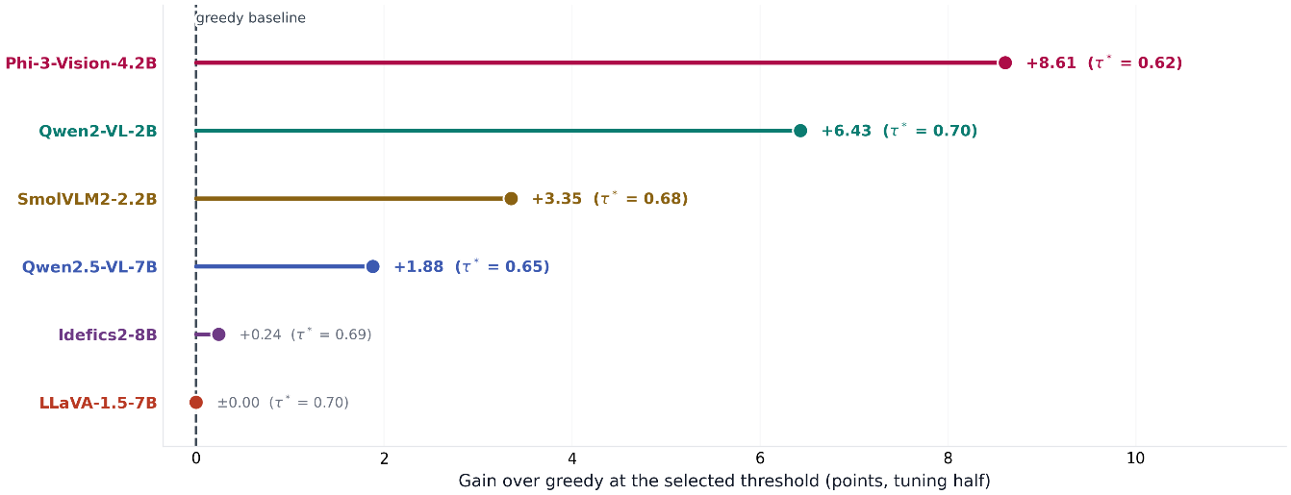
Figure A2: Gain over greedy decoding at each model's selected threshold τ* on the tuning half: the gate buys the most exactly where hallucination bias is largest.

