**Git is a VCS (Version control system) to track your files.**

**Untracked-----Staged-----Tracked**

**git init**

**git status**

**git add backup.sh**

**git rm --cache backup.sh**

**git status**

**git add backup.sh**

**git commit -m “added backup.sh”**

**git restore backup.sh**

**git log –-oneline**

**git branch**

**git branch checkout -b dev**

**git merge**

**git remote -v**

**git remote add origin URL**

**git remote url-set origin https://token@github.com/flexis007/shell-script.git**





**git push origin master**

**git pull origin master**

**git clone url**

**git diff**

**git fork**

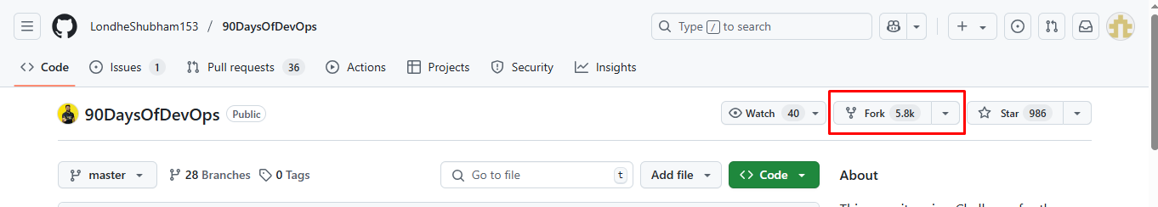

**Branching Strategies**

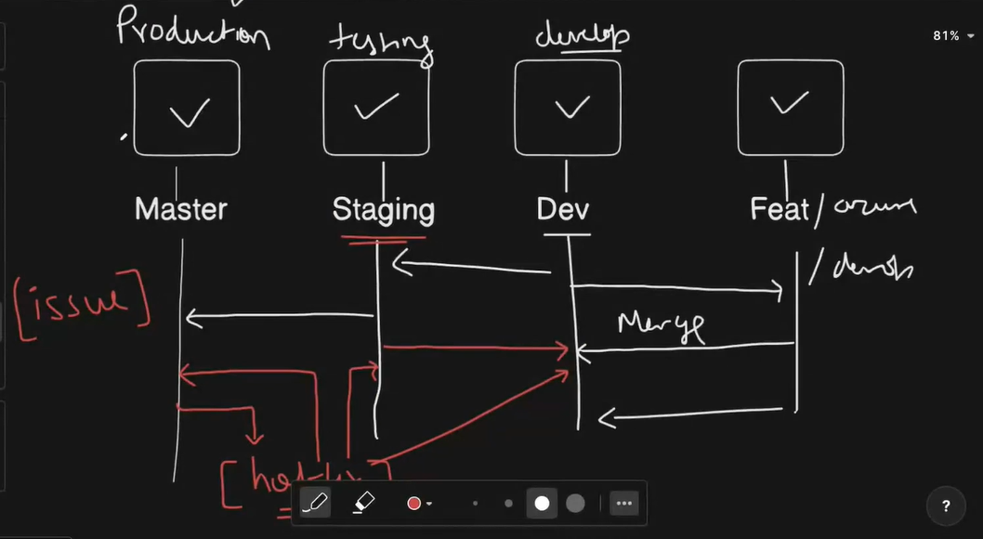

**git fetch vs git pull**

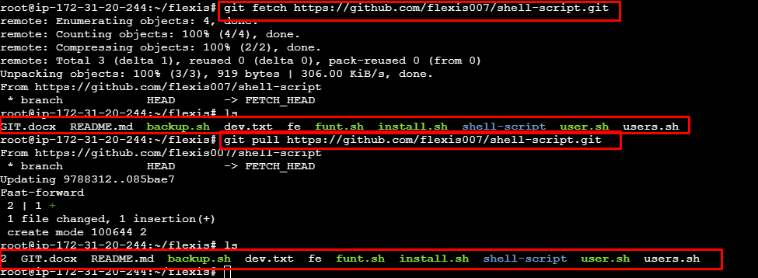

**git Pull Request**

**git revert**

**if you have 3 commit and revert 2nd commit on same file then it will conflict but if only 2 commit and revert last one it’s not conflict.**

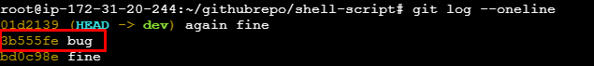

**git reset**

**soft --- untracked + stage**

**mixed ---- untrack**

**hard ---- delete**

**git stash**

**git stash pop**

