

**CSE302: Database Systems (Section 01)**

**[FALL 2022]**

**Project Report**

FIFA WORLD CUP 2022

Project URL/Link

**Submitted by:**

|  |  |  |
| --- | --- | --- |
| **Student ID** | **Student Name** | **Contribution Percentage** |
| **2020-1-60-181** | **Mariya Rahman Momo** | **35%** |
| **2019-3-60-085** | **Farhan Rabby** | **25%** |
| **2019-2-60-059** | **Shairin Siddique** | **20%** |
| **2020-1-60-222** | **Sanjida Akter** | **20%** |

# E-R Model of the Project

Assumptions: Here, we assumed MTeamDetails and Substitutes entity set are the weak entity set. A coach may not be assigned to a team but a team must have a couch. A FinalResult may not be the final result of FIFA2022 (assumed that the FinalReault entity set contents the final result of some other FIFA world cups).

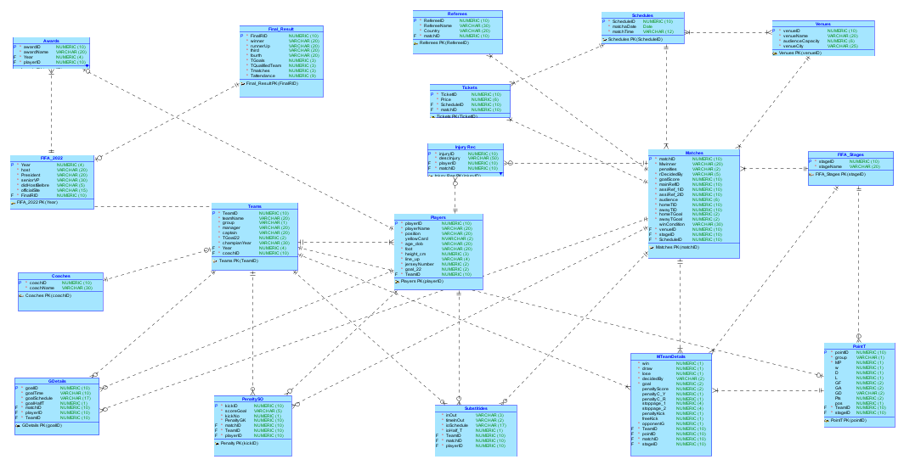

# Relational Data Model of the Project

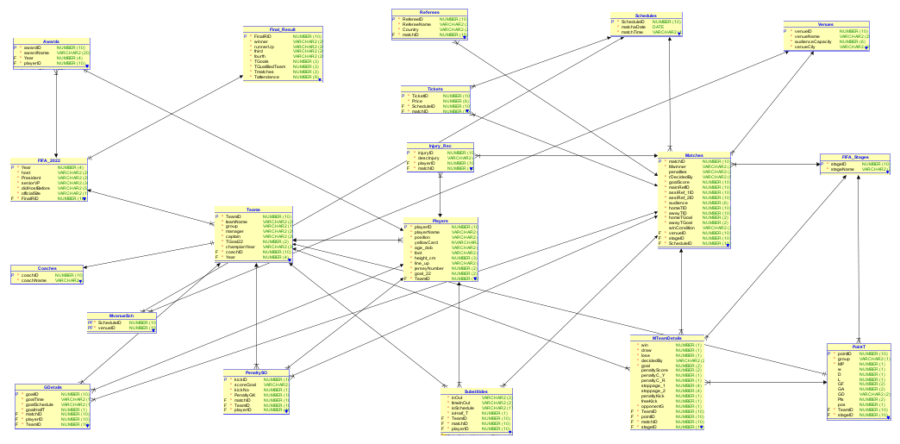

1. Complete Schema

Players (playerID, playerName, position, yellowCard, age_dob, foot, height_cm, line_up, jerseyNumber, goal_22, teamID)

Matches (matchID, Mwinner, penalties, rDecidedBy, goalScore, mainRefID, assiRef_1ID, assiRef_2ID, audience, homeTID, awayTID, homeTGoal, awayTGoal, winCondition, venueID, stageID, scheduleID)

FIFA_Stage (stageID, stageName)

Awards (awardID, awardName, year, playerID)

FIFA_2022 (year, host, president, seniorVP, didHostBefore, officialSite, finalRID)

Teams (teamID, teamName, group, manager, captain, TGoal22, champianYear, year, coachID)

Final_Result (finalRID, winner, runnerUp, third, fourth, TGoals, TQualifiedTeam, Tmatches, Tattendence)

Referees (refereeID, refereeName, country, matchID)

Tickets (ticketID, price, scheduleID, matchID)

Schedules (scheduleID, matchdate, matchTime)

Venues (venueID, venueName, audienceCapacity, venueCity)

Coaches (coachID, coachName)

GDetails (goalID, goalTime, goalschedule, goalHalfT, matchID, playerID, teamID)

PenaltySO (kickID, scoreGoal, kickNo, penaltyGK, matchID, teamID, playerID)

Substitutes (inOut, timeInOut, ioSchedule, ioHalf_T, teamID, matchID, playerID)

MTeamDetails (win, draw, lose, decidedBy, goal, penaltyScore, penaltyC_Y, penaltyC_R, stoppage_1, stoppage_2, penaltyKick, freeKick, opponentG, teamID, pointID, matchID, stageID)

Injury_Rec (injuryID, descInjury, playerID, matchID)

PointT (pointID, group, MP, W, D, L, GF, GA, GD, Pts, Pos, teamID, stageID)

MvenueSCH (scheduleID, venueID)