DATA VISUALISATION

**Dataset:** Dataset that I chose to apply visualisation techniques is world-happiness-report-2019.csv. This data is a survey of the happiness level of 156 countries by analyzing different factors. Four factors that I used for visualization are given as follows:

* Country (region): It represents names of countries.
* Social Support: It shows level of social support that is contributing directly in calculating happiness score.
* Freedom: The factor of freedom that is used to determine the happiness of the country.
* Corruption: This is an extent to which corruption is affecting level of happiness of a country.

1. **Line Graph:**

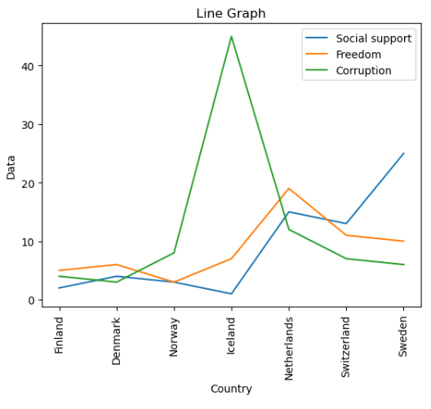

Line Graph is useful to find trends over period of time. This line graph shows that Netherland has more freedom than other countries whereas Sweden has highest level of social support. Moreover, Denmark has lowest level of corruption.

1. **Bar Graph**

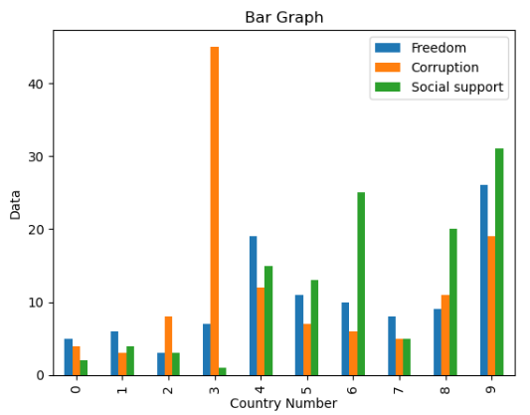

Bar graph also known as Bar chart that presents data of different categories with rectangular bars. Three colorful bars are used to happiness level of ten countries by analyzing their freedom, corruption and social support. Country with number 3 has lowest level of social support and has highest corruption rate. Whereas, country with number 9 has highest levels of social support and freedom.

1. **Scatter Plot**

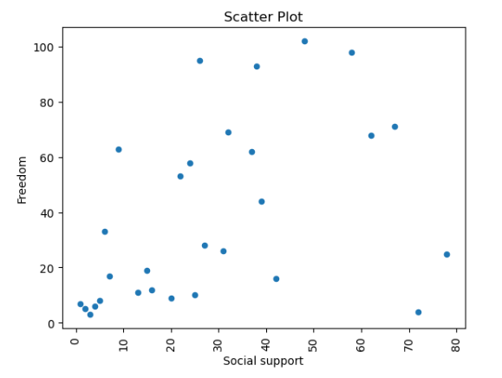

A scatter plot is a visual representation of relation between two variables by using dots. In above scatter plot, it can be noticed that first five dots representing countries are highly correlated with respect to its freedom and social support level while other countries after that have low or no correlation between freedom and social support level.

**Dataset reference link:**

<https://github.com/imgraham1/539_FinalProject/blob/master/world-happiness-report-2019.csv>

**Github link:**

<https://github.com/Farhan608/DataVisulization>