**Comments on meeting Friday 12/05:**

**Data cleaning:**

Huma’s part

**Scores to Quantify variables:**

* Sleep score: <https://www.goodmedicine.org.uk/files/assessment,%20pittsburgh%20psqi.pdf> (Very good quality, same questions, same answers, we can take this one)
* Food/nutrition score: <https://fns-prod.azureedge.us/sites/default/files/healthy_eating_index/HEI-2015%20Components%20and%20Scoring%20Standards_2.pdf>

<https://knozc.pan.pl/images/stories/MLonnie/KomPAN_manual_english_version_25-11-2020_last_korekta_2021.pdf>

* Alcohol

<https://www.ncbi.nlm.nih.gov/pmc/articles/PMC3379009/figure/F1/>

<https://www.mirecc.va.gov/cih-visn2/Documents/Provider_Education_Handouts/AUDIT_Test_Manual.pdf>

* Tobacco, Screen time and physical activity can be more straightforward and count directly and create our score, because there is only one variable related to these variables.
* Stress

<https://www.sciencedirect.com/science/article/pii/S1976131712000527>

<https://pubmed.ncbi.nlm.nih.gov/20064889/>

* Anxiety

<https://www.sciencedirect.com/science/article/pii/S0165032716313696>

Once these scores have been applied we will have these quantitative variables:

* Sleep (Y, variable to predict)
* Stress (X1)
* Anxiety (X2)
* Food (X3)
* Drink (X4)
* Tobacco (X5)
* Screen time (X6)

**Data analysis:**

1. **Descriptive statistics:**
   1. Correlation visualization
   2. Covariance visualization
   3. Also descriptive analysis of the sleep score to have an overall view of how people sleep according to the score.
2. **Inferential statistics:**
   1. Linear regression (with, without interaction,...) of the **quantitative variables**.
   2. With **categorical variables**: separate data based on a certain categorical variable(s) and do a t.test between the different groups comparing the mean of the **Sleep score**.

DataSet:

**Screen Time:**

For the below question, we label the respondent response by the following approach

**What are the main activities you use your laptop for? (More than one option can be chosen)**

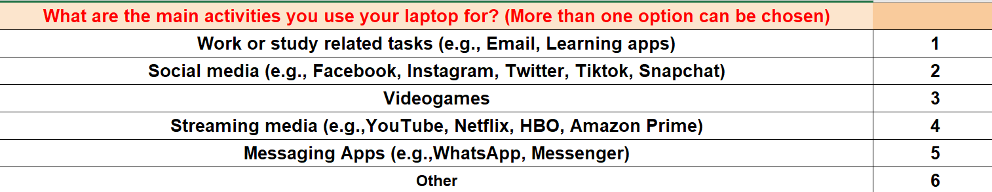

**What are the main activities you use your smartphone for? (More than one option can be chosen)**

